**1.**[**Sweet Corn Soup Recipe | Whole Food Plant Based Recipes**](https://www.nutritionscience.in/blog/sweet-corn-soup-recipe-whole-food-plant-based-recipes)

Feb 13, 2019

**Sweet Corn Soup Recipe**

Course: Breakfast, Soup  
Cuisine: American  
Prep Time: 10 minutes  
Cook Time: 15 minutes  
Servings: 2 Servings

### INGREDIENTS

1. 1/2 cup Sweet Corn Kernels
2. 2 Spring Onions
3. 2 1/2 cups Water
4. 5 pods garlic
5. 1/2 tsp Black Pepper Powder
6. 1 Lemon
7. 2 tbsp Sunflower Seeds Soaked overnight or at least for 5 hours
8. 4 tsp Miso Paste (Healthy Salt Alternative. See Nutrition Science Highlights below)
9. 2 tbsp Coriander leaves and Stems

### INSTRUCTIONS

1. Take sweet corn kernels in a vessel with water and cook with a closed lid.
2. While the vegetables are being cooked, peel and crush garlic. Keep aside for ten minutes. After ten minutes, add crushed garlic to the boiling vegetables.
3. While soup is being cooked, blend sunflower seeds with black pepper powder, miso paste, and enough water to make sunflower seed cream in a high powered blender. If using a regular mixie, soak sunflower seeds to 15- to 20 minutes first.
4. Once soup is cooked, remove from stove and mix in salty, spicy sunflower seed cream. Squeeze lemon. Garnish with freshly chopped coriander leaves. Serve fresh!

## Nutrition Science Highlights of Whole Food Plant Based Sweet Corn Soup:

1. Miso paste is fermented & salted soya bean paste. Maximum recommended salt intake is 3 grams per day per person. In addition to helping us restrict salt intake, replacing salt with miso paste also helps by neutralising the negative effects of salt by soya phytonutrients. You can easily make fresh miso paste at home by mixing 100 grams of cooked soya paste with 10 grams of salt, or 10 tablespoons of cooked soya paste with 1 tablespoon of salt. If making at home, ensure to use immediately, or freeze in batches to use later.
2. Soups often contain cream, milk, and butter. Dairy products have been found to be associated with increased risk of chronic diseases, such as diabetes mellitus, hypertension, obesity, asthma, PCOS, and heart disease. We can still enjoy our milk, cream, and butter though - as long as they are made from whole plant foods!
3. When garlic is chopped, crushed, ground or bitten into, two chemicals stored in different parts of garlic's cells combine in a chemical reaction to form allicin. This is a slightly bitter compounds that deters insects, but happens to be very beneficial to our health. Allicin helps reduce blood pressure and protect the heart and other organs, fight off lung infections, and reduce inflammation. Unfortunately, cooking destroys one of the enzymes required to form allicin. This can be overcome by crushing garlic and keeping it aside for ten minutes while the chemical reaction takes place. Once allicin is formed, it is heat stable and can be safely cooked. Alternatively, some raw garlic can be added after cooking, to a dish that has cooked garlic in it.

# 2.Pulihora Recipe | Kokum Rice Recipe | Whole Food Plant Based Recipes

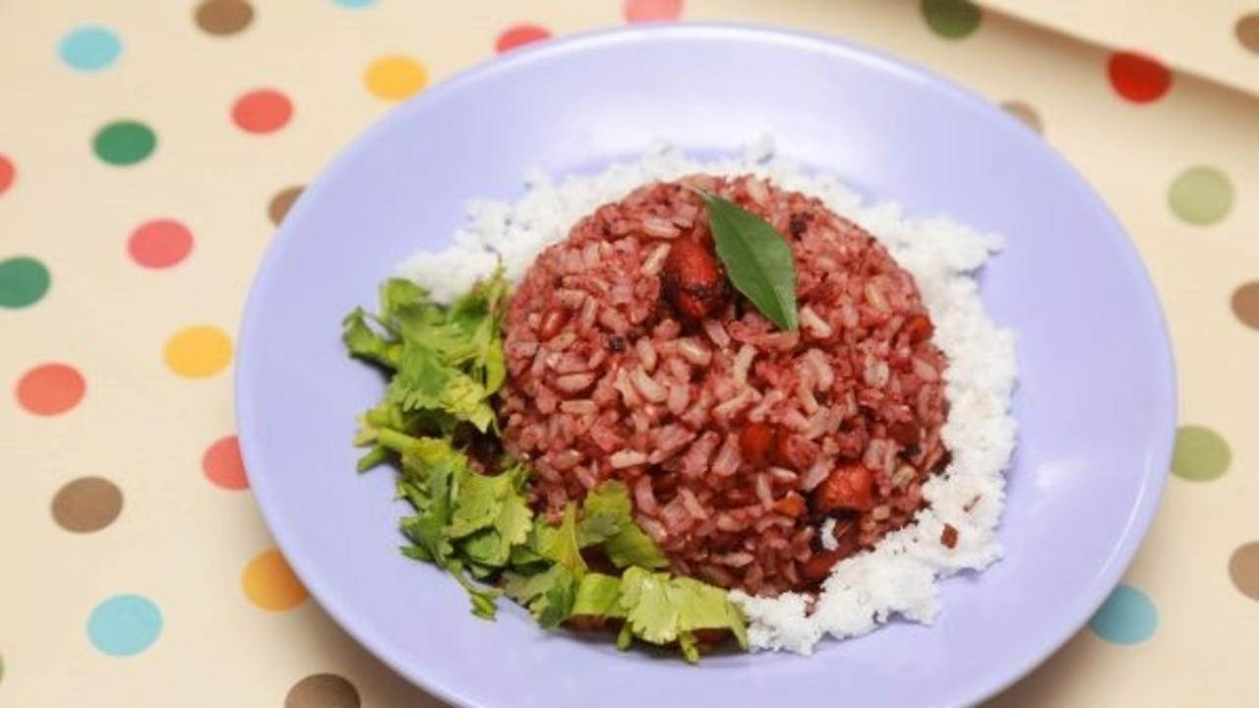

Kokum Pulihora is the first dish to be wiped clean, in our feasts. Spicy and tangy, nobody can make out that it doesn’t have any oil, tamarind or red chili powder!

Kokum is a bright red, super tangy fruit that grows in the Western Ghats. It has many medicinal properties and can be used in place of tamarind in many recipes. Pulihora or Puliogare is popular South Indian dish, usually prepared with tamarind as the main ingredient.

Tamarind was in widespread use in Tamil Nadu, Andhra Pradesh and surrounding areas for many reasons – one important reason being, the ground water contained a lot of fluoride, and tamarind impeded fluoride absorption. It also helps prevent kidney stone formation when your food is dry on a daily basis.

While it is harmless in small quantities, consuming large quantities leads to that well-known feeling of acidity after eating puliogare and sambar rice.

Extracted oil is somewhat neutral when it comes to health. On the other hand, whole nuts prevent and even reverse heart disease! We have written a detailed pulihora recipe step by step! Hope you enjoy this puliyogare recipe!

## Whole Food Plant Based Pulihora Recipe with Kokum

Course: Course 3 (Grain Dishes) at Lunch & Dinner Meals, Festival Dish  
Cuisine: Andhra Recipe from South India  
Prep Time: 30 minutes   
Cook Time: 15 minutes  
Servings: 4 people

#### INGREDIENTS

1/2 cup Kokum / Garcinia / Punarpuli  
1 cup Unpolished Rice  
2 tsp Peanuts  
1 tsp Mustard Seeds  
1 tsp Jeera / Cumin Seeds  
1 tsp Bengal Gram Dal / Chana Dal  
1 tsp Urad Dal / Split Black Gram Dal  
1/8 tsp Fenugreek / Methi Seeds  
1 pinch Asafoetida / Hing  
1 tsp Turmeric Powder  
1 tsp Black Pepper Powder  
1 Green Chili  
1 sprig Curry Leaves  
1 tbsp Date Syrup  
4 tsp Miso Paste  
Water as required

#### INSTRUCTIONS

1. Wash kokum once and soak it in water for 30 minutes. Blend smoothly and boil. Let it cook well.
2. Cook rice with enough water with partially closed lid. Check from time to time that it doesn't get burnt. Turn off stove once cooked and spread on a plate to cool down completely
3. Chop green chili into pieces.
4. Meanwhile, dry roast groundnuts, bengal gram and urad dal separately. Roast on a low flame until light brown. Do not over roast them. Transfer to boiling kokum paste. See Nutrition Science Highlights for Pulihora Recipe below for details.
5. Dry roast jeera, mustard seeds, and fenugreek seeds separately for a few seconds until they start sputtering, then immediately transfer to the boiling kokum paste.
6. Add miso paste, date syrup, black pepper powder, turmeric powder, asafoetida, chopped green chili, and curry leaves to the boiling kokum paste. Turn off stove. Pulihora Masala Spice Mix is ready.
7. Pour Pulihora Masala Spice Mix on cooked rice. Mix gently, without smashing rice grains. Garnish with grated coconut and coriander leaves. Serve fresh with [Achu Murukku](https://www.nutritionscience.in/blog/murukku-recipe-diwali-recipe-whole-food-plant-based-recipes) and [Vellarikkai Pacchadi](https://www.nutritionscience.in/blog/vellarikkai-pacchadi-cucumber-raitha-recipe-whole-food-plant-based)!

### Plant Based Chef Pro Tips for Best Pulihora Recipe

1. Adjust the sourness as required by adding a little more or less of pulihora mixture or rice.
2. Pulihora mix can be used with unpolished rice or poha (beaten rice).
3. Puliyogare can also be prepared with any millet rice.
4. If you adding cashews or almonds, avoid roasting them. It is best to

# 3.Cheezy Popcorn Recipe | How to Make Popcorn with Popcorn Machine | Whole Food Plant Based Recipe



 Cheesy Popcorn Recipe for movie night!

### Whole Food Plant Based Cheezy Popcorn Recipe

Course: Snacks  
Cuisine: American Recipe  
Prep Time: 5 minutes  
Cook Time: 2 minutes  
Servings: 2 cups

#### Equipment Required:

Air Popped Popcorn Maker Machine  
Spray Bottle

#### INGREDIENTS

1 tbsp Corn Kernels dried  
1 tbsp Apple Cider Vinegar  
1 tbsp Nutritional Yeast Powder

#### INSTRUCTIONS

1. Pour a few tsp of dried corn kernels into the air popped popcorn maker machine and turn it on. Within a minute or two, the corn will pop and popcorn is ready. Transfer to a large vessel for mixing.
2. Using a spray bottle, spray apple cider vinegar to evenly coat popcorn.
3. Sprinkle nutritional yeast powder and toss.
4. Serve fresh for popcorn movie time!

# 4.Banana Chia Seed Smoothie Recipe | How to Make Smoothies | Whole Food Plant Based Recipes

.

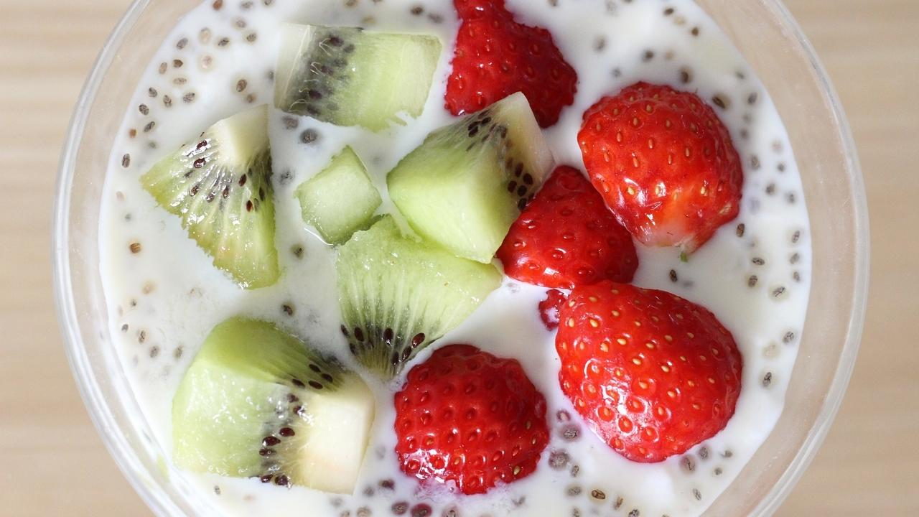

Banana Chia Smoothie sounds exotic, but is super simple to make!

### Whole Food Plant Based Banana Chia Smoothie Recipe

Course: Course 1: Raw, Juice & Smoothie, Snack  
Cuisine: Raw Vegan Recipe  
Prep Time: 10 minutes  
Servings: 2 glasses

#### INGREDIENTS

6 Yelakki Bananas / 3 Large Bananas  
2 tbsp Chia Seeds  
1/4 cup [Date Syrup](https://www.nutritionscience.in/blog/date-syrup-recipe-whole-food-plant-based)1/4 cup Raisins  
1/2 tsp Cinnamon Powder  
1/4 tsp Pepper Powder

#### INGREDIENTS

1. Peel Bananas.
2. Grind all ingredients together to get Banana Chia Seed Smoothie.
3. Garnish with chia seeds. Serve fresh!

### Plant Based Chef Pro Tips for Best Banana Chia Seed Smoothie

1. The more berries, chia seeds, and spices you use, the healthier and yummier your smoothie becomes!
2. Top the smoothie with fruits like mango, strawberry or kiwi!

# 5.Chakotha Masiyal | Keerai Masiyal Recipe | Whole Food Plant Based Recipes

Chakotha Masiyal is a mildly spiced, super nutritious mashed greens recipe from Tamil Nadu.

### Whole Food Plant Based Chakotha Masiyal Recipe

Course: Course 2: Vegetable Dish / Side dish for Course 3 (Grain Dishes) at Lunch & Dinner Meals  
Cuisine: Satwik Tamil Recipe from South India  
Prep Time: 10 minutes  
Cook Time: 30 minutes  
Servings: 2 people

#### INGREDIENTS

1. 2 cups or 1 bunch Chakotha leaves

##### Kootu Masala

1. 1/4 cup Coconut Grated
2. 1 tsp Urad Dal / Black Gram Dal / Ulutham Paruppu / Uddina Bele
3. 1 tsp Pepper Powder
4. 1/2 tsp Tumeric Powder
5. 2 tsp Miso Paste (Healthy Salt Replacement. See Nutrition Science Highlights below)
6. 1 Lemon
7. 10 Curry Leaves
8. 1 tsp Mustard Seeds

#### INSTRUCTIONS

##### Kootu Podi Masala

1. Dry roast urad dal until light brown. Do not allow to darken or burn. Remove from stove and keep aside.
2. Dry roast mustard until it begins sputtering. As soon as it starts sputtering, switch off stove and transfer to a cup.
3. Grind all masala ingredients (except mustard seeds) into a paste, then mix mustard seeds into it.

##### How to make Chakotha Masiyal

1. Separate chakotha leaves from stems. Chop chakotha leaves into long, thin slices. Cook in a thick bottomed vessel or kadai with a few tsp of water, with closed lid. Stir from time to time and add water if required. While this is cooking, you can prepare the kootu masala as outlined above.
2. Once chakotha greens are fully cooked, switch off stove and use a wooden or metal masher to mash the greens well.
3. Mix in kootu podi masala. Garnish with curry leaves. Serve fresh!

# 6.Jolada Kadubu | Jowar Recipes with Jowar Flour | Whole Food Plant Based Recipes

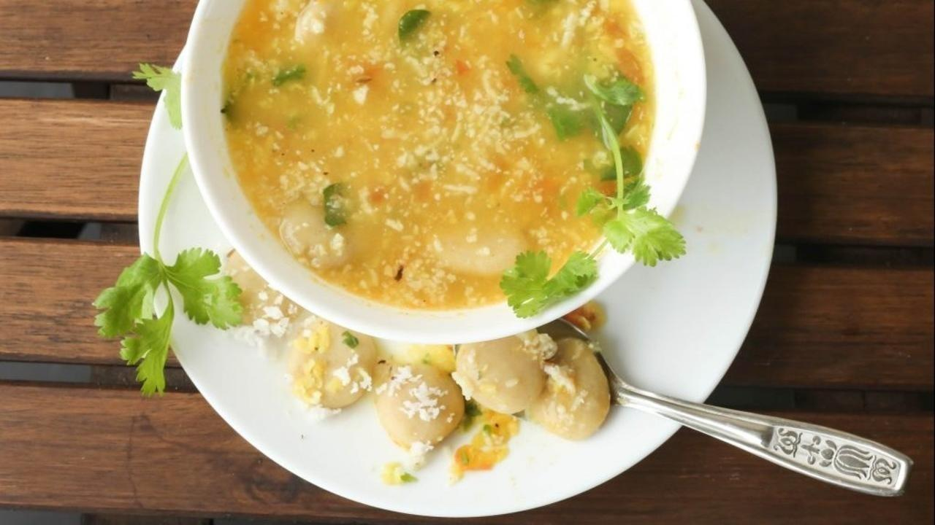

Jolada Kadubu nearly made me break my fast! Let me tell you the story. 🙂

I had recently undertaken a fruit diet. Curious about the food I was eating, my mother in law had begun transforming her diet to a whole foods plant based diet too! *Yippee!*

We were discussing about what to cook for dinner when she said, ‘Let’s cook up some Joladha Kadubu!’ – a healthy one-pot traditional dish, easy to cook and easy to digest. It is a combination of sorghum dumplings with lentil soup. A few minutes later, a broth was merrily brewing away on the stove, tickling my already enhanced smell receptors! I promised her that I will taste it once I start eating cooked food, and noted down the recipe in detail. It smelled absolutely yummy. If I hadn’t controlled myself, I would have finished it then and there! 😀

Sorghum or Jowar is a millet, one of the healthiest cereals. It grows well without irrigation, and was one of the most important crops of North Karnataka until rice and sugarcane took over. The native variety, widely sought after, is whiter than the hybrid one and makes much better kadubus.

Sorghum dumplings or Joladha Kadubu is popular in the Banahatti region of Bagalkot district, North Karnataka, where this dish is one of the few that are permitted in villages for patients and lactating mothers. One reason is because the dish is cooked without oil.

Recipe courtesy : Pushpavati Kulli

Get ready to have a healthy, delicious and soothing soup! 🙂

### Whole Food Plant Based Jolada Kadubu Recipe

Course: Course 3 (Grain Dishes) at Lunch & Dinner Meals  
Cuisine: North Karnataka Recipe from South India  
Prep Time: 15 minutes   
Cook Time: 30 minutes  
Passive Time: 10 minutes  
Servings: 4 people

#### Ingredients

##### For Lentil Soup

1/2 cup Moong dal / Small Yellow Split Lentils  
1 Tomato  
8 cloves Garlic  
1 cm piece Fresh Ginger  
2 1/2 glasses Water

##### For Garnishing

2 tsp Jeera / Cumin Seeds  
1 tsp Turmeric Powder  
1/2 tsp Black Pepper  
Juice of 1 Lemon  
4 tsp Miso Paste (Healthy Salt Alternative. See Nutrition Science Highlights below)  
2 tbsp Coconut grated  
8 leaves Curry Leaves  
1 tbsp Coriander Stems & Leaves chopped

##### For Jolada Kadubu

1 cup Jowar atta / Sorghum flour  
1/4 cup Flaxseed Powder  
1 cup Water

#### INSTRUCTIONS

##### Handmade Jolada Kadubu / Sorghum dumplings

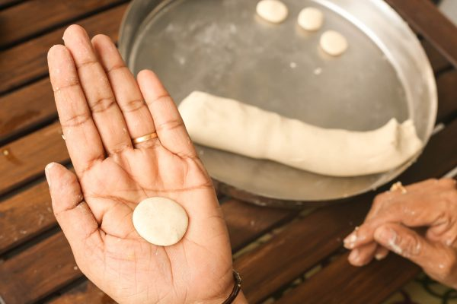

1. Heat 1 cup water until it boils.
2. Mix jowar flour and flaxseed powder in a bowl or on a plate. Make a small well in the middle and pour half the boiling water. Mix with a ladle. Slowly add more boiling water and mix. Once well mixed and cool enough, knead well with hands till it forms a dough.
3. Make small balls out of the dough and flatten them on your palm. One cup of jowar flour will give 30-40 balls. These are Jolada Kadubu. Arrange on a plate and keep aside.

##### https://s3.amazonaws.com/kajabi-storefronts-production/blogs/10455/images/o74XsHQGRLSL6lyr86oO_Jolada_Kadubu_3.jpg

##### Lentil soup

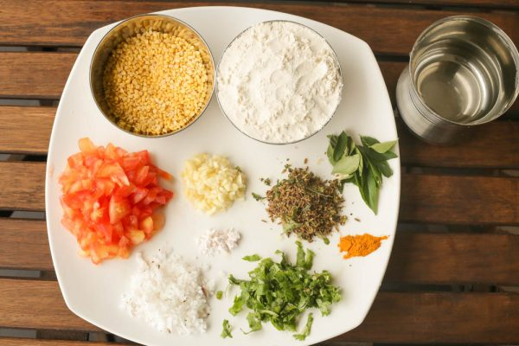

1. Wash and soak moong dal overnight or at least for 30 minutes.
2. Boil 1/2 cup moong dal with 2 1/2 cups of water on low flame.
3. While moong dal is being cooked, chop 1 medium tomato into small pieces. Peel and chop ginger into small pieces. Crush Jeera, Pepper, Curry leaves to make a coarse paste.
4. Peel and crush / grind garlic to a paste. Keep aside for ten minutes. After this, until the dal is cooked, you can use the time to make jolada kadubu and keep them aside.
5. Once dal is nearly fully cooked, add chopped tomato, ginger, and garlic, and cook till done.

##### How to Make Jolada Kadubu

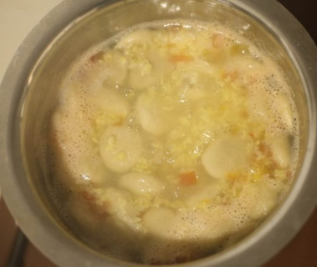

1. Add Sorghum dumplings / Jowar Kadubus slowly to the boiling dal mixture. Once the jolada kadubus are cooked, they will rise to the top.
2. Once the sorghum dumplings / jowar kadubus are cooked remove from stove and add the jeera-pepper-curry leaves mixture, turmeric powder, lemon juice, miso paste, grated coconut, curry leaves, and coriander leaves.
3. Wait until the jolada kadubu cools down fully. Serve fresh!

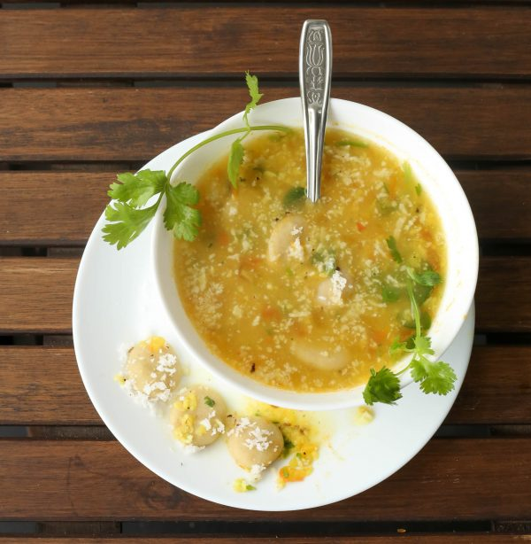

### Plant Based Chef Pro Tips for Best Jolada Kadubu Recipe

1. Similar Kadubu dishes can be prepared using ragi / finger millet flour too.
2. To make it yummier, add chopped onion and jeera powder to sorghum dough while mixing with water.
3. One slit green chilli can be added without chopping or grinding to make it spicier!
4. Dumplings should be added before spices as they take time to cook.

# 7.Athimadhuram Kashayam Recipe | Liquorice Tea | Whole Food Plant Based Recipes



Athimadhuram kashayam is a refreshing drink from Tamil Nadu. Athimadhuram uses commonly include cold and coughs. You can use liquorice powder or athimadhuram powder to make kashaya powder ahead of time and store it to use daily to get athimadhuram benefits.

### Whole Food Plant Based Athimadhuram Kashayam Recipe

Course: Beverage, Snack  
Cuisine: Tamil Recipe from South India  
Prep Time: 5 minutes  
Cook Time: 5 minutes  
Servings: 2 servings

#### INGREDIENTS

2 cups Water  
1/2 tsp Athimadhuram / Liquorice Root Powder  
1/2 tsp Chukku Podi / Dry Ginger Powder  
1/4 tsp Arisi Thippili Powder / Long Pepper Powder OR Black Pepper Powder  
6 Almonds

#### INSTRUCTIONS

1. Heat water to a boil.
2. Remove from stove and mix in spice powders. Keep covered for 2 minutes, then serve fresh with a side of almonds!

# 8.Radish Pickle Recipe | How to Make Pickle Recipes | Whole Food Plant Based Recipes

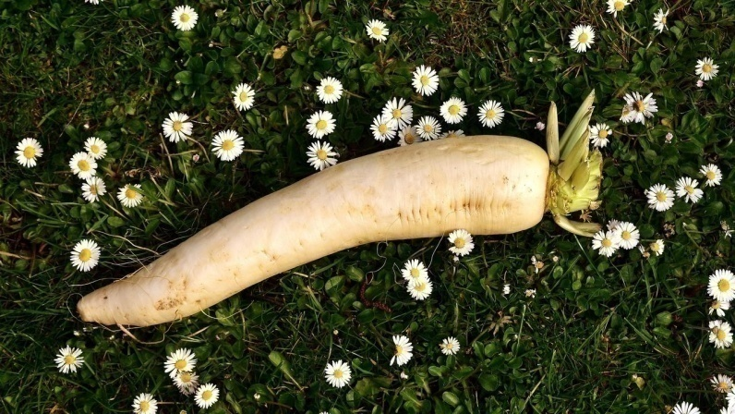

Radish Pickle is fresh, tangy and spicy! Try it with any grain dish you want!

### Whole Food Plant Based Radish Pickle Recipe

Course: Side Dish for Course 3: Grain Dishes at Lunch & Dinner Meals  
Cuisine: Indian Recipe  
Prep Time: 5 minutes  
Passive Time: 30 minutes  
Servings: 4 people

#### INGREDIENTS

1 Radish  
1 Green Chili  
1/2 cup Vinegar

#### INSTRUCTIONS

1. If radish has any black spots, peel only those parts. The rest of the radish does not need to be peeled. Chop radish into thin, one inch long pieces.
2. Slit green chili along its length
3. Soak radish pieces and slit green chili in apple cider vinegar. Store in a glass bottle at room temperature for 8 to 12 hours, then transfer to the fridge.

### Plant Based Chef Pro Tips for Best Radish Pickle Recipe

1. If you like milder pickles, soak some raisins instead of the green chili to get a slightly sweet, not so spicy radish pickle.
2. When taking pickle out of the jar, ensure to use a fresh, clean spoon. Do not use a wet or soiled spoon, or fingers.
3. Once this batch of radish pickle gets over, the vinegar can be reused to make more radish pickle.

# 9.Proso Millet Rice | Milet Recipes | Whole Food Plant Based Recipes

Whole Proso Millet Rice is rich in dietary fibre, phytonutrients, and other antioxidants, and also has a great texture and taste.

Here's how you can switch white rice with unpolished millets.

### Whole Food Plant Based Proso Millet Rice Recipe

Course: Fundamental Recipe; Course 3 (Grain Dish) for Lunch & Dinner Meals  
Cuisine: Indian Recipe  
Prep Time: 2 minutes  
Cook Time: 20 minutes  
Passive Time: 5 hours  
Servings: 2 servings

#### INGREDIENTS

1/2 cup Proso Millet  
Water

#### INSTRUCTIONS

1. Soak proso millet rice in water overnight, or at least for 6 hours. If you don't have time to soak this, don't worry, just skip to the next step and increase cooking time by five minutes.
2. Boil promo millet rice with double the quantity of water. Keep the lid half closed. Check from time to time. If water spills over, open lid some more for a few minutes, until some water evaporates. If promo millet rice is getting burnt from lack of water, add more water. Once proso millet rice is nearly fully cooked, remove from stove and keep closed. Once it has cooled down completely, serve proso millet rice fresh!

# 10.Ridge Gourd Chutney | Chutney Recipe | How to Make Chutney | Whole Food Plant Based Recipe.

Ridge Gourd Chutney is the perfect complement to Ridge Gourd Curry!

### Whole Food Plant Based Ridge Gourd Chutney Recipe

Course: Chutneys, Side Dish for Course 3 (Grain Dishes) at Lunch & Dinner Meals  
Cuisine: Tamil Recipe from South India  
Prep Time: 15 minutes  
Servings: 4 People

#### INGREDIENTS

Peels from 2 medium Ridge Gourd OR 1 large Ridge Gourd  
2 tsp Urad Dal (Uluthamparuppu / uddina bele)  
2 tsp Bengal Gram Dal (Kadalai Paruppu / Kadlebele)  
20 leaves Curry Leaves (Karuvepelai / karibevu soppu)  
1 Amla / Gooseberry / Nellikkai  
1/2 cup Fresh Coconut  
4 tbsp Flaxseed Powder  
1/2 tsp Cumin Seeds Jeera  
1/4 tsp Black Pepper  
1 small Green Chili  
1 pinch Asafoetida (Perunkaayam / Hing)  
4 tsp Miso Paste (Healthy Salt Alternative. See Nutrition Science Highlights below)

#### Instructions

1. Dry roast each of the dals separately, taking care not to let them brown too much or get burnt. See Nutrition Science Highlights for WFPB Ridge Gourd Chutney below for details.
2. Peel ridge gourd. Chop up the peels into small pieces. Use the rest of the ridge gourd for [Ridge Gourd Curry Recipe](https://www.nutritionscience.in/blog/ridge-gourd-curry-recipe-ridge-gourd-recipe-whole-food-plant-based-recipes)
3. Cook chopped ridge gourd peel with minimal water and closed lid until done.
4. Chop coconut into small pieces.
5. Chop amla into pieces and remove the core.
6. Grind all the ingredients together in a mixie, with water as required.

# 11.Spearmint Tea Recipe | Green Tea Recipe | How to Make Tea | Whole Food Plant Based Recipes

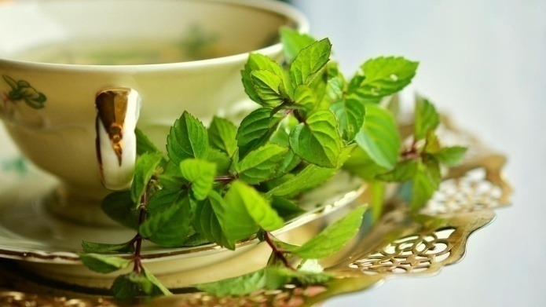

Spearmint tea, refreshingly delicious and ready in two minutes!

### Whole Food Plant Based Spearmint Tea Recipe

Course: Beverage, Snack  
Cuisine: Tamil Recipe from South India  
Prep Time: 5 minutes  
Cook Time: 5 minutes  
Servings: 2 servings

#### INGREDIENTS

2 cups Water  
10 Spearmint Leaves  
4 Green Tea Leaves  
2 tsp Raisins  
6 Almonds

#### INSTRUCTIONS

1. Heat water to a boil. While this is being heated, chop raisins into 2-4 pieces each.
2. Remove from stove and mix in chopped raisins, spearmint leaves and green tea leaves. Keep covered for 2 minutes, then serve your spearmint green tea fresh with a side of almonds!

### Plant Based Chef Pro Tips for Best Spearmint Tea Recipe

1. If you enjoy a milky tea, mix in 2 tbsp [almond butter](https://www.nutritionscience.in/blog/almond-butter-recipe-whole-food-plant-based) once your prepared tea has cooled a little.

# 12.Khichdi Recipe | Dal Khichdi | Whole Food Plant Based Recipe

Dal Khichdi, morning and evening, yes!

### Whole Food Plant Based Dal Khichdi Recipe

Course: Course 3 (Grain Dishes) at Lunch & Dinner Meals  
Cuisine: North Indian Recipe  
Prep Time: 10 minutes   
Passive Time:  30 minutes  
Cook Time: 30 minutes  
Servings: 4 people

#### INGREDIENTS

1 cup Brown Rice  
1/2 cup Toor Dal / Split Pigeon Pea  
1 inch piece Ginger  
1 tsp Turmeric Powder  
1 stick Cinnamon  
1 Green Cardamom  
1 Bay Leaf  
4 cups Water  
1 Dried Red Chili

##### Garnishing

1 tsp Cashew  
2 tsp Coriander Stems & Leaves chopped  
1/4 cup Coconut paste  
1 tsp Black Pepper Powder  
1 tsp Jeera / Cumin Powder  
1 pinch Asafoetida / Hing / Perunkaayam  
4 tsp Miso Paste (Healthy Salt Alternative. See Nutrition Science Highlights below)  
1/2 tsp Cumin Seeds / Jeera  
1 strand Curry Leaves

#### INSTRUCTIONS

1. Wash and Soak brown rice and toor dal for at least 30 minutes. Use the water for your garden.
2. Peel and chop ginger into small pieces. Mix brown rice, toor dal, ginger, turmeric powder, cinnamon, cardamom, and bay leaf with water and cook with a partially closed lid. Check the water once in a while and add more if required. Ensure to not let it boil over or get burnt. This is easiest when using a mud pot.
3. Once dal khichdi is nearly cooked, break dried red chili into 2-3 pieces and add to the boiling dal khichdi. Once cooked, remove from stove.
4. Dry roast jeera mildly. Crush jeera and black pepper coarsely. Add to dal khichdi, along with miso paste, perunkaayam / asafoetida, chopped coriander leaves, curry leaves, coconut paste and cashews.
5. Allow to cool completely and serve fresh with [Gobi Matar Tofu Gravy](https://www.nutritionscience.in/blog/gobi-matar-tofu-gravy-recipe-whole-food-plant-based).

### Plant Based Chef Pro Tips for Best Dal Khichdi Recipe

1. To make your khichdi super creamy, mash the cooked rice and dal well before they cool down, and add some cashew paste after cooking. Yum!

# 13.Kathirikai Kootu Recipe | Brinjal Lentil Curry Recipe | Whole Food Plant Based Diet Recipes

Kathirikai Kootu is a Tamil Grandmother recipe, guaranteed to wow your relatives!

### Whole Food Plant Based Kathirikai Kootu Recipe

Course: Course 2: Vegetable Dish / Side dish for Lunch & Dinner Meals  
Cuisine: Tamil Recipe from South India  
Prep Time: 10 minutes  
Cook Time: 30 minutes  
Servings: 2 people

#### INGREDIENTS

1. 1/4 cup Moong Dal Green Gram Dal / Paasi Paruppu / Paithamparuppu
2. 1 tbsp Peanuts
3. 4 medium Kathirikai / Brinjals

##### Kathirikai Kootu Podi Masala

1. 1/4 cup Coconut Grated
2. 1 tsp Urad Dal Black Gram Dal / Ulutham Paruppu / Uddina Bele
3. 1 tsp Pepper Powder
4. 1/2 tsp Tumeric Powder
5. 2 tsp Miso Paste (Healthy Salt Replacement. See Nutrition Science Highlights below for details)
6. Juice of 1 Lemon
7. 10 Curry Leaves
8. 1 tsp Mustard Seeds

#### INSTRUCTIONS

##### Kathirikai Kootu Podi Masala

1. Dry roast urad dal until light brown. Do not allow to darken or burn. Remove from stove and keep aside.
2. Dry roast mustard until it begins sputtering. As soon as it starts sputtering, switch off stove and transfer to a cup.
3. Grind all kathirikai kootu podi masala ingredients (except mustard seeds) into a paste, then mix mustard seeds into it.

##### Kathirikai Kootu

1. Preferably, soak moong dal overnight or at least for 4-5 hours. Take soaked moong dal in vessel, add enough water to cover the dal and start cooking with a partially closed lid.
2. Remove stems and chop each kathirika / brinjal into 4 quarters. Add to the moong dal after about ten minutes of cooking. Stir from time to time and add water if required. The final consistency should be a thick, pourable liquid. While this is cooking, you can prepare the kootu masala as outlined above.
3. Once kathirikai / brinjal is fully cooked, switch off stove and mix in masala. Garnish with curry leaves. Serve fresh!

# 14.Chettinad Paruppu Urundai Kuzhambu | Kulambu Recipe | Whole Food Plant Based Diet Recipes

## Whole Food Plant Based Chettinad Paruppu Urundai Kuzhambu Recipe

Course: Side Dish for Course 3 (Grain Dish) at Lunch & Dinner Meals  
Cuisine: Chettinad Recipe from Tamil Nadu in South India  
Prep Time: 20 minutes  
Cook Time: 30 minutes  
Passive Time: 5 hours  
Servings: 4 servings

### INGREDIENTS

##### Ingredients for Paruppu Urundai / Lentil Balls

1 cup Chana Dal / Bengal Gram Dal  
1/4 cup Toor Dal  
4 tbsp Flaxseed Powder  
1 Onion  
1 Dried Red chili  
1 tsp Jeera / Cumin Seeds  
1 tsp Saunf / Fennel Seeds  
1 pinch Asafoetida / Perunkaayam / Hing  
1/4 cup Coriander Leaves chopped  
5 Curry leaves

##### Ingredients for Kuzhambu

1 Onion  
2 Tomatoes  
10 cloves Garlic  
1 tbsp dried fruits Kokum / Garcinia  
2 teaspoon Coriander (Dhania) Powder  
1/2 teaspoon Turmeric powder (Haldi)  
1/2 cup Coconut grated  
1 tsp Black Sesame / Black Til  
1/2 tsp Fenugreek Seeds / Methi / Venthayam  
1 tsp Urad Dal / Split White Lentils  
1 tsp Fennel seeds  
1 tsp Black Pepper Powder  
1/4 tsp Asafoetida / Perunkaayam / Hing  
1 tsp Mustard seeds  
1/4 cup Coriander Leaves chopped  
10 Curry Leaves  
4 tsp Miso Paste (Healthy Salt Alternative. See Nutrition Science Highlights below)

### How to Make Whole Food Plant Based Chettinad Paruppu Urundai Kuzhambu Recipe

#### How to Make Paruppu Urundai

1. Soak kadalai paruppu / chana dal and thuvaram paruppu / toor dal overnight, or at least for an hour in hot water.
2. Grind with flaxseed powder, saunf, jeera, and red chili to a coarse paste.
3. Peel and chop onion finely. Mix into paruppu urundai batter along with asafoetida / perunkaayam / hing, coriander leaves, and curry leaves. Mix well.
4. Make small lemon sized balls of paruppu urundai and keep aside.

#### How to Make Chettinad Paruppu Urundai Kulambu

1. Peel and slice and chop onions into long, thin slices. Grind tomatoes and kokum into a smooth paste.
2. Cook chopped onion with tomato kokum paste, dhaniya powder, and turmeric powder. Add water if required, to make a thin paste.
3. While this is cooking, peel and crush garlic into a paste. Keep aside for ten minutes. Once ten minutes are over, add into the boiling vegetable curry, along with the paruppu urundai we have earlier prepared.
4. In a thick bottomed pan, dry roast methi / fenugreek seeds and urad dal on low flame until slightly browned. Do not allow to brown too much or get burnt. See Nutrition Science Highlights for Chettinad Paruppu Urundai Kuzhambu below for details.
5. Grind roasted urad dal and methi / fenugreek seeds with coconut, black sesame, fennel seeds, black pepper powder, asafoetida, and miso paste to make chettinad paruppu urundai kuzhambu podi masala.
6. Once the paruppu urundai are fully cooked, switch off stove and mix in chettinad chettinad paruppu urundai kuzhambu podi masala we have prepared in the previous step.
7. Dry roast mustard seeds. As soon as they start sputtering, mix into chettinad paruppu urundai kuzhambu along with chopped coriander leaves and curry leaves. Serve fresh with [red rice](https://www.nutritionscience.in/blog/red-rice-recipe-whole-food-plant-based-diet-recipes)!

# 15.Cream of Mushroom Soup Recipe | Mushroom Recipe | Whole Food Plant Based Diet Recipes

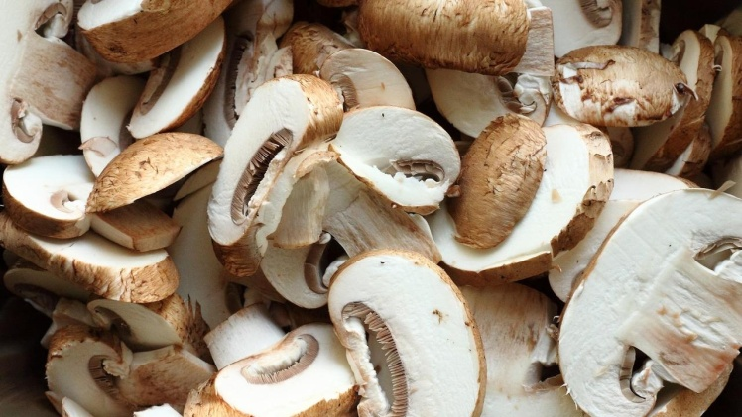

Cream of Mushroom soup is a super healthy recipe, yet unbelievably drool-worthy!

## Whole Food Plant Based Cream of Mushroom Soup Recipe

Course: Breakfast, Soups  
Cuisine: Italian Recipe, French Recipe, American Recipe  
Prep Time: 10 minutes  
Cook Time: 15 minutes  
Servings: 2 people

### INGREDIENTS

1. 1 packet / 200g White Button Mushrooms
2. 1 Onion
3. 5 cloves Garlic
4. 1 tsp Black Pepper Powder
5. Juice of 1 Lemon
6. 2 tbsp Almonds Soaked overnight or at least for 5 hours
7. 2 tsp Miso Paste
8. 2 sprigs Spring Onions

### INSTRUCTIONS

1. Wash and chop white button mushrooms in half. Take chopped mushrooms in a vessel 1 cup water and cook with a closed lid.
2. While the mushrooms are being cooked, peel and crush garlic. Keep aside for ten minutes. After ten minutes, add crushed garlic to the boiling mushrooms.
3. Once cooked, drain mushroom soup stock and keep aside to mix back later. Spread mushrooms on a plate to cool off.
4. Once mushrooms are cool, blend them in a high powered blender along with pepper powder, soaked almonds, and miso paste to a smooth paste. Mix back with mushroom soup stock.
5. Peel and chop spring onions into small pieces. Garnish cream of mushroom soup with lemon juice and chopped spring onions. Serve fresh!

# 16Stew Recipe | Kerala Vegetable Stew Recipe | Whole Food Plant Based Diet Recipes

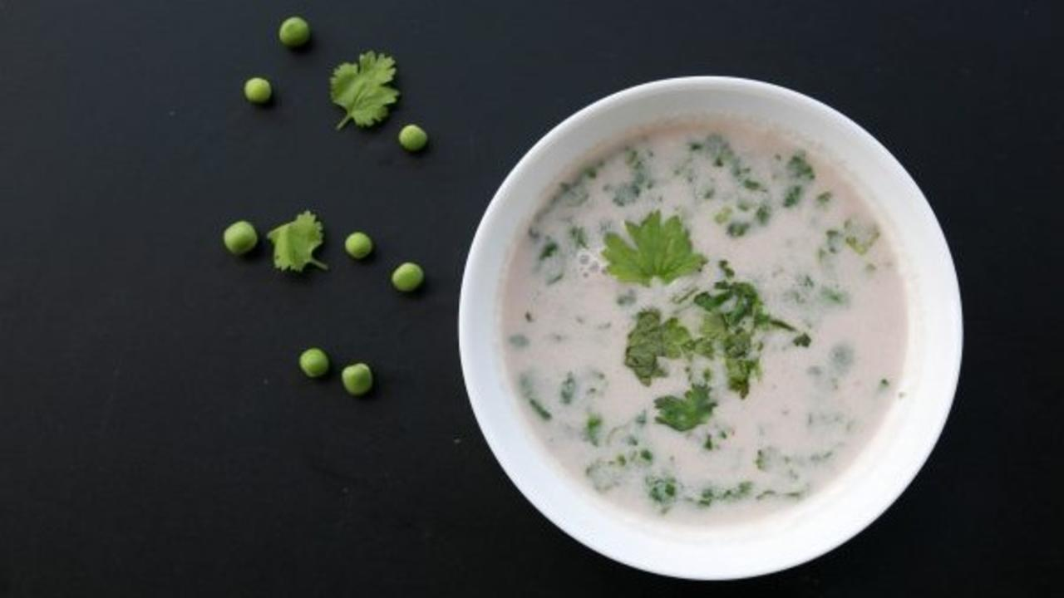

Vegetable stew with coconut, a Christmas speciality from the villages of Kerala. Get ready to indulge in Nutty Goodness! A few handpicked spices bring out the characteristic aroma and flavour of this vegetable stew.

### Whole Food Plant Based Kerala Vegetable Stew Recipe

Course: Course 2 (Vegetable Dish) for Lunch & Dinner Meals  
Cuisine: Satwik Kerala Recipe from South India  
Prep Time: 10 minutes   
Cook Time: 10 minutes  
Servings: 4 people

#### INGREDIENTS

2 cup Mixed Vegetables: chopped, carrot, beans, peas, potato etc  
1 Green Chili slit  
1 cm piece Ginger  
1 tsp Black Pepper  
1 stick Cinnamon  
3 Cloves  
1/4 tsp Cardamom powder OR 1 Green Cardamom  
4 tsp Miso Paste (Healthy Salt Alternative. See Nutrition Science Highlights below)  
1/4 cup Coconut grated  
1 cup Water as required  
2 tbsp Coriander Steams & Leaves chopped

#### Instructions

1. Pound or blend the spices into powder. Peel and crush ginger. Chop vegetables into small cubes. Slit green chili.
2. Cook vegetables with spices. Use very little water and cook with closed lid.
3. Once the vegetables are cooked well and tender, switch off stove.
4. Blend coconut with minimal water and mix into cooked vegetables.
5. Garnish with chopped coriander leaves. Serve warm with [unpolished rice](https://www.nutritionscience.in/blog/brown-rice-recipe-whole-food-plant-based) or neer dosa.

### Plant Based Chef Pro Tips for Best Kerala Vegetable Stew Recipe

1. If you want a tadka or seasoning for the vegetable stew, dry roast curry leaves and mustard seeds and immediately add to the stew so they release their flavour into the stew.
2. You can use any vegetables like potato, cauliflower etc.
3. Use soya milk, almond butter, or cashew butter instead of coconut paste to get different vegetable stew flavours!

# 17.Kadala Curry Recipe | Kerala Kadala Curry for Puttu Recipe | Whole Food Plant Based Recipes

Kadala curry is a favourite traditional Kerala recipe.

### Whole Food Plant Based Kadala Curry Recipe

Course: Side Dish for Course 3 (Grain Dishes) for Lunch & Dinner Meals  
Cuisine: Kerala Recipe from South India  
Prep Time: 10 minutes   
Cook Time: 30 minutes  
Servings: 4 people

#### INGREDIENTS

1 cup Kadala / Black Chickpeas / Kala Chana  
1 Onion  
2 Tomatoes  
1 cm piece Ginger  
5 cloves Garlic  
1 Green Chili  
2 tsp Dhaniya / Coriander Seed Powder  
1 tsp Turmeric Powder  
1 tsp Black Pepper Powder  
1/2 tsp Garam Masala Powder  
1/2 cup Coconut grated  
1 tsp Mustard Seeds  
10 Curry Leaves  
4 tsp Miso Paste (Healthy Salt Alternative. See Nutrition Science Highlights below for details)  
1/4 tsp Asafoetida / Hing

#### INSTRUCTIONS

1. Soak kadala / black chickpeas / kala chana overnight, or at least for 6 hours.
2. Drain water (use for garden!) and boil or pressure cook chana until cooked.
3. Slit green chili along its length. Peel onions and ginger. Chop onion and tomatoes into quarters, and blend together with ginger.
4. Start cooking onion-tomato-ginger paste with slit green chili.
5. Peel and crush / grind garlic to a paste. Keep aside for ten minutes, then add to the boiling onion-tomat-ginger paste, along with dhaniya powder and turmeric powder.
6. Once cooked, remove from stove and mix in cooked kadala.
7. Grind coconut with black pepper powder, garam masala, miso paste, and hing. Mix into kadala curry.
8. Dry roast mustard seeds. As soon as they begin sputtering, mix into kadal curry along with curry leaves. Serve fresh with [Kerala Red Rice Puttu](https://www.nutritionscience.in/blog/red-rice-puttu-recipe-how-to-make-puttu-puttu-kadala-curry-whole-food-plant-based-recipe)!

### Plant Based Chef Pro Tips for Best Kadala Curry Recipe

1. For a creamy Kadala Curry, mash or grind some of the cooked black chickpeas to a paste and mix it into the kadala curry!

# 18.Badam Barfi Recipe | How to Make Barfi | Whole Food Plant Based Recipes

Badam barfi gift boxes will be a super hit among your family and friends. Try it out! Upgrade to food that truly loves you back.

### Whole Food Plant Based Badam Barfi Recipe

Course: Course 1: Raw, Salad, Snacks, Desserts  
Cuisine: Eastern Indian Recipe, Persian Recipe  
Prep Time: 10 minutes   
Servings: 3 people

#### INGREDIENTS

1 cup Kashmiri Badam  
1 cup Soft Dates  
5 strands Saffron / Kesari / Kungumapoo

#### INSTRUCTIONS

1. Grind Kashmiri badam and saffron into a powder in a high powdered blender or mixie. Once ground to a fine powder, remove some powder and keep aside. Continue grinding until it sticks to the sides of the blender. Open the mixie, scrape down the sides, and grind again. Repeat this process until a smooth, liquid, saffron almond butter is formed.
2. Separately, pulse 6 soft dates at a time in a high powered blender until ground to a paste. Repeat with 6 soft dates at a time, until all the dates are fully blended.
3. Mix saffron almond butter with date paste, but do not knead too much.
4. Spread or press to form a 1/2 cm thick sheet on a plate or silicone sheet. Cut into squares with a sharp knife.
5. Refrigerate for one hour to make Badam Barfi firm. Serve fresh!

### Plant Based Chef Pro Tips for Best Badam Barfi Recipe

1. Kashmiri Badam has a greater oil content than Californian Almonds. Use Kashmiri Badam for the best badam barfi recipe.
2. You could also add other spices, like cardamom / elaichi, cinnamon, or cloves to get different flavours or badam barfi recipe!
3. Dissolve badam barfi in water for lip smacking badam milk or badam mylk!

# 19.Ukkarai Recipe Without Ghee | Okkarai Recipe | Diwali Recipe | Whole Food Plant Based Recipes

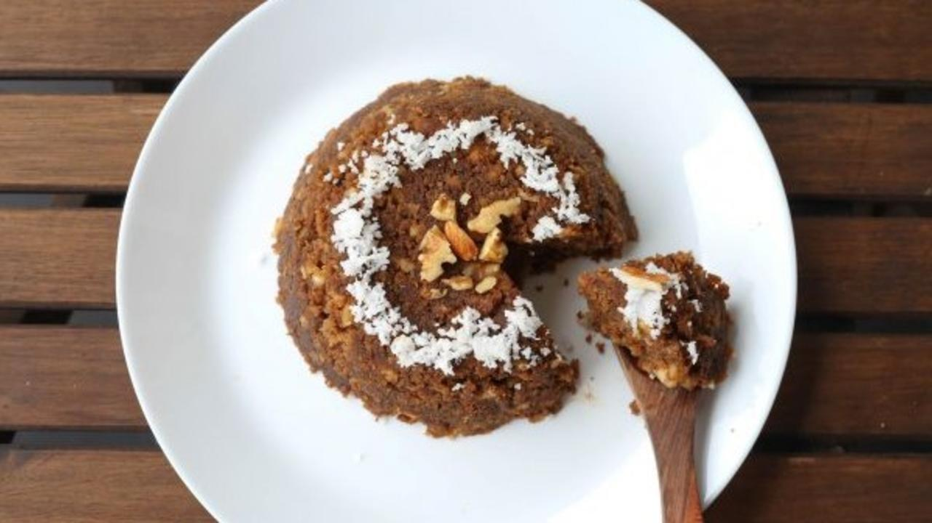

Ukkarai is an indulgent Tamil delicacy for Deepavali. Try out this easy, yet amazingly tasty ukkarai recipe!

### Whole Food Plant Based Ukkarai Recipe

Course: Dessert for Course 3 (Grain Dishes) at Lunch & Dinner Meals; Festival Recipe; Diwali Recipe  
Cuisine: Tamil Recipe from South India  
Prep Time: 20 minutes   
Cook Time: 20 minutes  
Servings: 4 people

#### INGREDIENTS

##### Gram Pudding for Ukkarai Recipe

1/2 cup Bengal Gram Dal / Kadale Bele / Kadalai Paruppu  
1/2 cup Moong Dal / Petite Yellow Split Lentils  
1 cup Date Syrup  
Water as required  
1/4 tsp Cardamom Powder / Elakkai / Elaichi

##### Garnishing

2 tbsp Coconut grated  
2 tsp Almonds & Walnuts  
1 tsp Raisins

### INSTRUCTIONS

1. Soak bengal gram dal and moong dal for an hour.
2. Grind soaked grams into thick batter, along with date syrup. Add minimal water so ukkarai remains fluffy and not gooey!
3. Pour batter on idli plates and steam cook until well cooked.
4. Let it cool down. Put the cooled gram idlis into a blender and pulse a few times until you get fluffy ukkarai!
5. Add cardamom powder. Mix well.
6. Switch off the stove and garnish with grated coconut, nuts, and raisins. Serve fresh!

### Plant Based Chef Pro Tips for Best Ukkarai Recipe

1. Any nuts can be used. There is no need to fry or even roast the nuts. If you want nuts to be crunchy, dehydrate nuts in a dehydrater for 6 hours. If you want nuts to be juicy, soak nuts in water overnight.
2. Ukkarai should be consumed within a few hours of preparation, like any freshly prepared dish.

# 20.Chocolate Black Rice Payasam | How to Make Payasam for Chocolate Day | Whole Food Plant Based Recipes

Chocolate Black Rice Payasam for Chocolate Day on 7 July! Upgrade to food that truly loves you back.

### Whole Food Plant Based Chocolate Black Rice Payasam Recipe

Course: Dessert in Course 3 (Grain Dishes) at Lunch & Dinner Meals; Chocolate Recipe  
Cuisine: Continental Recipe  
Prep Time: 10 minutes   
Cook Time: 30 minutes  
Servings: 4 people

#### INGREDIENTS

1/2 cup Black Rice / Forbidden Rice  
1/2 cup Date Syrup  
2 tbsp Cocoa Powder  
1/2 cup Coconut grated  
1/4 cup Almonds soaked  
1/4 cup Raisins  
Water as required

#### INSTRUCTIONS

1. Soak black rice at least for 30 minutes. Cook with 1 cup of water with a partially closed lid. Check on it once in a while an adjust water if required. Do not allow to boil over or get burnt.
2. Meanwhile, grind coconut into a smooth paste, along with date syrup. Once ground to a paste, mix in cocoa powder to make chocolate mixture.
3. Once black rice is cooked, remove from stove and mix in chocolate mixture.
4. Wait until it cools down completely. Garnish with soaked almonds and raisins. Serve Fresh!

### Plant Based Chef Pro Tips for Best Chocolate Black Rice Payasam Recipe

1. Add cinnamon and cloves for a greater range of flavor.
2. Cooking black rice in a mud pot is easier than a steel vessel, as it gets cooked evenly.
3. While partially covering the boiling black rice with a plate for chocolate black rice payasam recipe, it is wise to pour some water on the plate. If the plate remains cool, the boiling mixture will not boil over!

# 21.Moonga Udhak Recipe | Green Gram Mylk Recipe | Whole Food Plant Based Recipes



The early summer morning beverage that’s been in fashion for the last few centuries in Karnataka, green gram mylk or moonga udhak is a drink prepared from roasted moong dal and jaggery. Udhak means water in Konkani, and mylk is the name for plant based milk. Green gram mylk is perfect when you have a long morning of hard work ahead of you! Here’s to a good cup of tradition from the grinding stone!

### Whole Food Plant Based Moonga Udhak Recipe

Course: Beverage; Snack; Dessert; Dairy Alternative  
Cuisine: Udupi Recipe from Coastal Karnataka in South India  
Prep Time: 5 minutes   
Cook Time: 2 minutes  
Servings: 1 glass

#### INGREDIENTS

2 tsp Hesaru Kaalu / Sabut Moong / Whole Green Gram  
1 tsp Almonds  
1/4 cup Date Syrup  
1/4 tsp Elaichi / Cardamom Powder  
3/4 glass Water

#### INSTRUCTIONS

1. Dry roast moong dal on low flame on iron tava till it gives nice aroma. Be careful not to let it get burnt or browned too much! See Nutrition Science Highlights for WFPB Moonga Udhak below for details.
2. Blend roasted moong dal and almonds together without water. Once it is powdered, add date syrup, cardamom powder, and water. Blend together to get delicious Moonga Udhak of milk-like consistency.
3. Garnish with a dash of cardamom powder and serve chilled. Remember to stir before serving, as solids may separate within a few minutes if kept standing.

### Plant Based Chef Pro Tips for Best Moonga Udhak Recipe

1. Use cinnamon powder, clove powder, mint leaves, black pepper powder, and ground ginger paste, for a variety of flavours!

# 22.Kuih Binka Ubi Recipe | How to Make Cassava ka Halwa | Whole Food Plant Based Recipes

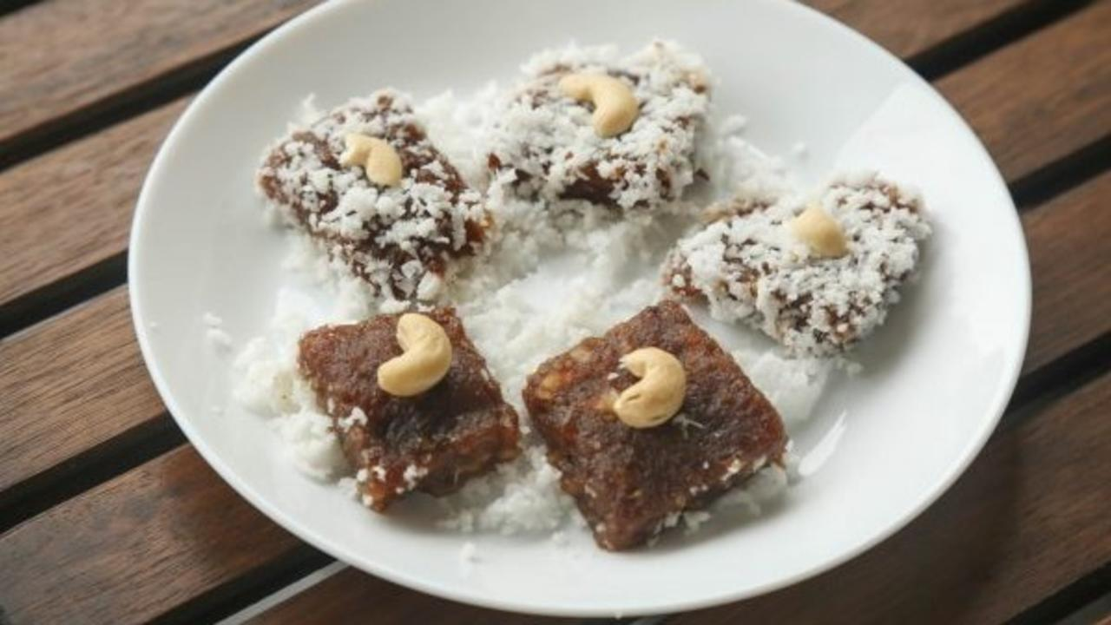

Cassava Cake or Kuih Binka Ubi is a delicious, sweet dessert from Malaysia. Easy to prepare, cassava cake is yummy and a sure hit at family feasts!

In Malaysia and other South East Asian countries, Kuih means bite-sized snack or dessert foods. Tapioca or Cassava cake is usually prepared during Hari Raya, Chinese New year festivals and weddings. A popular street food, you can see these cakes made from cassava or rice in various colors being sold in cities across the country.

Cassava cake can be steamed or baked, and topped with grated coconut. Pandan or screwpine leaves are used for extra flavour.

The recipe which we are sharing is a Whole Food Plant Based version. Coconut is best eaten raw, so this recipe does not cook coconut milk. If you want to make it really fancy, you could serve this halwa bathed in sweet (unfiltered) coconut mylk.

Enjoy this gooey and delectable steamed cassava cake!

### Whole Food Plant Based Cassava ka Halwa Recipe

Course: Festival Dishes, Snacks; Desserts in Course 3 at Lunch & Dinner Meals  
Cuisine: Chinese Recipe, Malaysian Recipe  
Prep Time: 15 minutes   
Cook Time: 20 minutes  
Servings: 3 people

#### INGREDIENTS

1 cup Cassava / Tapioca grated  
1 cup [Date Syrup](https://www.nutritionscience.in/blog/date-syrup-recipe-whole-food-plant-based)1/4 tsp Cardamom / Elaichi Powder  
1/2 cup Coconut grated  
6 Cashews

#### INSTRUCTIONS

1. Peel and grate cassava.
2. Blend 1 cup grated cassava into a smooth paste.
3. Add date syrup and cardamom / elaichi powder and blend again. Add 1-2 tsp water if too thick, or extra cassava if too thin. Make sure it is not watery. Adjust the sweetness as desired.
4. Pour this mixture into square-shaped molds or idli plates. Steam cook for 20-30 minutes or until cooked well.
5. Once cooked, remove from steaming vessel and let it cool down while still inside the mould or idli plates.
6. Once cook, remove from mould or idli plates, cut into desired shapes and roll in grated coconut. Serve topped with a fresh cashew nut!
7. Add any nuts as toppings.
8. You could also boil the cassava & date syrup mixture and pour into moulds once cooked, like the usual style of halwa recipes. We find that steaming is easier and simpler. 🙂

# 23.Pumpkin Curry Recipe | How to Make Pumpkin Curry | Whole Food Plant Based Recipes



A simple and delectable dish, made using yellow pumpkin.

### Whole Food Plant Based Pumpkin Curry Recipe

Course: Course 2 (Vegetable Dish) for Lunch & Dinner Meals  
Cuisine: Satwik Tamil Recipe from South India  
Prep Time: 15 minutes   
Cook Time: 20 minutes  
Servings: 4 people

#### INGREDIENTS

600 g Yellow Pumpkin  
2 Onions  
3 Tomatoes  
1 Green Chili  
1/4 cup Groundnuts  
1 tsp Turmeric Powder  
1/2 tsp Black Pepper Powder  
1 tsp Cumin Seeds / Jeera Powder  
1 pinch Asafoetida (Perunkaayam / Hing)  
4 tsp Miso Paste (Healthy Salt Alternative. See Nutrition Science Highlights below)  
1/4 cup Fresh Coconut grated  
2 tbsp Coriander Stems & Leaves chopped  
Water as required

#### INSTRUCTIONS

1. Cut yellow pumpkin (with peel) into big pieces.
2. Peel onions. Chop onions and tomato into 4 pieces each. Slit green chili along its side without cutting it into two.
3. Boil yellow pumpkin with groundnuts, onions, tomatoes, chili, and turmeric powder with just enough water to cover half the vegetables, until the yellow pumpkin is well cooked. If you prefer to get the onions cooked just right, add them when the pumpkin is half cooked.
4. While the vegetables are boiling, peel and crush or grind garlic to a paste. Keep aside for ten minutes, then add to the boiling vegetables.
5. Once the pumpkin is cooked, remove from stove and add black pepper powder, jeera powder, asafoetida / hing, miso paste, grated coconut, and chopped coriander leaves. Serve fresh!

# 24.Mediterranean Salad Recipe | Mediterranean Diet | Whole Food Plant Based Recipes

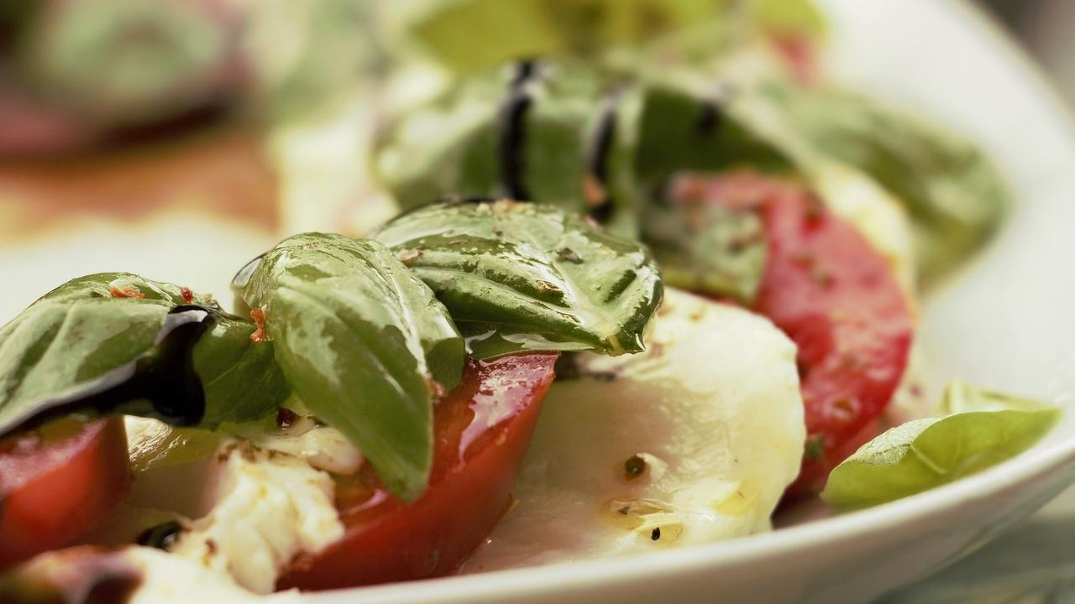

Mediterranean salad recipe, delicious yet simple.

### Whole Food Plant Based Mediterranean Salad Recipe

Course: Course 1 (Raw Dishes) at Lunch & Dinner Meals; Breakfast; Snack  
Cuisine: Mediterranean Recipe  
Prep Time: 15 minutes  
Servings: 4 cups

#### INGREDIENTS

2 Tomatoes OR 20 Cherry Tomatoes  
1 Onion  
2 Handfuls Lettuce Leaves mixed  
1/4 cup Kabuli Chana / Garbanzo Beans  
1/2 tsp Black Pepper Powder  
Juice of 1 Lemon  
4 tsp Miso Paste (Healthy Salt & Soya Sauce Alternative. See Nutrition Science Highlights below)  
1/2 cup Almonds  
1/4 cup Basil Leaves or Dill Leaves

#### INSTRUCTIONS

1. Soak kabuli chana overnight. Boil with minimal water until well cooked. Drain and reserve water to use as aquafaba in other recipes.
2. Peel onions. Chop onions and tomatoes into cubes. If using cherry tomatoes, chop in half. Chop lettuce leaves into large pieces.
3. Mix all ingredients together. Serve fresh!

### Plant Based Chef Pro Tips for Best Mediterranean Salad Recipe

1. Make feta cheeze by crumbling tofu and marinating in lemon juice and miso paste, along with nutritional yeast, and add it to your mediterranean salad recipe!

# 25.Ceylon Kootu with Ceylon Cinnamon Recipe | Whole Food Plant Based Recipes

Ceylon Kootu is a super success in all our workshops, originating from Sri Lanka.

### Whole Food Plant Based Ceylon Kootu with Ceylon Cinnamon Recipe

Course: Course 2 (Vegetable Dishes) at Lunch & Dinner Meals  
Cuisine: Sri Lankan Recipe  
Prep Time: 20 minutes   
Cook Time: 20 minutes  
Servings: 4 People

#### Ingredients

1/4 cup Carrot chopped  
1/4 cup Potato diced  
1/4 cup Beans chopped  
1/4 cup Cauliflower chopped  
1/4 cup Peas shelled  
1/4 cup Onion finely chopped  
1/2 cup Tomato finely chopped  
1 Green Chili slit  
4 Cloves  
1 piece Cinnamon  
1 tsp Mustard Seeds  
1 cup Fresh Coconut grated  
4 tsp Miso paste  
1 pinch Asafoetida  
2 tbsp Coriander leaves chopped

#### Instructions

1. Add all the vegetables together with cloves, cinnamon, and chili. and add water in a kadai. The water should be enough to cook the vegetables till soft. Cover and cook until done.
2. Once it is cooked, remove from stove. Dry roast mustard seeds. Once they start sputtering, add them to the cooked vegetables.
3. Add miso paste, grated coconut, coriander leaves, and asafoetida and mix. Your Yummy Ceylon Kootu is now ready to be served!

# 26.Inji Thuvaiyal | Ginger Chutney | Whole Food Plant Based Recipes

Inji Thuvaiyal (Ginger Chutney) is a very refreshing chutney. The smell of ginger kicks your senses awake – and improves your digestion too. This is one recipe that dulls down the usually strong taste of ginger into a very pleasurable, palatable experience.

### Whole Food Plant Based Inji Thuvaiyal Recipe

Course: Chutneys, Side Dish for Course 3 (Grain Dishes) at Lunch & Dinner Meals  
Cuisine: Tamil Recipe from South India  
Prep Time: 15 minutes   
Servings: 4 People

#### Ingredients

2 inch piece Ginger (Inji / Sunti / Adrak)  
2 tsp Urad Dal (Uluthamparuppu / uddina bele)  
2 tsp Bengal Gram Dal (Kadalai Paruppu / Kadlebele)  
20 leaves Curry Leaves (Karuvepelai / karibevu soppu)  
1 dried fruit Garcinia (Kokum / Punarpuli)  
1/2 cup Fresh Coconut  
1/2 tsp Cumin Seeds Jeera  
1/4 tsp Black Pepper  
1 small Green Chili  
1 pinch Asafoetida (Perunkaayam / Hing)  
4 tsp Miso Paste (Healthy Salt Alternative. See Nutrition Science Highlights below)

#### Instructions

1. Dry roast each of the dals separately, taking care not to let them brown too much or get burnt. See Nutrition Science Highlights for WFPB Inji Thuvaiyal below for details.
2. Peel ginger.
3. Cut coconut into small pieces.
4. Grind all the ingredients together in a mixie, with water as required. Thick ginger chutney is our personal favourite, with just a little water. Serve fresh with [brown rice](https://www.nutritionscience.in/blog/brown-rice-recipe-whole-food-plant-based) or [foxtail millet upma](https://www.nutritionscience.in/blog/foxtail-millet-rava-upma-recipe-millet-upma-recipe-whole-food-plant-based-recipes).

# 27.Jhunka Vada Recipe | Zunka Bhakar | Whole Food Plant Based Recipes

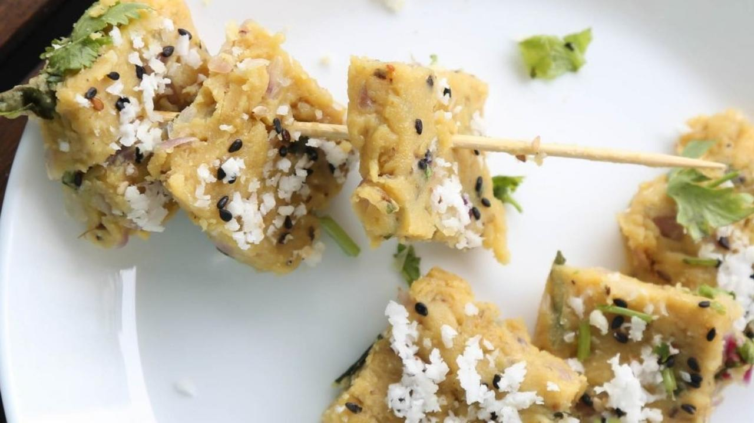

Jhunka vade is a mouth watering steamed vada from North Karnataka and Maharashtrian cuisine, made with gram / besan flour.

It is generally served with Jowar roti or bhakri. There are two versions of jhunka – one is a gravy, called jhunka in Karnataka and Pithla in Maharashtra. The other is this recipe, Jhunka vade, a solid preparation. Jhunka vade is very easy to make and requires very few ingredients. People use it for weddings or festivals to serve many people easily. It is also popular among the poorer classes.

If you already prepare jhunka vade at home, simply replace the oil and green chili with a garnish of black pepper powder and grated coconut to make it a healing dish! 🙂

### Whole Food Plant Based Jhunka Vada Recipe

Course: Side Dish for Course 3 (Grain Dishes) at Lunch & Dinner Meals  
Cuisine: Maharashtra Recipe & North Karnataka Recipe from South India  
Prep Time: 10 minutes   
Cook Time: 10 minutes  
Servings: 4 people

#### Ingredients

##### Jhunka

1/2 cup Besan flour gram flour  
1 cup Water  
2 tsp Miso Paste

##### Seasoning

2 cups Cabbage chopped  
1 Onion chopped  
1 tsp Curry leaves / kadi patta  
1/2 tsp Fresh Ginger peeled & crushed  
1/2 tsp Black Pepper crushed, fresh green pepper if available  
1/2 tsp Jeera crushed  
1/2 tsp Mustard Seeds

##### Garnishing

1/4 cup Coconut grated  
1 tsp Black sesame seeds  
2 tsp Coriander leaves chopped

#### Instructions

1. Prepare the ingredients so that you can use them easily!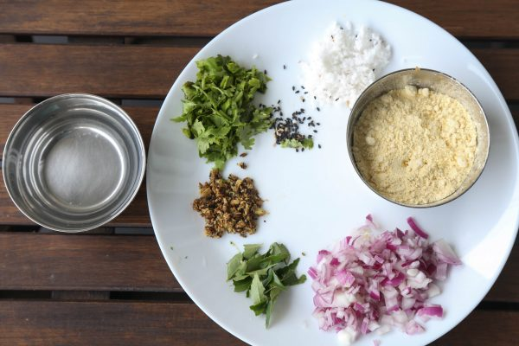
2. Mix 1/2 cup besan flour with 1/2 cup water so no lumps are formed. Add the rest of the water, mix well to get thin dosa batter like consistency and keep aside.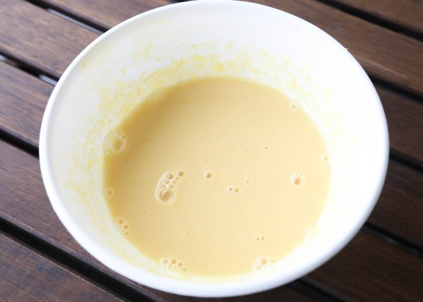
3. Dry roast jeera, crushed ginger, curry leaves, chopped onions and cabbage on an iron vessel. Add a few tsp water if required, to prevent them from getting burnt.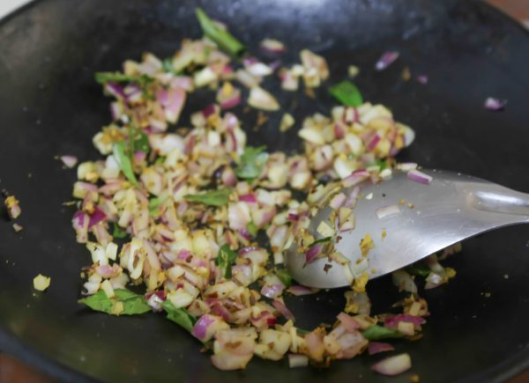
4. Once onions are cooked, start adding the besan batter slowly and keep stirring till it thickens. Add black pepper powder, roasted mustard seeds and miso paste when it is almost done. Stir well.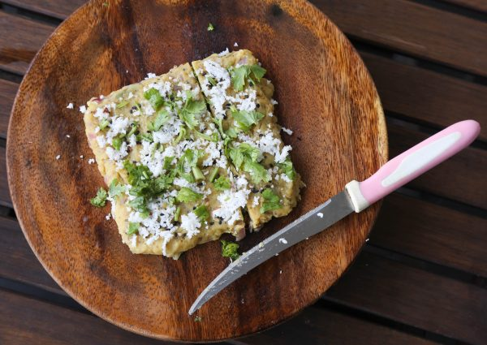
5. Once it cooks well and thickens, wet a wooden board with plain water and pour jhunka on it to make jhunka vada. Leave it to cool for a few minutes, then cut it into different shapes once it becomes solid.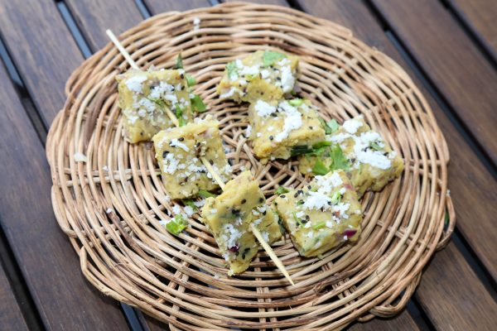
6. Serve jhunka vada with fresh [bajra bhakri](https://www.nutritionscience.in/blog/bajra-roti-recipe-pearl-millet-flatbread-whole-food-plant-based)! 🙂

### Plant Based Chef Pro Tips for Best Jhunka Vada Recipe

1. Jhunka gravy can be prepared by using 1/2 cup besan flour and 2 cups water. After seasoning, 1 cup water should be boiled first (like how we make upma) and then batter should be added and stirred till it is cooked.
2. Plain junka vade with just miso paste can be used as paneer or tofu replacements in other recipes..

# 28.Kokum Juice Recipe | Kokum Fruit Recipes | Whole Food Plant Based Recipes

Kokum juice is super popular in Western Ghats, Karnataka.

### Whole Food Plant Based Kokum Juice Recipe

Course: Beverage, Juice, Snack, Breakfast  
Cuisine: Karnataka Recipe from South Indian  
Servings: 2 glasses  
Prep Time: 5 minutes  
Passive Time:

#### INGREDIENTS

4 Kokum dried fruits / Garcinia  
4 tbsp [Date Syrup](https://www.nutritionscience.in/blog/date-syrup-recipe-whole-food-plant-based)1/4 tsp Cardamom / Elaichi Powder  
1 1/2 glasses Water

#### INSTRUCTIONS

1. Soak kokum in water overnight or at least for 2 hours.
2. Add other ingredients. Mix well. Serve cool.

# 29.Masala Bhindi Recipe Without Oil | Okra Recipe | Whole Food Plant Based Recipes

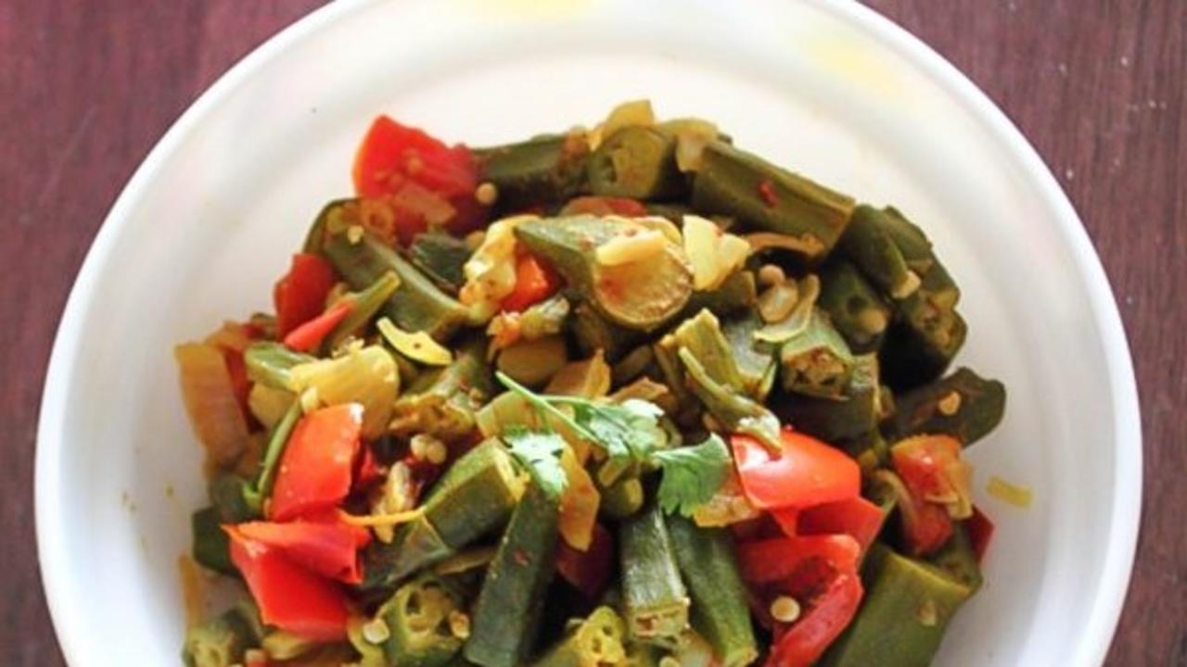

One of the favourite dishes for all of us is a serving of yummy Bhindi Masala. Here is a version that uses no oil, and yet has the same experience of eating one with lots of oil for frying.

### Whole Food Plant Based Masala Bhindi Recipe

Course: Course 2 (Vegetable Dish) for Lunch & Dinner Meals  
Cuisine: Indian Recipe  
Prep Time: 10 Minutes   
Cook Time: 15 Minutes  
Servings: 4 People

#### INGREDIENTS

1/2 Kg Bhindi / Okra / Ladies Finger  
2 Tomatoes  
1 Onion  
1 tsp Jeera Cumin seeds  
4 tsp Miso Paste (Healthy Salt Alternative. See Nutrition Science Highlights below)  
1/2 tsp Garam Masala

#### INSTRUCTIONS

1. Cut the Bhindi into long pieces of one inch size
2. Grind the tomatoes and Jeera into a paste. Do not use water to grind.
3. Chop the onions into fine pieces.
4. Put chopped bhindi and onions with tomato paste in a kadai and add 1/4 cup water.
5. Do not close the vessel. Keep in low to medium flame but turn the mix over very gently without breaking the Bhindi, ONLY when required.
6. Once the bhindi is cooked, remove from flame and add miso paste and garam masala. Your Masala Bhindi is now ready!

### Plant Based Chef Pro Tips for Best Masala Bhindi Recipe

1. Instead of using oil, cooking bhindi / okra in something sour makes its stickiness go away!

# 30.Amte Kai Coconut Chutney Recipe | Konkani Recipes | Whole Food Plant Based Recipes

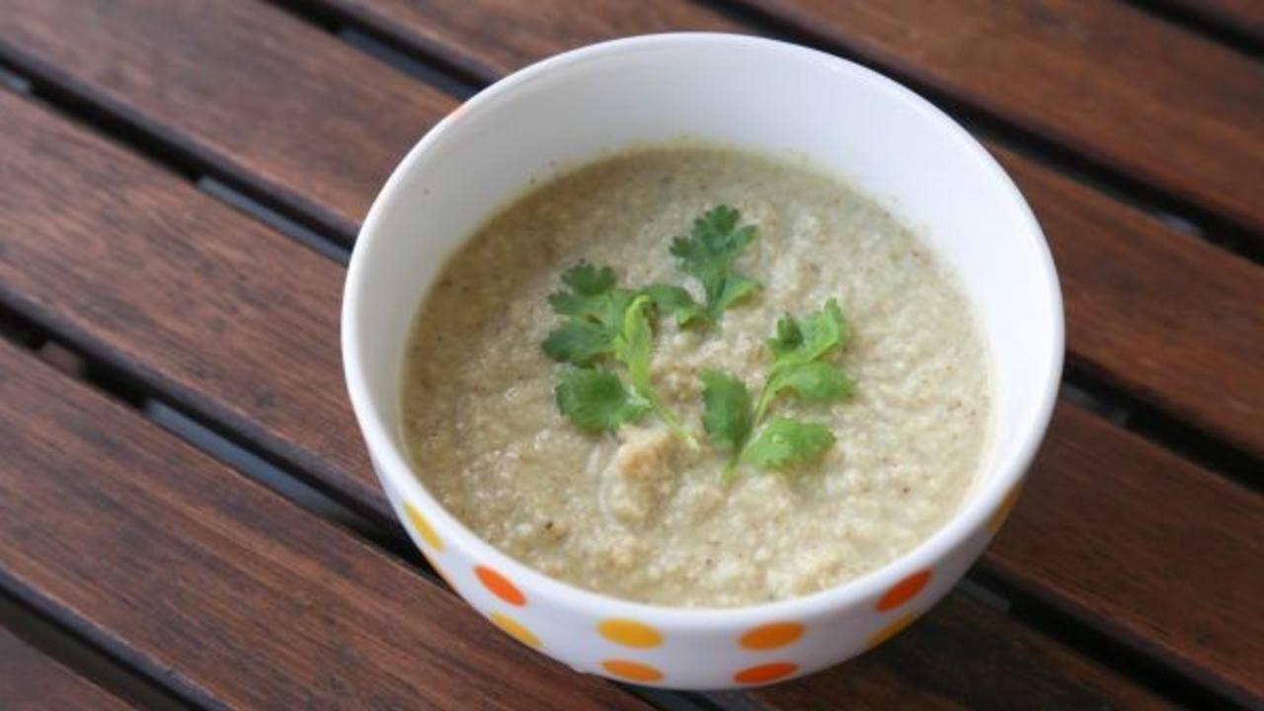

Amte kai coconut chutney! Have you tasted ambarella? It looks like a small raw mango, and tastes amazing! The perfect sourness for a lip smacking chutney.

Known by many names like Amte kai in Kannada, Ambade in Tulu, Ambado in Konkani, Ambarella or Hog Plum in English, this fruit is very popular in Asian, American and African countries. In India, it is used in chutney, pickles, soups and curry. Rich source of dietary fibres and Vitamin B complex!

Chutneys today are popularly garnished with an oil tadka. This is unnecessary and does not add any health benefit to the chutney. In fact, nut-based chutneys like amte kati chutney have plenty of natural oil by themselves, from the whole nut. This oil is of much better quality than any extracted unrefined or refined oil.

Amte kai coconut chutney is a traditional dip prepared with ambarella and coconut with selected spices. Also check out [Amte Kai Chutney without coconut](https://www.nutritionscience.in/blog/amte-kai-chutney-recipe-ambade-ambarella-or-hog-plum-dip-whole-food-plant-based-recipes).

### Whole Food Plant Based Amte Kai Coconut Chutney Recipe

Course: Chutneys; Side Dish for Snacks & Course 3 (Grain Dishes) at Lunch & Dinner Meals  
Cuisine: Satwik Konkani Recipe from Coastal Karnataka in South India  
Prep Time: 10 minutes   
Servings: 4 people

#### INGREDIENTS

4 Ambarella / Hog Plums  
1/2 cup Fresh Coconut grated  
1/2 tsp Cumin Seeds / Jeera  
1/4 tsp Dhaniya / Coriander Seeds  
1/4 tsp Black Pepper  
1/4 cup Coriander Leaves chopped  
2 Dates  
4 tsp Miso Paste  
1/4 cup Water

#### INSTRUCTIONS

1. Soak dates overnight on drinking water or for 30 minutes in hot water.
2. Wash, peel and chop ambarella into small pieces. Remove seeds if fruit is not tender.
3. Grate coconut.
4. Dry roast jeera and coriander seeds mildly on low flame. Blend jeera, coriander seeds, pepper into a fine powder.
5. Add all ingredients and blend into a smooth chutney, with a dip like consistency. Serve with Dosa, Idli or Roti!

### Plant Based Chef Pro Tips for Best Amte Kai Coconut Chutney Recipe

1. Dry tadka or seasoning can be prepared with dry roasted mustard seeds and curry leaves.
2. Amte kai can be replaced with raw mango or gooseberry (nellikai / amla) in case you don't find ambarella.

# 31.Moong Dal Recipe | How to Make Dal | Whole Food Plant Based Recipes

 Moong Dal, mummy ke haath se. What could be more delicious?

### Whole Food Plant Based Moong Dal Recipe

Course: Side Dish for Course 3 (Grain Dishes) at Lunch & Dinner Meals  
Cuisine: North Indian Recipe  
Prep Time: 10 min  
Passive Time: 6 hours  
Cook Time: 20 mins  
Servings: 4 People

#### INGREDIENTS

1/2 cup Moong Dal / Split Yellow Lentils / Paithamparuppu / Pasi Paruppu / Hesaru Bele  
2 Tomatoes  
10 cloves Garlic  
1 cm piece Ginger  
1 Green Chili  
1 tsp Turmeric Powder  
1 tsp Jeera / Cumin Powder  
1 tsp Black Pepper Powder  
1/4 cup Peanuts  
1 tsp Mustard Seeds  
10 Curry Leaves  
2 tbsp Coriander Stems & Leaves chopped  
4 tsp Miso Paste (Healthy Salt Alternative. See Nutrition Science Highlights below)

#### INSTRUCTIONS

1. Soak moong dal and peanuts overnight or at least for 6 hours. Add enough water to cover the dal and cook with a partially closed lid.
2. While moong dal is being cooked, chop tomatoes into small pieces. Peel and chop ginger into tiny pieces. Slit green chili along its length. Add to moong dal and continue cooking.
3. While this is cooking, peel and crush or grind garlic into a paste. Keep aside for ten minutes.
4. Once garlic has rested for minutes, mix into the moong dal on the stove along with turmeric powder.
5. After a minute or two, once the raw smell goes away, turn off stove and add in jeera powder, black pepper powder, grated coconut, curry leaves, chopped coriander leaves, and miso paste. Mix well.
6. Dry roast mustard until it just starts sputtering. Once it does, mix into moong dal. Serve fresh with [akki roti](https://www.nutritionscience.in/blog/akki-roti-recipe-akki-rotti-recipe-whole-food-plant-based-recipes), [mooli parathas](https://www.nutritionscience.in/blog/mooli-paratha-recipe-radish-whole-wheat-flatbread-whole-food-plant-based) or [bajra roti](https://www.nutritionscience.in/blog/bajra-roti-recipe-pearl-millet-flatbread-whole-food-plant-based)!

### Plant Based Chef Pro Tips for Best Moong Dal Recipe

1. In order to prevent the dal from boiling over, pour some water on to the plate used to cover the boiling dal. If the air at the top of the vessel stays cool, the moong dal is less likely to boil over!

# 32.Akki Roti Recipe | Akki Rotti Recipe | Whole Food Plant Based Recipes

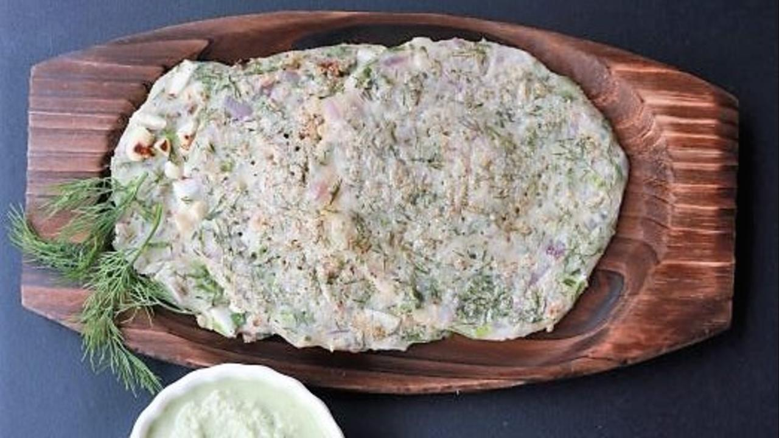

Akki Roti is a melt-in-the mouth, soft Indian bread which is full of flavour. The smell of this absolutely divine dish has woken me up many a time. My friends would probably vote for these rotis as a hot favourite. I would carry extra akki rotis to school, yet they would disappear in no time. My mother would add onions, carrots and spices to the roti, so, often, it needed no accompaniment.

Recently, I met my aunt with some fresh Akki roti. She looked at my box and asked “Akki roti? But I thought rice is not good for health. Aren’t wheat rotis better?”. “Well, not these ones,” I quipped “especially because I have made them with unpolished rice. Now they are as healthy as they were meant to be traditionally”. Many of us eat rice and use rice flour that is unhealthy because it is polished and stripped of its fiber and nutrients. At PHC Lifestyle Clinic's cooking workshops, we use any of the many varieties of unpolished rice, therefore, it is highly nutritious.

In Kannada, akki means rice and roti means bread or tortilla and there are many varieties of this super popular dish based on the ingredients used. With sabbakki or dill, avarekaalu or hyacinth bean, onions and carrots or just plain salted, these rotis are a staple in many households. It is served with fresh coconut or tomato chutney.

Traditionally, we make these rotis on soft cotton cloth or a banana leaf and flip them onto the hot tava. Although you can also directly make it on the tava by patting it round with water, it requires some practice.

This recipe will show you how to make akki rotti with dill leaves, like our Shepi Kadubu. Furthermore, you can add your favourite veggies to it as well.

### Whole Food Plant Based Akki Roti Recipe

Course: Course 3 (Grain Dish) for Lunch & Dinner Meals  
Cuisine: Udupi Recipe from North Karnataka in South India  
Prep Time: 10 minutes   
Cook Time: 10 minutes  
Servings: 4 Akki Rotis

#### INGREDIENTS

1 cup Unpolished Rice flour or Soaked Unpolished Rice  
1/2 cup Dill leaves  
1/4 cup Groundnut  
2 tbsp Flaxseed Powder  
2 tsp Miso Paste (Healthy Salt Alternative. See Nutrition Science Highlights below)  
1/2 tsp Jeera / Cumin Seeds  
1 cup Water as required

#### INSTRUCTIONS

There are two methods to prepare akki roti, outlined below. Either of them can be used:

##### Akki Roti Recipe Method One

1. Soak unpolished rice overnight.
2. Blend it in the morning with little water to get a batter with a consistency like that of thick neer dosa batter. Chop dill leaves, roast groundnuts and crush it coarsely. Add it to batter along with other ingredients and water as required and mix well.
3. Heat tawa till a drop of water dances around when you splash water on it. Splash a ladle of batter so it forms a round roti. Close with a lid so it cooks well. Once done, flip it and let the other side get cooked as well. Wait until it cools fully, then serve fresh. Enjoy! 🙂
4. Serve warm with fresh coconut chutney!

##### Akki Roti Recipe Method Two

1. Chop dill leaves, roast groundnuts and crush it coarsely. Mix unpolished rice flour with all other ingredients and water as required to get a dough-like consistency.
2. Using water, wet a banana leaf or muslin cloth. Take a small ball of dough and press / tap it on to the leaf or cloth to get a thin rice bread.
3. Heat tawa till a drop of water dances around when you splash water on it. Gently place the flattened rotti on it and remove the leaf or cloth. Make some evenly spaced holes with a fork so it gets cooked evenly. Close with a lid so it cooks well. Once done, flip it and let the other side get cooked as well. Wait until it cools fully, then serve fresh. Enjoy! 🙂
4. Serve warm with fresh coconut chutney!

### Plant Based Chef Pro Tips for Best Akki Roti Recipe

1. If you prefer crispy rotis, flatten more and cook for longer.
2. Use onions if you wish, but this will no longer be a satwik recipe.
3. Plain akki roti can be made with another method. Boil water, pour rice flour and flaxseed powder slowly and mix it well to get a dough like consistency, and use this to make rotis.

# 33.Dill Kadubu Recipe | How to Make Kadubu | Whole Food Plant Based Recipes

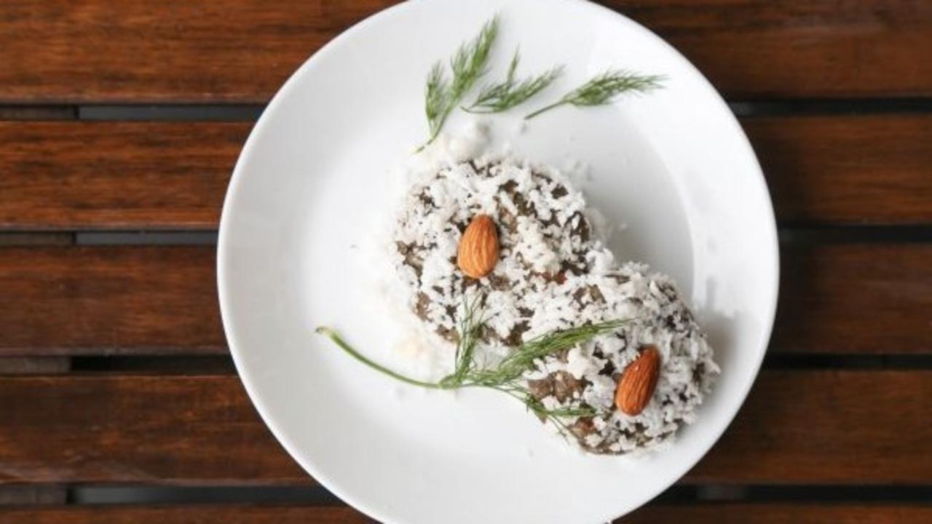

Shepi is a fragrant, yummy kadubu from the Konkan region of coastal Karnataka. My mother shared a story with me the other day. She told me that fishermen would often be at sea for up to 15 days. On their return, their wives would welcome them with a feast, which included this sweet idli. Dill leaves are highly nutritious. They have been used for centuries to relieve menstrual pain.

Dill idli is traditionally made with a combination of rice, dill leaves, coconut and jaggery. To make it healthier, we have converted it into a kadubu, steaming unpolished rice with jaggery with dill, and adding fresh grated coconut afterwards.

There are many variations of this recipe – without jaggery or with bananas even. Go crazy with your own twist! This is called Mandas in Konkani.

Recipe courtesy : Roopa Kharvi, Gangolli

### Whole Food Plant Based Dill Kadubu Recipe

Course: Festival Recipe; Dessert in Course 3 (Grain Dish) at Lunch & Dinner Meals  
Cuisine: Udupi Recipe from Coastal Karnataka in South India  
Prep Time: 10 minutes   
Cook Time: 20 minutes  
Servings: 4 people

#### INGREDIENTS

1 cup Red or brown rice soaked  
4 tbsp Flaxseed Powder  
1 cup [Date Syrup](https://www.nutritionscience.in/blog/date-syrup-recipe-whole-food-plant-based)  
1 cup Dill Leaves chopped  
1 cup Water  
1/2 cup Coconut grated

#### INSTRUCTIONS

1. Soak equal quantity of red and brown rice (or you could just use one variety, just make sure it is unpolished rice) in water overnight, or at least for 5-6 hours.
2. Blend soaked rice with water as required. The rice should only be ground until it is coarse broken rice, and not to a smooth paste.
3. Mix in flaxseed powder, date syrup, and dill leaves. Add water as required to get idli batter consistency.
4. Pour the batter into idli plates and steam cook for 15-20 minutes.
5. Grate coconut.
6. Once idlis are cooked, take them out and let them cool completely. Garnish with coconut and serve fresh!

### Plant Based Chef Pro Tip for Best Dill Kadubu Recipe

1. There are two ways to serve this dish:
   1. Cut idlis into small pieces, add grated coconut and serve.
   2. Pulse idlis in mixie, mix with grated coconut, and shape it into kadubu, or modaka-like dumplings. If blending, use 3-4 pulses of one second each to make it fluffy, otherwise it will become a paste.
2. Serve with a hearty spoonful of date syrup!

# 34.Papaya Orange Smoothie Recipe | Orange Color Smoothies | Whole Food Plant Based Recipes

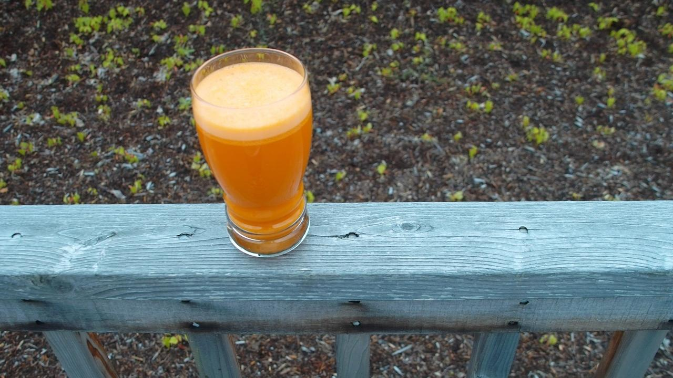

Green Smoothie, the perfect way to kick-start the day! With the goodness of greens and bananas, sweetened with dates and flavoured with spices, these smoothies certainly pack a punch.   
Anti-oxidant rich and super filling, they are a great post-workout refresher as well. Although everyone knows that smoothies are healthy, not may know that they can be yummy too!

Try this Green Smoothie after a good workout session or just before a long day.

### Whole Food Plant Based Green Smoothie Recipe

Course: Course 1: Raw, Juice & Smoothie, Snack  
Cuisine: Raw Vegan Recipe  
Prep Time: 10 minutes  
Servings: 2 glasses

#### INGREDIENTS

1 small Papaya  
2 Oranges  
1/4 cup [Date Syrup](https://www.nutritionscience.in/blog/date-syrup-recipe-whole-food-plant-based)1/4 cup Raisins  
2 tbsp Mint Leaves / Pudina  
1/2 cm piece Ginger  
1 tbsp Flaxseed Powder  
3 Walnuts

#### INGREDIENTS

1. Peel and remove seeds of papaya. Peel oranges. Peel ginger.
2. Blend all ingredients together, except walnuts, to get papaya orange smoothie.
3. Garnish with walnuts. Serve fresh!

### Plant Based Chef Pro Tips for Best Green Smoothie

1. The more berries, herbs, and spices you use, the healthier and yummier your smoothie becomes

# 35.Ridge Gourd Curry Recipe | Ridge Gourd Recipe | Whole Food Plant Based Recipes

A simple and delectable dish, made using ridge gourd.

### Whole Food Plant Based Ridge Gourd Curry

Course: Course 2 (Vegetable Dish) for Lunch & Dinner Meals  
Cuisine: Satwik Tamil Recipe from South India  
Prep Time: 5 minutes  
Cook Time: 15 minutes  
Servings: 4 People

#### INGREDIENTS

2 medium Ridge Gourds OR 1 large Ridge Gourd  
1 Green Chili  
4 tsp Miso Paste (Healthy Salt Alternative. See Nutrition Science Highlights below)  
1/4 cup Fresh Coconut grated  
1 pinch Asafoetida (Perunkaayam / Hing)  
2 tbsp Coriander chopped

#### INSTRUCTIONS

1. Wash the vegetables well.
2. Lightly scrape the ridges of the ridge gourd so as to remove the sharp edges and the fibre that runs through them. Reserve the scraped edges for making [Ridge Gourd Chutney](https://www.nutritionscience.in/blog/ridge-gourd-chutney-chutney-recipe-how-to-make-chutney-whole-food-plant-based-recipes).
3. Chop ridge gourd once lengthwise. Chop again to make 4 long pieces. Then cut into smaller pieces, about 1.5 cm in width.
4. Slit green chili on one side along its length.
5. Put the chopped ridge gourd and green chili in a vessel with 2 cups of water to boil. The water should be just below the level of the vegetables. Cover with a lid and simmer until cooked.
6. Once cooked, remove from stove.
7. Grate the coconut. Alternatively, cut and grind it.
8. Chop coriander into small pieces.
9. Add miso paste, hing / asafoetida, grated coconut, and chopped coriander. Serve fresh!

# 36.Palak Keerai Masiyal Recipe | Spinach Recipe | Whole Food Plant Based Recipes

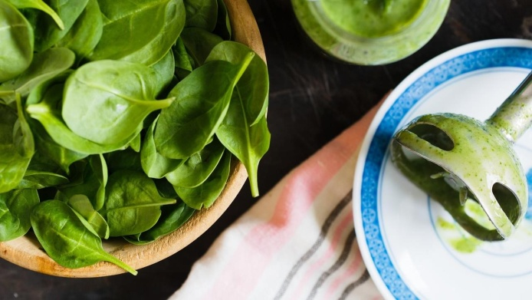

A must have everyday, it can be done to such perfection using just the traditional recipe, without oil.

### Whole Food Plant Based Palak Keerai Masiyal Recipe

Course: Course 2 (Vegetable Dish) for Lunch & Dinner Meals  
Cuisine: Tamil Recipe from South India  
Prep Time: 15 minutes   
Cook Time: 20 minutes  
Servings: 2 People

#### INGREDIENTS

1 bunch OR 2 cups Palak / Spinach Greens  
1 Green Chili  
1 cm piece Ginger  
4 cloves Garlic  
1 Onion  
2 Tomatoes  
1 tsp Jeera / Cumin Powder  
1/2 tsp Black Pepper Powder  
2 tsp Miso Paste (Healthy Salt Alternative. See Nutrition Science Highlights below)  
1 pinch Asafoetida / Perunkaayam / Hing  
1/4 cup Fresh Coconut grated

#### INSTRUCTIONS

1. Wash the spinach well and chop finely. Peel and chop onion finely. Chop tomatoes finely. Slit green chili along its length. Peel and chop ginger finely.
2. Cooked chopped palak with 1/4 cup water, along with chopped onions, tomatoes, chili, and ginger.
3. While the palak and other vegetables are cooking, peel and crush or grind garlic to a paste. Keep aside for ten minutes. Once the garlic has sat for ten minutes, mix into the boiling vegetables and cook until done.
4. Once cooked, remove from stove. Mash well with a wooden or metal masher.
5. Mix in jeera powder, black pepper powder, miso paste, asafoetida / perunkaayam / hing, and grated coconut.

### Plant Based Chef Pro Tips for Best Palak Keerai Masiyal Recipe

1. Most of the flavour in this dish comes from the vegetables. For the palak / spinach flavour to stand, this dish is best served before any spice-heavy dishes during the meal.

# Pasta Integrale Recipe | Handmade Whole Wheat Tagliatelle Pasta Recipe | Whole Food Plant Based Recipes

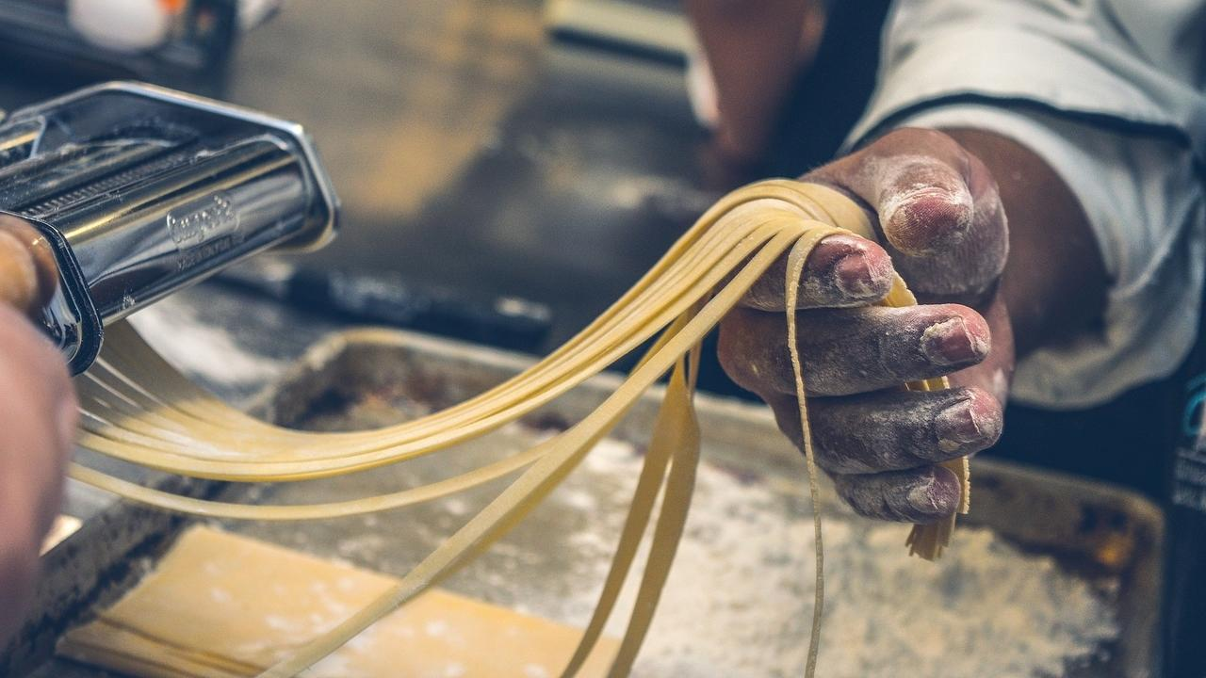

Pasta Integrale means 'Whole Pasta', made using whole grains, with all their nutrition intact!

### Whole Wheat Roti

Course: Course 3 (Grain Dish) for Lunch & Dinner Meals  
Cuisine: Italian Recipe  
Prep Time: 15 minutes  
Cook Time: 10 minutes  
Servings: 2 People

#### INGREDIENTS

##### For Pasta Integrale:

1 cup Whole Wheat Flour coarsely ground  
2 tbsp Flaxseed Powder  
Water

##### For Marinara Sauce:

5 tomatoes  
2 Onions  
10 pods garlic  
2 tsp Miso Paste  
1 plant Basil  
1 tsp Black Pepper Powder

##### For Garnishing:

1/4 cup cashews  
2 tsp Apple Cider Vinegar  
2 tsp Miso Paste

#### INSTRUCTIONS

##### How to make Handmade Whole Wheat Pasta

1. Mix flaxseed powder with 3/4 of the whole wheat flour in a large bowl. Make a well in the center, slowly add water little by little, while kneading. Once the dough has come together, stop adding water and knead to a stiff dough. The dough should be soft to the touch, but not sticky. If sticky, add more flour. If too hard, add more water.
2. Take a ping-pong ball sized piece of dough and roll it into a ball between your hands. Flatten into a thick disc.
3. Dust with the remaining whole wheat flour and roll it out into a roti or chapathi with a rolling pin.
4. Dust some extra flour on both sides of the roti. Using a long, sharp knife, cut long strips as thinly as possible, and mix them up with the extra flour that they have already been dusted with. This type of pasta is called tagliatelle. Keep aside and repeat with the next ball of dough.
5. In the meantime, fill a large vessel nearly fully with water and heat until it boils.
6. Once water is boiling, take a handful of tagliatelle and drop it into the boiling water. After 2 to 3 minutes, the tagliatelle will float to the top and not sink back to the bottom.
7. Fill another vessel almost fully with cold water and keep it next to the boiling water. Using a ladle, transfer the cooked and floating tagliatelle to the vessel with cold water. After a minute or two, once it has cooled down completely, remove the tagliatelle and transfer to a plate or another vessel.

##### How to make Tomato Marinara Sauce

1. Peel Onions. Chop onion and tomato into quarters, and grind into a smooth paste.
2. Heat in a thick bottomed saucepan or vessel.
3. While it is being cooked, peel and crush or grind garlic into a paste. Keep aside for ten minutes, then add to the boiling onion tomato mixture.
4. Chop off the roots from the basil plant.
5. Once cooked, remove from stove and add miso paste, basil and black pepper powder.

##### How to Make Pasta Integrale

1. Grind cashews with vinegar and miso paste and a little water to make cashew cream.
2. Simply mix cooked and cooled pasta with marinara sauce, garnish with cashew cream and a couple of basil leaves. Serve Pasta Integrale fresh!

# 37.Thai Papaya Salad | Easy Som Tam Salad Recipes | Whole Food Plant Based Recipes

Thai papaya salad or Som Tam is super easy to prepare, and it only takes few minutes to dazzle your friends with this exotic dish!

### Whole Food Plant Based Thai Papaya Salad Recipe

Course: Course 1 (Raw Dishes) & Side Dish for Course 3 (Grain Dishes) at Lunch & Dinner Meals; Breakfast; Snack  
Cuisine: Thai Recipe  
Prep Time: 10 minutes  
Servings: 4 cups

#### INGREDIENTS

1 Unripe Green Papaya  
1/2 Raw Mango  
1 cup Moong Sprouts / Bean Sprouts  
1 inch piece Fresh Turmeric Root OR 1/2 tsp Turmeric Powder  
4 cloves Garlic  
1 Dried Red Chili  
Juice of 1 Lemon  
4 tsp Miso Paste (Healthy Salt & Soya Sauce Alternative. See Nutrition Science Highlights below)  
1 tbsp [Date Syrup](https://www.nutritionscience.in/blog/date-syrup-recipe-whole-food-plant-based)  
1/2 cup Peanuts  
2 Spring Onions  
1/4 cup Basil Leaves

#### INSTRUCTIONS

1. Peel unripe green papaya and fresh turmeric root. Grate both using a grater into long, thin strips. Grate raw mango (don't peel) into similar long, thin strip.
2. Peel and chop garlic into small pieces. Break, slice or crush dried red chili into small pieces. Chop spring onion into long, thin pieces. Slice basil leaves into long, thin strips.
3. Dry roast peanuts on a low flame until they are just cooked, but not brown. See why in Nutrition Science Highlights for WFPB Thai Papaya Salad Recipe below.
4. Mix all ingredients together. Garnish with chopped basil leaves. Serve fresh!

### Plant Based Chef Pro Tips for Best Thai Papaya Salad

1. To roast peanuts evenly and minimise acrylamide formation (see below), bake in an oven at 120 deg C for 30 minutes or so, keeping an eye on it to see when it is done.
2. Coriander leaves can also be used to garnish this thai salad bowl.
3. Som Tam, Thai Papaya Salad, is traditionally served as a side dish to black sticky rice.

# 38.Snake Gourd Soup Recipe with Turmeric & Ginger | Whole Food Plant Based

Snake gourd soup is a delicious way to prepare snake gourd, especially if you haven't cooked much with it until now.

### Whole Food Plant Based Snake Gourd Soup Recipe with Turmeric & Ginger

Course: Soup, Snack  
Cuisine: South Indian Recipe  
Prep Time: 10 minutes  
Cook Time: 15 minutes  
Servings: 2 People

#### INGREDIENTS

1. 1/2 small Snake Gourd
2. 1/2 tsp Turmeric Powder
3. 1/2 tsp Black Pepper Powder
4. 1 Onion Red
5. 1 inch piece Ginger
6. Juice of 1 Lemon
7. 3 tsp Miso Paste (Healthy Salt Alternative. See Nutrition Science Highlights below)
8. 2 tbsp Almond Butter
9. 1 tbsp Coriander Leaves Chopped

#### INSTRUCTIONS

1. Chop snake gourd into small or large pieces. Peel and chop ginger into small pieces.
2. Boil chopped snake gourd, onions and ginger with just enough water to cover the chopped vegetables, in a closed vessel.
3. Once cooked, drain stock and reserve to mix back into soup. Spread cooked vegetables on a plate to cool off.
4. Once cool, grind in a blender or mixie with turmeric powder, black pepper powder, lemon juice, miso paste, and almond butter.
5. Mix back with stock. Garnish with coriander leaves. Serve fresh!

# 39.Kashmiri Kahwa Recipe | Spiced Green Tea | Whole Food Plant Based Recipes

Warm, soothing Kashmiri Kahwa from the Himalayan mountains of India

### Whole Food Plant Based Kashmiri Kahwa Recipe

Course: Beverages, Snacks  
Cuisine: Kashmiri Recipe from North India  
Prep Time: 2 minutes  
Cook Time: 2 minutes  
Servings: 2 people

#### INGREDIENTS

##### Kashmiri Kahwa Spiced Green Tea Powder

1. 4 tsp Green Tea Leaves
2. 4 strands Saffron
3. 1 inch piece Cinnamon
4. 2 Green Cardamom / Elaichi Peeled
5. 2 Cloves

##### Sweetened Almond Mylk

Click the ingredient names to check out recipes:

1. 4 tsp [Almond Butter](https://www.nutritionscience.in/blog/almond-butter-recipe-whole-food-plant-based)
2. 2 tbsp [Date Syrup](https://www.nutritionscience.in/blog/date-syrup-recipe-whole-food-plant-based)

#### INSTRUCTIONS

##### Kashmiri Kahwa Spiced Green Tea Powder

1. Peel green cardamom / elaichi. Grind all ingredients together into a very fine powder.

##### Sweetened Almond Mylk Concentrate

1. Blend almond butter with date syrup and some water, if required.

##### Kashmiri Kahwa Spiced Green Tea

1. Heat a little less than 2 glasses of water in a vessel. Once it starts boiling, remove from stove, add 1/2 to 1 tsp of Kashmiri kahwa spiced green tea powder. Mix well and cover for 3 minutes.
2. Once tea has infused and cooled down slightly, mix in sweetened almond mylk concentrate. If the milk splits, wait until it cools down some more, then blend. It will return to a smooth consistency. Serve warm, not too hot!

# 40.Mushroom Biriyani Recipe | Whole Food Plant Based Recipes

Deliciously satisfying biriyani recipe that uses mushrooms for a super meaty sensation.

### Whole Food Plant Based Mushroom Biriyani Recipe

Course: Course 3: Grain Dishes for Lunch & Dinner Meals, Meat Replacement Dishes  
Cuisine: North Indian Recipe  
Prep Time: 20 minutes  
Cook Time: 25 minutes  
Servings: 2 people

#### INGREDIENTS

##### Mushroom Biriyani Rice

1. 3/4 cup Brown Basmati Rice
2. 1 Bay Leaves
3. 1 Star Anise
4. 1 Green Cardamom / Elaichi
5. 1/2 stick Cinnamon
6. 2 Cloves
7. 1 pinch Saffron

##### Mushroom Biriyani Masala

1. 1 small strand Mace
2. 3 Cloves
3. 2 Green Cardamom / Elaichi
4. 1 cm piece Cinnamon
5. 1 pinch Nutmeg powder
6. 1/2 tsp Stone Flower / Dagad Phool / Kalpasi
7. 1 tsp Turmeric Powder
8. 2 tsp Black Pepper Powder
9. Mushroom Biriyani Gravy
10. 1/2 tsp Cumin / Jeera
11. 2 Onion Red
12. 1 Green Chili
13. 4 Tomatoes
14. 1 Packet (200g) White Buttom Mushrooms
15. 1 inch piece Ginger
16. 5 cloves garlic
17. 1/4 cup Coconut Ground to Paste
18. 1/4 cup Pudina Leaves
19. 2 tbsp Miso Paste (Healthy Salt Replacement, See Nutrition Science Highlights below)
20. 1 Lemon Quartered & Peeled
21. 2 tbsp Coriander Leaves

#### INSTRUCTIONS

##### Mushroom Biriyani Masala

1. Grind all ingredients together to make Biriyani masala

##### Mushroom Biriyani

1. Soak brown basmati rice overnight. Cook rice with whole spices - cardamom, cinnamon, bay leaves, cloves, and star anise - in sufficient water. The water should be just enough to cook rice completely, without making it sticky or undercooked. Keep the vessel closed while cooking, and check the rice from time to time. Avoid mixing rice too often or mashing it. Once cooked, mix in saffron strands, spread on a large plate to cool down, and keep aside.
2. Wash and chop mushrooms into 4 pieces each. Peel and chop onions. Chop tomatoes into small pieces. Slit green chili along its length. Peel and grind ginger and garlic to a paste. Keep aside for ten minutes before using for next step.
3. In a kadai / wok, dry roast jeera. Once jeera starts sputtering, add onions and chili, along with 1-2 tsp water. Once cooked, add tomato and mushrooms, and saute.
4. Once ginger-garlic paste has been kept aside for ten minutes, add it to the mushroom gravy and continue cooking. When almost fully cooked, add biriyani masala and saute until cooked. Once cooked, remove from stove.
5. Grind coconut paste, mint / pudina leaves, miso paste, and lemon juice into a smooth paste. Mix into mushroom biriyani gravy.
6. Mix gravy with rice, taking care not to mash rice grains. Garnish with coriander leaves. Serve fresh with Capsicum Raisin Raitha!

# 41.Mushroom Biriyani Recipe | Whole Food Plant Based Recipes

Deliciously satisfying biriyani recipe that uses mushrooms for a super meaty sensation.

### Whole Food Plant Based Mushroom Biriyani Recipe

Course: Course 3: Grain Dishes for Lunch & Dinner Meals, Meat Replacement Dishes  
Cuisine: North Indian Recipe  
Prep Time: 20 minutes  
Cook Time: 25 minutes  
Servings: 2 people

#### INGREDIENTS

##### Mushroom Biriyani Rice

1. 3/4 cup Brown Basmati Rice
2. 1 Bay Leaves
3. 1 Star Anise
4. 1 Green Cardamom / Elaichi
5. 1/2 stick Cinnamon
6. 2 Cloves
7. 1 pinch Saffron

##### Mushroom Biriyani Masala

1. 1 small strand Mace
2. 3 Cloves
3. 2 Green Cardamom / Elaichi
4. 1 cm piece Cinnamon
5. 1 pinch Nutmeg powder
6. 1/2 tsp Stone Flower / Dagad Phool / Kalpasi
7. 1 tsp Turmeric Powder
8. 2 tsp Black Pepper Powder
9. Mushroom Biriyani Gravy
10. 1/2 tsp Cumin / Jeera
11. 2 Onion Red
12. 1 Green Chili
13. 4 Tomatoes
14. 1 Packet (200g) White Buttom Mushrooms
15. 1 inch piece Ginger
16. 5 cloves garlic
17. 1/4 cup Coconut Ground to Paste
18. 1/4 cup Pudina Leaves
19. 2 tbsp Miso Paste (Healthy Salt Replacement, See Nutrition Science Highlights below)
20. 1 Lemon Quartered & Peeled
21. 2 tbsp Coriander Leaves

#### INSTRUCTIONS

##### Mushroom Biriyani Masala

1. Grind all ingredients together to make Biriyani masala

##### Mushroom Biriyani

1. Soak brown basmati rice overnight. Cook rice with whole spices - cardamom, cinnamon, bay leaves, cloves, and star anise - in sufficient water. The water should be just enough to cook rice completely, without making it sticky or undercooked. Keep the vessel closed while cooking, and check the rice from time to time. Avoid mixing rice too often or mashing it. Once cooked, mix in saffron strands, spread on a large plate to cool down, and keep aside.
2. Wash and chop mushrooms into 4 pieces each. Peel and chop onions. Chop tomatoes into small pieces. Slit green chili along its length. Peel and grind ginger and garlic to a paste. Keep aside for ten minutes before using for next step.
3. In a kadai / wok, dry roast jeera. Once jeera starts sputtering, add onions and chili, along with 1-2 tsp water. Once cooked, add tomato and mushrooms, and saute.
4. Once ginger-garlic paste has been kept aside for ten minutes, add it to the mushroom gravy and continue cooking. When almost fully cooked, add biriyani masala and saute until cooked. Once cooked, remove from stove.
5. Grind coconut paste, mint / pudina leaves, miso paste, and lemon juice into a smooth paste. Mix into mushroom biriyani gravy.
6. Mix gravy with rice, taking care not to mash rice grains. Garnish with coriander leaves. Serve fresh with Capsicum Raisin Raitha!

# 42.Moong Sprouts Kosambari Recipe | Traditional Indian Salad | Whole Food Plant Based

Nothing like some Fresh Moong Sprouts Salad when you want something crunchy, lemony, and healthy. This super tasty salad will disappear faster than you’d imagine and is a great hit even among children.

You can put together this super simple salad in a jiffy, but don’t let its simplicity deceive you. This humble salad packs a punch with loads of antioxidants, protein, and tang! This Fresh Moong Sprouts Salad offers just the right amount of freshness on a hot summer day.

Try this quick salad and tag us in pictures with the hashtag #BeYourOwnDoc, we would sure love to see them.

Upgrade to food that truly loves you back!

## Moong Sprouts Kosambari Recipe

Course: Breakfast, Course 1: Raw for Lunch & Dinner Meals, Raw Snack, Salad  
Cuisine: Tamil Recipe from South India  
Prep Time: 10 minutes  
Passive Time: 5 hours  
Servings: 2 people

### INGREDIENTS

1. 1 cup Green Gram mung beans / whole moong dal
2. 1 Tomato
3. 1/2 Cucumber
4. 1/2 Onion
5. 1/8 inch Fresh Turmeric Root
6. 1 plant Fresh Coriander Leaves
7. 1/8 tsp Black Pepper Powder
8. 1 tbsp Almonds
9. 1/2 Lemon
10. 1 tsp Miso Paste

### INSTRUCTIONS

1. Soak green gram overnight in water. The next morning, drain out the water and tie the green gram in a muslin cloth. Leave to sprout for a minimum of 5-6 hours or a maximum of 24 hours.
2. Peel onion and fresh turmeric root. Chop tomato, cucumber, turmeric root, and onion into small pieces. Mix them into the sprouts with almonds, miso paste, and pepper.
3. Garnish with coriander leaves and lemon juice. Serve fresh!

# 43.Foxtail Millet Curd Rice Recipe | Samai Mosaranna | Whole Food Plant Based

This Foxtail Millet Curd Rice is a preparation that neither requires rice nor curd. Surprised? What’s more, it’s also creamy and delicious. In most parts of South India, curd rice is a must have at the end of every meal and the go to meal when one is unwell.

This ever popular dish is not as healthy as one commonly believes owing to both white rice and curd.

Curd made using cow milk is not only unsuitable for human beings, but is further contaminated with pus and hormones. Even milk that is not contaminated with externally injected hormones is linked to chronic lifestyle diseases such as diabetes, asthma, obesity, heart-disease, etc.

You can still enjoy delicious curd rice and make it a healing dish by simply using Coconut based curd and Foxtail millet. We think that the Foxtail Millet Curd Rice is super delicious and creamy. What do you think? Try it and let us know.

Upgrade to food that truly loves you back.

## Whole Food Plant Based Foxtail Millet Curd Rice Recipe

Course: Course 3: Grain Dishes for Lunch & Dinner Meals  
Cuisine: Karnataka Recipe from South India  
Prep Time: 10 minutes  
Cook Time: 20 minutes  
Servings: 4 people

### INGREDIENTS

1. 1 cup Foxtail Millet
2. 1/2 Coconut
3. 1/2 tsp Mustard Seeds
4. 1/2 tsp Cumin Seeds
5. 1 tsp Split Black Gram Urad Dal
6. 1 Green Chilli slit
7. 1/2 inch Fresh Ginger minced
8. 5-6 Fresh Curry Leaves
9. 1 handful Fresh Coriander Leaves
10. 1 Lemon
11. A pinch Asafoetida
12. 4 tsp Miso Paste

### INSTRUCTIONS

1. Cook foxtail millet with 2 1/2 cups of water. Stir from time to time, ensuring it does not get burnt. Cook until well cooked and mashable. Once cooked, spread on a plate or large vessel to cool down completely.
2. Remove coconut pulp from shell. Grind with a little water to as smooth a paste as possible. Mix with foxtail millet rice once it is completely cool.
3. Heat a pan. Dry roast split black gram on a low flame till it acquires a golden brown tinge. At this point, add mustard seeds, cumin seeds, slit green chili, chopped ginger, curry leaves, asafoetida and roast it for a few seconds.
4. Add this tempering to the millet and curd mix. Squeeze lemon and mix in miso as well. Stir well. Adjust the sourness by adding more lemon juice if required. Add more water if you prefer a watery consistency.
5. Garnish with finely chopped coriander leaves and serve fresh!

### Plant Based Chef Pro Tips for Best Foxtail Millet Curd Rice Recipe

1. You can use onions as well while roasting.
2. Add extra coconut curd if you like it creamy!
3. You could also grind up tender coconut pulp instead of mature coconut pulp. This gives a much creamier curd rice!

# 44.Tender Coconut Instant Curds Recipe | Whole Food Plant Based

I used to love curds. I could do without any dairy product – except for curds. When I found out how deadly curd is for cows and for us, I figured, I’d be better off without it.

Over time, my craving for curds also reduced, though there were still days when I dreamt of that bowl of white yumminess. That is, until I found this recipe.

Can you imagine making curds in less than 5 minutes?

## Whole Food Plant Based Tender Coconut Instant Curd Recipe

Course: Side dish, Dairy Alternative, Fundamental Recipe  
Cuisine: South Indian Alternative Recipe  
Prep Time: 10 minutes  
Servings: 1 cup

### INGREDIENTS

1 Tender Coconut With thick coconut meat  
Water as required  
2 Lemons  
2 tsp Miso Paste (Healthy Salt Alternative. See Nutrition Science Highlights below)

### INSTRUCTIONS

1. Scoop out the tender coconut meat and grind as smooth as you can adding water in intervals to achieve your desired consistency.
2. Squeeze the lemons, add lemon juice and miso paste to the mixie, give it once last blend and you are done! Garnish with curry leaves and serve fresh.

### RECIPE NOTES

1. You could also mix in some asafoetida powder, and garnish with cashew nuts, mustard seeds, cumin seeds, and chopped green chili!

# 45.Jicken Curry | Raw Jackfruit Mock Chicken Curry | Whole Food Plant Based

Have you tasted Raw Jackfruit Mock Chicken Curry? If not, you’re in for a surprise! This strongly flavoured curry is a treat to the senses with every bite. If you are a meat eater transitioning to a plant based lifestyle or just someone who loves to experiment, this uniquely textured dish is for you.

Raw jackfruit is used in many Asian cuisines! It is popularly used in coastal Karnataka, Kerala, West Bengal and Srilanka. In addition, the raw jackfruit’s unique meaty texture works wonders across a whole range of dishes including curries, side dishes, and kebabs.

Our Raw Jackfruit Mock Chicken Curry is made by cooking raw jackfruit in a myriad of spices. Much like meat, the jackfruit itself doesn’t have much flavour, but is great when marinated or cooked with spices as it absorbs them all! What’s more? In addition, we don’t use a single drop of oil or dairy in making this dish. We also show you how to cook it to best preserve nutrition.

Try this healing dish and tag us in your photos with the hashtag #BeYourOwnDoc and we’ll feature you on our [Instagram page](https://www.instagram.com/nutritionscience.in)

Upgrade to food that truly loves you back.

### Whole Food Plant Based Raw Jackfruit Curry / Mock Chicken Curry

Course: Course 2: Vegetable Dishes & Side Dish for Course 3: Grain Dishes for Lunch & Dinner Meals, Meat Replacement Dishes  
Cuisine: Karnataka Recipe from South India  
Prep Time: 10 minutes  
Cook Time: 20 minutes  
Servings: 4 people

#### INGREDIENTS

1 cup Tender Jackfruit peeled and chopped  
1 Green Chilli slit  
1 cup Water  
4 tsp Miso Paste (Healthy Salt Alternative. See Nutrition Science Highlights below)

##### Raw Jackfruit Mock Chicken Curry Masala

2 tsp Coriander Powder  
1/4 inch Cinnamon Stick  
2 Cloves  
2 inch Fresh Ginger minced  
2 small Tomato chopped  
1 tsp Fennel Seeds  
1 tsp Poppy Seeds  
1/2 tsp Turmeric Powder  
1/4 tsp Black Pepper  
1 handful Fresh Coriander Leaves  
4 pods Cardamom

##### Coconut Paste

1 cup Fresh Coconut grated  
1/2 cup Water

#### INSTRUCTIONS

1. Peel and chop the tender jackfruit for a yield of one cup.
2. Heat a pan and lightly roast poppy seeds until they turn light brown or pop, and transfer to a plate to cool.
3. Boil the jackfruit with slit green chilli in water. Add more water in intervals if you desire a thinner gravy.
4. Chop the tomato and mince the ginger.
5. Blend together the roasted poppy seeds, cinnamon, clove, cardamom, fennel seeds,, tomato, ginger and the remaining ingredients for the masala. Add water while blending if required.
6. Add the ground masala to the jackfruit when it is about 3/4 cooked.
7. Once cooked, take it off the stove and mix in miso paste.
8. Grind the coconut with water to make coconut paste. Add this to the cooked jackfruit and mix well.
9. Garnish with coriander leaves and serve hot with rice or jowar roti!

# 46.Tomato Basil Soup Recipe | Tomato Soup Recipe | Soup Recipes | Whole Food Plant Based Recipes

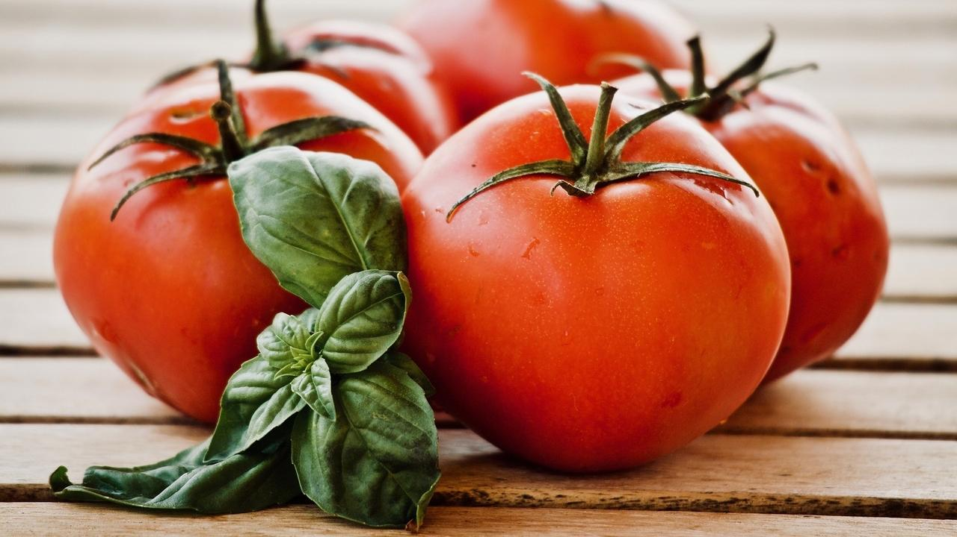

Come rain come shine, a bowl of delectable Tomato Basil Soup is a good way to dine. The sweet-tangy tomato and the minty aromatic basil blend together perfectly to make for a mouth-watering soup.

This simple and soothing Tomato Basil Soup is easy to make and can be whipped up in no time. What’s more, this recipe contains healing ingredients and is made in a method that best preserve and enhances nutrients while still being super yummy!

Enjoy this flavourful and aromatic soup to your heart’s content. Upgrade to food that truly loves you back.

## Whole Food Plant Based Tomato Basil Soup Recipe

Course: Breakfast, Lunch & Dinner, Snack, Soup  
Cuisine: Italian Recipe  
Prep Time: 5 minutes  
Cook Time: 10 minutes  
Servings: 2 people

### INGREDIENTS

4 Tomato  
1/3 cup Fresh Basil Leaves  
1/2 tsp Turmeric Powder  
1/2 tsp Pepper Powder  
2 cups Water  
4 tsp Miso Paste

### INSTRUCTIONS

1. Chop the tomatoes into chunky pieces. In a pot, boil them with the 2 cups of water till cooked.
2. Strain out any remaining water into a bowl and cool down the tomatoes. Spreading them out evenly on a flat surface will speed up the process.
3. Once cool, blend them together till smooth with the basil, pepper, turmeric powder, and miso paste. Once blended, mix with the stock (the strained water)
4. Serve fresh and warm!

### Plant Based Chef Pro Tips for Best Tomato Basil Soup Recipe

1. If you like your tomato basil soup creamy, add some boiled potatoes, almond mylk, or coconut paste while blending.
2. Garlic can be used for extra flavour!

.

# 47.Gobi Matar Tofu Gravy Recipe | Whole Food Plant Based

## Whole Food Plant Based Gobi Matar Tofu Gravy Recipe

Course: Course 2: Vegetable Dishes for Lunch & Dinner Meals  
Cuisine: North Indian Recipe  
Prep Time: 20 minutes  
Cook Time: 20 minutes  
Servings: 4 servings

### INGREDIENTS

#### Main Ingredients

1 cup Cauliflower florets  
1 cup Green Peas fresh  
1/2 cup Tofu

#### Gravy

2 Tomatoes  
1 Onion red  
1/2 Green Chili  
1 tbsp Date Syrup

#### Masala Spice Mix

1/2 cup Cashews soaked  
1/4 tsp Cumin Seeds / Jeera Powder  
1/4 tsp Coriander Seeds / Dhaniya Powder  
1/4 tsp Black Pepper Powder  
1 Clove  
1 cm piece Cinnamon  
1/2 tsp Turmeric Powder  
1 Green Cardamom  
1/8 tsp Fenugreek / Methi Seeds  
4 tsp Miso Paste (Healthy Salt Alternative. See Nutrition Science Highlights below)

#### Garnishing

2 tbsp Coriander Leaves Chopped  
1 tsp Mustard Seeds

### INSTRUCTIONS

#### Vegetables & Legumes

1. Steam fresh green peas for 5 minutes. Add cauliflower and continue steaming for 5 minutes. Finally, add tofu and steam for 5 more minutes, until all are cooked.

#### Masala Spice Mix

1. Grind all masala ingredients together until smooth. Keep aside.

#### Gravy

1. Grind all gravy ingredients together and cook in a saucepan or thick bottomed kadai / wok until well cooked. This sauce can also be prepared in advance and refrigerated for multiple recipes! See Plant Based Chef Pro Tips below.
2. Once cooked, remove from stove, mix in masala spice mix and vegetables.
3. Dry roast mustard seeds until they start popping. As soon as they start popping, immediately mix with gobi matar tofu gravy. Garnish with fresh coriander leaves and serve fresh!

### Plant Based Chef Pro Tips for Best Gobi Matar Tofu Gravy Recipe

1. If making tomato sauce in advance, mix with black pepper powder, miso paste, and turmeric powder before refrigerating. This lasts for 2-3 days and can be used for multiple recipes.

# 48.Veg Kurma Recipe | Veg Korma Recipe | Whole Food Plant Based

## Whole Food Plant Based Veg Kurma Recipe

Course: Course 2: Vegetable Dish for Breakfast, Lunch & Dinner Meals  
Cuisine: Mughlai Recipe  
Prep Time: 15 minutes  
Cook Time: 20 minutes  
Servings: 4 people

### INGREDIENTS

1/2 Carrot  
1/2 head Broccoli  
1/2 Sweet Potato  
1/2 Onion  
1 Tomato  
1 Green Chili  
1 inch piece Cinnamon  
3 Cloves

#### Kurma Masala

1 clove garlic  
1 inch piece Ginger  
1/4 cup Coriander Leaves  
1/2 tsp Fennel Seeds / Saunf  
1 tsp Dhaniya / Coriander Seeds  
2 tsp Poppy Seeds / Khus Khus  
3/4 cup Coconut grated  
1/4 cup Cashews  
1 tsp Turmeric Powder  
1 tsp Pepper Powder  
Juice of 1 Lemon  
4 tsp Miso Paste (Healthy Salt Alternative. See Nutrition Science Highlights below)

### INSTRUCTIONS

#### Cooking Kurma Vegetables

1. Wash and chop carrot and sweet potato into long, rectangular pieces.
2. Cook all chopped vegetables together with a slit green chili, cinnamon, cloves, and minimal water.
3. Peel and crush / grind garlic to a paste. Keep aside for ten minutes.

#### Kurma Masala Recipe

1. Dry roast poppy seeds for about half a minute. Peel ginger.
2. Grind poppy seeds with ginger, coriander seeds / dhaniya, and fennel seeds / saunf to a smooth paste to make Kurma Masala.
3. Separately, grind cashews and grated coconut to a smooth paste, along with turmeric powder, pepper powder, quartered & peeled lemon, and miso paste, to make a coconut spice paste. This must be added only cooking, as described in the last step. Preferably, soak cashews overnight or at least for 5 hours before grinding.

#### Bringing it all together

1. Once Kurma Masala is ready, add it into the half-cooked vegetables and continue cooking.
2. Once vegetables are fully cooked, remove from stove and mix in coconut spice paste. Garnish with coriander leaves. Serve fresh!

# 49.How to Make Poha | Easy Poha Recipe | Whole Food Plant Based

Quick and easy poha recipe with red rice poha

### How to Make Poha - Whole Food Plant Based Poha Recipe

Course: Breakfast, Course 3: Grain Dishes for Lunch & Dinner Meals  
Cuisine: Maharashtra Recipe from North India  
Prep Time: 5 minutes  
Cook Time: 15 minutes  
Servings: 2 servings

#### INGREDIENTS

1/2 cup Flattened Red Rice / Red Rice Poha / Red Rice Aval  
1/2 cup Fresh Green Peas  
1 Onion  
1/2 Green Chili  
1 tsp Turmeric Powder  
1/2 tsp Black Pepper Powder  
3 tsp Miso Paste (Healthy Salt Alternative, see Nutrition Science Highlights)  
Juice of 1/2 Lemon  
1/2 tsp Garam Masala  
2 tbsp Coriander Leaves & Stems Chopped

#### INSTRUCTIONS

1. Sprinkle drinking water on poha, just enough to get it fully wet. Leave it aside for a few minutes to absorb the water and soften.
2. Peel and chop onion into long, thin slices. Chop green chili, Saute onion and chili with a few spoons of water until cooked. Add fresh green peas and some more water. Cook with closed lid.
3. Once cooked, remove from stove and mix in turmeric powder, black pepper powder, miso paste, and garam masala. Squeeze lemon juice. Mix poha in.
4. Garnish with chopped coriander. Serve fresh!

# 50.Christmas Cake Recipe | Cake for Christmas | Merry Christmas | Whole Food Plant Based Recipe

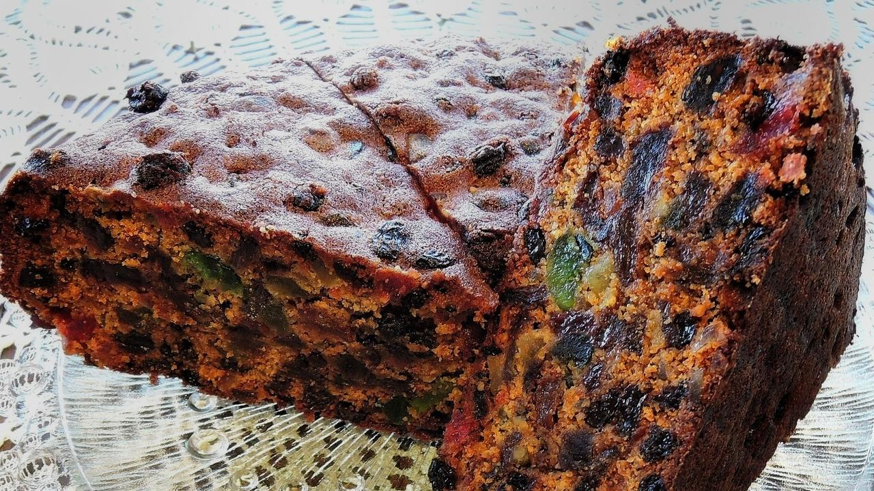

Spiced Fruit and Nut Christmas Cake, popularly known as 'Christmas Fruit Cake' or 'Christmas Plum Cake' is an all-time favourite come Christmas. Baking this delicious, antioxidant-rich cake is a tradition in most Christian homes. Filled with dried fruits, nuts, and strong aromatic spices this spongy cake is a treat to the senses. We have for you a recipe that combines the goodness of dried fruits, nuts and spices with whole grains, nut butters and date syrup! 'Tis the season to be jolly indeed!

### Whole Food Plant Based Baked Christmas Cake Recipe

Course: Christmas Recipe, Snack, Dessert in Course 3 (Grain Dishes) at Lunch & Dinner Meals  
Cuisine: British Recipe  
Servings: 1 Cake

#### INGREDIENTS

##### Main Ingredients for Christmas Cake Batter

1 1/2 cups Red Rice Flour  
1 1/2 cups Whole Wheat Flour  
2 1/2 cups [Date Syrup](https://www.nutritionscience.in/blog/date-syrup-recipe-whole-food-plant-based)  
1/4 cup [Almond Butter](https://www.nutritionscience.in/blog/almond-butter-recipe-whole-food-plant-based)  
1 tsp Baking Soda  
1 tbsp Vinegar  
Orange Juice  
Lemon Zest from 1 Lemon freshly grated  
Orange Zest from 1 Orange freshly grated

##### Dry Fruits & Nuts for Christmas Cake

1 cup Raisins  
2 Plums  
1 cup Figs  
2 tbsp Cashews  
2 tbsp Unsalted Pistachios  
2 tbsp Almonds  
2 tbsp Walnuts

##### Christmas Cake Spice Mix

2 sticks Cinnamon  
4 Cloves  
1 tsp Fennel Seeds  
2 Star Anise  
3 Cardamom  
Few strands Saffron

#### INSTRUCTIONS

1. Chop nuts. Soak dry fruits and nuts in orange juice overnight. While making orange juice, remove seeds before grinding, and do not filter after grinding. If you do, orange juice becomes a processed food.
2. Grind all ingredients into a fine powder.
3. Mix all ingredients together, along with enough orange juice to make a christmas cake batter of pourable consistency.
4. Line a baking tin with unbleached parchment paper or use a silicone cake baking tray.
5. Pour cake batter into the baking tin. Bake at 180 deg C for 55 minutes.
6. Once done, check to see if it is cooked by poking in a knife, then allow to cool completely on a cake cooling rack. Serve fresh!

### Plant Based Chef Pro Tips for Best Christmas Cake Recipe

1. Christmas Cake batter should be diluted with orange juice just until it reaches a thick but pourable consistency.

# 51.Aloo Paratha Recipe | Aloo Recipe | Paratha Recipe | Whole Food Plant Based Recipe



## Whole Food Plant Based Aloo Paratha Recipe

Course: Course 3: Grain Dishes for Lunch & Dinner Meals, Breads  
Cuisine: North Indian Recipe  
Prep Time: 10 minutes  
Cook Time: 5 minutes  
Servings: 2 People

### INGREDIENTS

1 cup Whole Wheat Flour Coarsely Ground  
3 tbsp Flaxseed Powder  
2 Potatoes   
1/2 tsp Turmeric Powder  
1/2 tsp Black Pepper Powder  
1/2 tsp Cumin / Jeera Powder  
1/2 tsp Coriander Seed / Dhaniya Powder  
2 tbsp Coriander Leaves Chopped  
1/2 tsp Garam Masala  
2 tsp Miso Paste

### INSTRUCTIONS

1. Steam or boil potatoes until cooked. Chop into small pieces and let is cool completely. Mash with turmeric powder, black pepper powder, jeera powder, dhaniya powder, coriander leaves, garam masala, and garam masala to make aloo paratha stuffing.
2. Mix all 3/4 of the whole wheat flour and flaxseed powder in a large bowl and knead into a dough, adding water little by little while kneading. Once the dough has come together, stop adding water and knead to a stiff dough. The dough should be soft to the touch, but not sticky. If sticky, add more flour. If too hard, add more water.
3. Take a ping-pong ball sized piece of dough and roll it into a ball between your hands. Shape into a cup, fill with aloo paratha stuffing, and seal the ball of dough.
4. Dust with the remaining whole wheat flour and roll it out into a thick aloo paratha with a rolling pin.
5. Heat a thick bottomed pan or tawa. It is hot enough when a bit of water dropped on the pan dances instead of evaporating immediately.
6. Dust off any extra flour from the aloo paratha, place it on the tawa and reduce flame to sim or medium. Close with a lid. After a minute or two, once cooked, flip over. It is cooked on the first side if light brown spots have begun appearing. If the spots are large or dark brown, the methi paratha has been overcooked. Tear off the dark parts and consume only the unbrowned parts.
7. After 1 minute or two of flipping over, once cooked, take the aloo paratha off the tawa. By now, small, light brown spots should have appeared on both sides and the aloo paratha should have been fully cooked.
8. Wait for a few minutes until it cools down, then serve fresh! (See Nutrition Science Highlights to find out why!)

# 52.Rajma Masala Recipe | Rajma Recipe for Rajma Chaval | Whole Food Plant Based Recipes

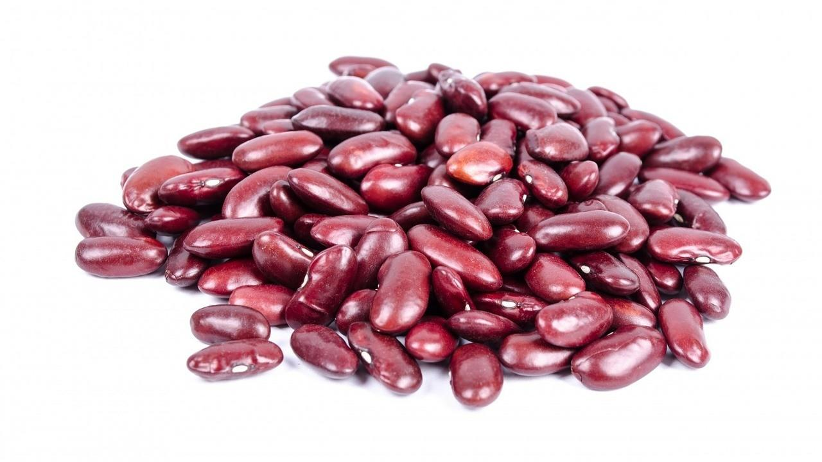

Delicious, warm and aromatic Rajma Masala recipe brings back memories of Ma's Rajma Chawal, doesn't it?

## Whole Food Plant Based Rajma Masala Recipe

Course: Side dish for Course 3: Grain Dishes at Lunch & Dinner Meals  
Cuisine: North Indian Recipe  
Prep Time: 10 minutes  
Cook Time: 30 minutes  
Passive Time: 5 hours  
Servings: 2 people

### INGREDIENTS

1. 1 cup Red Rajma / Red Kidney Beans
2. 1 Bay Leaves
3. 1 stick Cinnamon
4. 1 Onion Red
5. 1 Tomatoes
6. 1 inch piece Ginger
7. 4 cloves Garlic
8. 1 tsp Cumin / Jeera Powder
9. 1/2 tsp Pepper Powder
10. 1/2 tsp Turmeric Powder
11. 1/4 cup Cashews
12. Juice of 1 Lemon
13. 2 tsp Miso Paste (Healthy Salt Replacement. See Nutrition Science Highlights below)

### INSTRUCTIONS

1. Soak rajma / red kidney beans overnight. Pressure cook soaked rajma with bay leaf and cinnamon until well cooked.
2. Peel and mash / grind garlic. Keep aside for ten minutes to rest.
3. Peel onions. Grind onions, tomato, and ginger. Heat on a kadai and cook.
4. After ten minutes of waiting, add garlic paste and cook for two minutes, then remove from stove and mix with cooked rajma.
5. Mix in cumin / jeera powder, turmeric powder, and pepper powder. Grind lemon juice and miso paste with some of the cooked rajma, then mix back into the rajma masala.
6. Grind soaked cashews to a smooth paste and garnish rajma masala with cashew paste. Serve fresh!

# 53.Maghrebi Mint Tea | Moroccan Peppermint Tea Recipe | Whole Food Plant Based Recipes



Maghrebi Mint Tea from Morroco, this recipe is a traditional preparation that leaves your throat feeling warm but super cool!

### **Whole Food Plant Based Maghrebi Peppermint Tea Recipe**

Course: Beverage, Snack  
Cuisine: South Indian Recipe  
Prep Time: 5 minutes  
Servings: 2 Glasses

#### **INGREDIENTS**

1 tsp Green Tea Leaves  
1 tsp Peppermint Leaves  
1 tsp Raisins  
6 Walnuts  
2 glasses Water

#### **INSTRUCTIONS**

1. Heat water to a boil. Remove from stove, then mix in green tea leaves, peppermint leaves, and raisins. Leave covered for 3 minutes.
2. Garnish with 3 walnuts each. Serve fresh!

### **Plant Based Chef Pro Tips for Best Maghrebi Peppermint Tea Recipe**

1. Use other herbs and spices, like mint, basil, coriander leaves, or cinnamon to create different flavours!

# 54.Clear Zoodles Soup Recipe | Zoodles Recipe | Cook Zoodles in Soup Recipe | Whole Food Plant Based Recipes

Innovative Zoodles Recipe with Zucchini Zoodles to make with your child on a Sunday Evening.

### Whole Food Plant Based Clear Zoodles Soup Recipe

Course: Soup; Snack; Beverage; Breakfast  
Cuisine: American Recipe  
Prep Time: 15 minutes   
Cook Time: 20 minutes  
Servings 2 people

#### INGREDIENTS

1 Zucchini  
1 Onion  
10 cloves Garlic  
1 inch piece Ginger  
2 leaves Lemongrass  
2 tbsp Apple Cider Vinegar  
2 tsp Miso Paste (Healthy Salt Alternative. See Nutrition Science Highlights below)  
1/2 tsp Cinnamon Powder  
1 tsp Black Pepper Powder  
6 Almonds  
2 tbsp Coriander Leaves chopped  
Water as required

#### INSTRUCTIONS

1. Use a spiralizer to make zoodles from zucchini. Peel and chop onion into long, thin slices. Peel and chop ginger into tiny pieces. Boil onion with 1 cup of water and lemongrass leaves.
2. In the meantime, peel and crush or grind garlic to a paste. Keep aside for ten minutes, then add to the boiling vegetables along with zoodles. Continue cooking for two minutes until cooked but crunchy.
3. Once cooked, switch off the stove. Chop almonds into slivers.
4. Mix in apple cider vinegar, miso paste, chopped almonds, cinnamon powder, black pepper powder, and coriander leaves. Serve fresh!

### Plant Based Chef Pro Tips for Best Clear Zoodles Soup Recipe

1. For more flavors, you can add pudina, sage, rosemary, curry leaves, doddapatre, tulsi, basil, thyme, oregano, etc.

# 55.Murukku Recipe | Diwali Recipe | Whole Food Plant Based Recipes

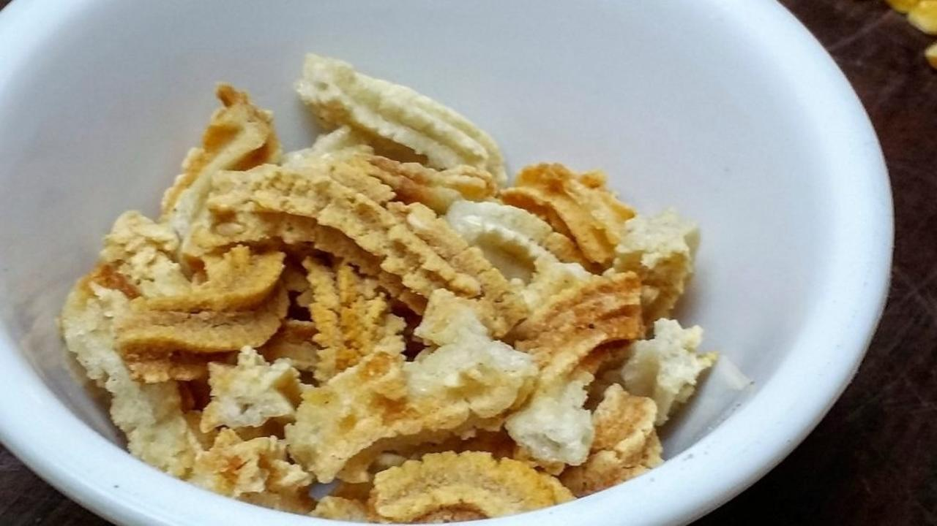

Who doesn’t love a good murkku? Or a dozen? How about when it’s baked? And oil-free? AND made from whole ingredients? 😀

The problem with fried food is, well, they are fried. First, we extract oil from a nut or seed, losing out on most of the nut’s nutrition. Then, we heat the oil to a high temperature, destroying what little nutrition remains in the oil. Then, we fry something in it. Have you ever tried burning a couple of banana chips? If you haven’t, do try it today. Be sure to hold the chips with a pair of tongs – and place a sheet of paper underneath to catch all the oil that drips from it!

How to make them healthier? Use an oven instead of a frying pan. And, replace oils with whole nuts. That’ll amp up the nutrient quotient significantly.

However, foods like murukku, even when baked, are cooked at a high temperature and are very dry. Try eating them mindfully, you will find that you do not enjoy them as much as fresh food like fruits or vegetables – or even fresh nuts! Here’s a recipe that takes you closer to health. If you want to go all the way, enjoy a cup of fresh fruits and nuts instead! 🙂

### Whole Food Plant Based Murukku Recipe - Diwali Recipe

Course: Side Dish for Course 3 (Grain Dishes) for Lunch & Dinner Meals; Diwali Recipe  
Cuisine: Tamil Recipe from South India  
Prep Time: 10 min   
Cook Time: 30 min  
Servings: 4 servings

#### INGREDIENTS

1 cup Brown Rice flour  
1/2 cup Moong dal flour  
1/4 cup Bengal Gram Dal flour  
1/2 cup Flaxseeds  
1/2 cup Peanuts  
1/4 tsp Asafoetida / Perunkaayam / Hing  
4 tsp Miso Paste (Healthy Salt Alternative. See Nutrition Science Highlights below)  
Water for Dough

#### INSTRUCTIONS

##### Dough

1. Grind groundnuts in a mixie without water until you get raw peanut butter. You may need to scrape the sides of the mixie a few times. Use a small jar!
2. Grind the dals and flaxseed one after the other in a mixie without water, to a fine flour.
3. Mix all ingredients together with water to make a soft dough. Ensure that the dough isn't too wet.

##### Baking

1. Pre-heat oven to 160 deg C
2. Line a baking tray with unbleached parchment paper or a reusable silicone sheet. Do not apply any oil on the paper, sheet or tray.
3. Use a murukku machine (for achu murukku) with star shaped holes to squeeze out long or round murukku or chakli on the parchment paper. Be careful not to make too many layers, as they will stay soft. Squeeze out in a single layer for best results.
4. Bake at 160 deg C, turning once after 15 minutes. Murukku or chakli will be ready in 20 to 25 minutes!
5. Once done, remove from oven. Wait until it is fully cool. Enjoy with a vegetable or nut dip!

### Plant Based Chef Pro Tips for Best Murukku Recipe for your Diwali Recipes

1. Add jeera / cumin seeds or omum / ajwain / caraway seeds for an aromatic flavour!
2. Ensure that it does not brown too much. See Nutrition Science Highlights below to find out why.

# 56.Pasala Keerai Molagootal Recipe | Malabar Spinach Pepper Stew Recipe | Whole Food Plant Based Recipes

Pasalai Keerai Molagootal, Malabar Spinach Pepper Stew from Palakkad, Kerala. Delicious in its simplicity.

### **Whole Food Plant Based Pasalai Keerai Molagootal Recipe**

Course: Course 2 (Vegetable Dish) and Side Dish for Course 3 (Grain Dishes) at Lunch & Dinner Meals  
Cuisine: Palakkad Recipe from Kerala  
Prep Time: 10 minutes  
Cook Time: 20 minutes  
Servings: 2 people

#### **INGREDIENTS**

2 cups Yellow Pumpkin / Mathanga chopped  
1 tsp Turmeric Powder  
1 tsp Cumin Powder / Jeera Powder  
1 tsp Black Pepper Powder  
½ cup Coconut grated  
4 tsp Miso Paste (Healthy Salt Alternative. See Nutrition Science Highlights below)  
10 Curry Leaves  
1 tsp Mustard Seeds  
1 tsp Urad Dal

#### **INSTRUCTIONS**

1. Soak moong dal overnight. Cook with turmeric powder and enough water to cover the dal until half cooked.
2. Chop malabar spinach / pasalai keerai. Add pasalai keerai to the boiling moong dal and continue boiling until well cooked. Mash with a wooden masher.
3. Grind coconut with jeera powder, black pepper powder, and miso paste. Mix into cooked pasalai keerai and moong dal.
4. Dry roast mustard. When it starts popping, immediately mix into pasalai keerai molagoottal.
5. Dry roast urad dal on low flame until cooked just enough. Do not allow to brown too much. See Nutrition Science Highlights for Mathanga Erissery below for details. Once roasted enough, mix into pasalai keerai molagoottal.
6. Garnish with curry leaves. Serve fresh!

**Plant Based Chef Pro Tips for Best Pasalai Keerai Molagoottal Recipe**

1. This is a very mild recipe, preferably served at the beginning of course 2, after watery vegetable dishes and before other, more spicy dishes.
2. Add ginger for a wider flavour profile.

# 57.Mixture Recipe | Diwali Recipe | Baked Zero Oil Mixture Recipe | Whole Food Plant Based Recipes

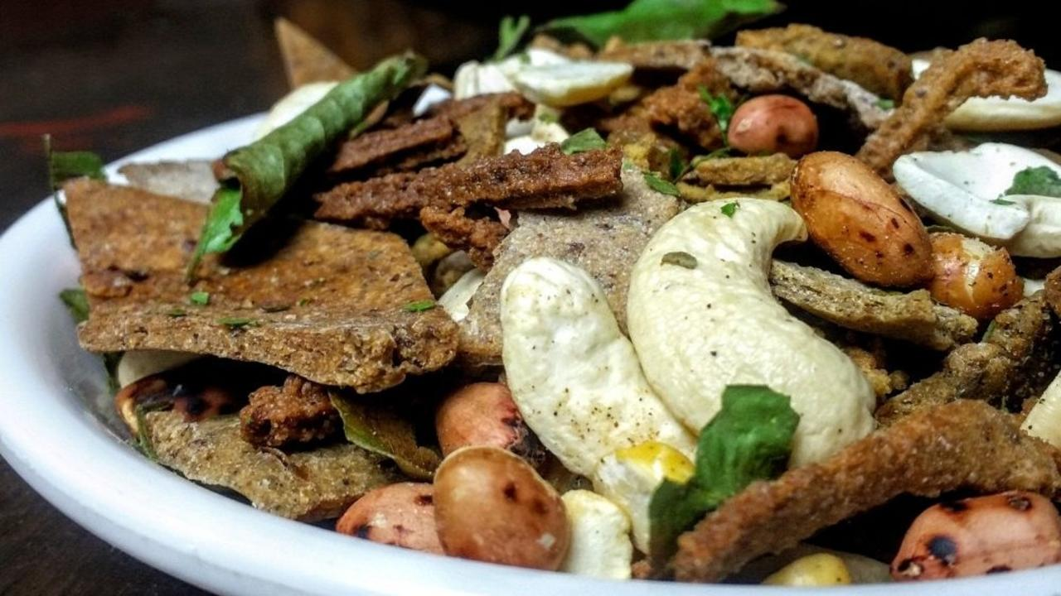

Mixture – originally invented to utilise all leftover fried food, mixture has become a dish that is specially prepared from scratch in many bakeries today.

If you do not have time to make all the ingredients in this mixture recipe, you can just make one or two, or simply skip all the pre-prepared ingredients.

The problem with fried foods is, well, they are fried. First, we extract oil from a nut or seed, losing out on most of the nut’s nutrition. Then, we heat the oil to a high temperature, destroying what little nutrition remains in the oil. Then, we fry something in in it. Have you ever tried burning a couple of banana chips? If you haven’t, do try it today. Be sure to hold the chips with a pair of tongs – and place a sheet of paper underneath to catch all the oil that drips from it!

How to make them healthier? Use an oven instead of a frying pan. And, replace oils with whole nuts. That’ll amp up the nutrient quotient significantly.

However, foods like mixture, even when baked, are cooked at a high temperature and are very dry. Try eating them mindfully, you will find that you do not enjoy them as much as fresh food like fruits or vegetables – or even fresh nuts! Here’s a recipe that takes you closer to health. If you want to go all the way, enjoy a cup of fresh fruits and nuts instead! 🙂

### Whole Food Plant Based Baked Mixture Recipe

Course: Side Dish for Course 3 (Grain Dishes) at Lunch & Dinner Meals  
Cuisine: Indian Recipe  
Servings: 7 Cups

#### INGREDIENTS

##### Main Ingredients

1 cup Red Rice flakes / Red Rice Poha / Aval / Avalakki  
1/2 cup Roasted Gram Dal  
1 cup Groundnuts / Peanuts  
1/2 cup Cashew  
1/2 cup Almond / Badam  
4 tsp Flax Seeds

##### Optional Ingredients

[1/2 cup Mullu Murukku](https://www.nutritionscience.in/blog/murukku-recipe-diwali-recipe-whole-food-plant-based-recipes)  
[1/2 cup Omapudi / Sev](https://www.nutritionscience.in/blog/ompudi-recipe-sev-recipe-for-sev-puri-chaat-recipe-baked-oil-free-whole-food-plant-based-recipes)  
[1/2 cup Barnyard Millet Ribbon Pakoda](https://www.nutritionscience.in/blog/barnyard-millet-ribbon-pakoda-recipe-oil-free-millet-recipes-whole-food-plant-based-recipes)  
[1/2 cup Diamond Biscuit](https://www.nutritionscience.in/blog/jowar-sweet-diamond-biscuits-recipe-diwali-recipes-whole-food-plant-based-recipes)  
[1/2 cup Sweet Diamond Biscuit](https://www.nutritionscience.in/blog/jowar-sweet-diamond-biscuits-recipe-diwali-recipes-whole-food-plant-based-recipes)

##### Tadka

2 tsp Mustard Seeds  
2 tsp Jeera / Cumin Seeds  
15 Curry Leaves  
3 tsp Black Pepper Powder  
3/4 tsp Salt  
3 tbsp Soya Flour

#### INSTRUCTIONS

1. Dry roast rice flakes, ground nuts and flax seeds on low flame, without letting them get too brown. See Nutrition Science Highlights below to find out why!
2. Mix all ingredients together, except tadka ingredients. Click links in the ingredient list for making mullu murukku, ompudi / sev, barnyard millet ribbon pakoda, diamond biscuit and sweet diamond biscuit.
3. Dry roast mustard seeds, jeera / cumin seeds, curry leaves, and soya flour separately. Mix all tadka ingredients in mixture. Keep in an airtight container.

### Plant Based Chef Pro Tips for Best Baked Mixture Recipe

1. Use thinner red rice flakes / aval / avalakki / poha for better results
2. Add 1/2 cup raisins if you want a sweet and spicy mixture

# 58.Mathanga Erissery Recipe | Erissery Curry | Pumpkin Erissery | Whole Food Plant Based Recipes

Pumpkin Stew from Kerala, simple and delectable.

### **Whole Food Plant Based Mathanga Erissery Recipe**

Course: Course 2 (Vegetable Dish) and Side Dish for Course 3 (Grain Dishes) at Lunch & Dinner Meals  
Cuisine: Kerala Recipe  
Prep Time: 15 minutes  
Cook Time: 20 minutes  
Servings: 4 people

#### **INGREDIENTS**

2 cups Yellow Pumpkin / Mathanga chopped  
1 Green Chili  
1 tsp Turmeric Powder  
1 tsp Cumin Powder / Jeera Powder  
½ tsp Black Pepper Powder  
½ cup Coconut grated  
4 tsp Miso Paste (Healthy Salt Alternative. See Nutrition Science Highlights below)  
10 Curry Leaves  
1 tsp Mustard Seeds  
1 tsp Urad Dal

#### **INSTRUCTIONS**

1. Remove yellow pumpkin seeds and reserve for pumpkin seed chutney.
2. Chop yellow pumpkin into bite-sized cubes with peel. The peel can be eaten, so there is no need to peel pumpkin. Peel and chop onion into long, thin slices. Slit green chili along its length. Cook chopped yellow pumpkin with chopped onions, turmeric powder and slit green chili until fully cooked.
3. Grind coconut with jeera powder, black pepper powder, and miso paste. Mix into cooked yellow pumpkin.
4. Dry roast mustard. When it starts popping, immediately mix into mathanga erissery.
5. Dry roast urad dal on low flame until cooked just enough. Do not allow to brown too much. See Nutrition Science Highlights for Mathanga Erissery below for details. Once roasted enough, mix into pumpkin erissery.
6. Garnish with curry leaves. Serve fresh!

**Plant Based Chef Pro Tips for Best Mathanga Erissery Recipe**

1. This is a very mild recipe, preferably served at the beginning of course 2, before other, more spicy, vegetable dishes.
2. Add ginger for a wider flavour profile.

# 59.Moong Sprout Chaat | Aloo Chaat | Chaat Recipe | Whole Food Plant Based Recipes

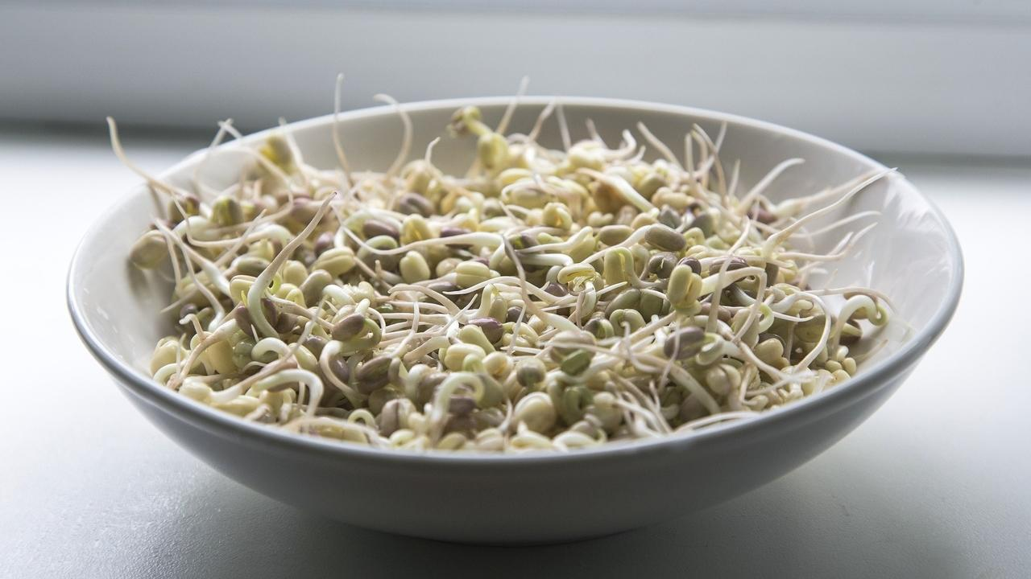

### **Whole Food Plant Based Moong Sprouts Aloo Chaat Recipe**

Course: Salad, Snacks, Course 1 (Raw Dish) for Lunch & Dinner Meals  
Cuisine: North Indian Recipe  
Prep Time: 20 minutes  
Passive Time: 20 minutes  
Servings: 4 People

#### **INGREDIENTS**

1 Potato  
2 Tomatoes  
2 Onions  
1 Carrot  
1 cup Whole Moong / Whole Green Gram  
1/4 cup Pomegrate Arils, from 1/2 Pomegranate  
1 tbsp Almonds  
2 tbsp [Green Chutney](https://www.nutritionscience.in/blog/green-chutney-recipe-coriander-pudina-chutney-recipe-whole-food-plant-based-recipes)  
1 tbsp [Date Syrup](https://www.nutritionscience.in/blog/date-syrup-recipe-whole-food-plant-based)  
1/2 tsp Black Pepper Powder  
Juice of 1 Lemon  
1/4 cup Coriander Stems & Leaves chopped

#### **INSTRUCTIONS**

1. Soak whole moong / green gram overnight. Hang up in a cotton cloth or keep in a vessel with holes to sprout for 12 to 24 hours.
2. Wash potatoes well. Chop into quarters and steam until cooked.
3. Peel onions. Chop onions and tomatoes into small pieces. Grate carrot.
4. Mix all ingredients together. Garnish with chopped coriander leaves & stems to make Moong Sprouts Chaat. Serve fresh!

### **Plant Based Chef Pro Tips for Best Methi Sprouts Aloo Chaat Recipe**

1. Other sprouts could be added too, like brown chana and peanuts!

# 60.Tofu Butter Masala Recipe | Whole Food Plant Based Recipe

## Tofu Butter Masala Recipe

Course: Course 2: Vegetable Dish for Lunch & Dinner Meals, Side dish for Course 3: Grain Dishes  
Cuisine: North Indian Recipe  
Prep Time: 20 minutes  
Cook Time: 20 minutes  
Servings: 4 servings

### INGREDIENTS

1. 1 1/2 cup OR 200g packet Tofu
2. 4 Tomatoes
3. 1 Onion red
4. 1 cm piece Ginger Peeled
5. 1/2 Green Chili
6. 5 cloves gGrlic Peeled
7. 1 tbsp Date Syrup
8. 1 tsp Garam Masala
9. 1/2 tsp Black Pepper Powder
10. 6 tsp Miso Paste (Healthy Salt Alternative. See Nutrition Science Highlights below)
11. 1 tbsp Nutritional Yeast
12. 1/2 Lemon
13. 1/2 cup Cashews soaked
14. 2 tbsp Coriander Leaves Chopped

### INSTRUCTIONS

1. Chop tofu into squares and steam or boil until cooked.
2. Grind tomatoes, onions, chili, ginger, and date syrup together until smooth and cook in a saucepan or thick bottomed kadai / wok.
3. While tofu butter masala gravy is being cooked, peel and mash/grind garlic to a paste. Keep aside for ten minutes, then add to the gravy.
4. Once cooked, remove from stove, mix in steamed tofu, garam masala, black pepper powder, miso paste, and nutritional yeast. Squeeze lemon and mix well.
5. Grind cashews with just enough water to make cashew cream using a high powered blender. If using a regular mixie, pre-soak for 15 to 20 minutes before grinding.
6. Mix cashew cream into the gravy. Garnish Tofu Butter Masala with fresh coriander leaves and serve fresh!

# 61.Peas Pulao Recipe | Veg Pulao with Brown Basmati Rice | Whole Food Plant Based Recipes

Peas Pulao is a dish with a rich history. Born in ancient India, pulāka in sanskrit means a ‘ball of rice’. Pulao was mentioned in the Mahabharatha, and taken to Europe by Alexander the Great. Interestingly, the first recipe for pulao was written by Avicenna, an ancient Persian physician!

Peas Pulao is usually served with raitha. If you prefer a thin raitha, you could use coconut milk thambulli as a base. If you enjoy a thick, creamy raitha, peanut mylk is a better idea. Plant based mylks give you all the yumminess of milk without any of the cruelty or disease that comes with dairy milk. Enjoy!

### Whole Food Plant Based Peas Pulao Recipe

Course: Course 3 (Grain Dish) at Lunch & Dinner Meals  
Cuisine: North Indian Recipe  
Prep Time: 15 minutes   
Cook Time: 30 minutes  
Servings: 4 people

#### INGREDIENTS

1 cup Brown Basmati Rice  
1 cup Fresh Green Peas  
1 stick Cinnamon  
3 Cloves  
1 Bay leaf  
1/2 cm piece Ginger chopped  
1/2 tsp Black Pepper Powder  
1/2 tsp Jeera Powder / Cumin Powder  
1/4 cup Coconut grated  
4 tsp Miso Paste  
1/4 Lemon  
2 tbsp Coriander leaves chopped  
2 tsp Nuts Almonds or Cashews

#### INSTRUCTIONS

1. Soak 1 cup brown basmati rice for 30 minutes. Cook with 1 cup water. Make sure it does not get overcooked. Switch off the stove when it is just cooked, spread on a plate, and allow to cool.
2. Boil fresh green peas with cinnamon, cloves and bay leaf and just enough water to cover half the peas.
3. Peel ginger. Blend ginger, coconut, jeera powder, black pepper powder, miso paste, and lemon juice. Mix into peas pulao.
4. Garnish with coriander leaves and soaked nuts. Serve fresh with [Tofu Butter Masala](https://www.nutritionscience.in/blog/tofu-butter-masala-recipe-whole-food-plant-recipes)

### Plant Based Chef Pro Tips for Best Peas Pulao Recipe

1. Add exactly the right amount of water to cook brown basmati rice and peas for the right pulao consistency!
2. Experiment with other vegetables or greens like palak or methi for different versions of Veg Pulao.
3. If you like it spicy, then slit green chili can be added to boiling vegetables. Make sure not to bite the chili!
4. Apart from [raw vegan raitha](https://www.nutritionscience.in/blog/raw-vegan-raitha-recipe-whole-food-plant-based), you could also serve peas pulao with Coconut Thambulli instead of buttermilk or Peanut Curds instead of dairy curds.

# 62.Mixed Greens & Sweet Potato Kebab Recipe | Best Oil-Free Kebab Recipe | Whole Food Plant Based Recipes

Delicious & soft kebabs made from mixed greens and sweet potato. Delish!

### Whole Food Plant Based Mixed Greens & Sweet Potato Kebab Recipe

Course: Side dish for Course 3: Grain Dishes at Lunch & Dinner Meals, Snack  
Cuisine: Middle Eastern Recipe  
Prep Time: 20 mins  
Cook Time: 30 mins  
Servings: 4 people

#### INGREDIENTS

2 cups Mixed Greens chopped - Amaranthus, Palak, etc.  
1 large or 2 small Sweet Potatoes  
1 Onion  
5 cloves Garlic  
1 tbsp Black Pepper Powder  
1 tsp Red Chili Powder  
1/2 cup Coriander Stems & Leaves chopped  
4 tbsp Miso Paste (Healthy Salt Alternative. See Nutrition Science Highlights below)

#### INSTRUCTIONS

1. Cook sweet potatoes until done, with skin. Leave on a plate to cool completely.
2. Peel garlic, grind to a smooth paste and keep aside for ten minutes.
3. In the meantime, peel onion and grind it to a smooth paste with mixed greens, black pepper powder, red chili powder, coriander, and miso paste.
4. Once garlic has rested for ten minutes, grind it once again with sweet potato to a smooth paste. Mix both pastes together to make a soft batter that you can form into patties.
5. Pat into patties on your palm and roast on a tawa on low flame for two to three minutes, flipping once. Serve fresh!

# 63.Hot and Sour Soup Recipe | Veg Soup | How to Make Soup | Whole Food Plant Based Recipes

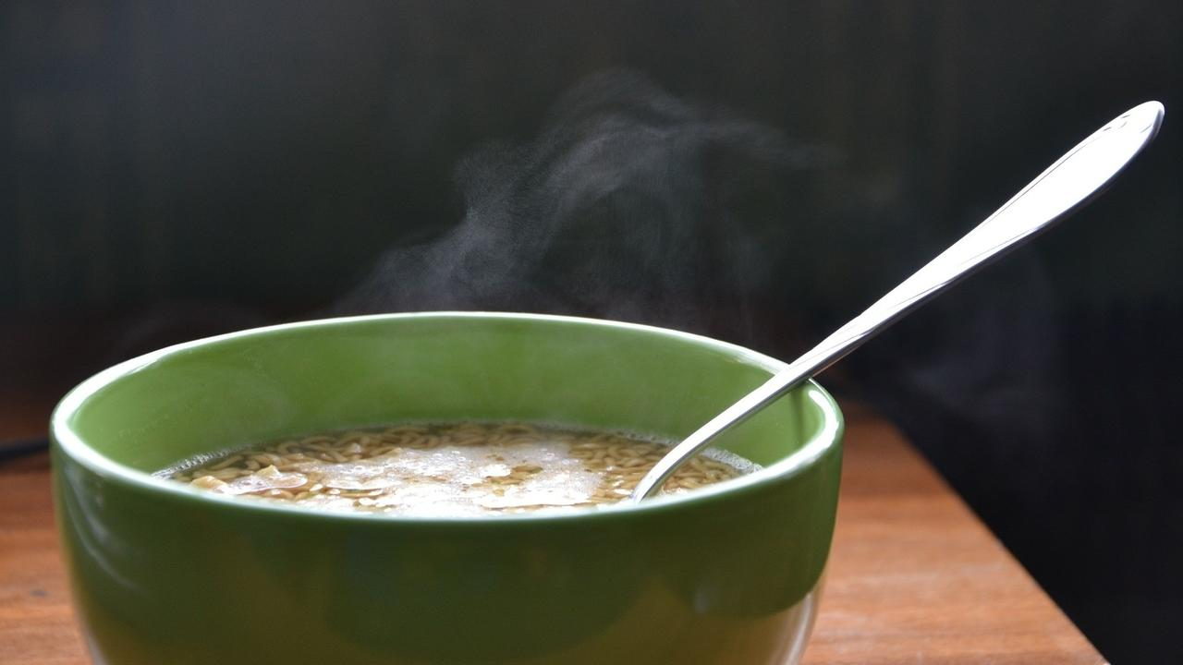

 Soothing, warm, spicy, veg hot and sour soup. Enjoy on a warm day or cold night!

### Whole Food Plant Based Hot and Sour Soup Recipe

Course: Soup; Snack; Beverage; Breakfast  
Cuisine: Chinese Recipe  
Prep Time: 10 minutes   
Cook Time: 20 minutes  
Servings 2 people

#### INGREDIENTS

1/2 medium sized Carrot  
1/2 cup Cabbage shredded  
4 White Button Mushrooms  
1 Onion  
10 cloves Garlic  
1 inch piece Ginger  
2 leaves Lemongrass  
2 tbsp Apple Cider Vinegar  
2 tsp Miso Paste (Healthy Salt Alternative. See Nutrition Science Highlights below)  
1/2 tsp Cinnamon Powder  
1 tsp Black Pepper Powder  
6 Almonds  
2 tbsp Coriander Leaves chopped  
Water as required

#### INSTRUCTIONS

1. If carrots have any dark spots, lightly peel only the spots. No need to peel carrot otherwise. Chop into tiny pieces. Shred cabbage using a mandolin, or chop into a long, thin pieces using a sharp knife. Chop mushrooms into tiny pieces. Peel and chop ginger into tiny pieces. Boil chopped vegetables with 1 cup of water and lemongrass leaves.
2. In the meantime, peel and crush or grind garlic to a paste. Keep aside for ten minutes, then add to the boiling vegetables. Continue cooking until done.
3. Once cooked, switch off the stove. Chop almonds into slivers.
4. Mix in apple cider vinegar, miso paste, chopped almonds, cinnamon powder, black pepper powder, and coriander leaves. Serve fresh!

### Plant Based Chef Pro Tips for Best Hot and Sour Soup Recipe

1. For more flavors, you can add pudina, sage, rosemary, curry leaves, doddapatre, tulsi, basil, thyme, oregano, etc.

# 64.Tulsi Ginger Tea Recipe | Tulsi Tea with Tulsi Leaves | Whole Food Plant Based Recipes

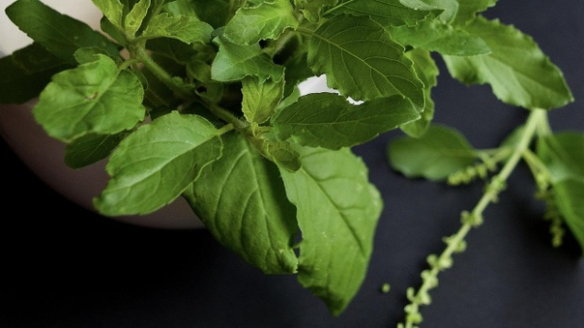

### **Whole Food Plant Based Tulsi Ginger Kashayam Recipe**

Course: Beverage, Snack  
Cuisine: South Indian Recipe  
Prep Time: 5 minutes  
Servings: 2 Glasses

#### **INGREDIENTS**

2 sprigs Tulsi / Holy Basil  
½ cm piece Ginger  
1 tsp Raisins  
6 Walnuts  
2 glasses Water

#### **INSTRUCTIONS**

1. Peel ginger and chop into tiny pieces. Chop raisins.
2. Heat water to a boil. Remove from stove, then mix in tulsi leaves, chopped ginger and raisins. Leave covered for 3 minutes.
3. Garnish with 3 walnuts each. Serve fresh!

### **Plant Based Chef Pro Tips for Best Tulsi Ginger Kashayam Recipe**

1. Use other herbs and spices, like mint, basil, coriander leaves, or cinnamon to create different flavours!

# 65.Ompudi Recipe | Sev Recipe for Sev Puri Chaat Recipe | Baked Oil-Free Whole Food Plant Based Recipes

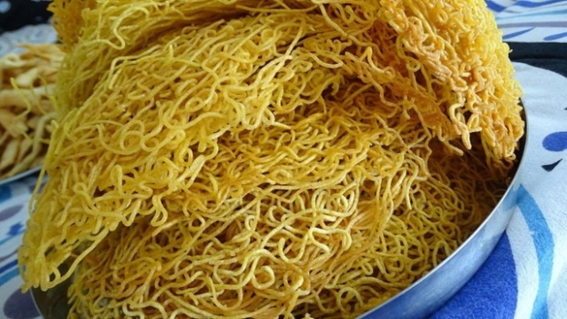

Ompudi or Sev has become ubiquitous in street food today. Sev is a one-size-fits-all topping for all chaats and many other dishes!

The problem with fried food is, well, they are fried. First, we extract oil from a nut or seed, losing out on most of the nut’s nutrition. Then, we heat the oil to a high temperature, destroying what little nutrition remains in the oil. Then, we fry something in it. Have you ever tried burning a couple of banana chips? If you haven’t, do try it today. Be sure to hold the chips with a pair of tongs – and place a sheet of paper underneath to catch all the oil that drips from it!

How to make them healthier? Use an oven instead of a frying pan. And, replace oils with whole nuts. That’ll amp up the nutrient quotient significantly.

However, foods like ompudi or sev , even when baked, are cooked at a high temperature and are very dry. Try eating them mindfully, you will find that you do not enjoy them as much as fresh food like fruits or vegetables – or even fresh nuts! Here’s a recipe that takes you closer to health. If you want to go all the way, enjoy a cup of fresh fruits and nuts instead! 🙂

### Whole Food Plant Based Baked Ompudi Recipe

Course: Side Dish for Course 3 (Grain Dishes) at Lunch & Dinner Meals  
Cuisine: Indian Recipe  
Prep Time: 10 min   
Cook Time: 10 min  
Servings: 4 servings

#### INGREDIENTS

2 cups Bengal Gram Flour Besan / Kadale Hittu / Kadalai Maavu  
1 cup Brown Rice flour  
1/2 Flaxseed Powder  
1 Potato  
20 grams Ajwain / Omum / Caraway Seeds  
2 tsp Black Pepper Powder  
4 tsp Miso Paste

#### INSTRUCTIONS

##### Ompudi Dough

1. Grind ajwain to a fine powder in a mixie.
2. Mix all dry ingredients together. Filter through a sieve to remove any large particles.
3. Grind potato in a mixie to a fine paste.
4. Mix the dry ingredients and potato paste with sufficient water to make a soft dough. Make sure it isn't watery!

##### Baking Sev

1. Pre-heat oven to 140 degrees celsius
2. Line a baking tray with unbleached parchment paper or a silicone sheet. Do not apply any oil on the paper or the tray.
3. Use a murukku machine with dotted holes to squeeze out omapudi or sev on the parchment paper. Be careful not to make too many layers, as they will stay soft. Squeeze out a single layer for best results.
4. Bake at 140 degrees celsius. Omapudi or sev will be ready in 15 to 20 minutes! It has a tendency to burn easily, keep a watch to ensure this doesn't happen. Also, ensure that it does get browned too much. See Nutrition Science Highlights for Baked Ompudi Recipe below for details.
5. Once baked, cool completely and use for sev puri, bhel puri, or topping any chaat of your choice!

# 66.Red Rice Recipe | Rice Recipe | How to Make Rice | Whole Food Plant Based Diet Recipes

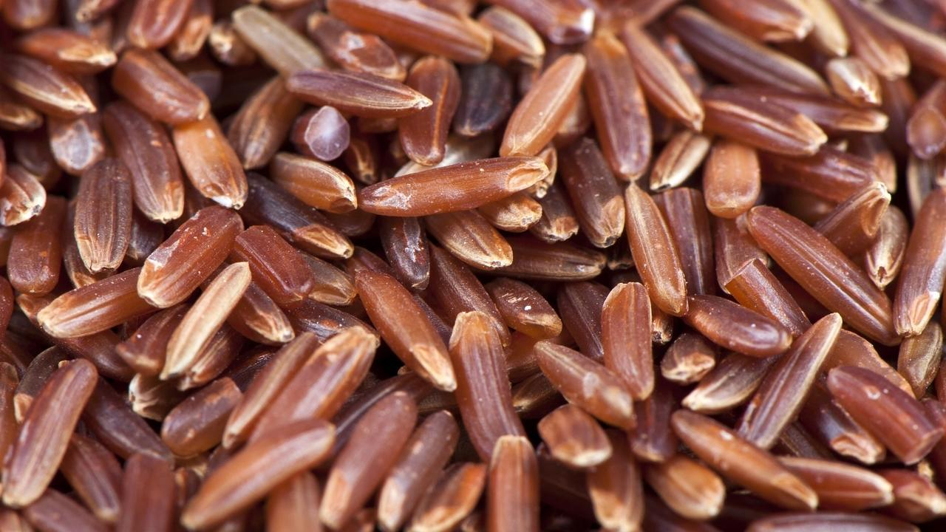

Red Rice is a variety of unpolished rice that retains the bran of the rice. The bran of the rice is rich in dietary fibre, phytonutrients, and other antioxidants. Whole grains such as redrice has a unique flavour and texture in addition to being healthy.

Here's how you can switch your polished grains with unpolished ones such as red rice.

## Whole Food Plant Based Red Rice Recipe

Course: Fundamental Recipe, Course 3: Grain Dish for Lunch & Dinner  
Cuisine: Indian  
Prep Time: 2 minutes  
Cook Time: 20 minutes  
Passive Time: 5 hours  
Servings: 2 servings

### INGREDIENTS

1. 1/2 cup Red Rice Raw
2. Water

### INSTRUCTIONS

1. Soak raw red rice in water overnight, or at least for 6 hours. If you don't have time to soak this, don't worry, just skip to the next step and increase cooking time by five minutes.
2. Boil red rice with double the quantity of water. Keep the lid half closed. Check from time to time. If water spills over, open lid some more for a few minutes, until some water evaporates. If rice is gettig burnt from lack of water, add more water. Once rice is nearly fully cooked, remove from stove and keep closed. Once it has cooled down completely, serve fresh with [chettinad paruppu urundai kuzhambu](https://www.nutritionscience.in/blog/chettinad-paruppu-urundai-kuzhambu-kulambu-recipe-whole-food-plant-based-diet-recipes)!

# 67.Carrot Tomato Soup Recipe | How to Make Carrot Soup | Whole Food Plant Based Recipes



Carrot soup, loved by children and adults alike! Soups are an amazing way to consume a lot of vegetables in one go. Very simple to prepare, carrot soup requires just a few ingredients. In this recipe, we have used just carrot, salt and pepper.

When cooking Naturopathic food, we experience the amazing taste of individual vegetables, which we don’t get to observe in dishes that are heavily spiced.

You could up the ante by adding just one herb or spice to this soup if you wish. If you have a child at home, ask the child to choose the herb! 🙂

When you are feeling creative, you could even make a cream of carrot soup. Simply mix in some cashew cream or peanut mylk after the soup is cooked

Time for some warm, soothing carrot soup!

### Whole Food Plant Based Carrot Tomato Soup Recipe

Course: Soup; Snack; Beverage; Breakfast  
Cuisine: Satwik French Recipe  
Prep Time: 5 minutes   
Cook Time: 10 minutes  
Servings 2 people

#### INGREDIENTS

2 medium sized Carrots  
3 Tomatoes  
2 tsp Miso Paste (Healthy Salt Alternative. See Nutrition Science Highlights below)  
1/2 tsp Cinnamon Powder  
1/2 tsp Black Pepper Powder  
Water as required

#### INSTRUCTIONS

1. If carrots have any dark spots, lightly peel only the spot. No need to peel carrot otherwise. Chop into large chunks. Remove the stem scar from tomatoes and chop into quarters. Boil chopped carrots with just enough water to cover them.
2. Once cooked, switch off the stove. Remove carrot and tomato pieces from the stock and let cool on a plate for a couple of minutes.
3. Blend cooked carrot and tomato with miso paste, cinnamon powder and black pepper powder. Mix with stock. Serve warm.

### Plant Based Chef Pro Tips for Best Carrot Tomato Soup Recipe

1. For more flavors, you can add coriander, curry leaves, mint, lemon grass, doddapatre, tulsi, basil, thyme, oregano, etc.
2. To make cream of carrot soup, add cashew cream or peanut mylk after the soup is cooked.

# 68.Pineapple Relish Recipe | Pineapple Recipes | Pineapple Benefits | Whole Food Plant Based Recipes



### Whole Food Plant Based Pineapple Relish Recipe

Course: Breakfast; Course 1 (Raw Dish) for Lunch & Dinner Meals; Snack; Salad  
Cuisine: Indian Recipe  
Prep Time: 10 minutes  
Servings: 2 people

### INGREDIENTS

4 cups Pineapple peeled & diced  
2 tbsp Cashews  
1 Onion  
5 cloves Garlic  
1/2 tsp Black Pepper Powder  
2 tsp Miso Paste (Healthy Salt Alternative. See Nutrition Science Highlights below)  
Juice of 1/2 Lemon

### INSTRUCTIONS

1. Peel and chop pineapple into 1 inch squares.
2. Peel onion. Chop into long slices. Peel and slice garlic.
3. Soak cashews overnight in water or at least for half an hour in hot water. Grind to a paste, with black pepper powder, miso paste, and lemon juice.
4. Mix all ingredients. Serve fresh!

### Plant Based Chef Pro Tips for Best Pineapple Relish Recipe

1. Garnish with raisins for bursts of flavour.
2. Garnish with coriander leaves for a fresh aroma.

# 69.Amte Kai Huli Recipe | Konkani Recipe | Whole Food Plant Based Recipes

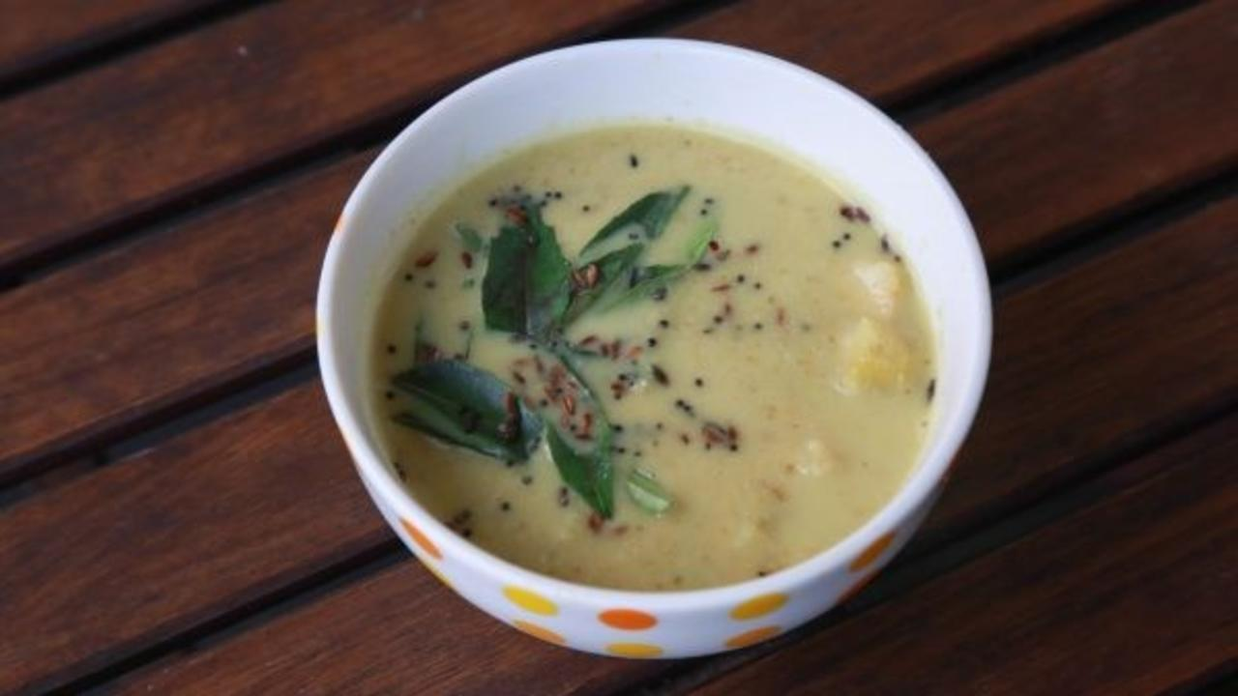

Amte kai huli! I’m sure you have tasted tomato saaru, even majjige huli. Have you tasted ambarella sour curry? It looks like a raw mango and tastes amazing!

Known by many names like Amte kai in Kannada, Ambade in Tulu, Ambado in Konkani, Ambarella or Hog Plum in English, this fruit is very popular in Asian, American and African countries. In India, it is used in chutney, pickles, soups and curry. Rich source of dietary fibre and Vitamin B complex!

Amte Kai Huli or Curry today is popularly garnished with an oil tadka. This is unnecessary and does not add any health benefit to the curry. Whole nuts are the best sources of oil. We have used whole coconut, and added it at the end to avoid cooking it, which reduces its health benefits.

This is a famous traditional curry recipe prepared with ambarella, coconut and selected spices for weddings in Coastal Karnataka. Red chili is popularly, used but we are replacing it with pepper, which is less of an irritant to the digestive tract and packs an equally spicy punch! 🙂

### Whole Food Plant Based Amte Kai Huli Recipe

Course: Side Dish for Course 3 (Grain Dishes) for Lunch & Dinner Meals  
Cuisine: Coastal Karnataka Recipe from South India  
Prep Time: 15 minutes   
Cook Time: 15 minutes  
Servings: 2 people

#### INGREDIENTS

5 Ambarella chopped  
1/2 tsp Turmeric Powder  
1/2 tsp Coriander Seeds Powder / Dhaniya Powder  
1/4 tsp Fenugreek Seeds / Methi  
1 tsp Whole Black Urad Dal  
1 tsp Bengal Gram Dal / Chana Dal  
1/2 cup Coconut grated  
1 tsp Black Sesame Seeds  
1/2 tsp Cumin Seeds Powder / Jeera Powder  
1/2 tsp Black Pepper Powder  
1 tbsp [Date Syrup](https://www.nutritionscience.in/blog/date-syrup-recipe-whole-food-plant-based)  
2 tsp Miso Paste (Healthy Salt Alternative. See Nutrition Science Highlights below)  
1 cup Water as required

##### Tadka / Seasoning / Tempering

1/2 tsp Mustard Seeds  
1 sprig Curry Leaves

#### INSTRUCTIONS

1. Wash, peel and chop ambarella into small pieces. Remove seeds if the fruit is not tender. Whole ambarella with skin removed can also be used.
2. Boil Amte Kai with a little water, turmeric powder, dhaniya powder,
3. Dry roast methi seeds and the two dals separately, stopping when they are slightly brown. Take care not to brown them too much. See Nutrition Science Highlights below for details.
4. Blend roasted methi and dals with coconut, black sesame seeds, jeera powder, black pepper powder, miso paste, and date syrup to a smooth paste.
5. Once ambarella is cooked well, turn off the stove. Add spiced coconut paste and close the lid. Let the coconut mixture absorb the sourness of ambarella.
6. Dry tadka or seasoning can be prepared with mustard seeds and curry leaves, by dry roasting them for a few seconds. Serve with unpolished rice, millet rice or rotis.

### Plant Based Chef Pro Tips for Best Amte Kai Huli Recipe

1. Slit green chili can be added for more spice!
2. Garnish with coriander leaves if you love them!
3. Amte kai can be replaced with raw mango or gooseberry (nellikai / amla) in case you don't find ambarella at a grocery store near you.

# 70.Olan Recipe with Ashgourd & Cowpeas | How to Make Olan | Whole Food Plant Based Recipes

### **Whole Food Plant Based Olan Recipe**

Course: Course 2 (Vegetable Dish) and Side Dish for Course 3 (Grain Dishes) at Lunch & Dinner Meals  
Cuisine: Kerala Recipe  
Prep Time: 15 minutes  
Cook Time: 20 minutes  
Servings: 4 people

#### **INGREDIENTS**

2 cups Ashgourd peeled & chopped  
1 cup Cowpeas  
1 Green Chili  
1 tsp Cumin Powder / Jeera Powder  
½ tsp Black Pepper Powder  
½ cup Coconut grated  
4tsp Miso Paste (Healthy Salt Alternative. See Nutrition Science Highlights below)  
10 Curry Leaves

#### **INSTRUCTIONS**

1. Soak cowpeas overnight. Start boiling with enough water to cover cowpeas fully.
2. In the meantime, peel ashgourd and reserve peel and seeds for ashgourd peel & seed chutney.
3. Chop ashgourd into large, bite-sized cubes. One cowpeas are half cooked, add chopped ashgourd and cook until both are fully cooked.
4. Grind coconut with jeera powder, black pepper powder, and miso paste. Mix into cooked ashgourd & cowpeas.
5. Garnish with curry leaves. Serve fresh!

**Plant Based Chef Pro Tips for Best Olan Recipe**

1. This is a very mild recipe, preferably served at the beginning of course 2, before other, more spicy, vegetable dishes.
2. Add ginger for a wider flavour profile.
3. Substitute cowpeas with black eyed peas for a differently colored olan.

# 71.Jowar Sweet Diamond Biscuits Recipe | Diwali Recipes | Whole Food Plant Based Recipes

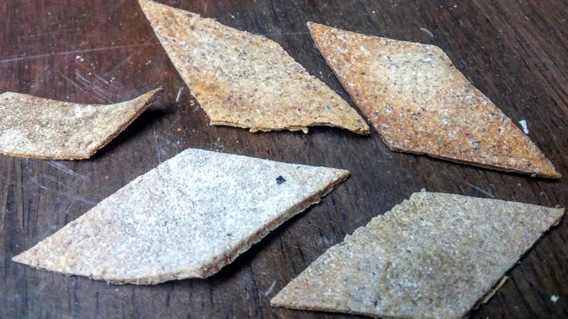

Shine bright like a diamond! Maybe not so bright, if you’re made from jowar – but absolutely yummy!

The problem with fried foods is, well, they are fried. First, we extract oil from a nut or seed, losing out on most of the nut’s nutrition. Then, we heat the oil to a high temperature, destroying what little nutrition remains in the oil. Then, we fry something in it. Have you ever tried burning a couple of banana chips? If you haven’t, do try it today. Be sure to hold the chips with a pair of tongs – and place a sheet of paper underneath to catch all the oil that drips from it!

How to make them healthier? Use an oven instead of a frying pan. And, replace oils with whole nuts. That’ll amp up the nutrient quotient significantly.

However, foods like biscuits, mixture, even when baked, are cooked at a high temperature and are very dry. Try eating them mindfully, you will find that you do not enjoy them as much as fresh food like fruits or vegetables – or even fresh nuts! Here’s a recipe that takes you closer to health. If you want to go all the way, enjoy a cup of fresh fruits and nuts instead! 🙂

### Whole Food Plant Based Diwali Jowar Sweet Diamond Biscuit Recipe

Course: Festival Dishes, Side Dish for Course 3 (Grain Dishes) at Lunch & Dinner Meals, Snacks  
Cuisine: Tamil Recipe from South India  
Prep Time: 15 min   
Cook Time: 30 min  
Servings: 4 people

#### INGREDIENTS

2 cups Jowar Flour  
2/3 cup Flaxseed  
1/2 cup [Date Syrup](https://www.nutritionscience.in/blog/date-syrup-recipe-whole-food-plant-based)  
Water

#### INSTRUCTIONS

##### Diwali Jowar Sweet Diamond Biscuit Dough

1. Grind flaxseed to a fine powder, then mix with jowar flour. Keep a little jowar flour aside for rolling out the dough.
2. Dilute date syrup with a little water, then heat to a boil and mix with jowar flaxeed powder mix. Knead till chapathi-dough-like consistency.

##### Biscuit cutting

1. Use some jowar flour to dust the kitchen counter and roll out dough to make large rotis of 2-3 mm thickness. Ensure that you have rolled it out evenly!
2. Use a knife to cut into the roti. Draw parallel lines 1 inch apart, from left to right, then diagonal line to make diamond shapes.

##### Baking Jowar Sweet Diamond Biscuit

1. Pre-heat oven to 160 degrees celsius
2. Line a baking tray with unbleached parchment paper or silicone sheet. Do not apply any oil on the paper or the tray.
3. Arrange the diamond shaped pieces on the parchment paper. Arrange them in a single layer.
4. Bake at 160 degrees celsius. Sweet diamond biscuits will be ready in 30 to 40 minutes depending on thickness. Turn over once at 20 minutes.

### Plant Based Chef Pro Tips for Best Jowar Diamond Biscuits Recipe

1. Substitute date syrup with salt and black pepper powder to make spicy diamond biscuits!

# 72.Jowar Roti Recipe | Roti Bakar | Sorghum Millet Flatbread | Whole Food Plant Based

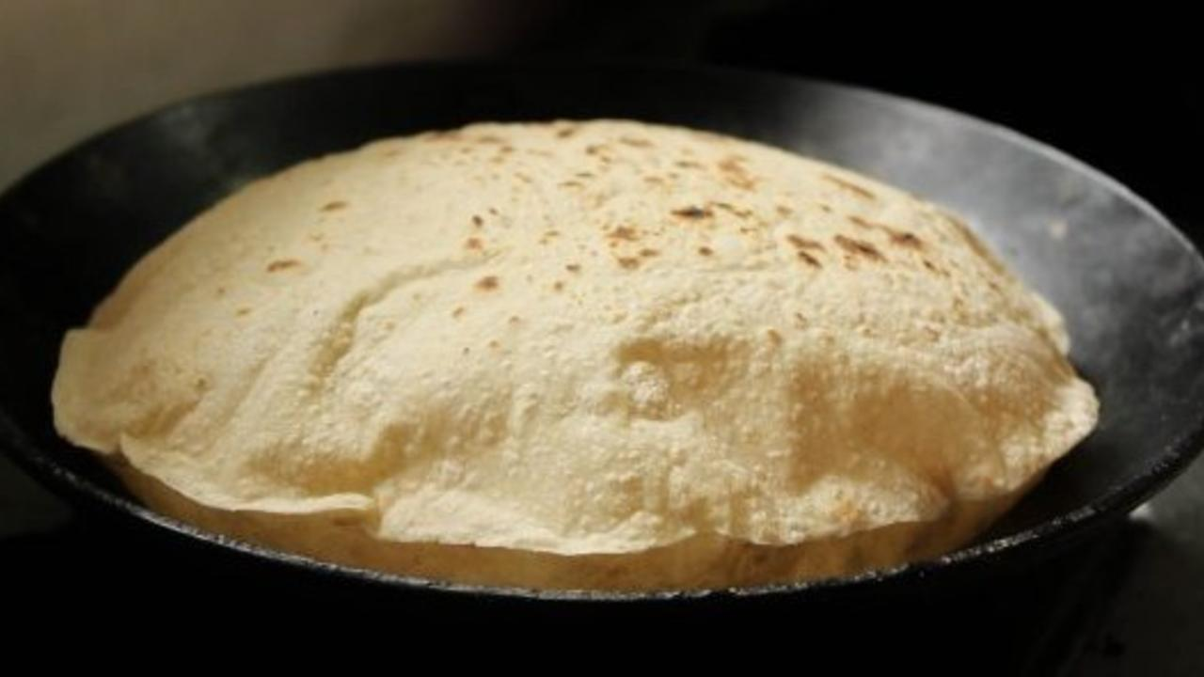

Jowar Roti is a gluten free Indian flatbread. This millet roti is extremely nutritious, affordable and easy to make. It is a staple cereal in many parts of the country, predominantly Rajasthan and parts of North Karnataka. Jowar like many millets are hardy crops and grow well in dry conditions making it a boon in hot dry areas.

Having a variety of whole grains like sorghum in our diet ensures that we have better nutrition and the new flavours and textures are a bonus.

Enjoy our whole food plant based Jowar Roti recipe and send us pictures of your experiments with them.

## https://s3.amazonaws.com/kajabi-storefronts-production/blogs/10455/images/gG4iPfZmRDmNdSPGaErd_Jowar_Roti_2.jpg

## Whole Food Plant Based Jowar Roti Recipe

Course: Course 3: Grain Dishes for Lunch & Dinner Meals  
Cuisine: Rajasthani, Udupi & North Karnataka Recipe from India  
Prep Time: 30 minutes  
Cook Time: 20 minutes  
Servings: 10 Jowar Rotis

### INGREDIENTS

1. 2 1/2 cups coarsely ground Jowar Flour (Sorghum Flour) for dough
2. 1/2 cup Flaxseed Powder (Ground up Flaxseeds)
3. 1 cup coarsely ground Jowar Flour (Sorghum Flour) for rolling out bajra rotis
4. Water as required

### INSTRUCTIONS

1. Boil 2 cups water.
2. Mix jowar flour with flaxseed powder and keep ready. Once water boils, slowly add water little by little into the flour mixture and mix well. Stop adding water once the flour comes together into a kneadable dough. The consistency must be soft but not sticky.
3. Knead for five to ten minutes. At the end, you should be able to make a ball without any breaks. If it breaks, add a little water and knead again. If it is too sticky, add some flour. The consistency should be perfect for the perfect roti.
4. Take a ping-pong ball sized piece of sorghum & flaxseed powder dough and roll it into a ball between your hands. Flatten into a thick disc.
5. Dust with sorghum flour and roll it out into a jowar roti with a rolling pin.
6. Heat a thick bottomed pan or tawa. It is hot enough when a bit of water dropped on the pan dances instead of evaporating immediately.
7. Dust off any extra flour from the sorghum flatbread, place it on the tawa and reduce flame to sim or medium. Close with a lid. After 30 to 60 seconds, once cooked, flip over. It is cooked on the first side if light brown spots have begun appearing. If the spots are large or dark brown, it has been overcooked. Tear off the dark parts and consume only the unbrowned parts.
8. After 20 to 30 seconds, take the roti / chapathi off the tawa. By now, small, light brown spots should have appeared on both sides and the roti / chapathi should have been fully cooked.
9. Wait for a few minutes until it cools down, then serve.

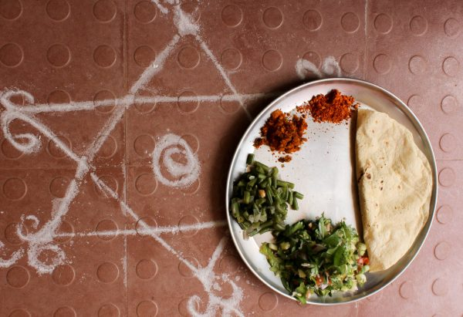

# 73.Uthappam Recipe | Dosa Recipe | Indian Dosa | Onion Uthappam Recipe | Whole Food Plant Based Recipes

 Enjoy yummy, filling, spiced lentil & wholegrain pancakes from Karnataka: Uthappam Dosa Recipe!

### Whole Food Plant Based Uthappam Recipe

Course: Course 3 (Grain Dish) for Lunch & Dinner Meals  
Cuisine: Karnataka Recipe from South India  
Prep Time: 15 minutes   
Passive Time: 6 hours  
Cook Time: 10 minutes  
Servings: 2 People

#### INGREDIENTS

1 cup Red Rice   
1/4 cup Urad Dal / Ulutham Paruppu  
1 tbsp Methi / Fenugreek Seeds  
1 Onion  
1/2 Green Chili  
1/4 cup Coriander Stems & Leaves chopped  
2 tsp Miso Paste  
1 tsp Asafoetida / Perunkaayam / Hing  
2 drops Sesame Oil to season tawa

#### INSTRUCTIONS

#### How to Make Uthappam Batter / Dosa Batter

1. Soak red rice, methi seeds, and urad dal separately, overnight or at least for 6 hours.
2. Using a wet grinder, grind urad dal to a thick paste with methi seeds, and just enough water, then add rice and grind until rice is ground to broken rice. Stop grinding and do not allow rice to be ground to a flour.
3. Peel and chop onions into small pieces. Chop coriander stems & leaves, and green chili into small pieces.
4. Mix chopped onions, coriander stems & leaves, chopped green chili, miso paste and asafoetida into uthappam batter.

#### How to Make Uthappam Batter / Dosa Batter

1. Spread one or two drops of oil on a clean, dry iron tawa to season it. No more oil is needed after this step to make uthappams. Heat the iron tawa / dosai kallu until a drop of water splashed on it dances around instead of evaporating immediately.
2. Spread a ladle of Uthappam Batter / Dosa Batter thickly on the iron tawa, about 5mm thick.
3. Once the batter on top dries out, turn it over and cook for a minute.
4. Once cooked on both sides, remove from stove and allow to cool completely, then serve uthappam fresh with chutney or [kokum knol kohl sambar](https://www.nutritionscience.in/blog/kokum-knol-kohl-recipe-kohlrabi-recipes-whole-food-plant-based-recipes)!

### Plant Based Chef Pro Tips for Best Uthappam Recipe

1. Uthappam Batter / Dosa Batter should be thicker than regular dosa batter, and uthappam dosa is thicker than regular dosa too.
2. Vegetables can be grated and mixed in, and so can green leafy vegetables, like amaranthus and drumstick leaves.

# 74.Pitla Recipe | Jhunka Gravy | Gram Flour Curry | Whole Food Plant Based

Jhunka is a traditional gravy recipe from North Karnataka and Maharashtrian cuisine, made with gram flour / besan. It is a creamy gravy that goes perfectly with warm Jowar roti or Bhakri.

There are two versions of jhunka. One is a gravy, which is also called Pithla in Maharashtra. The other is a soft fluffy vade which is set into small squares and is usually served with chutney. People serve it at weddings or festivals because it is quick and easy to make. It is also popular among the poorer classes as it is a cheap source of nutrition.

If you already make Jhunka at home, a quick glance at this recipe will tell you how to convert it to a healing one.

Upgrade to food that truly loves you back!

## Whole Food Plant Based Pitla Recipe

Course: Side Dish for Course 3: Grain Dishes at Lunch & Dinner Meals  
Cuisine: Karnataka Recipe, Maharashtra Recipe from South India  
Prep Time: 5 minutes  
Cook Time: 10 minutes  
Servings: 2 People

### INGREDIENTS

1. 1 cup Besan / Gram Flour
2. 2 tbsp Flaxseed Powder
3. 2 cups Water
4. 1/2 inch Fresh Ginger
5. 6 leaves Fresh Curry Leaves
6. 1 Green Chilli
7. 1/2 tsp Mustard Seeds
8. 1/2 tsp Cumin Seeds
9. 1 tsp Turmeric Powder
10. 1/2 tsp Black Pepper Powder
11. 3 tsp Miso Paste (Healthy Salt Alternative. See Nutrition Science Highlights below)
12. 2 tsp Fresh Grated Coconut
13. 2 tsp Fresh Coriander Leaves

### INSTRUCTIONS

1. Mix besan flour and flaxseed powder with enough water to form a really thick paste without any lumps. Mix well with the rest of the water to get thin dosa batter consistency and keep it aside.
2. Crush cumin seeds and ginger. Slit chili along its length. Add these to the besan paste along with curry leaves, turmeric powder, black pepper powder, and miso paste.
3. Dry roast mustard seeds in a wok or frying pan. Once roasted, start adding the besan paste to the pan slowly while stirring. Make sure the flame is low.
4. The paste should thicken as it cooks. Once it reaches a custard-like consistency, switch off the stove and garnish with some grated coconut and fresh coriander. Spread it out on a plate or wooden chopping board. It will thicken some more on cooling. Serve fresh!

### Expert Tips from our Plant Based Chefs

1. In North Karnataka homes, you may be admonished for not using onion! If ever you visit, save yourself by roasting onions with mustard seeds. Add a spoon or two of water roasting.

# 75.Yummy Yam Sabzi Recipe | Yam Recipe | Whole Food Plant Based Recipes

We all know that yam needs to be fried to be tasty, right? Well, that can easily be proved otherwise. Here is a lovely, yummy yam recipe you cannot ignore.

### Whole Food Plant Based Yummy Yam Sabzi Recipe

Course: Course 2 (Vegetable Dishes) at Lunch & Dinner Meals  
Cuisine: Tamil Recipe from South India  
Prep Time: 15 minutes   
Cook Time: 20 minutes  
Servings: 4 People

#### INGREDIENTS

1/2 kg Yam  
1/2 cup Peanuts  
1/2 cup Pudina Leaves  
2 pods Cardamom  
1 Green Chili  
1 tsp Turmeric Powder  
1/2 tsp Black Pepper Powder  
1/2 cup Fresh Coconut grated  
4 tsp Miso Paste (Healthy Salt Alternative. See Nutrition Science Highlights below)  
1 pinch Asafoetida (Perunkaayam / Hing)

#### INSTRUCTIONS

1. Dry grind the pudina, pudina leaves, cardamom, green chili, coconut, miso paste, asafoetida, and black pepper powder together to make coconut masala paste.
2. Dice the yam into cubes and boil in minimal water with peanuts and turmeric powder until well cooked and all the water evaporates. Alternatively, steam cook.
3. Switch off stove and allow to cool completely.
4. Mix in coconut masala paste and gently turn the mix around without breaking the cubes. Serve garnished with pudina leaves.

### Plant Based Chef Pro Tips for Yummy Yam Sabzi Recipe

1. Warning : Sometimes, yam can cause an allergic reaction. Cooking usually solves the issue. Once you cook this Sabzi, please check by eating one piece. If your mouth and throat itches, please do not eat it. Your hands itching while cutting is another sign that it could cause an allergic reaction on eating

. [Login](https://www.nutritionscience.in/login)

# 76.Kokum Knol Kohl Sambar Recipe | Kohlrabi Recipes | Whole Food Plant Based Recipes

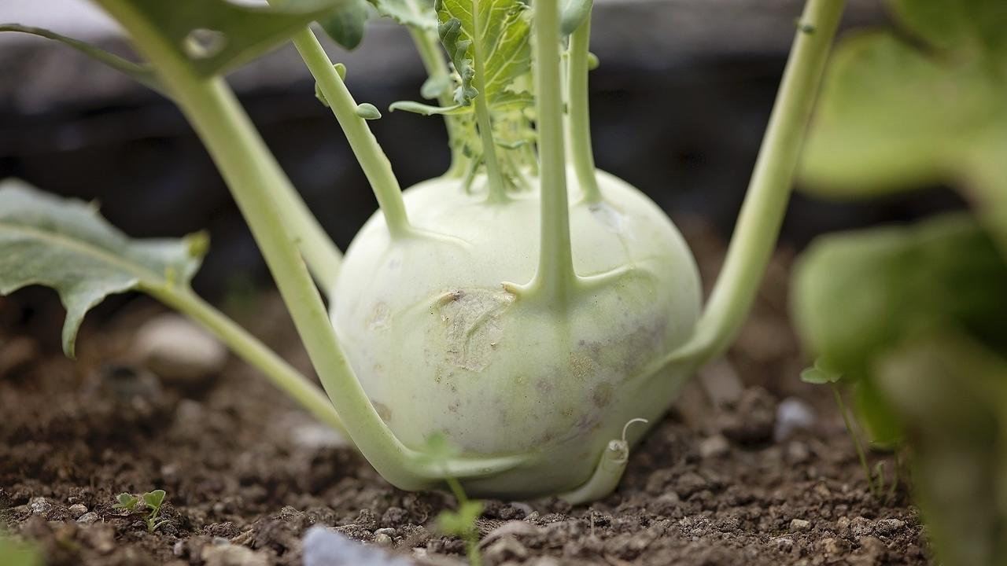

 Delicious, tangy, spicy kohlrabi sambar with kokum from the Western Ghats! Upgrade to Food that Truly Loves You Back!

### Whole Food Plant Based Kokum Knol Kohl Sambar Recipe

Course: Side Dish for Course 3 (Grain Dishes) for Lunch & Dinner Meals  
Cuisine: Tamil Recipe from South India  
Prep Time: 15 minutes   
Passive Time: 10 minutes  
Cook Time: 10 minutes  
Servings: 4 people

#### INGREDIENTS

##### Dal / Paruppu

1/2 cup Toor dal Pigeon Peas

##### Vegetable base

2 Knol Kohl  
2 Tomatoes  
6 dried fruits Kokum  
1 tsp Turmeric Powder  
To taste Asafoetida  
4 tsp Miso Paste (Healthy Salt Alternative. See Nutrition Science Highlights)  
2 Green Chili

##### Sambar Powder

2 tsp Bengal Gram Dal  
2 tsp Toor dal  
1/2 tsp Urad Dal  
1/2 tsp Fenugreek seeds / Methi seeds  
1 tsp Black Pepper  
1 tsp Jeera / Cumin seeds  
2 tsp Coriander Seeds / Dhaniya seeds  
10 leaves Curry Leaves  
1 tsp Mustard Seeds

##### Garnishing

1/2 cup Fresh Coconut  
1 small bunch Coriander plants

#### INSTRUCTIONS

##### Dal / Paruppu

1. Soak dal in water overnight, or for 2 - 3 hours. This makes iT more nutritious and easier to cook. If you are unable to soak it, no issues, use dry dal.
2. Boil dal with 1 cup water in a closed vessel. Stir every few minutes and add more water as the dal cooks if required, to prevent burning.
3. Once fully cooked, remove from stove and mash well.

##### Sambar Powder Recipe

1. Dry roast all the ingredients - dals, methi seeds, pepper, jeera, dhaniya and curry leaves - on low flame. If you wish to make it spicy, use 2 tsp of pepper powder. Use a small, thick-bottomed pan to prevent burning. To ensure that each one is roasted the right amount, roast each separately. Otherwise, put the dals and methi on the stove first, roast until half done, then add the other spices to roast fully. Remember, do not let any of the ingredients get burnt or browned too much.
2. Grind to a fine powder.
3. Dry roast mustard seeds. As soon it starts sputtering, mix into the powder. Keep aside to cook with vegetable base.

##### Vegetable Base for Kokum Knol Kohl Sambar

1. Wash and peel knol kohl. Chop into bite-sized 1-inch pieces. Grind tomatoes and kokum to a paste. Put them in an open vessel and cook.
2. Add the sambar powder you have prepared, turmeric powder, and asafoetida. Cook with a closed lid until the knol kohl is cooked well and the raw smell goes away. Add dal towards the end and mix well.

##### Kokum Knol Kohl Sambar Recipe

1. After the Kokum Knol Kohl sambar is cooked, remove from stove. Grind 1/2 cup fresh coconut to a smooth paste with miso paste and mix.
2. Add chopped coriander plants (leaves and stems) on top before serving. Serve with a cereal dish - rice, porridge, modakas, etc.

### Plant Based Chef Pro Tips for Best Kokum Knol Kohl Sambar Recipe

1. To try different varieties of Sambar, use amla / raw mango / lemon juice instead of tomato! Sourness gives Sambar its trademark taste!
2. If you wish to make the curry leaf flavour stand out, pinch some fresh curry leaves and drop them in.
3. If you wish to make it spicy, you can add one or two green chilis. Slit along one side and drop them in. This makes it easier to remove them while eating.
4. You could also try using some cinnamon in the sambar powder, or fresh herbs like pudina in the ground coconut garnish to give your own spin to the Sambar! Have fun! 🙂

# 77.Peanut Flaxseed Chutney Recipe | Peanut Butter | Whole Food Plant Based Recipes

## Whole Food Plant Based Peanut Flaxseed Chutney Recipe

Course: Side Dish for Course 3: Grain Dishes at Breakfast, Lunch & Dinner Meals  
Cuisine: Karnataka Recipe from South India  
Prep Time: 10 minutes  
Cook Time: 20 minutes  
Servings: 4 people

### INGREDIENTS

1 cup Peanuts  
1/4 cup Flaxseed  
10 cloves Garlic  
1 Amla / Nellikkai / Gooseberry  
2 tbsp Curry Leaves  
1 Red Chili  
1 cm piece Ginger  
1 tsp Black Pepper Powder  
1 tsp Jeera / Cumin Seeds  
4 tsp Miso Paste (Healthy Salt Alternative. See Nutrition Science Highlights below)

### INSTRUCTIONS

1. Grind flaxseeds to a fine powder.
2. Grind peanuts to a powder. Continue grinding, scraping down the sides once in a while, to make peanut butter.
3. Pour the peanut butter into a thick bottomed vessel with some water, mix, and bring to a boil. Ensure to keep stirring so it doesn't burn. Once the raw smell starts going away, add flaxseed powder and stir continuously until it gets a thick halwa consistency. Switch off stove.
4. Peel garlic and ginger. Chop amla and remove seed pods.
5. Grind or smash garlic to a paste. Keep aside for ten minutes, then proceed to next step.
6. Grind garlic paste with amla pieces, curry leaves, red chili, black pepper powder, jeera / cumin seeds, and miso paste. Mix into cooked peanut flaxseed mixture.
7. Stir fresh with dosa, idli, rice, or roti!

# 78.Hibiscus Tea Recipe | Afternoon Tea Without Sugar | Whole Food Plant Based Recipe

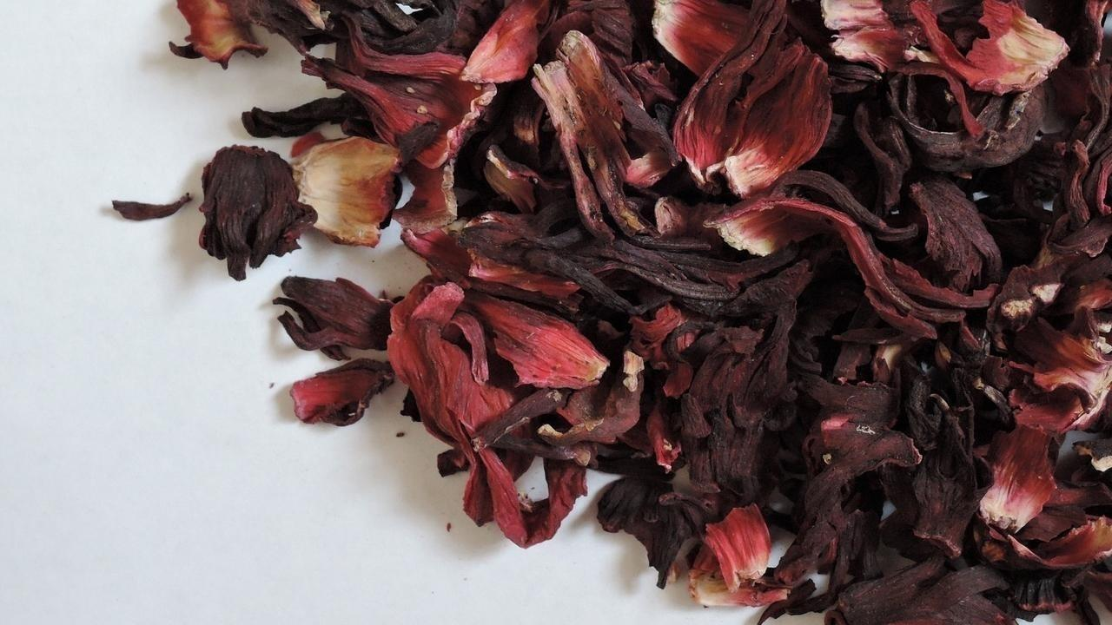

 Warm spiced hibiscus tea without sugar

### Whole Food Plant Based Hibiscus Tea Recipe

Course: Beverage, Snack, Herbal & Spice Tea  
Cuisine: Indian Recipe  
Prep Time: 1 minute  
Cook Time: 2 minutes  
Servings: 2 servings

#### INGREDIENTS

2 cups Water  
1/2 tsp Hibiscus Flower Powder  
2 tsp Raisins  
6 Almonds

#### INSTRUCTIONS

1. Heat water to a boil.
2. Chop raisins into 2-4 pieces each.
3. Remove boiling water from stove and mix in hibiscus flower powder and chopped raisins. Keep covered for 2 minutes, then serve fresh with a side of almonds!

# 79.Rose Tea Recipe | Afternoon Tea with the Rose Petals | Whole Food Plant Based Recipes

Uncategorized Dec 18, 2018



Indulgent Rose Tea to tickle your senses!

### Whole Food Plant Based Rose Tea Recipe

Course: Beverage, Snack, Herbal & Spice Tea  
Cuisine: Indian Recipe  
Prep Time: 1 minute  
Cook Time: 2 minutes  
Servings: 2 servings

#### INGREDIENTS

2 cups Water  
1/2 tsp dried Panir Rose Petals  
2 tsp Raisins  
6 Almonds

#### INSTRUCTIONS

1. Heat water to a boil.
2. Chop raisins into 2-4 pieces each.
3. Remove boiling water from stove and mix in dried panir rose petals and chopped raisins. Keep covered for 2 minutes, then serve fresh with a side of almonds!

# 80.Cream of Spinach Soup Recipe | Soup Recipe | Spinach Recipe | Whole Food Plant Based Recipes

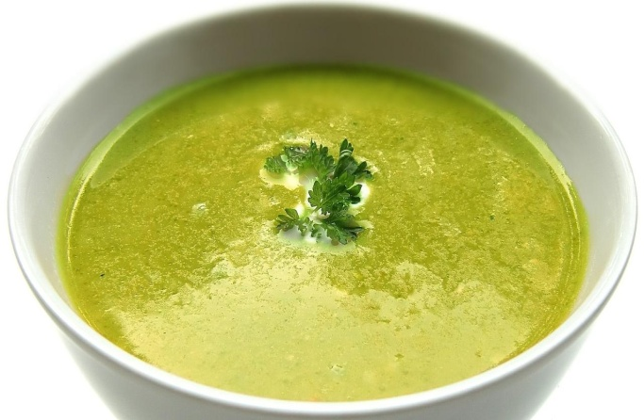

**Whole Food Plant Based Cream of Spinach Soup Recipe**

Course: Soup, Snacks, Breakfast  
Cuisine: British Recipe  
Prep Time: 10 minutes  
Cook Time: 10 minutes  
Servings: 2 People

**INGREDIENTS**

1 large bunch / 4 cups Spinach  
1 Onion  
5 cloves Garlic  
1/4 tsp Nutmeg Powder  
1 tsp Black Pepper Powder  
4 tsp Miso Paste (Healthy Salt Alternative. See Nutrition Science Highlights below)  
1 tsp Almond Butter  
1 tsp Parsley Leaves or Coriander Leaves  
Juice of 1 Lemon

**INSTRUCTIONS**

1. Chop off roots of spinach and chop spinach into large pieces. Peel and chop onion. Peel and crush or grind garlic to a paste and keep separately for ten minutes.
2. Cook spinach and onion with minimal water or steam until cooked, adding garlic once it has rested for ten minutes. (See Nutrition Science Highlights for details)
3. Cool completely, then blend with half of the almond butter, black pepper powder, miso paste, and lemon juice.
4. Dilute remaining almond butter with a little water to make almond cream. Garnish cream of spinach soup with almond cream and parsley or coriander leaves. Warm up if needed. Serve fresh!

**Plant Based Chef Pro Tips for Best Cream of Spinach Soup Recipe**

1. Use other herbs to garnish, such as thyme, basil leaves, curry leaves, and sage leaves for a wider range of flavours.
2. Add spices like cinnamon, star anise, or bay leaves while cooking spinach for a stronger flavor.

# 81.Garlic Rasam Recipe | Garlic Benefits with Minced Garlic | Poondu Rasam | Whole Food Plant Based Recipes

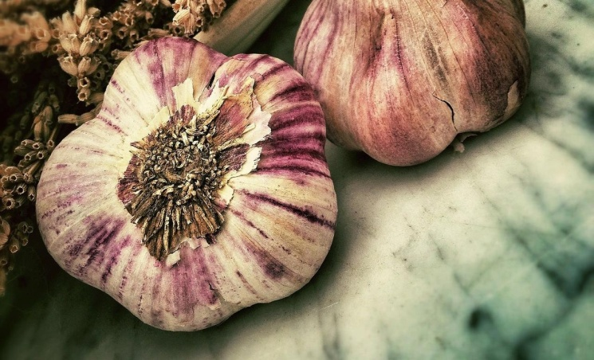

Warm, spiced garlic rasam to wake your senses and leave you feeling refreshed. Upgrade to food that truly loves you back!

### Whole Food Plant Based Garlic Rasam Recipe

Course: Side Dish for Course 3 (Grain Dishes) for Lunch & Dinner Meals, Festival Dishes, Soup, Beverage  
Cuisine: Tamil Recipe from South India  
Prep Time: 15 minutes   
Cook Time: 10 minutes  
Servings: 4 people

#### Ingredients

##### Garlic Rasam Powder / Poondu Rasam Podi

1 cup Dhaniya / Coriander Seeds  
1/2 cup Toor Dal / Split Pigeon Pea  
1/4 cup Black Pepper  
1/4 cup Jeera / Cumin Seeds  
1/2 cup Curry Leaves  
5 heads Garlic  
1/8 cup Turmeric Powder  
1 tbsp Asafoetida / Hing / Perunkaayam

##### Garlic Rasam / Poondu Rasam

2 Large Tomatoes chopped  
4 tsp Miso Paste (Healthier Salt Alternative. See Nutrition Science Highlights below)  
4 cups Water as required

##### Seasoning or Tadka

1 sprig Curry Leaves  
1/4 cup Coriander leaves chopped  
1 tbsp [Almond Butter](https://www.nutritionscience.in/blog/almond-butter-recipe-whole-food-plant-based)

#### Instructions

##### Garlic Rasam Powder Recipe

1. Dry roast toor dal on low flame until lightly browned. Do not allow to brown too much. See Nutrition Science Highlights for Garlic Rasam below for details.
2. Grind garlic to a smooth paste and keep aside for ten minutes.
3. Once garlic has rested for ten minutes, grind all ingredients together into a fine powder.

##### Garlic Rasam Recipe

1. Blend tomatoes into a smooth paste. Cook until done. Add water and 2 tbsp of Garlic Rasam Powder / Poondu Rasam Podi, and heat to a boil.
2. Switch off stove and mix in miso paste, curry leaves, coriander leaves, and almond butter.
3. Serve fresh with red rice!

### Plant Based Chef Pro Tips for Best Garlic Rasam Recipe

1. Adjust the spice and sourness as needed.
2. If you want a tadka, you could dry roast mustard and add to garlic rasam!

# 82.Manga Thuvaiyal Recipe | Raw Mango Chutney Recipe | Whole Food Plant Based Recipes

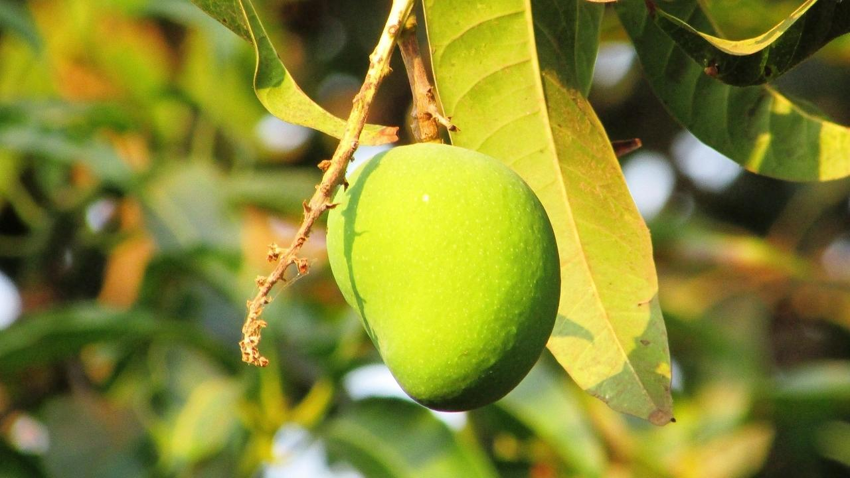

Super yummy, tangy manga thuvaiyal recipe

### Whole Food Plant Based Manga Thuvaiyal Recipe

Course: Chutneys, Side Dish for Course 3 (Grain Dishes) at Lunch & Dinner Meals  
Cuisine: Tamil Recipe from South India  
Prep Time: 15 minutes   
Servings: 4 People

#### Ingredients

1/2 Raw Mango  
2 tsp Urad Dal (Uluthamparuppu / uddina bele)  
2 tsp Bengal Gram Dal (Kadalai Paruppu / Kadlebele)  
20 leaves Curry Leaves (Karuvepelai / karibevu soppu)  
1/2 cup Fresh Coconut  
1/2 tsp Cumin Seeds Jeera  
1/4 tsp Black Pepper  
1 small Green Chili  
1 pinch Asafoetida (Perunkaayam / Hing)  
4 tsp Miso Paste (Healthy Salt Alternative. See Nutrition Science Highlights below)

#### Instructions

1. Dry roast each of the dals separately, taking care not to let them brown too much or get burnt. See Nutrition Science Highlights for WFPB Manga Thuvaiyal below for details.
2. Chop raw mango (without seed) into small enough pieces to grind in a mixie.
3. Cut coconut into small pieces.
4. Grind all the ingredients together in a mixie, with water as required. Thick manga chutney is our personal favourite, with just a little water.

# 83.Jowar Gujiya Recipe | Dumpling Recipe | Dumplings Recipe | Whole Food Plant Based Recipe



Gujiya or Karjikai is a super traditional, deep fried, half moon dumpling recipe, made with maida today. Here’s a baked, zero oil, sorghum millet version of gujiya that is irresistible in its own right!

This crescent shaped pastry has a sweet filling made out of lentils, nuts and jaggery, and every region in India has its own version. Every culture, too! You could even make karjikai of different shapes, like modaka or kozhukattai. Regardless of the shape, the first thing you think of, when you think of gujiya, is the crispy and crunchy outer shell with a sweet yumminess oozing out with every bite.

This dessert reminds us of the days before the Ganesha Chaturthi festival, when my mothers would shop for all the ingredients we need for gujiya, patholi, and ellu undes or til laddoos, and we would watch her preparing karjikai on the day before the festival, as an offering for the deity.

#### Gujiya Recipe: an offering that adds to your health with every bite!

We thought, why not make a healthy, guilt free version of everyone’s Ganesh Charturthi favorite recipe? Tada! Here’s a healthy twist with the goodness of Sorghum and sweet peanut stuffing, with not even a single drop of oil!

### Whole Food Plant Based Jowar Gujiya Recipe

Course: Dessert in Course 3 (Grain Dishes) at Lunch & Dinner Meals, Festival Dishes, Millet Dishes, Snacks, Sweets  
Cuisine: Indias Recipe  
Prep Time: 30 minutes   
Cook Time: 30 minutes  
Servings: 4 Baked Jowar Gujiya

#### Ingredients

##### Gujiya Dough

1 1/4 cup Jowar Atta / Sorghum Flour  
1/4 cup Flaxseed Powder  
1/8 tsp Turmeric Powder  
Water as required

##### Gujiya Stuffing

1/2 cup Groundnuts  
1/4 cup Roasted Bengal Gram / Hurgadle  
2 tsp Poppy Seeds  
2 tsp Black Sesame  
1 cup Date Syrup  
1/4 tsp Cardamom Powder / Elaichi Powder

#### Instructions

##### Gujiya Dough

1. Mix five parts jowar flour and one part flaxseed powder with turmeric powder to make gujiya flour. Boil 1.5 cups of water. When it starts boiling, add gujiya flour. Mix well and cook for two minutes until it comes together as a dough. Add more gujiya flour if needed. Switch off the stove. Knead well to make a smooth dough.
2. You should be able to make a ball without any breaks. If it breaks, add a little water and knead again. If it is too sticky, add some flour. Cover the kneaded dough with a damp cloth while the stuffing gets ready, to avoid losing moisture from dough and letting it develop cracks.

##### Gujiya Stuffing

1. Dry poppy seeds.
2. Heat date syrup while stirring constantly to allow the water to evaporate. Alternatively, grind soft dates to make a thick paste, or use date sugar.
3. Blend roasted gram dal, peanuts, sesame seeds, cardamom powder, poppy seeds, and elaichi powder to a coarse powder. Mix into concentrated date syrup. Use 1-2 tsp of this as stuffing.

##### How to Make Gujiya Recipe

1. Take a small lemon sized piece of dough and make a ball with it between your palms. Roll it flat, into a small Poori or Tortilla.
2. Place 1 to 2 tsp of stuffing on one side of the rolled tortillas and brush the edges with water so that you can form a crescent shaped dumpling (half moon / semicircle). If you have a dumpling mould available, use it to make the dumpling.
3. Once you fold it, press the edges to give shape either with hands or forks so that it sticks together and stuffing does not come out of it, until is well sealed. Repeat the same procedure with the rest of the dough and stuffing.
4. Preheat the oven to 160 deg C. Place the prepared dumplings on a baking tray lined with unbleached parchment paper or silicone sheet, and bake for 30-35 minutes at 160 degrees C.
5. Keep checking to make sure it doesn't get burnt. Over baking may result in stuffing getting burnt inside.
6. Enjoy these yummy and healthy dumplings!

### **Plant Based Chef Pro Tips for Best Gujiya Recipe**

1. If the gujiya shell becomes too dry, try adding a higher proportion of flaxseed powder to the mix.
2. If the stuffing is too wet, try using date sugar instead of date syrup.

# 84.Tofu Amaranthus Gravy Recipe | Whole Food Plant Based Recipes

## Tofu Amaranthus Gravy Recipe

Course: Course 2: Vegetable Dish for Lunch Meal, Side dish for Course 3: Grain Dishes  
Cuisine: North Indian Recipe  
Prep Time: 20 minutes  
Cook Time: 20 minutes  
Servings: 4 servings

### INGREDIENTS

#### Main Ingredients

1. 1 cup Tofu

#### Tofu Amaranthus Gravy

1. 2 cups Amaranthus Leaves & Stems Chopped
2. 1 Tomatoes
3. 1/2 Onion red
4. 1/2 Green Chili
5. 1 tbsp Date Syrup

#### Tofu Amaranthus Masala Mix

1. 1/2 cup Cashews soaked
2. 1/4 tsp Cumin Seeds / Jeera Powder
3. 1/4 tsp Coriander Seeds / Dhaniya Powder
4. 1/4 tsp Black Pepper Powder
5. 1 Clove
6. 1 cm piece Cinnamon
7. 1/2 tsp Turmeric Powder
8. 1 Green Cardamom
9. 1/8 tsp Fenugreek / Methi Seeds
10. 4 tsp Miso Paste Healthy Salt Alternative
11. 2 tbsp Coriander Leaves Chopped

### INSTRUCTIONS

1. Chop tofu into squares and steam or boil until cooked.
2. Grind all masala ingredients together until smooth. Keep aside.
3. Grind all gravy ingredients together until smooth and cook in a saucepan or thick bottomed kadai / wok until well cooked.
4. Once cooked, remove from stove, mix in spice mix and vegetables. Garnish Tofu Amaranthus Gravy with fresh coriander leaves and serve fresh!

# 85.Methi Sprout Chaat Recipe | Aloo Chaat | Chaat Recipe | Whole Food Plant Based Recipes

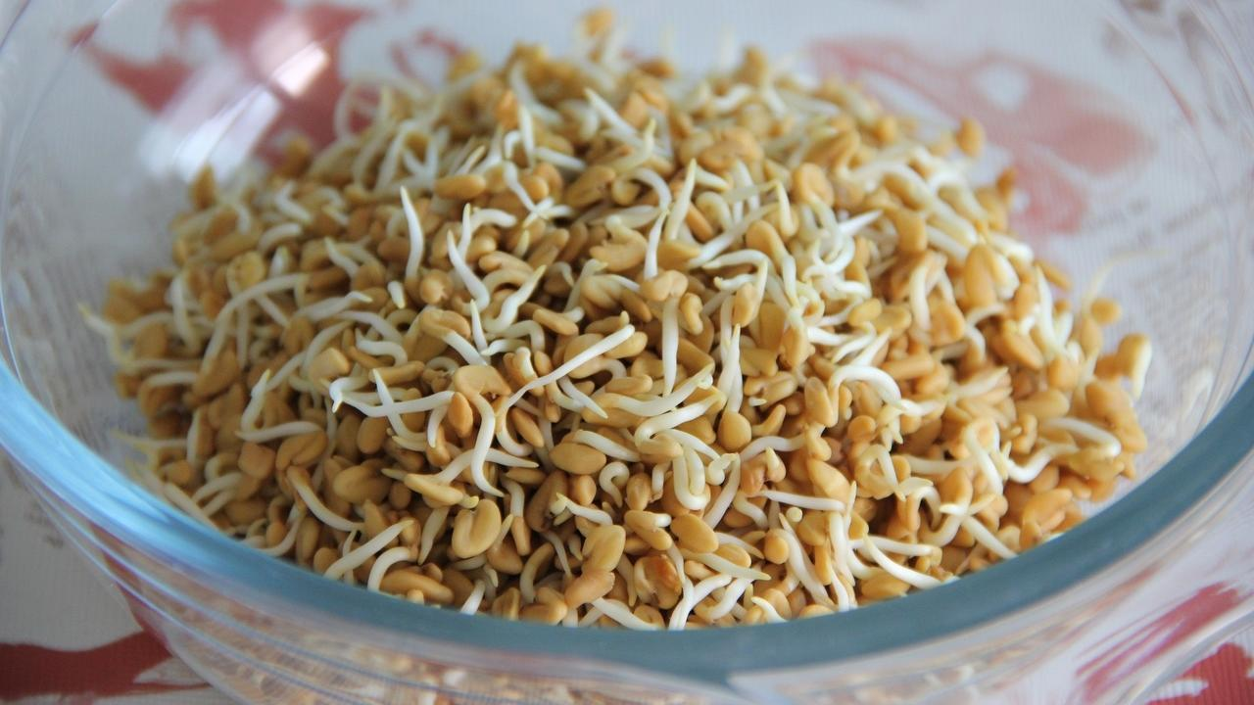

### **Whole Food Plant Based Methi Sprouts Aloo Chaat Recipe**

Course: Salad, Snacks, Course 1 (Raw Dish) for Lunch & Dinner Meals  
Cuisine: North Indian Recipe  
Prep Time: 20 minutes  
Passive Time: 20 minutes  
Servings: 4 People

#### **INGREDIENTS**

2 Potatoes  
2 Tomatoes  
2 Onions  
1 Carrot  
1/4 cup Methi / Fenugreek Seeds  
1/4 cup Pomegrate Arils, from 1/2 Pomegranate  
1 tbsp Almonds  
2 tbsp [Green Chutney](https://www.nutritionscience.in/blog/green-chutney-recipe-coriander-pudina-chutney-recipe-whole-food-plant-based-recipes)  
1 tbsp [Date Syrup](https://www.nutritionscience.in/blog/date-syrup-recipe-whole-food-plant-based)  
1/2 tsp Black Pepper Powder  
Juice of 1 Lemon  
1/4 cup Coriander Stems & Leaves chopped

#### 

#### **INSTRUCTIONS**

1. Soak methi overnight. Hang up in a cotton cloth or keep in a vessel with holes to sprout for 12 to 24 hours.
2. Wash potatoes well. Chop into quarters and steam until cooked.
3. Peel onions. Chop onions and tomatoes into small pieces. Grate carrot.
4. Mix all ingredients together. Garnish with chopped coriander leaves & stems to make Methi Sprouts Aloo Chaat. Serve fresh!

### **Plant Based Chef Pro Tips for Best Methi Sprouts Aloo Chaat Recipe**

1. Methi loses its bitterness once sprouted. However, if it is still bitter, use a smaller quantity of methi sprouts in this methi sprout aloo chaat *recipe.*

# 86.Jeera Rice Recipe with Basmati Brown Rice | Whole Food Plant Based Recipes

Delicious Jeera Rice Recipe without a single drop of oil!

### Whole Food Plant Based Burnt Garlic Fried Rice Recipe

Course: Course 3: Grain Dish for Lunch & Dinner Meals  
Cuisine: North Indian Recipe  
Prep Time: 2 minutes   
Cook Time: 30 minutes  
Servings: 4 people

#### INGREDIENTS

1 cup Basmati Brown Rice soaked  
2 tsp Jeera / Cumin Seeds  
1 tsp Urad Dal / Split White Lentil  
10 Curry Leaves  
1/2 Green Chili  
1/2 tsp Black Pepper Powder  
4 tsp Miso Paste (Healthy Salt Alternative. See Nutrition Science Highlights below)

#### INSTRUCTIONS

1. Soak 1 cup basmati brown rice for 30 minutes. Cook it with 2 cups water until it is soft but not over cooked. Spread it out on a large plate so it doesn't become sticky. Let it cool fully.
2. In the meantime, dry roast urad dal on low flame until just done.  Ensure that it does not darken. See Nutrition Science Highlights below for details.
3. Slit green chili into two long pieces. Dry roast until raw smell goes away. Dry roast jeera with chili for a few second until it start sputtering, then mix with cooked rice, along with roasted urad dal, chili, black pepper powder, and miso paste. Mix well, taking care not to mash the rice. Garnish with curry leaves. Serve fresh!

### Plant Based Chef Pro Tips for Best Jeera Rice Recipe

1. Jeera Rice is best served with [Tofu Amaranthus Gravy](https://www.nutritionscience.in/blog/tofu-amaranthus-gravy-recipe-whole-food-plant-based-recipes)!

# 87.Paruppu Keerai Kootu Recipe | Purselane Lentil Stew | Whole Food Plant Based Recipes

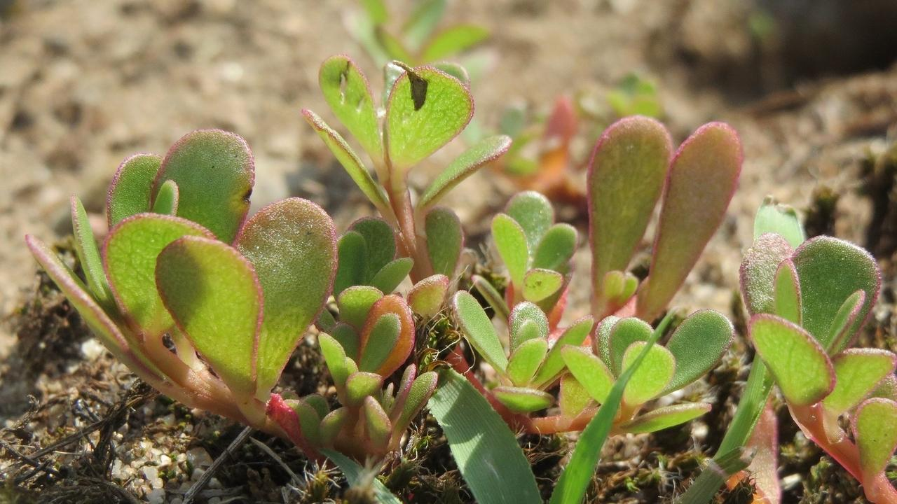

## Whole Food Plant Based Paruppu Keerai Kootu Recipe from Tamil Nadu

Course: Course 2: Vegetable Dish / Side dish for Lunch & Dinner Meals  
Cuisine: Tamil Recipe from South India  
Prep Time: 10 minutes  
Cook Time: 30 minutes  
Servings: 2 people

### INGREDIENTS

1. 2 cups or 1 bunch Paruppu Keera leaves
2. 1/4 cup Moong Dal Green Gram Dal / Paasi Paruppu / Paithamparuppu /
3. 1 tbsp Peanuts

#### Kootu Masala

1. 1/4 cup Coconut Grated
2. 1 tsp Urad Dal / Black Gram Dal / Ulutham Paruppu / Uddina Bele
3. 1 tsp Pepper Powder
4. 1/2 tsp Tumeric Powder
5. 2 tsp Miso Paste (Healthy Salt Replacement. See Nutrition Science Highlights below)
6. 1 Lemon
7. 10 Curry Leaves
8. 1 tsp Mustard Seeds

### INSTRUCTIONS

#### Kootu Masala

1. Dry roast urad dal until light brown. Do not allow to darken or burn. Remove from stove and keep aside.
2. Dry roast mustard until it begins sputtering. As soon as it starts sputtering, switch off stove and transfer to a cup.
3. Grind all masala ingredients (except mustard seeds) into a paste, then mix mustard seeds into it.

#### How to make Thandu Keerai Kootu

1. Preferably, soak moong dal and peanuts overnight or at least for 4-5 hours. Take soaked moong dal and peanuts in a vessel, add enough water to cover the dal and start cooking with a partially closed lid.
2. Cut off roots and chop paruppu keerai / common purselane leaves into small pieces. Add to the moong dal after about ten minutes of cooking. Stir from time to time and add water if required. The final consistency should be a thick, pourable liquid. While this is cooking, you can prepare the kootu masala as outlined above.
3. Once dal and greens are fully cooked, switch off stove and mix in masala. Garnish with curry leaves. Serve fresh!

# 88.Chow Chow Recipe | Squash Chayote Poriyal Recipe | Whole Food Plant Based Recipes

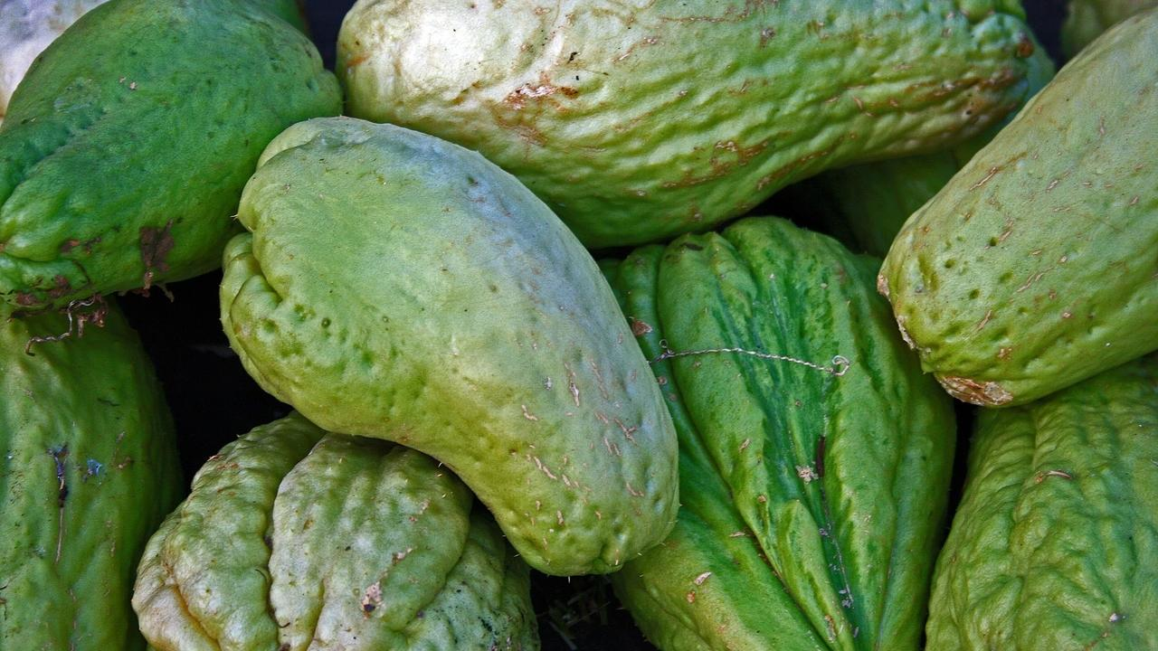

Delicious, satisfying chow chow recipe from South India

### Whole Food Plant Based Chow Chow Poriyal Recipe

Course: Course 2 (Vegetable Dish) for Lunch & Dinner Meals  
Cuisine: Tamil Recipe from South India  
Prep Time: 15 minutes   
Cook Time: 20 minutes  
Servings: 2 People

#### INGREDIENTS

2 Chow Chow / Chayote / Bangalore Brinjal  
1 Green Chili  
1 cm piece Ginger  
1 Onion  
1 tbsp Chana Dal / Kadalai Paruppu  
1 tsp Jeera / Cumin Powder  
1/2 tsp Black Pepper Powder  
2 tsp Miso Paste (Healthy Salt Alternative. See Nutrition Science Highlights below)  
1 pinch Asafoetida / Perunkaayam / Hing  
1/4 cup Fresh Coconut grated

#### INSTRUCTIONS

1. Wash chow chow / chayote, remove peel and chop finely. Peel and chop onion finely. Slit green chili along its length. Peel and chop ginger finely.
2. Dry roast chana dal without letting it burn or brown too much. Once roasted enough, add chopped chow chow with 1 tbsp water, along with chopped onions, chili, and ginger.
3. Keep an eye on the chow chow poriyal and stir once in a while so it doesn't get burnt.
4. Once cooked, remove from stove. Mix in jeera powder, black pepper powder, miso paste, asafoetida / perunkaayam / hing, and grated coconut.

### Plant Based Chef Pro Tips for Chow Chow Recipe

1. Ensure to stir every few minutes to prevent burning!

# 89.Keerai Poriyal Recipe | Spinach Recipe | Whole Food Plant Based Diet Recipes

### Whole Food Plant Based Keerai Poriyal Recipe

Course: Course 2 (Vegetable Dish) for Lunch & Dinner Meals  
Cuisine: Tamil Recipe from South India  
Prep Time: 15 minutes   
Cook Time: 20 minutes  
Servings: 2 People

#### INGREDIENTS

1 bunch OR 2 cups Palak / Spinach Greens  
1 Green Chili  
1 cm piece Ginger  
1 Onion  
1 tbsp Chana Dal / Kadalai Paruppu  
1 tsp Jeera / Cumin Powder  
1/2 tsp Black Pepper Powder  
2 tsp Miso Paste (Healthy Salt Alternative. See Nutrition Science Highlights below)  
1 pinch Asafoetida / Perunkaayam / Hing  
1/4 cup Fresh Coconut grated

#### INSTRUCTIONS

1. Wash the spinach well and chop finely. Peel and chop onion finely. Chop tomatoes finely. Slit green chili along its length. Peel and chop ginger finely.
2. Dry roast chana dal without letting it burn or brown too much. Once roasted enough, add chopped palak with 1 tbsp water, along with chopped onions, chili, and ginger.
3. Keep an eye on the keerai poriyal and stir once in a while so it doesn't get burnt.
4. Once cooked, remove from stove. Mix in jeera powder, black pepper powder, miso paste, asafoetida / perunkaayam / hing, and grated coconut.

### Plant Based Chef Pro Tips for Keerai Poriyal Recipe

1. Ensure to stir every few minutes to prevent burning!

# 90.Apple Pomegranate Salad | Fruit Salad Recipe | Whole Food Plant Based Recipes

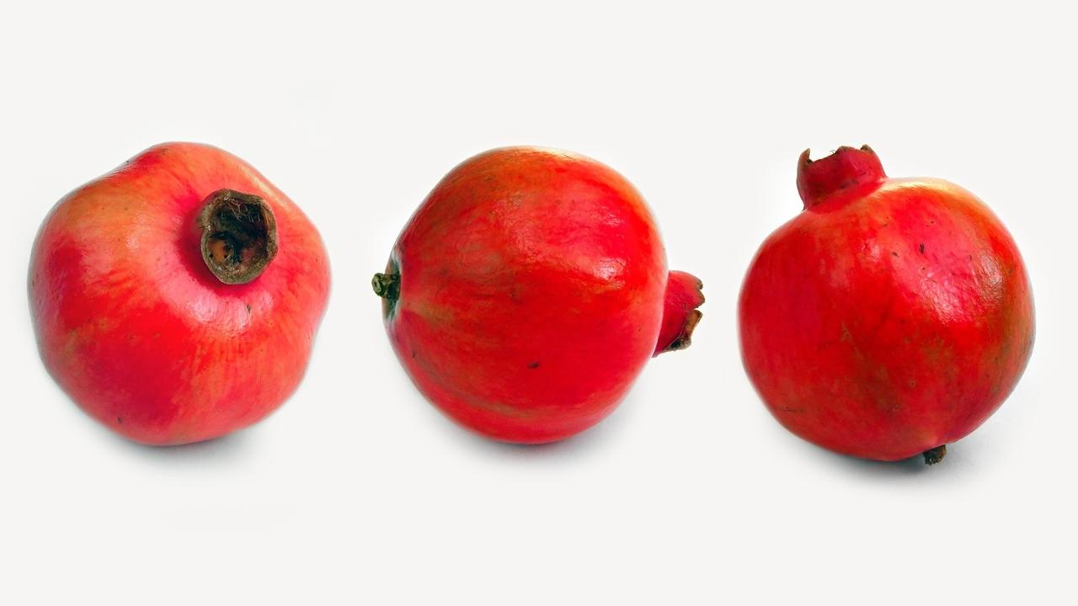

### Whole Food Plant Based Apple Pomegranate Salad Recipe

Course: Course 1 (Raw Dish) for Breakfast, Lunch & Dinner Meals; Snack; Salad  
Cuisine: Satvik Recipe  
Prep Time: 10 minutes   
Servings: 2 people

#### INGREDIENTS

2 Apples  
1 Pomegranate  
1/4 cup Raisins  
1 tbsp Almonds  
1/2 tsp Cinnamon Powder

#### INSTRUCTIONS

1. Chop apples into four quarters. Remove stalk and core. Chop into bite sized pieces.
2. Using a sharp knife, cut lines into the pomegranate skin, drawing large circles around the top and bottom. Then, cut vertical lines along the bulges on the sides. After this, you should be able to remove the sections of the pomegranate easily.
3. Coarsely chop almonds.
4. Mix all ingredients together. Serve fresh!

### Plant Based Chef Pro Tips for Best Apple Pomegranate Salad Recipe

1. Ensure to serve fresh, otherwise apple will get oxidised and brown.

.

# 91.Masala Matcha Green Tea Recipe | Matcha Tea Recipe | Whole Food Plant Based Recipes

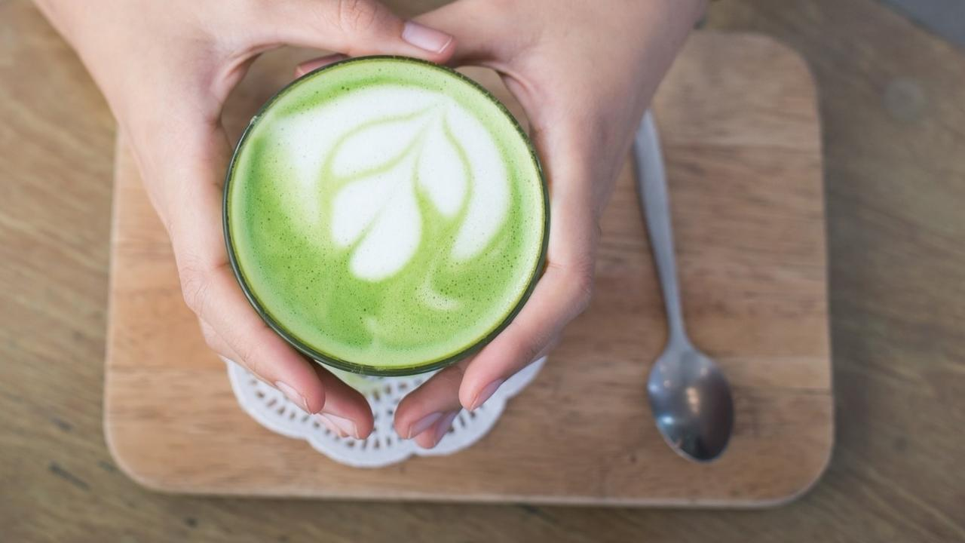

Spiced, aromatic, warm matcha green tea. The perfect drink for a cold afternoon!

### Whole Food Plant Based Masala Matcha Green Tea Recipe

Course: Beverages, Snacks, Herbal & Spice Tea  
Cuisine: Kashmiri Recipe from North India  
Prep Time: 2 minutes  
Cook Time: 2 minutes  
Servings: 2 people

#### INGREDIENTS

##### Masala Matcha Green Tea Powder

1. 1 tsp Matcha Green Tea Powder OR 2 tsp Green Tea Leaves
2. 1 inch piece Cinnamon
3. 1 Star Anise
4. 1 Green Cardamom / Elaichi Peeled
5. 1 tbsp Raisins
6. 6 Walnuts

#### INSTRUCTIONS

##### Masala Matcha Green Tea Powder

1. Peel green cardamom / elaichi. Grind elaichi, cinnamon, star anise, and matcha green tea together into a very fine powder.

##### Masala Matcha Green Tea

1. Chop raisins into two to four pieces each.
2. Heat 2 glasses of water in a vessel. Once it starts boiling, remove from stove, add 1/2 to 1 tsp of Masala Green Tea powder, along with chopped raisins. Mix well and cover for 3 minutes.
3. Once infused, allow to cool to a warm temperature.
4. Serve warm, not too hot, with a side of walnuts!

# 92.Green Chutney Recipe | Coriander Pudina Chutney Recipe | Whole Food Plant Based Recipes

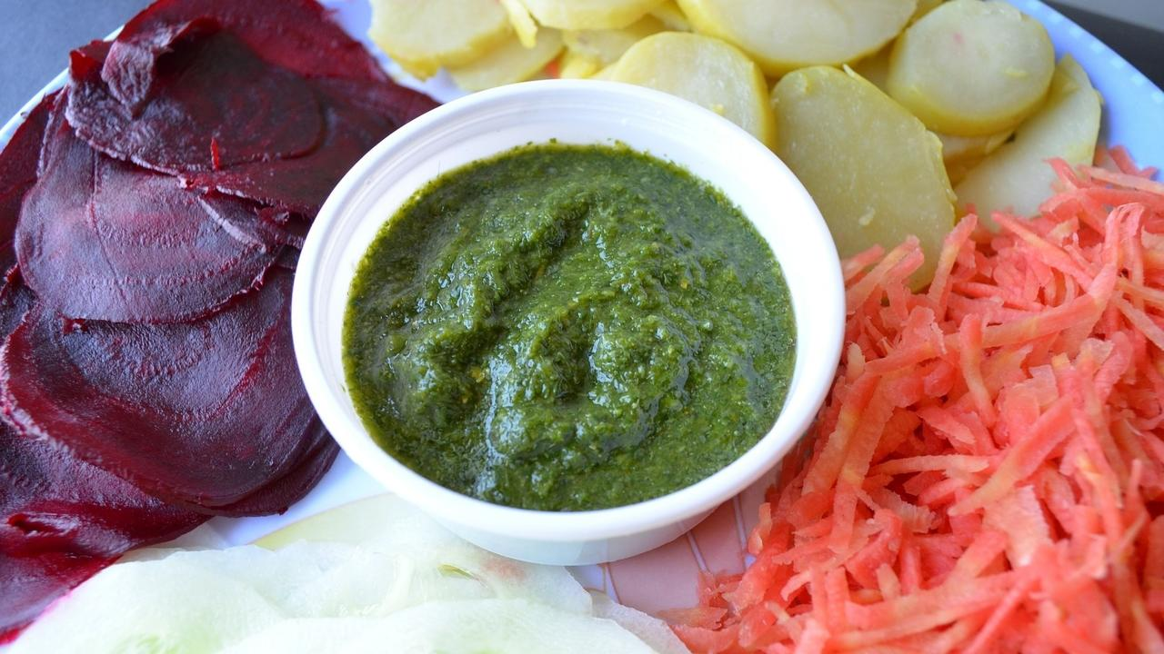

Spicy, tangy, and super flavoursome!

### Whole Food Plant Based Green Chutney Recipe

Course: Chutneys, Side Dish for Course 3: Grain Dishes at Lunch & Dinner Meals  
Cuisine: Indian Recipe  
Prep Time: 10 minutes   
Servings: 4 people

#### INGREDIENTS

1/2 bunch or 1 cup Coriander Stems & Leaves  
1/2 bunch or 1 cup Pudina / Mint Leaves  
1/2 Onion  
1 cm piece Ginger  
1 tsp Black Pepper  
2 tsp Miso Paste (Healthy Salt Alternative. See Nutrition Science Highlights below)  
2 tbsp Coconut grated  
Juice of 1/2 lemon  
1 pinch Asafoetida / Hing  
Water as required

#### INSTRUCTIONS

1. Remove pudina leaves. Chop coriander stems and leaves into large pieces. Peel ginger and onion.
2. Grind pudina and coriander leaves with coconut, onion, ginger, black pepper powder, miso paste, lemon juice, and hing to a smooth paste. Add just enough water to get the right consistency.
3. Pour the chutney into a bowl and garnish with chopped coriander leaves. Serve fresh!

### Plant Based Chef Pro Tips for Best Green Chutney Recipe

1. Add amla or raw mango to make it even tangier.
2. Do not add too much water as green chutney will become too watery.
3. If you like it spicy, add half a green chili while grinding.

# 93.Navratan Korma Recipe | Korma Curry Recipe | Whole Food Plant Based Recipes



### Whole Food Plant Based Navratan Korma Recipe

Course: Course 2 (Vegetable Dish) & Side dish for Course 3 (Grain Dish) for Lunch & Dinner Meals  
Cuisine: Mughlai Recipe from North India  
Prep Time: 20 minutes  
Cook Time: 20 minutes  
Servings: 4 servings

#### INGREDIENTS

1/2 Carrot  
10 Native Indian Beans  
1/2 cup Fresh Green Peas  
1/2 cup Tofu (Soya Paneer)  
4 Tomatoes  
2 Onions  
1 cm piece Ginger  
4 cloves Garlic  
1 tsp Turmeric Powder  
2 tsp Coriander Seeds Powder / Dhaniya Powder  
1 tsp Black Pepper Powder  
2 Pineapple Slices chopped  
1/4 cup Cashew  
1 tbsp Date Syrup  
1 tsp Garam Masala  
4 tsp Miso Paste (Healthy Salt Alternative. See Nutrition Science Highlights below)  
Juice of 1 Lemon  
1 tsp Raisins  
2 tbsp Coriander Stems & Leaves Chopped

#### INSTRUCTIONS

1. String beans. Chop carrot and beans into small pieces. Chop tofu into squares. Steam or boil all these vegetables and tofu until cooked.
2. Peel ginger and onion. Grind ginger, onion, tomato, turmeric powder, dhaniya powder into a smooth paste. Cook in a heavy bottomed pan.
3. While vegetables and navratna korma masala mix get cooked, grind cashews with date syrup, pineapple,black pepper powder, garam masala, miso paste, and lemon juice, to a smooth paste to make navratna korma cashew garnish.
4. Once vegetables and navratna korma masala mix are fully cooked, remove from stove, mix them together along with spices cashew paste. Garnish Vegan Navratan Korma with raisins & fresh coriander leaves. Serve fresh!

### Plant Based Chef Pro Tips for Best Navratan Korma Recipe

1. Navratna Korma is a spicy & sweet dish. Adjust sweetness and spice levels using black pepper powder and date syrup to suit your taste.

# 94.Adai Recipe | Adai Dosa Recipe | Adai Dosai | Whole Food Plant Based Recipes

Enjoy yummy, filling, spiced lentil pancakes from Tamil Nadu: Adai Dosa Recipe!

### Whole Food Plant Based Adai Recipe

Course: Course 3 (Grain Dish) for Lunch & Dinner Meals  
Cuisine: Tamil Recipe from South India  
Prep Time: 15 minutes   
Cook Time: 10 minutes  
Servings: 4 People

#### INGREDIENTS

1 cup Red Rice   
1/2 cup Toor dal / Thuvaram Paruppu  
1/2 cup Chana Dal / Bengal Gram Dal / Split Chickpeas / Kadali Paruppu  
1/4 cup Urad Dal / Ulutham Paruppu  
1/4 cup Moong Dal  
1/4 cup Peanuts  
1 tbsp Methi / Fenugreek Seeds  
2 dried Red Chillis  
2 Onions  
1/4 cup Coriander Stems & Leaves chopped  
1 inch piece Ginger  
1 tsp Black Pepper Powder  
4 tsp Miso Paste  
1 tsp Asafoetida / Perunkaayam / Hing  
2 drops Sesame Oil to season tawa

#### INSTRUCTIONS

#### How to Make Adai Batter / Adai Maavu

1. Soak red rice, methi seeds, peanuts, and the four dals separately, overnight or at least for 6 hours.
2. Using a wet grinder, grind the dals to a thick paste with peanuts, dried red chillis, methi seeds, and just enough water, then add rice and grind until rice is ground to broken rice. Stop grinding and do not allow rice to be ground to a flour.
3. Peel and chop onions into small pieces. Chop coriander stems & leaves into small pieces. Peel and chop ginger into tiny pieces.
4. Mix chopped onions, coriander stems & leaves, chopped ginger, black pepper powder, miso paste and asafoetida into adai batter.

#### How to Make Adai Dosa / Adai Dosai

1. Spread one or two drops of oil on a clean, dry iron tawa to season it. No more oil is needed after this step to make adais. Heat the iron tawa / dosai kallu until a drop of water splashed on it dances around instead of evaporating immediately.
2. Spread a ladle of adai batter / adai maavu on the iron tawa, about 5mm thick.
3. Once the batter on top dries out, turn it over and cook for a minute.
4. Once cooked on both sides, remove from stove and allow to cool completely, then serve fresh with chutney, sambar, or radish mustard stir fry!

### Plant Based Chef Pro Tips for Best Adai Recipe

1. Adai Maavu / Adai Batter should be thicker than regular dosa batter, and adai dosai is thicker than regular dosai too.
2. Vegetables can be grated and mixed in, and so can green leafy vegetables, like amaranthus and drumstick leaves

# 95.Radish Mustard Stir Fry | Radish Recipe with Mustard Seed | Stir Fry Recipes | Whole Food Plant Based Recipes

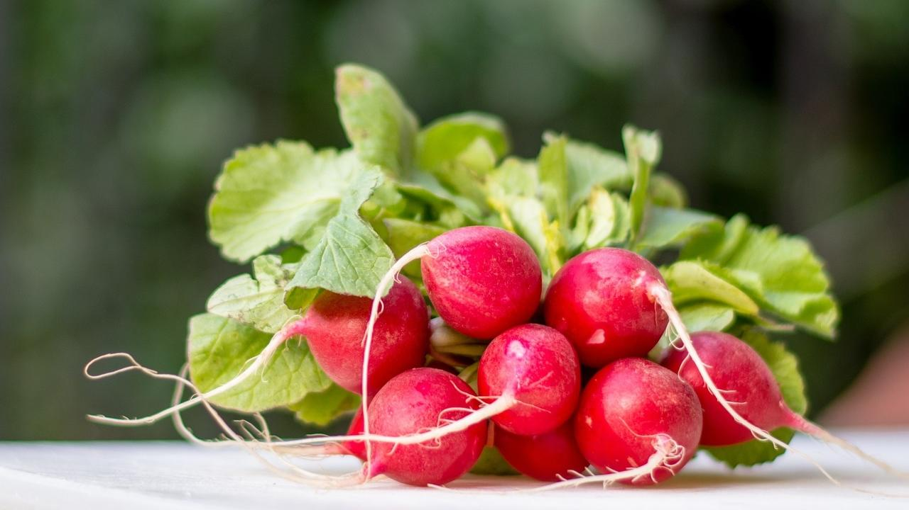

### **Whole Food Plant Based Radish Mustard Stir Fry Recipe**

Course: Course 2 (Vegetable Dish) at Lunch & Dinner Meals  
Cuisine: Indian Recipe  
Prep Time: 15 minutes  
Cook Time: 20 minutes  
Servings: 2 people

#### **INGREDIENTS**

2 Radishes  
1 Tomato  
1 Onion  
1 cm piece Ginger  
1/2 tsp Jeera Powder / Cumin Powder  
½ tsp Black Pepper Powder  
2 tbsp Coriander Leaves  
6 Almonds  
2 tsp Miso Paste (Healthy Salt Alternative. See Nutrition Science Highlights below)

#### **INSTRUCTIONS**

1. Grate radish. Peel onions. Chop onion and tomato into long, bite-sized pieces. Peel and grate ginger.
2. Cook together with a few splashes of water now and then if required. Don't let it burn.
3. Once radish is cooked just right, remove from stove and mix in miso paste and almonds. Dry roast mustard seeds. As soon as they start sputtering, mix into radish mustard stir fry. Garnish with chopped coriander leaves and stems. Serve fresh!

### **Plant Based Chef Pro Tips for Best Radish Mustard Stir Fry Recipe**

1. Keep stirring every few minutes to ensure that it does not burn. Add splashes of water when it starts looking dry. You can also use vinegar for a tangy taste!

# 96.Split Pea Soup Recipe | Recipe Pea Soup with Split Pea | Whole Food Plant Based Recipes

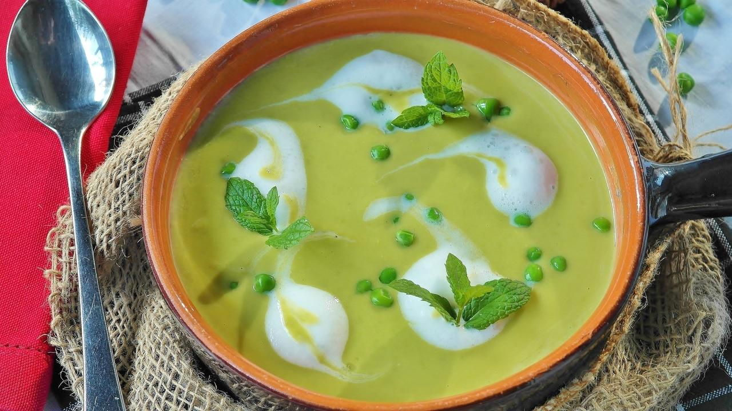

**Whole Food Plant Based Split Pea Soup Recipe**

Course: Soup, Snacks, Breakfast  
Cuisine: French Recipe, British Recipe  
Prep Time: 5 minutes  
Cook Time: 30 minutes  
Passive Time: 6 hours  
Servings: 4 People

**INGREDIENTS**

1 cup Split Peas / 2 cups Fresh Green Peas  
1 Onion  
5 cloves Garlic  
1 stalk Celery  
1 tsp Black Pepper Powder  
4 tsp Miso Paste (Healthy Salt Alternative. See Nutrition Science Highlights below)  
1 tsp Almond Butter  
10 Mint Leaves / Pudina Leaves  
Juice of 1 Lemon

**INSTRUCTIONS**

1. Soak split peas overnight or at least for 6 hours. Skip this step if using fresh green peas.
2. Peel and chop onion. Peel and crush or grind garlic to a paste and keep separately for ten minutes. Chop celery into slices.
3. Cook peas, onion and celery with minimal water or steam until cooked, adding garlic once it has rested for ten minutes. (See Nutrition Science Highlights for details)
4. Cool completely, then blend with half of the almond butter, black pepper powder, miso paste, half of the mint leaves, and lemon juice.
5. Dilute remaining almond butter with a little water to make almond cream. Garnish split pea soup with almond cream and remaining mint leaves. Warm up if needed. Serve fresh!

**Plant Based Chef Pro Tips for Best Split Pea Soup Recipe**

1. Use other herbs to garnish, such as thyme, parsley, basil leaves, curry leaves, and sage leaves for a wider range of flavours.
2. Add spices like cinnamon, star anise, or bay leaves while cooking split peas for a stronger flavor.

# 97.Paithama Laddoo Recipe | Lentil Laddoo | Diwali Special Recipe | Whole Food Plant Based Recipes

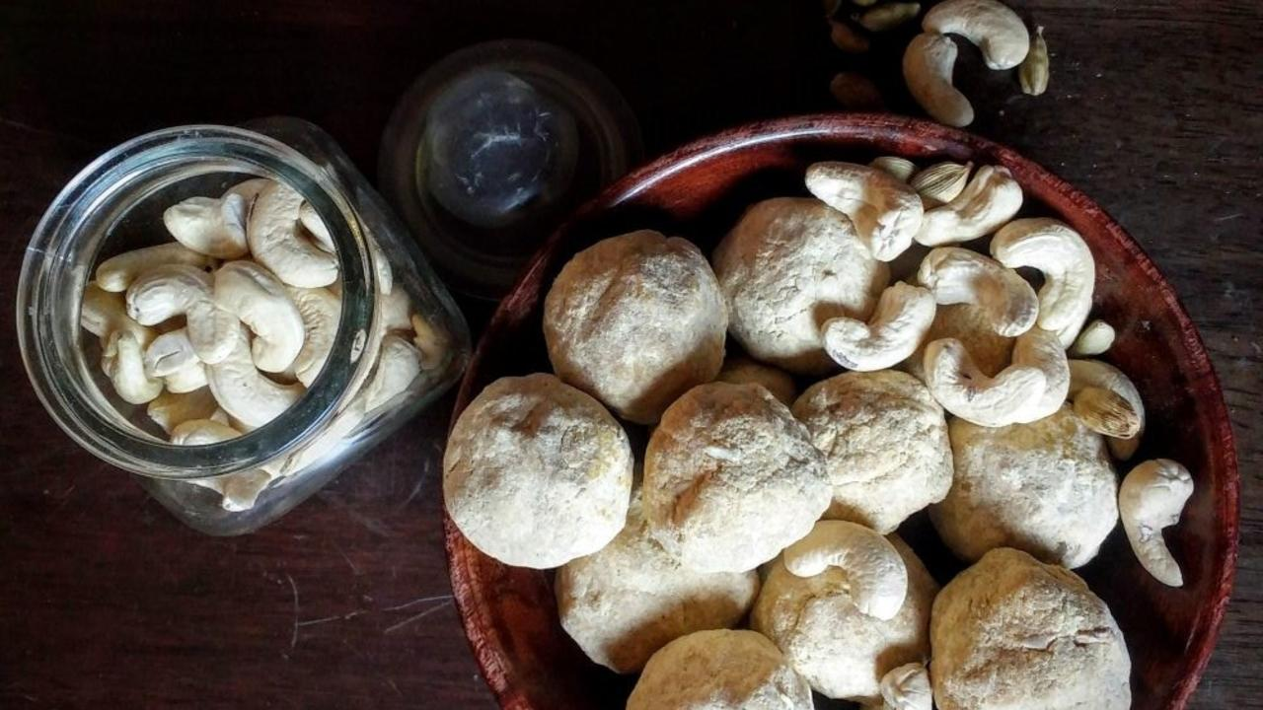

A delicious, sweet laddoo without using ghee, sugar or milk! What more could one ask for. 🙂

### Whole Food Plant Based Paithama Laddoo

Course: Desserts, Sweets  
Cuisine: Diwali Special Tamil Recipe from South India  
Prep Time: 20 minutes   
Cook Time: 20 minutes  
Servings: 12 Paithama Laddoos

#### INGREDIENTS

1 cup Moong dal  
1 cup Bengal Gram Dal  
2 cups Soft Dates  
4 Cardamom pods  
1/2 cup Cashew

#### INSTRUCTIONS

1. Dry roast moong dal and bengal gram dal separately on low flame. Do not allow to brown too much. See Nutrition Science Highlights for Paithama Laddoo below for details.
2. Grind to a fine powder in a mixie or high powered blender.
3. Peel and powder cardamom. Mix cardamom powder and cashew nuts with the flours and keep aside.  
   Remove seeds and grind soft date, 5 to 7 at a time if your mixie isn't high powered. Keep separately.
4. Mix all ingredients together. Serve fresh and consume as soon as possible!

### Plant Based Chef Pro Tips for Best Paithama Laddoo

Traditionally, Paithama Laddoo is prepared with jaggery syrup and is a super hard laddoo. This Whole Food Plant Based version is a soft laddoo, easier to eat and enjoy!

# 98.Ragi Roti Recipe | Roti Bakar | Ragi Recipe | Whole Food Plant Based Recipes

 Ragi roti is traditionally made from a soft, almost batter-y dough, patted out on a soft cotton cloth or a banana leaf and flipped onto the hot tava. Although you can also directly make it on the tava by patting it round with water, this requires some practice. Try it out today!

### Whole Food Plant Based Ragi Roti Recipe

Course: Course 3 (Grain Dish) for Lunch & Dinner Meals  
Cuisine: North Karnataka Recipe from South India  
Prep Time: 10 minutes   
Cook Time: 10 minutes  
Servings: 4 Akki Rotis

#### INGREDIENTS

1 cup Ragi Flour / Ragi Hittu  
1 Onion  
3 tbsp Flaxseed Powder  
1/2 tsp Jeera / Cumin Seeds  
1 cup Water as required

#### INSTRUCTIONS

1. Peel and chop onion into tiny pieces. Mix all ingredients together, with enough waterhot water to form a dough.
2. Using water, wet a banana leaf or muslin cloth. Take a small ball of dough and press / tap it on to the leaf or cloth to get a thin finger millet bread.
3. Heat tawa till a drop of water dances around when you splash water on it. Gently place the flattened rotti on it and remove the leaf or cloth. Make some evenly spaced holes with a fork so it gets cooked evenly. Close with a lid so it cooks well. Once done, flip it and let the other side get cooked as well.
4. Wait until it cools fully, then serve fresh with [green chutney](https://www.nutritionscience.in/blog/green-chutney-recipe-coriander-pudina-chutney-recipe-whole-food-plant-based-recipes). Enjoy! 🙂

### Plant Based Chef Pro Tips for Best Ragi Roti Recipe

1. If you prefer crispy rotis, flatten more and cook for longer.
2. Plain Ragi roti can be made with another method. Boil 5 parts water, pour 5 parts ragi flour and 1 part flaxseed powder slowly and mix it well to get a dough like consistency and use this to make rotis.

# 99.Lemongrass Tea Recipe | Ginger Lemongrass Recipe | Whole Food Plant Based Diet Recipes



 Warm spiced lemongrass tea with ginger

### Whole Food Plant Based Lemongrass Tea Recipe

Course: Beverage, Snack  
Cuisine: East Indian Receip & Sri Lankan Recipe  
Prep Time: 5 minutes  
Cook Time: 5 minutes  
Servings: 2 servings

#### INGREDIENTS

2 cups Water  
1 leaf Lemongrass  
1 cm piece Ginger  
2 tsp Raisins  
6 Almonds

#### INSTRUCTIONS

1. Heat water to a boil.
2. Peel ginger and chop into small pieces. Chop raisins into 2-4 pieces each.
3. Remove boiling water from stove and mix in lemongrass leaf, chopped raisins and chopped ginger. Keep covered for 2 minutes, then serve fresh with a side of almonds!

# 100.Thai Soup Recipe | Thai Food | Soup Recipe | Whole Food Plant Based Recipes

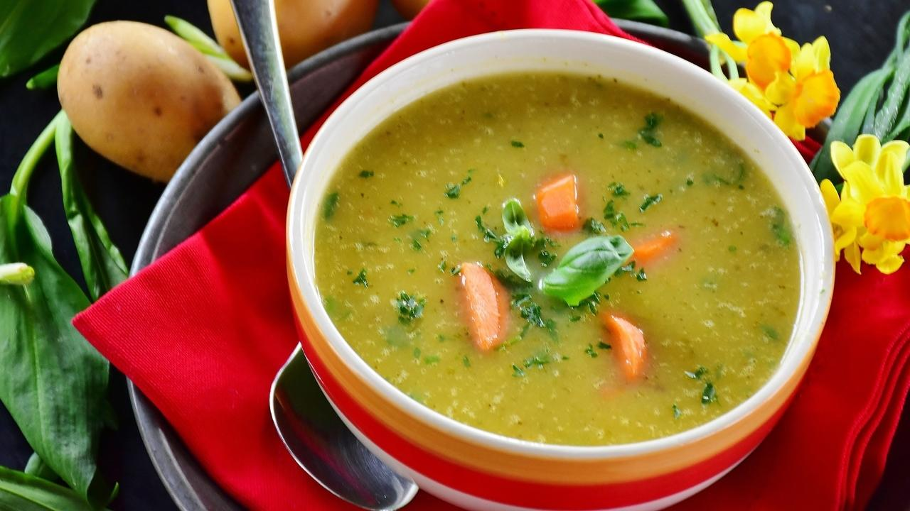

Delicious, aromatic, Thai soup in just fifteen minutes!

### **Whole Food Plant Based Thai Soup Recipe**

Course: Soup, Snacks, Breakfast  
Cuisine: Thai Recipe  
Prep Time: 5 minutes  
Cook Time: 20 minutes  
Servings: 4 People

#### **INGREDIENTS**

1 Carrot  
1 cup Spring Onion chopped  
10 White Buttom Mushrooms  
1 plant Lemongrass  
1 tsp Black Pepper Powder  
1 tsp Date Syrup  
4 tsp Miso Paste (Healthy Salt Alternative. See Nutrition Science Highlights below)  
Pulp of 1 Tender Coconut  
2 tbsp Coriander Leaves  
Juice of 1 Lemon

#### **INSTRUCTIONS**

1. Chop carrots into thin square pieces. Remove roots and chop spring onions into 1cm long pieces. Chop white button mushrooms into quarters. Remove lemongrass leaves. Chop tender portion of the lemongrass bulb into thin slices.
2. Cook all chopped vegetables with lemongrass in 3 cups of water.
3. While this is being cooked, blend black pepper powder powder, 3/4 of the tender coconut pulp, date syrup, miso paste, and lemon juice with 3 tbsp water.
4. Once vegetables are cooked, remove lemongrass leaves and mix in the blended nut and spice mix.
5. Blend the remaining tender coconut pulp to make tender coconut cream. Garnish thai soup with tender coconut cream and coriander leaves. Serve fresh!

### **Plant Based Chef Pro Tips for Best Thai Soup Recipe**

1. Use other herbs to garnish, such as thai basil leaves for a wider range of flavour.

# 101.Peanut Chutney Recipe | Shenga Chutney Recipe | Whole Food Plant Based Recipes

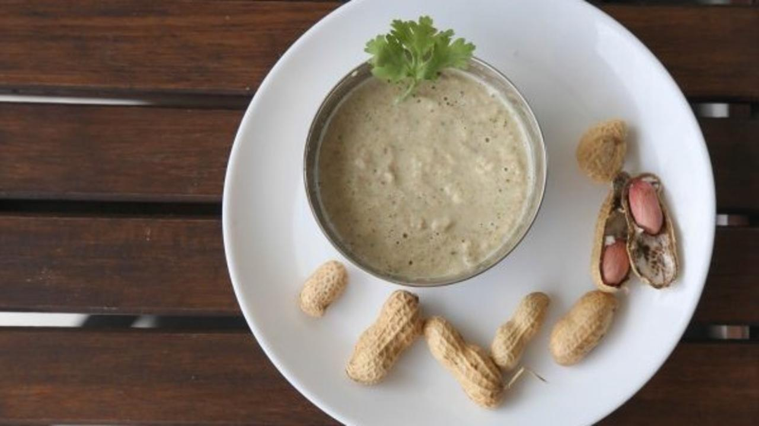

Yummy Peanut Chutney / Shenga Chutney from North Karnataka that goes with kadubu, dosa, idli, rotis and salads!

Hogayal, thuvayal or chutney is a nut-based ground preparation, served in homes across the Indian subcontinent since 500 BC. Most of them use coconut, peanut, sesame or other nuts as a base, flavoured with different herbs and spices. Some use raw vegetables as a base. This Shenga Chutney or Peanut Chutney is made from peanuts, flavoured using coriander leaves and pepper.

Chutneys today are popularly garnished with an oil tadka. This is unnecessary and does not add any health benefit to the chutney when nuts are already used. In fact, nut-based chutneys have plenty of natural oil by themselves, from the whole nut. This oil is of much better quality than any extracted oil, whether it is unrefined or refined.

This is the basic recipe. You can use it to make any number of variations, using ingredients like amla, jeera, pudina leaves etc. Have fun experimenting!

### Whole Food Plant Based Peanut Chutney Recipe

Course: Chutneys, Side Dish for Course 3 (Grain Dishes) at Lunch & Dinner Meals  
Cuisine: North Karnataka Recipe from South India  
Prep Time: 5 mins  
Cook Time: 5 mins  
Servings 2 people

#### INGREDIENTS

1/2 cup Peanuts  
1 small Onion chopped  
1/2 tsp Black Pepper Powder  
1 stalk Coriander leaves chopped  
2 tsp Miso Paste (Healthy Salt Alternative. See Nutrition Science Highlights below)  
1/2 cup Water As required

#### INSTRUCTIONS

1. Dry roast groundnuts on a low flame, stopping when they start changing colour. Do not allow them to turn brown. See Nutrition Science Highlights below for details.
2. Peel and chop onions. Dry roast onions with little water. Do not allow it to burn.
3. Blend roasted groundnuts, onions, miso paste, coriander leaves, and black pepper powder with little water as per required consistency.
4. Serve fresh as peanut chutney with raw vegetables or shenga chutney with kadubu, dosa, idli or roti!
5. Use fresh green pepper if available.
6. Oil free seasoning (dry tadka) of mustard seeds, jeera, curry leaves, urad dal can be added if required.
7. Skip onion to make it satwic.

# 102.Hummus Recipe | Recipe Hummus with Tahini | Whole Food Plant Based Recipes

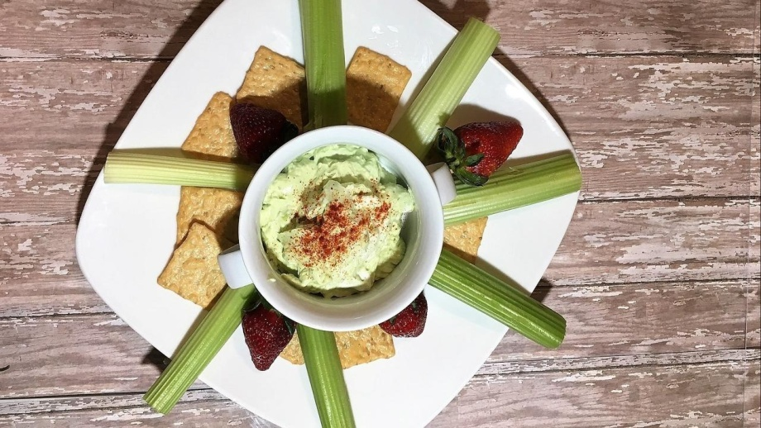

Authentic Hummus Recipe from the Middle East! First appearing in writing around 13th century in Egypt, hummus in Arabic literally translates to 'Chickpeas'. Here's a super simply recipe to make hummus without oil!

### Whole Food Plant Based Hummus Recipe with Tahini

Course: Chutneys, Side Dish at Lunch & Dinner Meals, Snacks  
Cuisine: North Karnataka Recipe from South India  
Prep Time: 10 mins  
Passive Time: 6 hours  
Cook Time: 20 mins  
Servings: 4 people

#### INGREDIENTS

1 cup Chickpeas / Kabuli Chana / Garbanzo Beans  
2 tbsp Black Sesame / Til  
5 cloves Garlic  
1 tsp Black Pepper Powder  
1/2 tsp Cumin Powder / Jeera Powder  
4 tsp Miso Paste .Juice of 1 Lemon  
Water As required

#### INSTRUCTIONS

1. Soak chickpeas overnight or at least for 6 hours.
2. Dry roast sesame seeds on a low flame, stopping when they start sputtering. Do not allow them to roast too much or get browned. See Nutrition Science Highlights below for details.
3. Grind sesame seeds to a powder in a mixie. Continue grinding, scraping down the sides of the mixie now and then, to make tahini.
4. Cook chickpeas until done. Peel garlic. Grind cooked chickpeas to a smooth paste in a high powdered blender with peeled garlic, tahini, miso paste, black pepper powder, and lemon juice.
5. Garnish with cumin powder / jeera powder. Serve fresh with celery, carrot and beetroot sticks!

### Plant Based Chef Pro Tips for Best Hummus Recipe with Tahini

1. Garnish with different herbs and spices, like coriander leaves, mint leaves, or basil leaves, for different flavours!

# 103.Kumbalkai Kottige Kadubu Recipe | How to Make Kotte Kadubu Recipe | Whole Food Plant Based Recipes

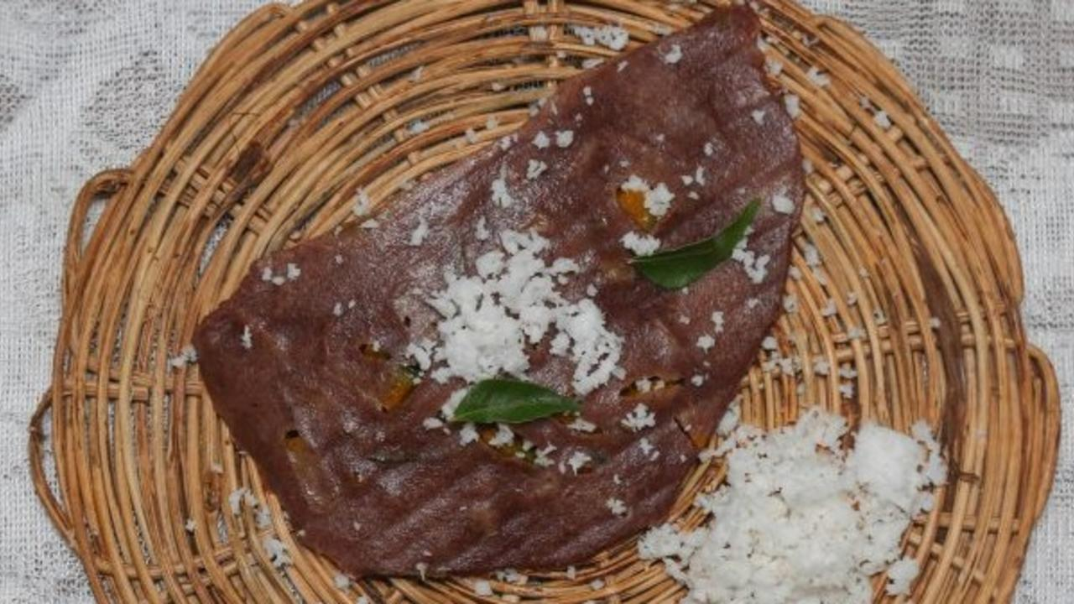

This festive dish traces its origins to the Havyaka community. Havyaks have an intrinsically healthy food system and use minimal oil in most of their dishes.

Traditionally, this lip-smacking dish brings together pumpkin, coconut, and green chillies, however, in this recipe, we have used pepper to spice things up instead! Serve it with grated coconut or coconut chutney for the prefect combination.

Kottige usually refers to banana leaf or any other leaf shaped into cups, which are filled with rice batter and stuffing.

Recipe Credit: Shilpa Bhat, Puttur

### Whole Food Plant Based Kumbalkai Kottige Kadubu Recipe

Course: Course 3 (Grain Dish) at Lunch & Dinner Meals  
Cuisine: Havyaka Recipe from Puttur & Mangalore in Coastal Karnataka, South India  
Prep Time: 10 minutes   
Cook Time: 15 minutes  
Servings: 2 people

#### INGREDIENTS

1 cup Red Rice  
1/4 cup Urad Dal  
1 tsp Methi / Fenugreek Seeds  
1/2 cup Yellow Pumpkin  
1/2 tsp Black Pepper Powder  
2 tsp Miso Paste (Healthy Salt Alternative. See Nutrition Science Highlights below)  
1 cup Water as required

#### INSTRUCTIONS

1. Soak red / brown rice for 3 hours. Separately, soak urad and methi seeds for 3 hours.
2. In the meantime, chop pumpkin into small pieces.
3. Grind urad dal and methi seeds into a smooth batter with minimal water. Add soaked rice to the mix and grind with minimal water to get thick batter. Stop grinding once the rice is ground into broken rice. If batter becomes too thin, it will spill out of the banana leaf. Mix pumpkin pieces with miso paste and black pepper powder to make pumpkin stuffing and keep aside.
4. Take a banana leaf. Cut a 10-12 inch square piece. Spread rice batter on it. Place a little pumpkin stuffing in the center and fold it in half to form the traditional kadubu shape, or else fold the four corners to form a cup into which you pour the batter and stuffing. Steam cook in an idli cooker for 15 minutes.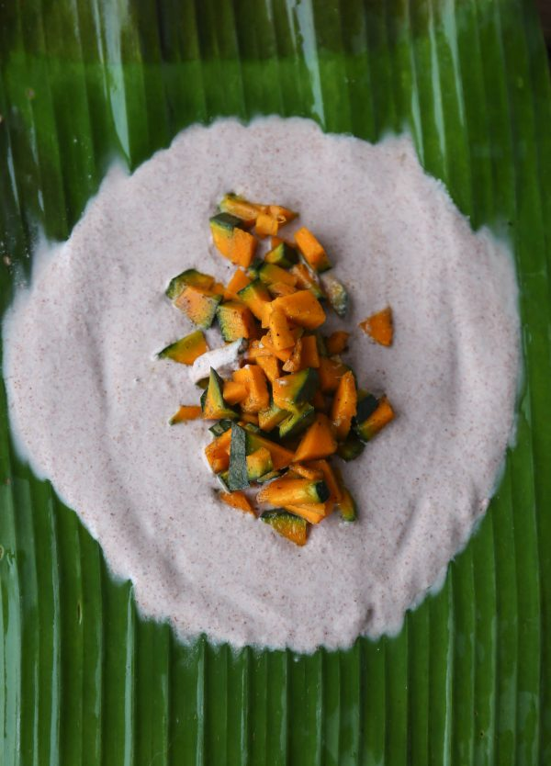
5. Once steamed, remove from idli cooker and allow to cool completely. Garnish with grated coconut and serve fresh. Pumpkin Kottige Kadubu can be served with [coconut chutney](https://www.nutritionscience.in/blog/coconut-chutney-recipe-how-to-make-coconut-chutney-whole-food-plant-based-recipes) or any curry of your choice!

### Plant Based Chef Pro Tips for Best Kumbalkai Kottige Kadubu Recipe

1. Right kind of rice should be used to get proper kadubus. Make sure you use unpolished rice!
2. Any other vegetable like gourds can also be used for stuffing.
3. Turmeric leaves, taro or large palak leaves can be used for steaming as well. If palak is used, the . .

# 104.Soya Flaxseed Vada Recipe | Flaxseed Benefits & Soya Bean | Whole Food Plant Based Recipes

Soya Flaxseed Vada combines two powerful foods that lower blood pressure, soya bean and flaxseed powder, into a single delicacy. Serve this daily for a sure fire way of getting your family to regularly consume both these foods!

## Whole Food Plant Based Baked Soya Flaxseed Vada Recipe

Course: Snacks, Side Dish for Lunch & Dinner Meals  
Cuisine: South Indian Recipe  
Prep Time: 15 minutes  
Cook Time: 40 minutes  
Servings: 4 People

### INGREDIENTS

1. 1 cup Vegetables (Whichever veggies your family fusses to eat!)
2. 1 cup Soya Beans
3. 1/4 cup Peanut
4. 1/2 cup Flaxseed
5. 1 inch piece Ginger
6. 1 tsp Jeera / Cumin Seeds
7. 1 Green Chili
8. 1 tsp Turmeric Powder
9. 1/2 tsp Black Pepper Powder
10. 1/2 tsp Jeera Powder / Cumin Seed Powder
11. 4 tsp Miso Paste (Healthy Salt Alternative. See Nutrition Science Highlights below)
12. 20 Curry Leaves
13. Water as required

### INSTRUCTIONS

1. Soak soya overnight or at least for 6 hours. Drain water and use for your garden.
2. Grind soya to a chunky paste with vegetables.
3. Coarsely grind peanuts into peanut powder. Grind flaxseeds into a fine powder.
4. Mix all ingredients together to form a chunky dough. Shape the dough into round discs of 2-inch diameter and 1 cm height.
5. Line a baking tray with unbleached parchment paper or silicone baking sheet.
6. Place the shaped vada at even intervals on the baking tray.
7. Bake at 120 deg C for 30 minutes, then turn the vadas over and bake for ten more minutes. Watch that they don't become too brown! The lighter, the healthier. See Nutrition Science Highlights for WFPB Soya Flaxseed Vada Recipe below for details.
8. Oil-free Baked Soya Flaxseed Vada is ready! Serve fresh with Pudina Chutney!

### Plant Based Chef Pro Tips for Best Baked Soya Flaxseed Vada Recipe

1. While shaping Soya Flaxseed Vadas, wet your hands from time to time to make it easier.

# 105.Whole Wheat Sandwich | Sandwich Recipe with Whole Wheat Bread | Whole Food Plant Based Recipes

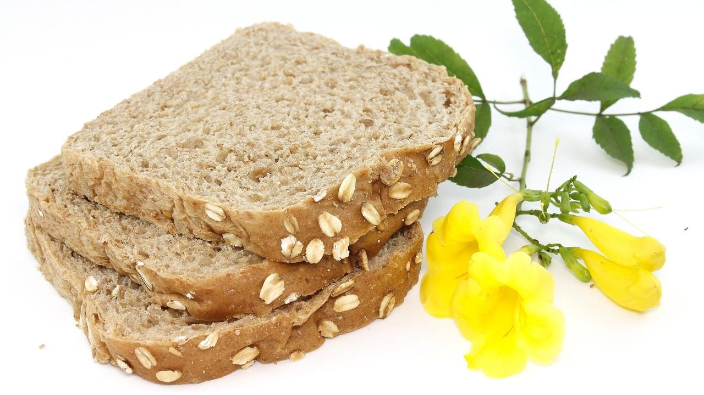

Here's a Thai Burnt Garlic Fried Rice Recipe without a single drop of oil!

### Whole Food Plant Based Whole Wheat Sandwich Recipe

Course: Course 3: Grain Dish for Lunch & Dinner Meals  
Cuisine: Continental Recipe  
Prep Time: 10 minutes   
Servings: 4 people

#### INGREDIENTS

8 slices Whole Wheat Bread  
1 cup Potato Cheese  
2 Tomatoes  
1 Onion  
1 Cucumber  
1/2 tsp Black Pepper Powder

#### INSTRUCTIONS

1. Spread potato cheese liberally on 4 whole wheat bread slices.
2. Peel onions. Slice onions, tomatoes, and cucumber. Arrange on the slices, on potato cheese.
3. Sprinkle black pepper powder. Cover with another slice of whole wheat bread. Serve fresh!

### Plant Based Chef Pro Tips for Best Whole Wheat Sandwich Recipe

1. Replace potato cheese with [almond butter](https://www.nutritionscience.in/blog/almond-butter-recipe-whole-food-plant-based) or pudina chutney for differen flavours
2. Add coriander leaves or oregano leaves, along with cinnamon powder or jeera powder for different combinations.

# 106.Burnt Garlic Fried Rice | Thai Fried Rice Recipe with Roasted Garlic | Whole Food Plant Based Recipes

Here's a Thai Burnt Garlic Fried Rice Recipe without a single drop of oil!

### Whole Food Plant Based Burnt Garlic Fried Rice Recipe

Course: Course 3: Grain Dish for Lunch & Dinner Meals  
Cuisine: Thai Recipe  
Prep Time: 10 minutes   
Cook Time: 30 minutes  
Servings: 4 people

#### INGREDIENTS

1 cup Brown Rice soaked  
20 cloves Garlic  
1 tbsp Peanuts  
5 Thai Basil Leaves  
1/2 Green Chili  
1/2 tsp Black Pepper Powder  
4 tsp Miso Paste (Healthy Salt Alternative. See Nutrition Science Highlights below)

#### INSTRUCTIONS

1. Soak 1 cup brown rice for 30 minutes. Cook it with 2 cups water until it is soft but not over cooked. Spread it out on a large plate so it doesn't become sticky. Let it cool fully.
2. While rice is being cooked, peel and crush or grind garlic to a paste. Keep aside for ten minutes. See Nutrition Science Highlights below for details.
3. In the meantime, dry roast groundnuts on low flame until just done.  Ensure that it does not darken. See Nutrition Science Highlights below for details.
4. Slit green chili into two long pieces. Once garlic has rested for ten minutes, dry roast with chili until raw smell goes away.
5. Mix roasted peanuts, garlic, chili, black pepper powder, and miso paste with cooked rice. Mix well, taking care not to mash the rice. Garnish wiht thai basil leaves. Serve fresh!

### Plant Based Chef Pro Tips for Best Burnt Garlic Fried Rice Recipe

1. Burnt Garlic Fried Rice is best served with [Thai Curry](https://www.nutritionscience.in/blog/thai-yellow-curry-recipe-thai-curry-recipe-whole-food-plant-based-recipes)!

# 107.Bok Choy Stir Fry Recipe | Recipe Bok Choy | Whole Food Plant Based Recipes

### **Whole Food Plant Based Bok Choy Stir Fry Recipe**

Course: Course 2 (Vegetable Dish) at Lunch & Dinner Meals  
Cuisine: Thai Recipe  
Prep Time: 15 minutes  
Cook Time: 20 minutes  
Servings: 2 people

#### **INGREDIENTS**

2 Bokchoys  
1 Onion  
10 cloves Garlic  
½ tsp Black Pepper Powder  
10 Basil Leaves  
6 Almonds  
2 tsp Miso Paste (Healthy Salt Alternative. See Nutrition Science Highlights below)

#### **INSTRUCTIONS**

1. Peel onions. Chop all vegetables into long, bite-sized pieces.
2. Cook together with a few splashes of water now and then. Don't let it burn.
3. In the meantime, peel and crush or grind garlic to a paste. Keep aside for ten minutes. Once garlic has rested for ten minutes, add to bok choy and continue cooking until done.
4. Once bok choy is cooked just right, remove from stove and mix in miso paste and almonds. Garnish with chopped basil leaves. Serve fresh!

**Plant Based Chef Pro Tips for Best Bok Choy Stir Fry Recipe**

1. Keep stirring every few minutes to ensure that it does not burn. Add splashes of water when it starts looking dry. You can also use vinegar for a tangy taste!

.

# 108.Fried Tofu Recipe | Zero Oil Fried Tofu Recipe | Whole Food Plant Based Recipes

Here's a Thai Burnt Garlic Fried Rice Recipe without a single drop of oil!

### Whole Food Plant Based Whole Wheat Sandwich Recipe

Course: Side Dish for Course 3: Grain Dish for Lunch & Dinner Meals  
Cuisine: Oriental Recipe  
Prep Time: 5 minutes  
Cook Time: 10 minutes  
Servings: 4 people

#### INGREDIENTS

200g / 1 block Tofu  
1 tbsp Apple Cider Vinegar  
1/2 tsp Red Chili Powder  
1/2 tsp Black Pepper Powder  
1 tso Dried Oregano Leaves  
4 tsp Miso Paste (Healthy Salt Alternative. See Nutrition Science Highlights below)

#### INSTRUCTIONS

1. Slice tofu into long, thin slices.
2. Mix apple cider vinegar, red chili powder, black pepper powder, dried oregano, and miso paste into a paste.
3. Smear the spice mix over each slice of tofu.
4. Arrange on a steel wire mesh tray and bake at 160 deg C for 10 to 15 minutes until crisp but not browned. See Nutrition Science Highlights for details.
5. Serve fresh with [Potato Cheese Dip](https://www.nutritionscience.in/blog/potato-cheese-recipe-cheese-and-potato-reimagined-whole-food-plant-based-recipes)!

### Plant Based Chef Pro Tips for Best Fried Tofu Recipe

1. Add jeera, dhaniya, and turmeric powder to the spice mix to create Indian flavours.
2. Add nutritional yeast for a cheesy flavour.

.

# 109.Fried Tofu Recipe | Zero Oil Fried Tofu Recipe | Whole Food Plant Based Recipes

Here's a Thai Burnt Garlic Fried Rice Recipe without a single drop of oil!

### Whole Food Plant Based Whole Wheat Sandwich Recipe

Course: Side Dish for Course 3: Grain Dish for Lunch & Dinner Meals  
Cuisine: Oriental Recipe  
Prep Time: 5 minutes  
Cook Time: 10 minutes  
Servings: 4 people

#### INGREDIENTS

200g / 1 block Tofu  
1 tbsp Apple Cider Vinegar  
1/2 tsp Red Chili Powder  
1/2 tsp Black Pepper Powder  
1 tso Dried Oregano Leaves  
4 tsp Miso Paste (Healthy Salt Alternative. See Nutrition Science Highlights below)

#### INSTRUCTIONS

1. Slice tofu into long, thin slices.
2. Mix apple cider vinegar, red chili powder, black pepper powder, dried oregano, and miso paste into a paste.
3. Smear the spice mix over each slice of tofu.
4. Arrange on a steel wire mesh tray and bake at 160 deg C for 10 to 15 minutes until crisp but not browned. See Nutrition Science Highlights for details.
5. Serve fresh with [Potato Cheese Dip](https://www.nutritionscience.in/blog/potato-cheese-recipe-cheese-and-potato-reimagined-whole-food-plant-based-recipes)!

### Plant Based Chef Pro Tips for Best Fried Tofu Recipe

1. Add jeera, dhaniya, and turmeric powder to the spice mix to create Indian flavours.
2. Add nutritional yeast for a cheesy flavour.

# 110.Guava Banana Salad Recipe | Fruit Salad Recipe | Whole Food Plant Based Recipes

Fresh Fruit Salad with juicy crunchy guava and soft sweet bananas topped off with some nuts and raisins. Yummy! This is a great way of eating loads of fruit, especially for those who don't like fruits too much.   
With the right amount of crunchiness, juiciness, and sweetness, this guavabanana salad is simple to put together and great to start the day with.

Enjoy!

### Whole Food Plant Based Guava Banana Salad Recipe

Course: Course 1 (Raw Dish) for Breakfast, Lunch & Dinner Meals; Snack; Salad  
Cuisine: Satvik Recipe  
Prep Time: 10 minutes   
Servings: 2 people

#### INGREDIENTS

4 Yelakki Bananas or 1 Large Banana  
2 Guavas  
1/4 cup Raisins  
1 tbsp Almonds  
1/4 Vanilla Pod

#### INSTRUCTIONS

1. Peel and chop banana and into slices.
2. Remove stem scars and chop guavas into bite-sized pieces.
3. Coarsely chop almonds.
4. Scrape vanilla seeds off vanilla pods.
5. Mix all ingredients together. Serve fresh!

### Plant Based Chef Pro Tips for Best Guava Banana Salad Recipe

1. Ensure to serve fresh, otherwise banana will get oxidised and brown.

.

# 111.Raw Vegan Raitha Recipe | Whole Food Plant Based

Woah! WFPB Raw Vegan Tender Coconut Raitha? Yes! It sure is a mouthful, one that is absolutely yummy! It’s a delicious, dairy free yogurt based raitha. This creamy, melt-in-the mouth raitha is not only tasty but healthier as well. This is a raw recipe which requires no fermentation. So you can have a instant yogurt and instant raitha.

What’s wrong with Cow's milk or yogurt? Well, it is not suitable for humans as it is loaded with proteins which is required for a calf to grow in full size in short time. Dairy cows are impregnated with hormonal injections and are kept in unhygienic conditions which is resulting in dairy cow milk being filled with hormones, pus, blood which is creating havoc in our health! Even milk from cows that are raised on a farm and fed organic fodder/grass fed is linked to chronic lifestyle diseases.

Tender coconut pulp is creamy, dense and rich because of which it is often the crowd favourite. You can use it to make a myriad of healing dishes including this Raw Vegan Tender Coconut Raitha.

Upgrade to food that truly loves you back.

## Whole Food Plant Based Raw Vegan Raitha Recipe

Course Meals: Side Dish for Course 3: Grain Dishes at Breakfast, Lunch & Dinner  
Cuisine: Indian Recipe  
Prep Time: 10 minutes  
Servings: 4 people

### INGREDIENTS

1. 1 Tender Coconut
2. 1 Lemon
3. 1/2 Cucumber
4. 1/4 inch Fresh Ginger
5. 1 Green Chilli
6. 1 plant Coriander
7. 1/4 tsp Black Pepper Powder
8. 2 tbsp Water
9. 4 tsp Miso Paste

### INSTRUCTIONS

1. Scoop out tender coconut pulp. Squeeze in lemon, add miso paste, pepper powder, and water, and blend into a smooth paste. This should give you a yogurt-like consistency.
2. Chop cucumber. Remove roots and chop coriander. Slit green chili along its length. Chop and crush ginger. Add these to the mix.
3. Serve with millet pulav or pongal, or as a dip with salads!

# 112.Foxtail Millet Rava Upma Recipe | Millet Upma Recipe | Whole Food Plant Based Recipes

Best served with Shenga Chutney or Peanut Chutney Recipe! Upgrade to food that loves you back.

### Whole Food Plant Based Foxtail Millet Rava Upma Recipe

Course: Course 3: Grain Dish for Lunch & Dinner Meals, Millet Dishes  
Cuisine: Tamil Recipe from South India  
Prep Time: 10 minutes   
Cook Time: 25 minutes  
Servings: 4 People

#### INGREDIENTS

1 cup Foxtail Millet Rava / Semolina  
2 Onions  
1 tbsp Urad Dal  
1 tbsp Bengal Gram Dal  
1 inch piece Ginger peeled & chopped  
1 small Green Chili chopped  
1/2 tsp Black Pepper Powder  
1 tsp Mustard Seeds  
1 pinch Asafoetida  
10 Curry Leaves  
2 tbsp Coriander leaves chopped  
4 tsp Miso Paste (Healthy Salt Alternative. See Nutrition Science Highlights below)  
1/4 cup Coconut freshly grated

#### INSTRUCTIONS

1. Roast the mustard, urad dal and bengal gram dal separately. Ensure you keep stirring while roasting as you will not have any oil to keep them from charring. Roasting them separately, is also towards this. Ensure to roast them minimally, only until they start sputtering or turn light brown. Once done, keep aside. See Nutrition Science Highlights below for details.
2. Chop green chili, peel and chop ginger and onion.
3. Heat 2 cups of water in a kadai or thick bottomed vessel with chopped green chili and chopped ginger.
4. When the water comes to a boil, add foxtail millet rava / semolina slowly. Mix and keep covered on sim until cooked. Stir once in a while to ensure it does not get burnt.
5. Once done, remove on to a plate, mix in miso paste, asafoetida / perunkaayam, black pepper powder, and roasted mustard and dals, and wait until they are completely cool.
6. Once cooled, garnish Foxtail Millet Rava Upma with freshly grated coconut, coriander leaves, and curry leaves. Serve Fresh!

### Plant Based Chef Pro Tips for Best Foxtail Millet Rava Upma Recipe

1. Serve with sambar and chutney, moist or watery dishes, to compensate for the dry nature of the Foxtail Millet Rava Upma Recipe.

# 113.Cauliflower Bisque Recipe | Cauliflower Recipe | Whole Food Plant Based Recipes

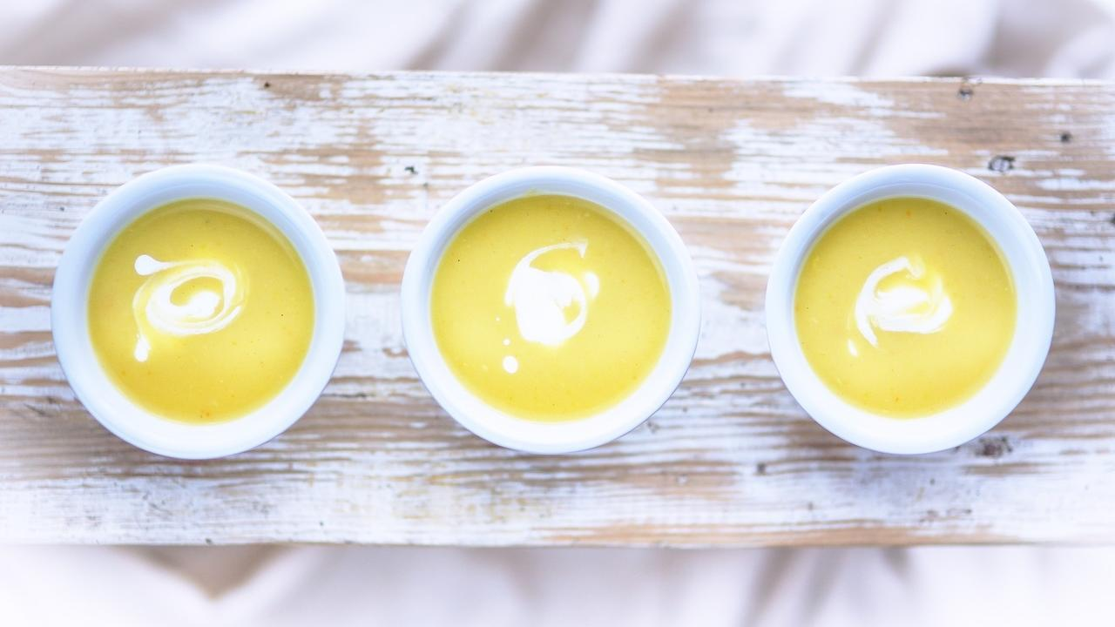

Amazingly Indulgent soup that no one would believe is 100% dairy free!

### **Whole Food Plant Based Cauliflower Bisque Soup Recipe**

Course: Soup, Snacks, Breakfast  
Cuisine: French Recipe  
Prep Time: 5 mins  
Cook Time: 20 mins  
Servings: 4 People

#### **INGREDIENTS**

1 Small Cauliflower  
2 Onions  
10 cloves Garlic  
1 tsp Black Pepper Powder  
1 tsp [Date Syrup](https://www.nutritionscience.in/blog/date-syrup-recipe-whole-food-plant-based)  
4 tsp Miso Paste (Healthy Salt Alternative. See Nutrition Science Highlights below)  
2 tbsp [Almond Butter](https://www.nutritionscience.in/blog/almond-butter-recipe-whole-food-plant-based)  
1 sprig Thyme fresh or dried

#### **INSTRUCTIONS**

1. Wash and chop cauliflower into large pieces. Keep 2-3 pieces aside and steam or boil the rest until cooked, along with peeled and chopped onions.
2. In the meantime, peel and crush or grind garlic to a paste. Keep aside for ten minutes, then add to the vegetable mix and steam or boil until cooked.
3. Once cooked, let it cool completely, then blend with raw cauliflower, black pepper powder, date syrup, miso paste, and most of the almond butter.
4. Dilute remaining almond butter with a little water to make almond cream. Garnish cauliflower bisque soup with almond cream and thyme leaves. Warm up if needed. Serve fresh!

### **Plant Based Chef Pro Tips for Best Cauliflower Bisque Soup Recipe**

1. Use other herbs to garnish, such as basil leaves, curry leaves, and sage leaves for a wider range of flavours.
2. Add bay leaves while cooking chickpeas for a stronger spice flavor.

# 114.Sukku Vellam Recipe | Sugar Free & Jaggery Free Ginger Laddoo Recipe | Whole Food Plant Based Recipes

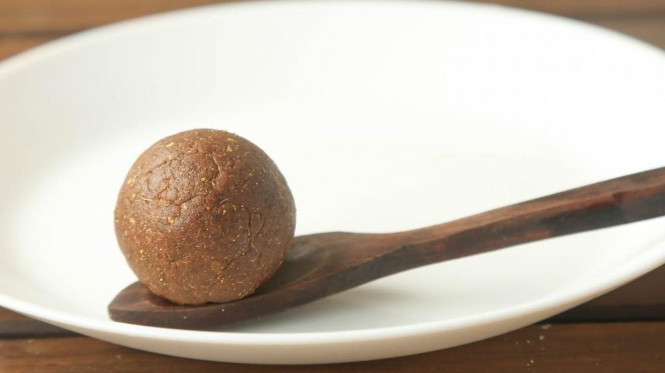

Ginger, pepper and ajwain. Any Indian mother will know what I’m talking about. After delivery, these three spices are used for pretty much every dish for many months! Along with other spices like fenugreek, they have an amazing healing effect on the body. Grandmothers would keep the new mother’s stock hidden, or they would be gobbled up by everybody else.

Traditional wisdom says that ginger helps enhance digestive power, and this is very important during lactation. It is a ‘heat producing’ food, in local customs.

In this recipe, we are using dry ginger powder, date syrup, crushed black pepper and ajwain seeds. They are usually made with ghee or coconut oil and stored for many days. We have omitted these disease-causing ingredients to enhance the health quotient of ginger laddoo even further. These ladoos can be quite strong! Take one ginger laddoo a day to give your stomach a boost. Enjoy the zing!

Recipe Credit: Rukmini Kharvi

### **Whole Food Plant Based Shunti Unde Recipe**

Course: Snacks, Sweets, Digestif  
Cuisine: Coastal Karnataka Recipe from South India  
Prep Time: 5 minutes  
Cook Time: 5 minutes  
Servings: 15 laddoos

#### INGREDIENTS

1. 2 tbsp Dry Ginger Powder  
   1 tsp Black Pepper Powder  
   1 tsp Ajwain Powder  
   2 tbsp Date Syrup  
   1 tbsp Almond Butter

#### INSTRUCTIONS

1. Blend all ingredients together and shape into balls. Add a few drops of water if required.
2. Serve one per day, specially for lactating mothers.

### Plant Based Chef Pro Tips for Best Shunti Unde Recipe

1. Anyone can enjoy this intense ginger laddoo! Make sure you've eaten well, otherwise it will make you quite hungry! 🙂

# 115.Peanut Butter Recipe | Dairy Alternative Recipes | Whole Food Plant Based Recipes

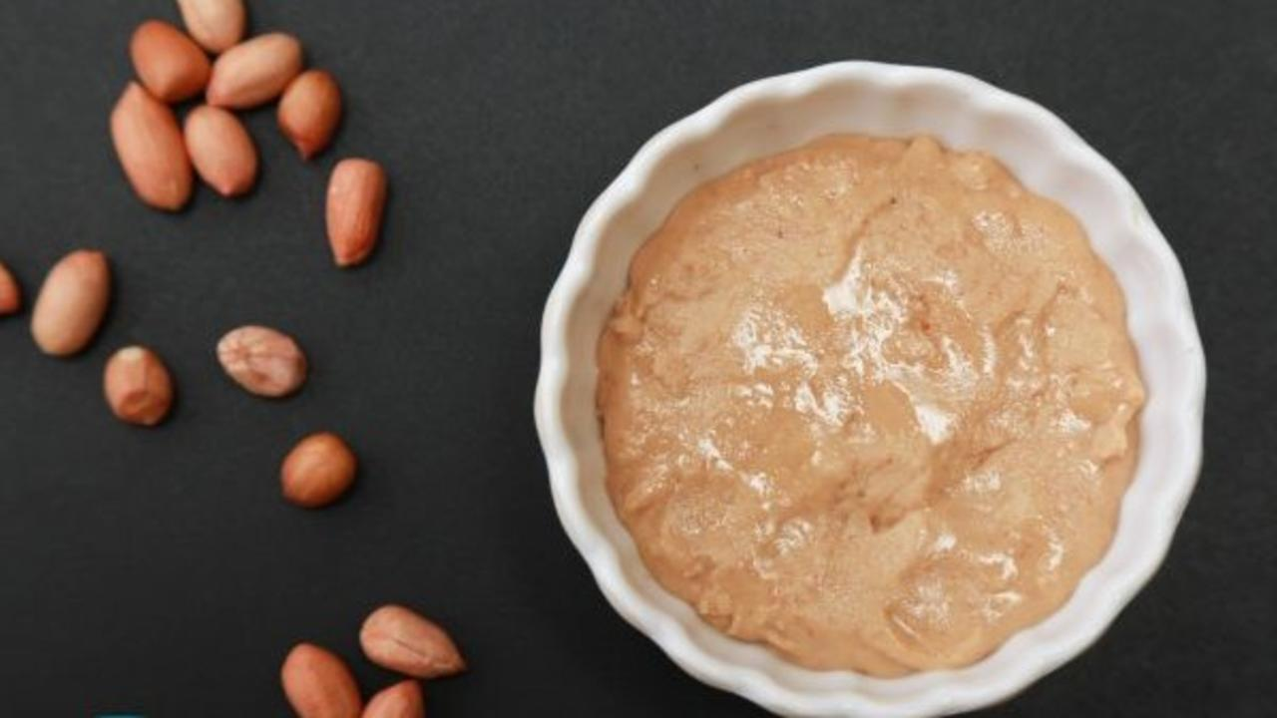

Peanut Butter doesn’t have butter!? exclaimed a friend as I savoured a dollop of the nut butter. No, I said, and no added sugar, oil, or preservative either. Rich, smooth and creamy peanut butter can be made with ease at home. What’s more, you can add your choicest natural flavours like cinnamon, raisins, date syrup, cocoa powder and the like, to personalise it.

Most of the peanut butters available in stores have unhealthy additives such as added refined sugars, extracted oil, and chemical preservatives. Even recipes for making peanut butter at home, often include added extracted oils. Oil inside the whole nuts are abundant in nutrition and contribute to health, unlike heated or refined extracted oils.

Here is a super simple, melt-in-the-mouth peanut butter recipe with only the goodness!

### Whole Food Plant Based Peanut Butter Recipe

Course: Fundamental Recipe, Dairy Alternative Recipe  
Cuisine: American Recipe  
Prep Time 10 minutes   
Cook Time: 10 minutes  
Servings 2 people

#### INGREDIENTS

1 cup Peanuts

#### INSTRUCTIONS

1. Roast peanuts on an iron tava over low flame, Do not burn or over roast it. Stop roasting it when it starts becoming slightly brown. See Nutrition Science Highlights below for details.
2. Let it cool. Blend till it becomes a powder. Continue blending, scraping down the sides whenever it gets stuck, till you get a smooth and buttery consistency.
3. Fresh peanut butter is ready! It will not melt like butter, but has a rich buttery taste and can be used as spread in any dish. Or, just gobble a spoon by itself!

### Plant Based Chef Pro Tips for Best Peanut Butter Recipe

1. Blend this peanut butter with some dates to make yummy peanut balls or peda.

# 116.Onion Raitha Recipe | How to Make Dairy-Free Onion Raitha | Whole Food Plant Based Recipes

Onion Raitha with Veg Pulav! The ultimate combination. But how do we make this creamy, melt-in-the mouth raitha that is only tasty but healthy as well? You could use this raw recipe. What's more, you don't need to ferment it. You can use this onion raitha recipe to make instant raitha!

What’s wrong with Cow's milk or yogurt? Well, it is not suitable for humans as it is loaded with proteins which is required for a calf to grow to full size in short time. Dairy cows are impregnated with hormonal injections and are kept in unhygienic conditions which is resulting in dairy cow milk being filled with hormones, pus, blood which is creating havoc in our health! Even milk from cows that are raised on a farm and fed organic fodder/grass fed is linked to chronic lifestyle diseases.

Switch to Plant Based Dairy Alternatives. Upgrade to food that truly loves you back.

### Whole Food Plant Based Onion Raitha Recipe

Course Meals: Side Dish for Course 3: Grain Dishes at Breakfast, Lunch & Dinner  
Cuisine: Indian Recipe  
Prep Time: 10 minutes  
Servings: 4 people

#### INGREDIENTS

1. 1/2 cup Cashews
2. 1 Lemon
3. 2 Onions
4. 1/4 inch Fresh Ginger
5. 1 Green Chilli
6. 1 plant Coriander
7. 1/4 tsp Black Pepper Powder
8. 2 tbsp Water
9. 4 tsp Miso Paste

#### INSTRUCTIONS

1. Soak cashews overnight or at least for 30 minutes. Squeeze in lemon, add miso paste, pepper powder, and water, and blend into a smooth paste. This should give you a creamy consistency.
2. Peel and chop onions. Remove roots and chop coriander. Slit green chili along its length. Chop and crush ginger. Add these to the mix.
3. Serve fresh, with [foxtail millet veg pulao](https://www.nutritionscience.in/blog/foxtail-millet-veg-pulao-recipe-veg-pulao-with-foxtail-millet-rice-whole-food-plant-based-recipes)!

# 117.Vale Bajji Ambat Recipe | Malabar Spinach Curry Recipe from Western Ghats | Whole Food Plant Based Recipe

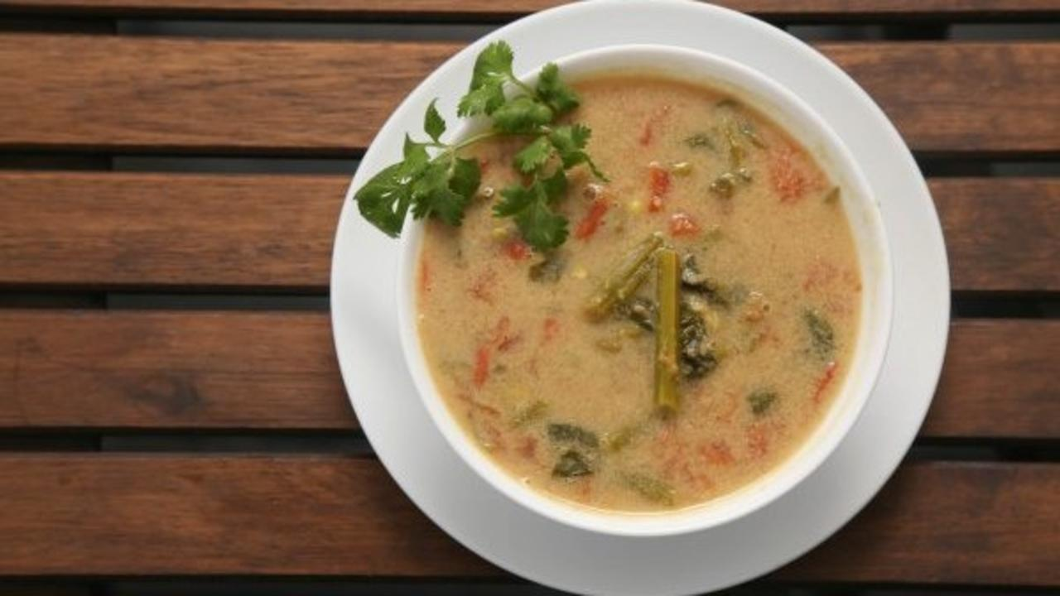

Vale Bajji Ambat is a delicious Konkan curry made with Malabar spinach or basale soppu, served with unpolished rice, jolada roti or ragi mudde. Vale bajji is the Konkan name for Malabar spinach, and ambat means curry. Malabar spinach is a highly nutritious green leafy vegetable, a perennial vine. It is also used as a home remedy for skin allergies.

Malabar spinach grows everywhere in coastal areas and western ghats of Karnataka. My aunt said that basale soppu would grow all around their homes in summer, they just had to harvest it and make this yummy curry. Both the stem and leaves are used in the curry. The stems need to be chewed on and fiber discarded, like drumsticks. The leaves can be eaten completely.

We have used the more traditional pepper instead of red chili that is used now, to make vale bajji ambat spicy without causing irritation to the digestive tract. We have also avoided garlic to make it satvik. We hope you enjoy it!

### Whole Food Plant Based Vale Bajji Ambat Recipe

Course: Course 2 (Vegetable Dishes) for Lunch & Dinner Meals  
Cuisine: Satvik Coastal Karnataka Recipe from South India  
Prep Time: 10 minutes   
Cook Time: 15 minutes  
Servings: 4 people

#### INGREDIENTS

1 cup Moong dal sprouted  
1 cup Coconut grated  
2 Tomato chopped  
2 cup Basale Soppu Vale Bajji / Malabar Spinach, chopped  
2 tsp Coriander Seeds Powder / Dhaniya Powder  
1 tsp Jeera / Cumin Seeds  
1 tsp Turmeric Powder  
1/2 tsp Black Pepper Powder  
4 tsp Miso Paste  
2 tsp Coriander leaves chopped  
2 cups Water

#### INSTRUCTIONS

1. Remove leaves of basale soppu and chop stems in 1-2 inch pieces. Boil sprouted moong dal, Malabar spinach, chopped tomatoes together 1 cup water, dhaniya powder, and turmeric powder.
2. Blend grated coconut with water, miso paste, jeera powder, and black pepper powder to a smooth paste.
3. Once vegetables are cooked, switch off stove. Add spiced coconut paste.
4. Garnish with coriander leaves and serve with brown rice, ragi mudde or [foxtail millet rava upma](https://www.nutritionscience.in/blog/foxtail-millet-rava-upma-recipe-millet-upma-recipe-whole-food-plant-based-recipes).

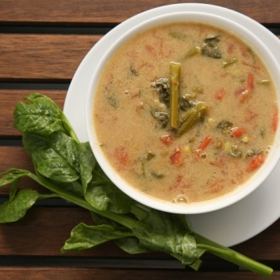

### Plant Based Chef Pro Tips for Best Vale Bajji Ambat Recipe

1. Split yellow moong dal or toor dal can also be used instead of sprouted moong dal.
2. Increase quantity of pepper for a spicy curry.
3. Use Kokum or Garcinia with tomato for an authentic Western Ghat flavour!
4. You can also add little bit of seeds like methi, poppy, fennel for more vibrant flavours.

# 118.Foxtail Millet Veg Pulao Recipe | Veg Pulao with Foxtail Millet Rice | Whole Food Plant Based Recipes

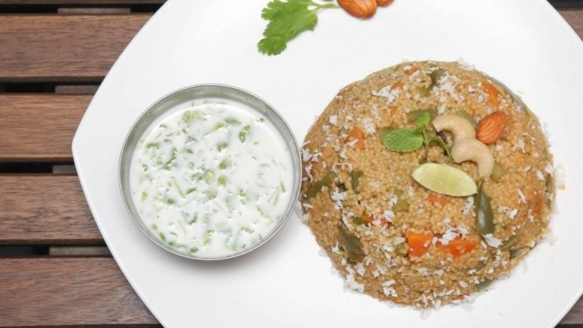

Foxtail Millet Vegetable Pulao is a dish with a rich history. Born in ancient India, pulāka in sanskrit means a ‘ball of rice’. Pulao was mentioned in the Mahabharatha, and taken to Europe by Alexander the Great. Interestingly, the first recipe for pulao was written by Avicenna, an ancient Persian physician!

Foxtail millet is deceptively simple to cook. Once you get the millet:water proportion right, you’re all set for a super healthy pulao! 🙂

Pulao is usually served with raitha. If you prefer a thin raitha, you could use coconut milk thambulli as a base. If you enjoy a thick, creamy raitha, peanut mylk is a better idea. Plant based mylks give you all the yumminess of milk without any of the cruelty or disease that comes with dairy milk. Enjoy!

### Whole Food Plant Based Foxtail Millet Veg Pulao Recipe

Course: Course 3 (Grain Dish) at Lunch & Dinner Meals, Millet Dishes  
Cuisine: North Indian  
Prep Time: 15 minutes   
Cook Time: 30 minutes  
Servings: 4 people

#### INGREDIENTS

1 cup Foxtail Millet / Navane  
1/2 cup Carrots chopped  
1/2 cup Beans chopped  
1/2 cup Capsicum chopped  
1/2 cup Fresh Green Peas  
1 stick Cinnamon  
3 Cloves  
1 Bay leaf

##### Veg Pulao Masala

1 Tomato chopped  
2 tsp Mint leaves chopped  
2 tsp Coriander leaves chopped  
1 tsp Fresh Ginger chopped  
1 tbsp Dhaniya / Coriander Seeds Powder  
1/2 tsp Black Pepper Powder  
1/2 tsp Jeera Powder / Cumin Powder  
4 tsp Miso Paste

#### Veg Pulao Garnishing

1 tsp Coriander leaves chopped  
2 tsp Coconut grated  
2 tsp Nuts Almonds or Cashews  
1/4 Lemon

#### INSTRUCTIONS

1. Soak 1 cup foxtail millet for 30 minutes. Cook with 1 cup water. Make sure it does not get overcooked. Switch off the stove when it is 3/4th of the way cooked.
2. Boil carrot, beans, and fresh green peas with cinnamon, cloves and bay leaf and just enough water to cover half the vegetables. Once they are almost cooked, add capsicum. Let it cook for a couple of minutes, while you prepare veg pulao masala.

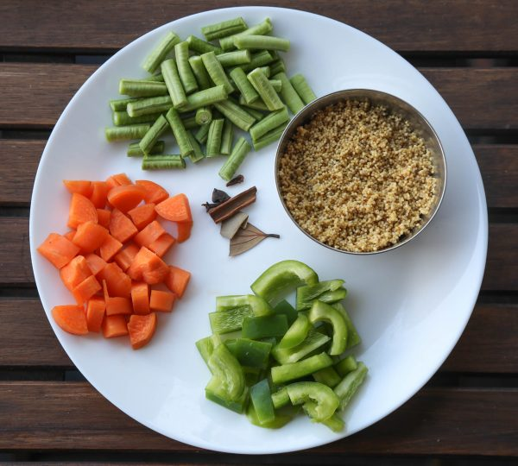

##### Veg Pulao Masala

1. Peel ginger. Blend tomato, dhaniya powder, and ginger to a paste.
2. Add this masala paste to the vegetable base and cook for few minutes.
3. Once it comes to a boil, add cooked millet and mix well. Close lid for few minutes and cook on low flame so that all the flavors are absorbed.
4. Once cooked, remove from stove, spread on a plate and let it cool completely.
5. Grind coconut with pudina leaves, jeera powder, black pepper powder, and miso paste. Mix into foxtail millet veg pulao.
6. Garnish with mint leaves and soaked nuts. Squeeze some lemon juice for some extra zing!
7. Serve fresh with [Raw Vegan Raitha](https://www.nutritionscience.in/blog/raw-vegan-raitha-recipe-whole-food-plant-based).

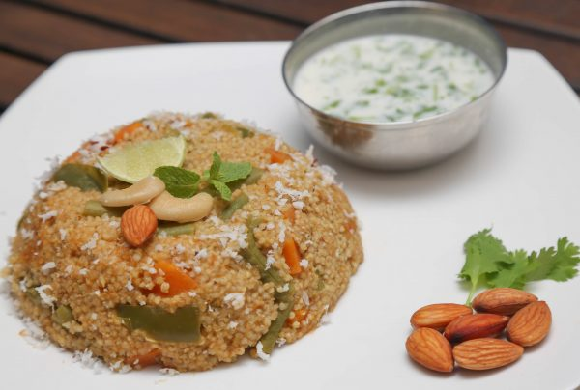

### Plant Based Chef Pro Tips for Best Foxtail Millet Pulao Recipe

1. Add exactly the right amount of water to cook millets and vegetables for the right pulao consistency!
2. Experiment with other vegetables or greens like palak or methi for different versions of Foxtail Millet Vegetable Pulao.
3. If you like it spicy then slit green chili can be added to boiling vegetables. Make sure not to bite the chili!
4. Apart from [raw vegan raitha](https://www.nutritionscience.in/blog/raw-vegan-raitha-recipe-whole-food-plant-based), you could also serve foxtail millet veg pulao with Coconut Milk Thambulli instead of buttermilk or Peanut Curds instead of dairy curds.

# 119.Chana Sundal Recipe | How to Make Sundal Recipe | Whole Food Plant Based Recipes

.

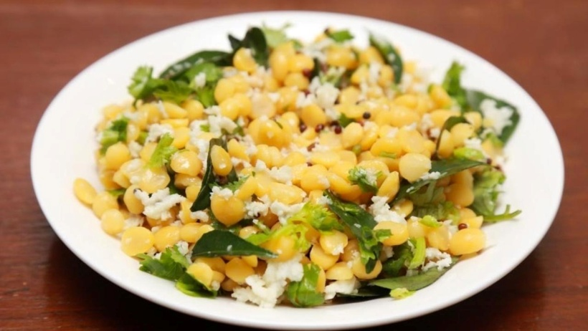

Sundal! Usili! Yum! Be it Ganesh Chaturthi or Navratri, our grandmother would prepare a different variety of sundal every day of the festivals.

#### Why Sundal?

This is the time of year when many different varieties of legumes are harvested, to be made into pulses and stored for the rest of the year. While they are available as fresh, whole legumes, sundal is the dish to feast on! Whole or split, Black, brown, white, and all shades in between, usli is quite a heavy dish! It can keep you full for hours, which was perfect for working for hours in the fields.

Sundal can be prepared from any legume, like white chickpeas, black chickpeas, split bengal gram, green peas, whole moong dal, you name it. Just cook them whole, add in some nuts, spices, herbs and a bit of miso paste, and voila!

Check out our tangy sundal recipe here, and share it with your cousins, aunts and uncles! 🙂

Also check out our [coconut thambulli recipe](https://www.nutritionscience.in/blog/Coconut-Thambuli-Dairy-Free-Buttermilk-Thambli-Dairy-Alternative-Whole-Food-Plant-Based-Recipes), the perfect accompaniment to usli!

Upgrade to food that truly loves you back!

### Whole Food Plant Based Chana Sundal Recipe

Course: Side Dish for Course 3 (Grain Dishes) for Lunch & Dinner Meals, Festival Dishes, Snack  
Cuisine: Satvik Karnataka Recipe from South India  
Prep Time: 5 minutes   
Cook Time: 20 minutes  
Servings: 4 people

#### INGREDIENTS

1 cup Split Bengal Gram soaked  
1 tsp Mustard Seeds  
1 tsp Cumin Seeds  
5-6 Curry Leaves  
1 Green Chili slit  
1/2 inch Ginger chopped  
1 pinch Asafoetida / Hing  
4 tsp Miso Paste (Healthy Salt Alternative. See Nutrition Science Highlights below)  
3 cups Water as required

#### Garnishing

3 tsp Coconut grated  
2 tsp Coriander Leaves chopped  
Juice of 1/2 Lemon

#### INSTRUCTIONS

1. Rinse Split Bengal Gram Dal thouroughly and soak it for 2-3 hours in enough water to cover it fully.
2. Drain the soaked water. Boil bengal gram dal on low flame with 1/2 tsp salt and 2-3 cups of water till it is soft and well cooked, but each gram separate from the others. If there is excess water, use for [Obbattu Saaru Recipe](https://www.nutritionscience.in/blog/obbattu-saaru-recipe-karnataka-recipe-whole-food-plant-based-recipes).
3. While it is cooking, dry roast mustard roast for a few seconds and switch off the stove as soon as its starts sputtering.
4. Garnish with dry mustard tadka, cumin seeds, curry leaves, slit green chili, pepper powder, finely chopped ginger, grated coconut, chopped coriander leaves, lemon juice, and asafoetida. Mix well.
5. Serve fresh!

### Plant Based Chef Pro Tips for Best Chana Sundal Recipe

1. Replace split bengal gram with black or white chickpeas and follow the same procedure.
2. Chopped onions can be added as well.

# 120.Methi Payasam Recipe | Methi Recipe During Pregnancy | Whole Food Plant Based Recipes

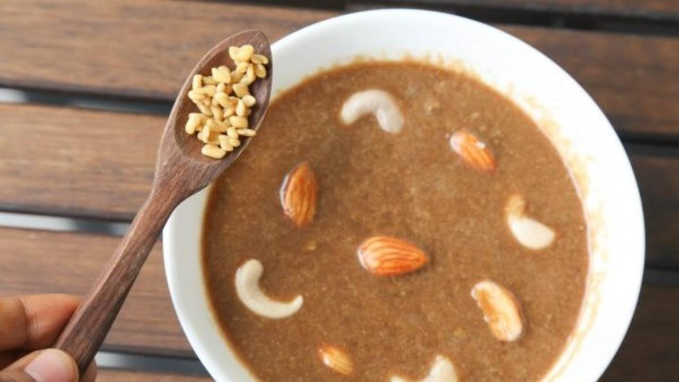

Methi Payasam or Menthe paez is a payasam or kheer made specially for lactating mothers. Don’t let that make you think twice – it’s super yummy!

Methi or Fenugreek is an amazing plant! Both the leaves and seeds are medicinal and highly nutritious. It has been found to be a galactogogue, which means it helps increase breast milk production. Since it is bitter, it slows down digestion and helps in slowing the rate at which sugar is absorbed by the digestive system. This has made scientists look at using methi seeds therapeutically for diabetes.

This methi payasa recipe from the villages of Karnataka will leave your family guessing what you put into it. Try it out and let us know how they like it! 🙂

Recipe courtesy : Tulasi Kharvi

### Whole Food Plant Based Methi Payasam Recipe

Course: Dessert in Course 3 (Grain Dishes) at Lunch & Dinner Meals, Sweet, Snack  
Cuisine: Satvik Coastal Karnataka Recipe from South India  
Prep Time: 10 minutes   
Cook Time: 30 minutes  
Servings: 2 people

#### INGREDIENTS

1 tbsp Methi Fenugreek Seeds  
1/2 cup Red Rice  
1 cup [Date Syrup](https://www.nutritionscience.in/blog/date-syrup-recipe-whole-food-plant-based)  
1 cup Coconut grated  
1/2 tsp Cardamom powder  
2 tsp Cashews & Almonds for garnishing  
2 cups Water

#### INSTRUCTIONS

1. Soak methi and unpolished rice separately overnight.
2. Cook soaked methi and unpolished rice in a vessel until soft.
3. Once cooked, remove from stove and add date syrup and cardamom powder.
4. Grind coconut to a paste and mix in. Let it cool completely.
5. Garnish with soaked nuts. Serve Fresh!

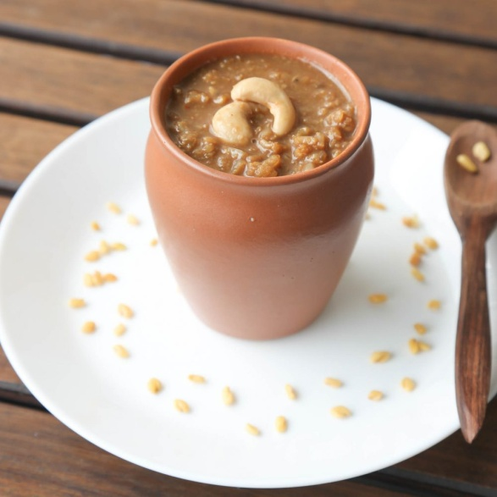

### Plant Based Chef Pro Tips for Best Methi Payasam Recipe

1. Sprouted methi can be used to reduce bitterness.

# 121.Jowar Puran Poli Recipe | How to Make Puran Poli | Whole Food Plant Based Recipes

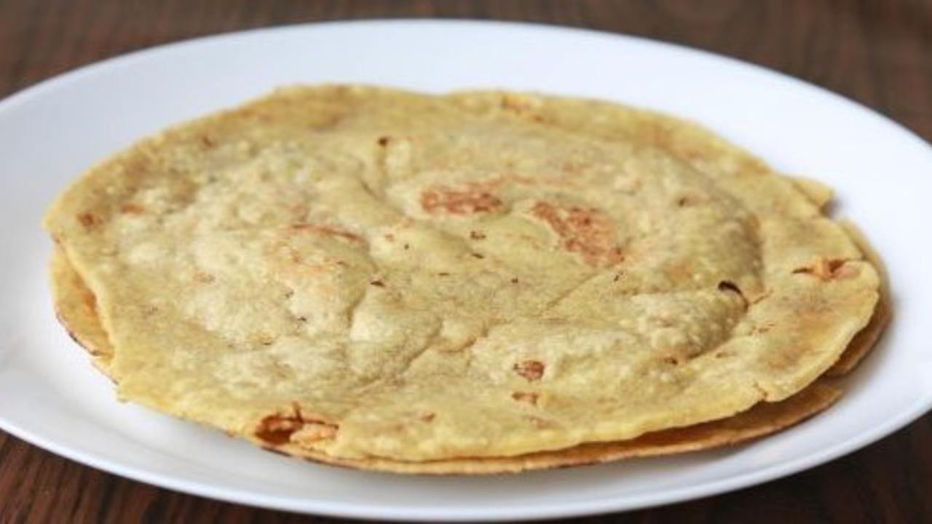

Puran Poli! Sweet memories of waiting with excitement as our grandmother rolled them out, one by one. I love them with a dollop of coconut paste. And you?

Puran Poli, Holige, Obbattu, Poli, Bobbatlu… this delicacy has as many names as variations, from different parts of India. It is one of the special feast recipes prepared during festivals like Ugadi, Diwali, weddings and other special occasions. There are several varieties of Holige depending on the sweet stuffing used like peanut holige, coconut (kai) holige, tur dal or bengal gram (bele) holige, and sesame seed (ellu) holige. Most people today prepare it using either maida/all purpose flour. But Maida is refined, and causes disease. One way around this is to find and use millets instead.

This is a millet version of the popular puran poli. After many weeks of experimenting, we have perfected this sorghum or jowar puran poli, and it tastes amazing!

Do try it out!

### Whole Food Plant Based Jowar Puran Poli Recipe

Course: Dessert in Course 3 (Grain Dish) at Lunch & Dinner Meals, Festival Dish, Millet Dish, Snack, Sweets  
Cuisine: Satvik Maharashtra Recipe from North India  
Prep Time: 10 minutes   
Cook Time: 30 minutes  
Servings: 4 people

#### INGREDIENTS

##### Jowar roti for Puran Poli

1 cup Sorghum Flour / Jowar Atta  
1/2 cup Groundnuts / Peanuts  
1/2 cup Besan flour / Garbanzo Bean Flour  
1/4 cup Flaxseed Powder  
1/2 tsp Turmeric Powder  
1 tsp Xanthan Gum (optional)  
Water as required

##### Puran Poli Stuffing

1 cup Bengal Gram Dal soaked  
1 cup Date Syrup  
1/4 tsp Cardamom Powder / Elaichi  
4 cup Water

#### INSTRUCTIONS

##### Puran Poli Stuffing

1. Soak bengal gram for 1 hour. Strain the water and use for your garden.
2. Cook soaked bengal gram dal with water until it becomes soft. Strain the water and use for [Obbattu Saaru Recipe](https://www.nutritionscience.in/blog/obbattu-saaru-recipe-karnataka-recipe-whole-food-plant-based-recipes).
3. Blend cooked bengal gram dal with date syrup and elaichi powder. This is Puran Poli Stuffing. Keep it aside.

##### Jowar Roti Dough for Puran Poli

1. Blend 1 cup raw groundnuts into a smooth raw peanut butter.
2. Boil 1.5 cup water. When it starts boiling, add 1 cup jowar flour, mix well, switch off the stove.
3. Mix this with 1/2 cup besan flour and peanut butter, turmeric powder, flaxseed powder and xanthan gum. Knead well to make a smooth dough. The dough should feel slightly oily at this point.
4. You should be able to make a ball without any breaks. If it breaks, add a little water and knead again. If it is too sticky, add some flour.

##### Preparing Jowar Puran Poli

1. Dust some flour on your hands and the kitchen counter. Take a small ball of dough. Flatten it first on your hands. Lay the flattened roti on the counter. You can choose to continue flattening it with hands or roll it with a chapati roller. Flatten it into a small roti or bread.
2. Now, take 1 or 2 tsp of stuffing prepared. Place it at the centre of roti and cover it with the flattened roti, press it well so that stuffing is at the centre and doesn't come out.
3. Now roll this again using dry flour so that it doesn't stick. Keep rolling to form a thin Holige or Roti.
4. Heat an iron tava - make sure it is heated well. If required, smear a drop of oil on iron tava and clean it up. This should be done only for the first puran poli, to season the tava. Once it is ready, place the roti on the tava and immediately smear some water on the roti - like how oil is generally smeared on chapatis. Be careful not to put too much water.
5. Turn the roti over just when the smeared water dries up. Let it cook on the other side. Once done, turn it over once more. Ensure both sides are cooked well.
6. Once cooked, let it cool fully. Serve fresh with coconut paste!

### Plant Based Chef Pro Tips for Best Jowar Puran Poli Recipe

1. You can close the lid while cooking roti to make it softer. Make sure it is on low flame!
2. Cook only for some time to get soft rotis. Cooking for more time will make it crispy but even that does taste good!
3. Smear peanut butter once roti is cooked and is warm so that roti can remain softer.
4. Serve with something watery, like coconut paste or cashew mylk.

# 122.Onion Tomato Chutney | How to Make Chutney | Whole Food Plant Based Recipes

### Whole Food Plant Based Onion Tomato Chutney Recipe

Course: Side Dish Course 3 (Grain Dish) at Lunch & Dinner Meals or Snacks; Chutney  
Cuisine: Tamil Recipe from South India  
Prep Time: 2 mins  
Cook Time: 10 mins  
Servings: 4 people

#### INGREDIENTS

4 Tomatoes  
2 Onions  
1 Green Chili  
1 inch piece Ginger4 tsp Miso Paste (Healthy Salt Alternative. See Nutrition Science Highlights below)  
5 Curry Leaves finely chopped  
1 pinch Asafoetida / Hing

#### INSTRUCTIONS

1. Peel onion and ginger. Grind onion, tomato, and green chili to a paste. Cook until done.
2. Mix in miso paste and asafoetida / hing.
3. Garnish with curry leaves. Serve fresh!

### Plant Based Chef Pro Tips for Best Onion Tomato Chutney Recipe

1. This is a super spicy recipe! Replace green chili with 1/2 tsp Black Pepper Powder for a milder onion tomato chutney recipe..

# 123.Nuchinunde Recipe | How to Make Nuchinunde | Whole Food Plant Based Recipes.

### Whole Food Plant Based Nuchinunde Recipe

Course: Course 3 (Grain Dish) at Lunch & Dinner Meals  
Cuisine: Satvik Karnataka Recipe from South India  
Prep Time: 5 mins  
Passive Time: 2 hours  
Cook Time: 15 mins  
Servings: 4 people

#### INGREDIENTS

2/3 cup Toor Dal  
1/3 cup Chana Dal / Bengal Gram Dal  
1/4 cup Dill Leaves / Sabsige Soppu Leaves  
1 inch piece Ginger1 Green Chilli  
10 Curry Leaves finely chopped  
1/4 cup Coconut grated  
1 pinch Asafoetida / Hing  
4 tsp Miso Paste (Healthy Salt Alternative. See Nutrition Science Highlights below)

#### INSTRUCTIONS

1. Soak toor dal and bengal gram dal / chana dal overnight or at least for 2 hours, then grind coarsely without adding water.
2. Peel ginger. Finely chopped ginger, green chili, curry leaves, miso paste, and hing / asafoetida. Mix into dal batter.
3. Form into oval-shaped dumplings and steam for 10 to 15 minutes.
4. Garnish with freshly grated coconut and serve fresh with [Majjige Huli](https://www.nutritionscience.in/blog/majjige-huli-recipe-how-to-make-majjige-huli-whole-food-plant-based-recipes)!

### Plant Based Chef Pro Tips for Best Nuchinunde Recipe

1. Use extra ginger for extra zing!
2. Try different herbs and spices, like coriander leaves, cumin / jeera powder garlic, and onion, for different flavours of nuchinunde.

# 124.Majjige Huli Recipe | How to Make Majjige Huli | Whole Food Plant Based Recipes

### Whole Food Plant Based Majjige Huli Recipe

Course: Side Dish for Course 3 (Grain Dish) at Lunch & Dinner Meals  
Cuisine: Satvik Karnataka Recipe from South India  
Prep Time: 10 mins  
Cook Time: 15 mins  
Servings: 4 people

#### INGREDIENTS

2 cups Ashgourd / White Pumpkin  
1 tsp Turmeric Powder  
1/2 tsp Methi Powder / Fenugreek Seed Powder  
1 Green Chilli  
1 tsp Cumin / Jeera Powder  
1 tsp Black Pepper Powder  
1 pinch Asafoetida / Hing  
4 tsp Miso Paste (Healthy Salt Alternative. See Nutrition Science Highlights below)  
Juice of 1 Lemon  
1 cup Grated Coconut or Coconut Paste  
1 tsp Mustard Seeds  
10 Curry Leaves

#### INSTRUCTIONS

1. Peel and remove seeds from ashgourd / white pumpkin. Reserve seeds and peel for making ashgourd peel chutney.
2. Chop ashgourd into large pieces. Boil in minimal water until cooked, with turmeric powder, methi powder and slit green chili.
3. Grind coconut with cumin / jeera powder, black pepper powder, miso paste, lemon juice, and asafoetida / hing.
4. Once ashgourd is cooked, remove from stove and mix in coconut masala paste.
5. Dry roast mustard seeds. As soon they start sputtering, mix into Majjige Huli.
6. Garnish with fresh curry leaves. Serve fresh with [Nuchinunde](https://www.nutritionscience.in/blog/nuchinunde-recipe-how-to-make-nuchinunde-whole-food-plant-based-recipes)!

### Plant Based Chef Pro Tips for Best Majjige Huli Recipe

1. Instead of coconut paste, use peanut curds for a slightly different consistency.

# 125.Mint Ginger Kashayam Recipe | Herbal Tea Recipe | Whole Food Plant Based Recipe

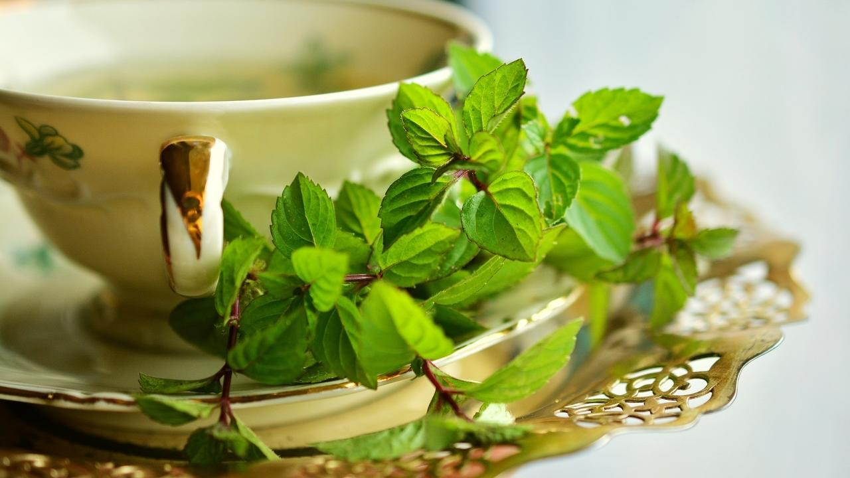

### **Whole Food Plant Based Mint Ginger Kashayam Recipe**

Course: Beverage, Snack  
Cuisine: South Indian Recipe  
Prep Time: 5 minutes  
Servings: 2 Glasses

#### **INGREDIENTS**

2 sprigs Mint / Pudina  
½ cm piece Ginger  
1 tsp Raisins  
6 Walnuts  
2 glasses Water

#### **INSTRUCTIONS**

1. Peel ginger and chop into tiny pieces. Chop raisins.
2. Heat water to a boil. Remove from stove, then mix in pudina / mint leaves, chopped ginger and raisins. Leave covered for 3 minutes.
3. Garnish with 3 walnuts each. Serve fresh!

### **Plant Based Chef Pro Tips for Best Mint Ginger Kashayam Recipe**

1. Use other herbs and spices, like basil, coriander leaves, or cinnamon to create different flavours!

# 126.Tomato Mint Juice Recipe | Smoothie Recipe | Whole Food Plant Based Recipes



### **Whole Food Plant Based Tomato Mint Juice Recipe**

Course: Beverage, Breakfast, Snack  
Cuisine: Indian Recipe  
Prep Time: 2 minutes  
Servings: 2 Glasses

#### **INGREDIENTS**

6 Tomatoes  
4 sprigs Mint / Pudina  
¼ tsp Black Pepper Powder  
6 Walnuts

#### **INSTRUCTIONS**

1. Chop tomatoes into quarters. Grind well in a high-powered blender with pudina / mint leaves and black pepper powder.
2. Garnish with 3 walnuts each. Serve fresh!

### **Plant Based Chef Pro Tips for Best Tomato Mint Juice Recipe**

1. Use other herbs and spices, like basil, coriander leaves, or cinnamon to create different flavours

# 127.Beans Paruppu Usili Recipe | Beans Usili Recipe | Whole Food Plant Based Recipes

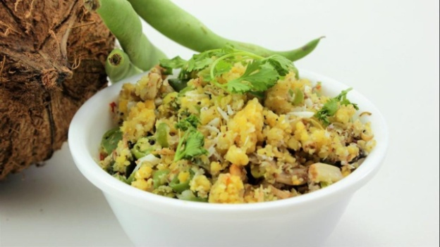

Simple dish with a combination of French beans and Lentil or grams! Here's an Usili Recipe without a drop of oil, yet light and fluffy. Check out how we did it!

### Whole Food Plant Based Beans Paruppu Usili Recipe

Course: Course 2 (Vegetable Dish) for Lunch & Dinner Meals  
Cuisine: Tamil Recipe from South India  
Prep Time: 15 min   
Passive Time: 5 min  
Cook Time: 10 min  
Servings: 2 cups

#### INGREDIENTS

200 grams Beans  
1/2 cup Toor dal / Split Pigeon Pea  
1/2 cup Bengal Gram Dal  
1 tsp Turmeric Powder  
1/2 Green Chili  
1 tsp Black Pepper Powder  
1 sprig Curry Leaves  
1 pinch Asafoetida / Hing  
4 tsp Miso Paste (Healthy Salt Alternative. See Nutrition Science Highlights below)  
1/4 cup Coconut grated

#### INSTRUCTIONS

##### Paruppu (Dal)

1. Wash and soak toor dal and bengal gram dal in water for at least one hour.
2. Drain water and grind dals into a chunky paste along with turmeric powder. Do not add water. The batter must be thick.
3. Steam cook the batter into idlis in an idli cooker. You could also spread it on a plate or wide vessel to cook it in a steamer. If you don't have either of these, take a big vessel with water. Place an upturned cup with a flat base in the centre of the vessel and keep your plate of dal batter on top of it. Ensure that the vessel isn't much wider than the plate - it could fall and create a mess! Cook until done.
4. Once it is cooked, take it out and let it cool completely. This is when it gets its crumby texture. Keep aside.
5. Place the idlis one by one in a mixie and pulse for just one second or less each, so that they are ground into a fluffy crumble. If you grind them for more than a second, they will become a thick paste. Avoid this.
6. Dry roast mustard seeds. When they start popping, mix into paruppu usili.
7. Mix paruppu usili with black pepper powder, curry leaves, hing / asafoetida, miso paste, and grated coconut.

#### Beans

1. String and cut beans into small pieces. Boil them in a vessel with closed lid. Use just enough water to cover less than one third of the beans, so there is no water left when the beans are cooked.

#### Final Beans Paruppu Usili Recipe

1. Mix the cooked beans and paruppu (dal). Be gentle so the paruppu remains fluffy.
2. Garnish with some more fresh coconut and curry leaves or coriander leaves.

### Plant Based Chef Pro Tips for Best Beans Paruppu Usili Recipe

1. Properly cooked Paruppu Usli should be light and crumby to touch, not heavy and wet.
2. This is a heavy-to-digest dish, and is normally served with other light side dishes that aid digestion - usually rasam or [pepper sambar (milagu kuzhambu](https://www.nutritionscience.in/blog/milagu-kuzhambu-recipe-pepper-broth-whole-food-plant-based-recipes)). Check out [obbattu saaru](https://www.nutritionscience.in/blog/obbattu-saaru-recipe-karnataka-recipe-whole-food-plant-based-recipes) to find out how to make lip smacking rasam without oil or tamarind!
3. Many other vegetables can also be used to prepare Paruppu Usli, like cluster beans (kotthavarangai), banana flower, and cabbage.
4. Adding a greater proportion of toor dal will give you a softer Usuli.

# 128.Obbattu Saaru Recipe | Karnataka Recipes | Whole Food Plant Based Recipes

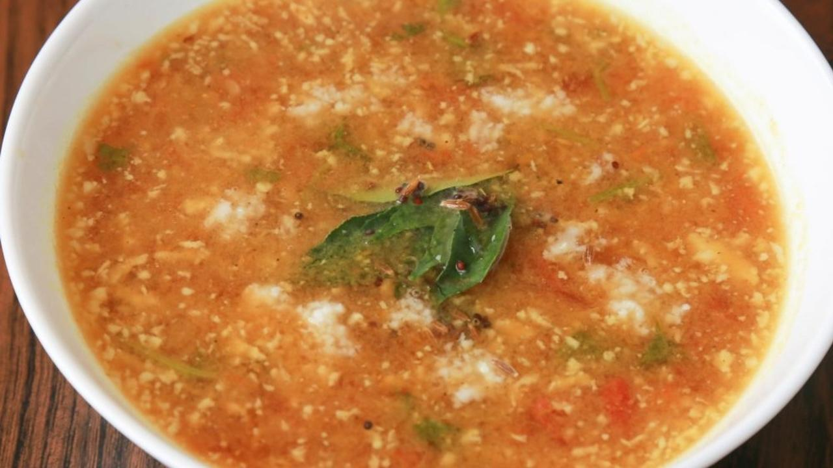

Obbattu Saaru or Holige Saaru is a rasam (soupy lentil dish) with a twist! It is made using the remaining stock after cooking the bengal gram stuffing for Holige. The stock and a bit of the obbatu stuffing is recycled with fresh pulpy tomatoes to create a new, wholesome, and soupy rasam or curry. Obbattu saaru is a dish popular in Karnataka and is prepared during festivals like Ugadi and Gowri Habba among others.

Obbattu Saaru is well-spiced and flavoured with pepper and other spices. It is sweetened with a dash of jaggery which balances out the natural sourness of tomatoes and makes for a yummy and soothing soup! Obbatu Saaru is usually prepared in large quantities and consumed over a day or two, however, it is good to make and consume this rasam fresh. It goes well with any unpolished rice, foxtail millet rice or ragi mudde.

Upgrade to food that truly loves you back!

### Whole Food Plant Based Obbattu Saaru Recipe

Course: Side Dish for Course 3 (Grain Dishes) for Lunch & Dinner Meals, Festival Dishes, Soup, Beverage  
Cuisine: Satvik Karnataka Recipe from South India  
Prep Time: 15 minutes   
Cook Time: 15 minutes  
Servings: 4 people

#### Ingredients

2 Large Tomatoes chopped  
1/2 cup Bengal Gram Dal chana dal, soaked  
1/4 cup [Date Syrup](https://www.nutritionscience.in/blog/date-syrup-recipe-whole-food-plant-based)  
1/2 tsp Cardamom powder  
1 tsp Black Pepper Powder  
1 tsp Cumin Seeds / Jeera  
2 tsp Coriander Seeds / Dhaniya Powder  
1 tsp Turmeric Powder  
1/8 tsp Fenugreek Seeds / Menthe Kaalu Pudi  
1/4 tsp Poppy Seeds / Gasgase  
1 Green Chili slit  
1 pinch Asafoetida / Hing  
1/4 tsp Turmeric Powder  
4 tsp Miso Paste (Healthier Salt Alternative. See Nutrition Science Highlights below)  
4 cups Water as required

##### Seasoning or Tadka

1 sprig Curry Leaves  
1/2 tsp Mustard Seeds / Sasive  
1/2 tsp Cumin Seeds / Jeera

##### Garnishing

1/4 cup Coriander leaves chopped  
1/4 cup Fresh Coconut grated

#### Instructions

1. Wash Bengal gram dal, add about 2 cup water and boil it on low flame with closed lid. Dal should be properly cooked and shouldn't be over cooked. Strain it and use the water or stock for rasam with 2 tsps of cooked dal to blend it for rasam. Rest of the cooked dal can be used to make Holige or Obbattu. Keep this aside.
2. Dry roast Poppy seeds lightly. Keep it aside. In the same tawa, add chopped tomato and cook it for sometime. Blend dry roasted poppy seeds with jeeera powder, dhaniya powder, black pepper powder, turmeric powder, half of chopped tomato, 2 tsp cooked dal and blend it into a smooth paste to make obbattu saaru masala.
3. Now to the bengal gram broth, add the remaining chopped tomato, ground obbattu saaru masala, date syrup, cardamom powder, and slit green chili. Let it cook well. Add water to adjust it to rasam or thin sambar consistency.  
   Once cooked, switch off stove and add miso paste and asafoetida / hing.
4. To prepare tempering, dry roast mustard seeds, cumin seeds and curry leaves. When they staart sputtering, immediately mix into obbattu saaru.
5. Garnish with coriander leaves and grated coconut. Serve with [kodo millet rice](https://www.nutritionscience.in/blog/kodo-millet-rice-recipe-how-to-make-millet-recipes-whole-food-plant-based-recipe) or [ragi mudde](https://www.nutritionscience.in/blog/how-to-make-ragi-mudde-ragi-mudde-recipe-whole-food-plant-based-recipes)

### Plant Based Chef Pro Tips for Best Obbattu Saaru Recipe

1. We haven't used onion or garlic to make it a satvik recipe. Crushed garlic can be cooked along with tomatoes if required.
2. Adjust the sweetness and sourness as needed.

# 129.Kodo Millet Rice Recipe | How to Make Millet Recipes | Whole Food Plant Based Recipe

 Upgrade to food that truly loves you back.

## Whole Food Plant Based Kodo Millet Rice Recipe

Course: Course 3: Grain Dishes for Lunch & Dinner Meals  
Cuisine: Fundamental Recipe, South Indian Recipe  
Prep Time: 2 minutes  
Cook Time: 20 minutes  
Servings: 4 people

### INGREDIENTS

1 cup Kodo Millet

### INSTRUCTIONS

1. Cook Kodo millet with 2 1/2 cups of water. Stir from time to time, ensuring it does not get burnt. Cook until cooked enough.
2. Once cooked, spread on a plate or large vessel to cool down completely. Serve fresh with [Harive Soppu Saaru](https://www.nutritionscience.in/blog/harive-soppu-saaru-recipe-dantina-soppu-saaru-recipe-whole-food-plant-based-recipes)!

### Plant Based Chef Pro Tips for Best Kodo Millet Rice

1. If you like your rice grains separate, use slightly less water and stir as little as possible, while ensuring to prevent burning
2. If you like your rice mashable, use slightly more water and stir well while cooking.

# 130.Harive Soppu Saaru Recipe | Dantina Soppu Saaru Recipe | Whole Food Plant Based Recipes

Harive Soppu Saaru is a south Karnataka delicacy, from Bengaluru, Mandya and Mysore. It is a hot favourite with Ragi balls / Mudde. This dish is filled with goodness that comes from greens and lentils. Harive Soppu translates to ‘Amaranthus Greens’. Cooked amaranthus greens are mashed to make this dish.

Enjoy making Harive Soppu Saaru the whole food plant based way with this recipe.

### Whole Food Plant Based Massoppu Saaru Recipe

Course: Course 2 (Vegetable Dish) or Side Dish for Course 3 (Grain Dishes) at Lunch & Dinner Meals  
Cuisine: South Karnataka Recipe from South India  
Prep Time: 10 minutes  
Passive Time: 2 hours  
Cook Time: 20 minutes  
Servings: 2 people

#### INGREDIENTS

2 cups Harive Soppu / Amaranthus Leaves and Stems chopped  
1/4 cup Togri Bele / Toor Dal / Pigeon Pea  
1 Tomato  
1 Onion  
8 cloves Garlic  
1 tsp Jeera  
1 tsp Pepper  
1 tsp Fennel Seeds / Saunf  
1 tsp Poppy Seed / Gasagase / Khus Khus  
1 tsp Coriander Seed / Dhaniya Powder  
3 tsp Miso Paste  
Water As required  
1/2 cup Coconut grated or ground to a paste  
2 tsp Coriander leaves

#### INSTRUCTIONS

1. Soak toor dal for 2 hours.
2. Wash harive soppu / amaranthus greens and chop it into small pieces. Peel and chop onion into small pieces. Chop tomato into small pieces.
3. Cook toor dal with a half closed lid, taking care not to let us boil over or get burnt. Once half cooked, add harive soppu / amaranthus greens, tomato, and onion. Continue cooking.
4. Peel and grind or crush garlic into a paste. Keep aside for ten minutes.
5. In the meantime, dry grind jeera, pepper, fennel, poppy seeds, dhaniya powder, and miso paste.
6. Once garlic has sat for ten minutes, mix into the boiling harive soppu saaru, along with the freshly ground masala.
7. Once dal and harive soppu / amaranthus greens are well cooked, let it cool for few minutes, then mash well with a wooden or metal masher. Alternatively, you could add 3/4 of the dish into a blender and blend to a paste, and then mix it back. However, mashing enhances the texture of the dish compared to blending.
8. Dry roast mustard seeds until they just start sputtering, then mix into harive soppu saaru.
9. Garnish with grated coconut or coconut paste, and coriander leaves. Serve fresh with [ragi mudde](https://www.nutritionscience.in/blog/how-to-make-ragi-mudde-ragi-mudde-recipe-whole-food-plant-based-recipes), red rice or steamed savory kadubus.

### Plant Based Chef Pro Tips for the Best Massoppu Saaru Recipe

1. Mixed green leafy vegetables can be used to make [massoppu saaru](https://www.nutritionscience.in/blog/massoppu-saaru-recipe-ragi-mudde-side-dish-whole-food-plant-based-recipes).
2. Dry roasted curry leaves and urad dal can be added along with dry roasted mustard seeds too.
3. A tsp of date syrup can be used for some sweetness and extra tomato or kokum for extra sourness.

# 131.Going Nuts Salad Recipe | Salad Recipes | Whole Food Plant Based Recipes

### **Whole Food Plant** Based**Going Nuts Salad Recipe**

Course: Breakfast, Snack, Salad, Course 1 (Raw Dish) at Lunch & Dinner Meals  
Cuisine: American Recipe  
Prep Time: 10 minutes  
Servings: 4 cups

#### **INGREDIENTS**

2 Tomatoes  
1 Onion  
1 large or 2 small Cucumbers  
2 tbsp Almonds  
2 tbsp Walnuts  
2 tbsp Sunflower Seeds  
2 tbsp Flaxseeds  
2 tbsp Watermelon Seeds  
1 tbsp Chia Seeds  
2 tbsp Cashews  
½ tsp Black Pepper Powder  
4 tsp Miso Paste (Healthy Salt Alternative. See Nutrition Science Highlights below)  
Juice of 1 Lemon   
¼ cup Coriander Stems & Leaves chopped

#### **INSTRUCTIONS**

1. Peel onions. Chop tomatoes, onions, and cucumbers into medium sized cubes.
2. Grind cashews with a few tsp of water to a smooth paste with black pepper powder, miso paste, and lemon juice.
3. Mix all ingredients together. Garnish with chopped coriander stems & leaves. Serve fresh!

### **Plant Based Chef Pro Tips for Best Going Nuts Salad Recipe**

1. Soak nuts overnight to make them sweeter and more nutritious.
2. Use other herbs and spices, like cinnamon, jeera powder, basil leaves, curry leaves, and pudina to create different flavours!

# 132.Raw Coconut Blueberry Cheesecake Recipe | No Bake Cheesecake | Whole Food Plant Based Recipes



Cheesecake from ancient Greece, filled with the goodness of whole plant foods, packed with coconut and blueberry! Can it get healthier than this? 🙂

Cheesecakes today are made with a base or crust with layers of cheese, eggs, gelatin or fruits, many flavours and filled with sugar. Why use sugar and dairy when we can have an absolutely yummy, sugar free, dairy free, oil free, healing, whole foods plant based cheesecake?

The cherry on top? This recipe is 100% Raw!

Here comes a pseudo cheesecake to cheat our tummy with goodness of fresh blueberries, cashews, fresh tender coconut pulp, and the sweetness of dates and raisins. Blueberries are highly nutritious with amazing anti inflammatory properties and high antioxidant levels. Tender coconut is a superfood, and both its water and meat is very beneficial for health. Coconut meat provides an abundance of vitamins, minerals, antioxidants and fiber.

Get ready for a heavenly cheeseless cheesecake! Say cheese! 🙂

Course: Course 1 (Raw Dish) or Dessert at Lunch & Dinner Meals, Snacks, Sweets  
Cuisine: Greek Recipe, Raw Recipe  
Prep Time: 30 minutes   
Passive Time: 4 hours  
Servings: 3 people

#### INGREDIENTS

##### Ingredients for Cheesecake Crust

1/2 cup Almonds  
1/2 cup Walnuts  
1/2 cup Dates  
Few strands of Saffron

##### Ingredients for Blueberry Layer

1 cup Cashews  
3/4 cup Blueberries (any other berries or even pomegranate juice can be used)  
1/2 cup Dates  
Juice of 1/2 Lemon  
2 tsp Water as required

##### Ingredients for Tender Coconut Layer

1/2 cup Tender Coconut Pulp  
1/4 cup Raisins as per taste  
1/4 cup Cashews  
Juice of 1/4 Lemon  
1 tsp Tender Coconut Water as required  
1/2 tsp Elaichi / Cardamom Powder

#### INSTRUCTIONS

##### Cheesecake Crust

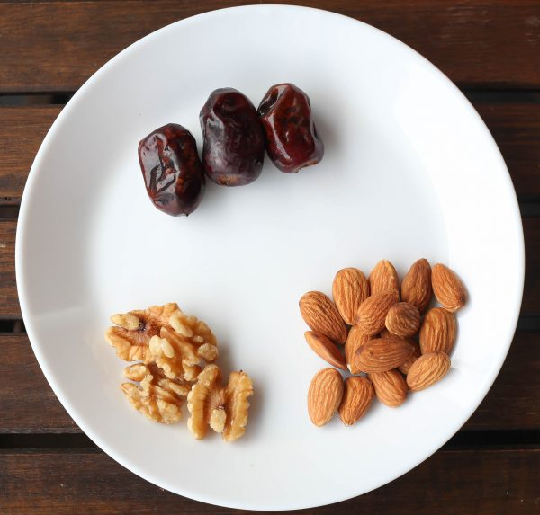

1. Soak dates for 2 hours in water.
2. Blend raw almonds and walnuts into a coarse powder with saffron. Keep aside.
3. Blend soaked dates to a paste. Blend again with powdered nuts so that it sticks together to form a crust layer. Adjust sweetness with extra dates if required.
4. Grease a cheesecake mould with little water or use unbleached parchment paper and press this mixture as the base or crust. Freeze for one hour.

##### Blueberry layer

1. Soak cashews and dates for 2 hours.
2. Blend soaked dates to a paste. Add soaked cashews, blueberry, and lemon juice. Blend into a smooth paste. Adjust sweetness if required.
3. Add this mixture on the crust. Freeze again for an hour.

##### Tender coconut layer

#### https://s3.amazonaws.com/kajabi-storefronts-production/blogs/10455/images/aebBlZdbT4237S5Vg0L1_Raw_Coconut_Blueberry_Cheesecake_2.jpg

1. Soak cashews and raisins for 2 hours. Blend tender coconut meat, cashews, raisins, elaichi, and lemon juice together into a smooth paste, Add 1-2 tsp tender coconut water if required.
2. Add this mixture on the blueberry layer.

##### Toppings

1. Blend 2 tsp fresh blueberries and pour it on the cheesecake layer. Freeze for minimum 2 hours. Take it out just before serving. Top with fresh blueberries and serve fresh!

### Plant Based Chef Pro Tips for Best Raw Coconut Blueberry Cheesecake Recipe

1. Any berries like fresh strawberry, cranberry can be used. If not available, use pomegranate juice or vegetable juices or make a plain layer without blueberries in above recipe. Bananas can also be used for a totally different flavour.
2. Chocolate layer can be prepared with fresh cocao nibs if available.
3. Add cinnamon or clove powder to spice things up!
4. Serve just before eating, as it tends to get too soft and gooey if it warms up.
5. Add toppings of any nuts, dry fruits or fruit.
6. Base layer or crust should be firm to keep the cheesecake in place. Use any nuts of your choice. Sunflower or pumpkin seeds can also be used for the crust instead of nuts.

# 133.Mexican Rice Recipe | With Mexican Beans Recipe | Whole Food Plant Based Recipes

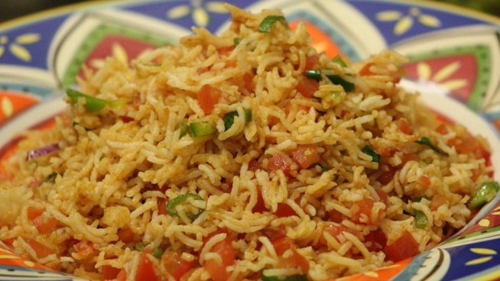

No Tamil Feast is complete without Puliyodarai and Coconut Rice! Here's a Coconut Rice Recipe without a single drop of oil!

### Whole Food Plant Based Mexican Rice Recipe

Course: Course 3: Grain Dish for Lunch & Dinner Meals  
Cuisine: Mexican Recipe  
Prep Time: 10 minutes   
Passive Time: 6 hours or Overnight  
Cook Time: 30 minutes  
Servings: 4 people

#### INGREDIENTS

1 cup Brown Basmati Rice  
1/2 cup Rajma / Red Kidney Beans  
4 Tomatoes  
1 Onion  
1 Green Chili  
5 cloves Garlic  
1/2 tsp Jeera / Cumin Powder  
1/4 tsp Black Pepper Powder  
1/4 cup Coriander Stems & Leaves chopped  
Juice of 1 Lemon  
1 tbsp [Almond Butter](https://www.nutritionscience.in/blog/almond-butter-recipe-whole-food-plant-based)  
4 tsp Miso Paste (Healthy Salt Alternative. See Nutrition Science Highlights below)

#### INSTRUCTIONS

1. Soak 1 cup brown basmati rice and rajma overnight, or at least for 6 hours. Pressure them separately until rice is just cooked enough, and rajma is well cooked. Once cooked, carefully spread brown basmati on a plate and let cool fully so the grains stay separate.
2. Peel garlic. Crush or grind to a paste and keep aside for ten minutes.
3. Peel onion. Chop onion, chili, and tomato into small pieces. Cook in a thick bottomed vessel. Once garlic has sat aside for ten minutes, add to this mix and cook until done.
4. Once cooked, remove from stove and add cooked rajma, jeera powder, black pepper powder, almond butter, miso paste, and lemon juice. Mix well.
5. Either layer the brown basmati rice and mexican beans in a bowl, or gently mix them together, garnish with coriander leaves, and serve fresh!

### Plant Based Chef Pro Tips for Best Mexican Rice Recipe

1. Mexican beans can be serve as a separate dish, or as a wrap with [corn tortillas (makki ki roti)](https://www.nutritionscience.in/blog/makki-ki-roti-recipe) too!

# 134.Guacamole Recipe | How to Make Guacamole with Raw Avocado | Whole Food Plant Based Recipes

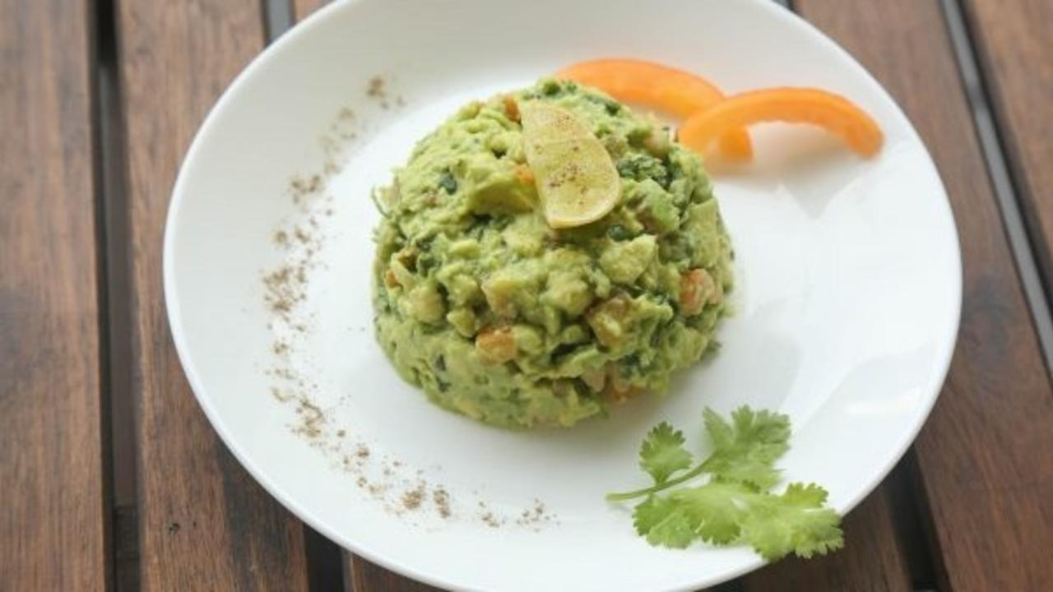

Guacamole Recipe, an Aztec delicacy with fresh avocado! Check out this authentic, quick, and yummy recipe from Mexican summers! You’d be surprised, it’s so simple!

The cousin brother of the Indian chutney, avocado guacamole is a truly mild fellow. Picture an old woman mashing ripe avocado and sea salt with a mortar and pestle. That’s guacamole for you! It may also include tomato, shallots, lemon juice, cilantro or coriander leaves, and pepper.

Fruits and nuts, unlike sweeteners and oils, are bursting with healthy carbs and fats, packaged with plenty of fiber and antioxidants. This means that they prevent and actually reverse diabetes, hypertension, PCOS, obesity, gout and other chronic lifestyle diseases!

Taking this one step further, in this guacamole recipe, we have avoided shallots to make it satwik. We love eating fresh guacamole added on top of raw cucumbers and with super soft and crispy neer dosa – this is, if any remains after the cooks have slyly eaten up most of it! What do you like eating it with? Comment below! 🙂

### Whole Food Plant Based Guacamole Recipe with Raw Avocado

Course: Course 1 (Raw Dish) at Lunch & Dinner Meals, Salad, Side Dishes, Snacks  
Cuisine: Satvik Mexican Recipe, Aztec Recipe  
Prep Time: 10 minutes   
Servings: 2 people

#### INGREDIENTS

1 Avocado Medium sized  
1 Lemon Medium sized  
1 Tomato  
1 pinch Pepper Powder  
2 tsp Coriander leaves chopped  
2 tsp Miso Paste (Healthy Salt Alternative. See Nutrition Science Highlights below)

#### INSTRUCTIONS

1. Cut avocado in two, remove seed and scoop out pulp. Add juice of half lemon immediately to prevent oxidation and browning. Mash the avocado with a fork into a chunky or fine paste, as you like your guacamole!
2. Chop tomatoes and coriander leaves into small pieces.
3. Add all ingredients to the avocado paste and mix. Serve as a dip with vegetables or as a side dish for Mexican Bean Wraps. Enjoy!

# 135.Cream of Pumpkin Soup | Recipe Pumpkin Soup | Whole Food Plant Based Recipe



Imagine some delicious, creamy and warm cream of pumpkin soup at the end of a long day. Soups are perhaps the best way of consuming a lot of vegetables and the yummiest way too. Children and adults alike take to well-made soups easily. If you are anything like me, you’ll know that there’s nothing like too much soup. Are you in the mood for some cream of pumpkin soup? Don’t reach out for the ready mix, instead get some pumpkin and we’ll show you the simplest and yummiest way to make some.

Pumpkins are a rich source of anti-oxidants and Vitamin A. This fibrous squash can be consumed in many forms and soup, curries, and pies top the list. This recipe for cream of pumpkin soup is really a bowl full of yumminess and health. Soups are truly soul food and we’ll show you how to make this soup with no animal products and yet oh so creamy and tasty!

Enjoy this delicious cream of pumpkin soup!

### Whole Food Plant Based Cream Of Pumpkin Soup

Course: Breakfast, Snacks, Soup, Beverage  
Cuisine: American Recipe  
Prep Time: 5 minutes   
Cook Time: 15 minutes  
Servings 2 people

#### INGREDIENTS

2 cups Yellow Pumpkin  
2 tbsp [Almond Butter](https://www.nutritionscience.in/blog/almond-butter-recipe-whole-food-plant-based)  
1/4 tsp Cinnamon Powder  
1/2 tsp Pepper as per taste  
2 tsp Miso Paste (Healthy Salt Alternative. See Nutrition Science Highlights below)  
1 cup Water as required

#### INSTRUCTIONS

1. Chop pumpkin into small pieces. Peels can be consumed as well. Boil pumpkin until cooked.
2. Once boiled, let it cool. Blend to a smooth paste, with the cooking water.
3. Mix in almond butter, cinnamon powder, pepper powder, miso paste, and lemon juice. Mix well.
4. Garnish with mint leaves. Serve fresh!
5. You can add spices like jeera, cloves etc to make it tastier.
6. Adjust consistency and creaminess by varying the quantity of water and almond butter.
7. To do a cream garnish, dilute the almond butter with some water to make almond cream, and garnish.

# 136.Coconut Rice Recipe | How to Make Coconut Rice | Whole Food Plant Based Recipes

No Tamil Feast is complete without Puliyodarai and Coconut Rice! Here's a Coconut Rice Recipe without a single drop of oil!

### Whole Food Plant Based Coconut Rice Recipe

Course: Course 3: Grain Dish for Lunch & Dinner Meals  
Cuisine: Tamil Recipe from South India  
Prep Time: 10 minutes   
Cook Time: 30 minutes  
Servings: 4 people

#### INGREDIENTS

1 cup Brown Rice soaked  
1 cup Coconut grated  
1 tsp Mustard Seeds  
1 tsp Urad Dal \ Split Black Gram  
3 tsp Peanuts roasted  
1 tbsp Curry Leaves  
1/2 Green Chili chopped  
4 tsp Miso Paste (Healthy Salt Alternative. See Nutrition Science Highlights below)

#### INSTRUCTIONS

1. Soak 1 cup brown rice for 30 minutes. Cook it with 2 cups water until it is soft but not over cooked. Spread it out on a large plate so it doesn't become sticky. Let it cool fully.
2. Dry roast groundnuts over low flame until just done.  Ensure that it does not darken. Remove on to a plate and roast urad dal the same way. Once it is light brown, add mustard seeds, curry leaves, chopped green chili and switch off the stove as soon as it starts sputtering. Make sure you do not over-roast any of these. See Nutrition Science Highlights below for details.
3. Once done, add the above seasoning to cooked rice, with grated coconut and miso paste. Mix well, taking care not to mash the rice. Serve fresh!

# 137.Vazhakkai Podimas Recipe | Raw Banana Recipe | Whole Food Plant Based Recipes

## Whole Food Plant Based Vazhakkai Podimas Recipe

Course: Course 2: Vegetable Dish for Lunch & Dinner Meals, Snack  
Cuisine: Tamil Recipe from South India  
Prep Time: 15 minutes   
Cook Time: 40 minutes  
Servings: 4 people

### INGREDIENTS

2 Vazhakkai / Raw Bananas  
2 tbsp Dhaniya / Coriander Seed Powder  
1 tbsp Jeera / Cumin Powder  
1 tbsp Turmeric Powder  
1 tbsp Black Pepper Powder  
1 pinch Asafoetida / Perunkaayam / Hing  
4 tsp Miso Paste (Healthy Salt Alternative. See Nutrition Science Highlights below)  
1/4 cup Coconut grated  
2 tsp Coriander Leaves

### INSTRUCTIONS

1. Peel and chop raw banana into bite-sized pieces. Steam for 10-15 minutes until cooked. If boiling, use minimal water so there is no excess water after it is cooked.
2. Grind or mix dhaniya powder, jeera powder, turmeric powder, black pepper powder, miso paste, and asafoetida / peunkaayam into a powder. Toss cooked vazhakkai with the powder to coat all of them evenly. Set aside to cool down completely.
3. Garnish with grated coconut and fresh coriander leaves and serve fresh!

### Plant Based Chef Pro Tips for Best Vazhakkai Podimas Recipe

1. Serve Vazhakkai Podimas along with a watery dish, such as raitha / pacchadi, to balance out the dryness.

# 138.Colocasia Sepankizhangu Podi Pota Poriyal | Oil Free Poriyal Recipes | Whole Food Plant Based Recipes

## Whole Food Plant Based Colocasia Sepankizhangu Podi Pota Poriyal Recipe

Course: Course 2: Vegetable Dish for Lunch & Dinner Meals, Snack  
Cuisine: Tamil Recipe from South India  
Prep Time: 15 minutes   
Cook Time: 40 minutes  
Servings: 6 people

### INGREDIENTS

1 kg Sepankizhangu / Colocasia / Arbi  
2 tbsp Dhaniya / Coriander Seed Powder  
1 tbsp Jeera / Cumin Powder  
1 tbsp Turmeric Powder  
1 tbsp Black Pepper Powder  
1 pinch Asafoetida / Perunkaayam / Hing  
6 tsp Miso Paste (Healthy Salt Alternative. See Nutrition Science Highlights below)  
1/4 cup Coconut grated  
2 tsp Coriander Leaves

### INSTRUCTIONS

1. Soak sepankizhangu / colocasia / arbi for 30 minutes to soften the mud sticking to them, if any. Wash welll to remove all the mud and dirt. Steam whole for 10 minutes until half cooked.
2. Peel and chop into 1 cm thick slices. It will be sticky at this point. This will go away after the next step.
3. Grind or mix dhaniya powder, jeera powder, turmeric powder, black pepper powder, miso paste, and asafoetida / peunkaayam into a powder. Toss chopped sepankizhangu / colocasia / arbi slices with the powder to coat all of them evenly.
4. Line a baking tray with unbleached parchment paper or silicone sheet. Arrange spiced sepankizhangu / colocasia / arbi slices on the tray without letting them touch each other.
5. Bake at 160 deg C for 10 minutes, then flip and bake for 5 more minutes or so until fully cooked.
6. Remove from oven and wait until they cool down fully. Garnish with grated coconut and fresh coriander leaves and serve fresh!

### Plant Based Chef Pro Tips for Best Baked Sweet Potato Wedges Recipe

1. Serve Colocasia Sepankizhangu Podi Pota Poriyal along with a watery dish, such as raitha / pacchadi, to balance out the dryness.

# 139.Manathakkali Keerai Masiyal Recipe | How to Make Manathakkali Keerai | Whole Food Plant Based Recipes

### Whole Food Plant Based Manathakkali Keerai Masiyal Recipe

Course: Course 2 (Vegetable Dish) for Lunch & Dinner Meals  
Cuisine: Tamil Recipe from South India  
Prep Time: 15 minutes   
Cook Time: 20 minutes  
Servings: 2 People

#### INGREDIENTS

1 bunch OR 2 cups Manathakkali Keerai Leaves / Black Nightshade or Sunberry Leaves  
1 Green Chili  
1 cm piece Ginger  
4 cloves Garlic  
1 Onion  
2 Tomatoes  
1 tsp Jeera / Cumin Powder  
1/2 tsp Black Pepper Powder  
2 tsp Miso Paste (Healthy Salt Alternative. See Nutrition Science Highlights below)  
1 pinch Asafoetida / Perunkaayam / Hing  
1/4 cup Fresh Coconut grated

#### INSTRUCTIONS

1. Separate and wash the manathakkali leaves well and chop finely. Peel and chop onion finely. Chop tomatoes finely. Slit green chili along its length. Peel and chop ginger finely.
2. Cooked chopped manathakkali with 1/4 cup water, along with chopped onions, tomatoes, chili, and ginger.
3. While the manathakkali and other vegetables are cooking, peel and crush or grind garlic to a paste. Keep aside for ten minutes. Once the garlic has sat for ten minutes, mix into the boiling vegetables and cook until done.
4. Once cooked, remove from stove. Mash well with a wooden or metal masher.
5. Mix in jeera powder, black pepper powder, miso paste, asafoetida / perunkaayam / hing, and grated coconut.

### Plant Based Chef Pro Tips for Best Manathakkali Keerai Masiyal Recipe

1. Most of the flavour in this dish comes from the vegetables. For the manathakkali keerai flavour to stand, this dish is best served before any spice-heavy dishes during the meal.

# 140.Potato Cheese Recipe | Cheese and Potato Reimagined | Whole Food Plant Based Recipes

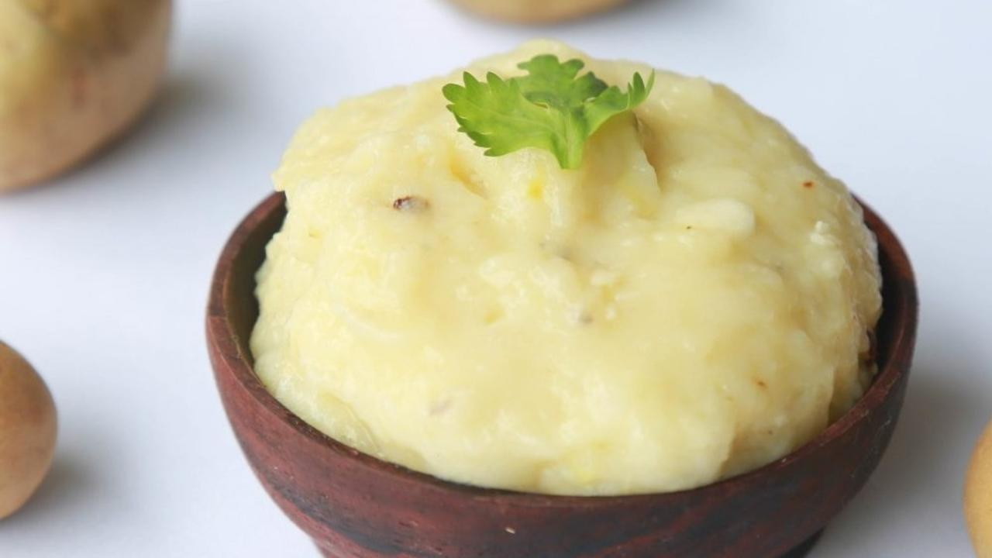

“Potato Cheese? What on earth is that?” gagged my friend, as she looked at a picture of what looked like a creamy dip with pepper and sundried tomatoes. “That looks like cheese” she added, clearly confused about why I was posting pictures of cheese after I had turned vegan.

Six months before I upgraded my diet to a Whole Plant Based one, I remember sitting around and googling for Plant Based cheese. Why? Because I LOVED CHEESE and I could eat cheese with almost anything. Heck, I would eat slices of plain cheese from time to time. So, needless to say, I was panicking mildly at the thought of having to “give it up”. Many people I know feel the same.

I had learnt enough about the effects of animal foods on human health, the health of the planet, and the cruelty behind it. I had made up my mind to transform.

So, imagine my joy when I found it in potatoes! Yes, you read right. Potato Cheese is as simple as it gets and it’s super yummy too. Read on to find out how the world’s favourite vegetable (It really is, look it up) can take a new form, one that will pleasantly surprise you.

Serve this versatile dish as a dip with veggies and salads. Spread it thick on some millet rotis to make some cheesy rolls. Eat it on the side with baked goodies like Murukku or Ribbon pakoda. Yum!

- Shyamala Suresh, Plant Based Chef, NutritionScience.in

### Whole Food Plant Based Potato Cheese Recipe

Course: Side Dish, Plant-based Cheese, Dairy Alternative  
Cuisine: Italian  
Prep Time: 10 minutes   
Cook Time: 20 minutes  
Servings: 2 people

#### INGREDIENTS

2 Potato  
1 tbsp Almond Butter  
Juice of 1 Lemon  
1/4 tsp Pepper Powder  
2 tsp Miso Paste (Healthy Salt Alternative. See Nutrition Science Highlights below)  
1 cup Water as required

#### INSTRUCTIONS

1. Boil or steam potatoes till they are cooked well.
2. Once done, blend with almond butter, miso paste, pepper and lemon juice. Use minimal water (if required) to get a cheese-like consistency.  
   Serve fresh with steamed veggies or vegetable sticks!

### Plant Based Chef Pro Tips for Best Potato Cheese Recipe

1. Garlic can be added too.
2. Add any herbs like pudina/mint, coriander, basil, thyme or oregano to enhance the flavour of the potato cheese recipe.

# 141.Muskmelon Dry Fruit Salad Recipe | Muskmelon Fruit Recipe | Whole Food Plant Based Recipes

### Whole Food Plant Based Musk Melon Dry Fruit Salad Recipe

Course: Breakfast; Course 1 (Raw Dish) for Lunch & Dinner Meals; Snack; Salad  
Cuisine: Indian Recipe  
Prep Time: 10 minutes  
Servings: 4 people

### INGREDIENTS

1 Muskmelon  
1/2 cup Dates deseeded  
1/4 cup Raisins  
2 tbsp Almonds  
1/4 tsp Elaichi / Cardamom Powder

### INSTRUCTIONS

1. Peel, remove seeds, and chop muskmelon into 1 inch squares.
2. Chop dates and almonds into halves.
3. Mix all ingredients. Serve fresh!

### Plant Based Chef Pro Tips for Best Watermelon Relish Recipe

1. Garnish with other spices like cinnamon, pepper powder, or saffron for different flavours.

# 142.Turmeric Latte Recipe | Turmeric Powder Recipe | Whole Food Plant Based Recipes



### **Whole Food Plant Based Turmeric Latte Recipe**

Course: Beverages, Dairy Alternatives, Snacks, Breakfast  
Cuisine: Indian Recipe  
Prep Time: 2 minutes  
Servings: 2 People

#### **INGREDIENTS**

½ cup [Date Syrup](https://www.nutritionscience.in/blog/date-syrup-recipe-whole-food-plant-based)  
4 tbsp [Almond Butter](https://www.nutritionscience.in/blog/almond-butter-recipe-whole-food-plant-based)  
½ tsp Turmeric Powder  
¼ tsp Black Pepper Powder

#### **INSTRUCTIONS**

1. Blend all ingredients together, with enough water to get 2 cups of turmeric latte. Serve fresh!

### **Plant Based Chef Pro Tips for Best Turmeric Latte Recipe**

1. If you prefer a warm latte, use warm water to dilute.

# 143.Tila Udhak Recipe | Ellu Neeru Recipe | Sesame Mylk Recipe | Dairy Alternatives | Whole Food Plant Based Recipes

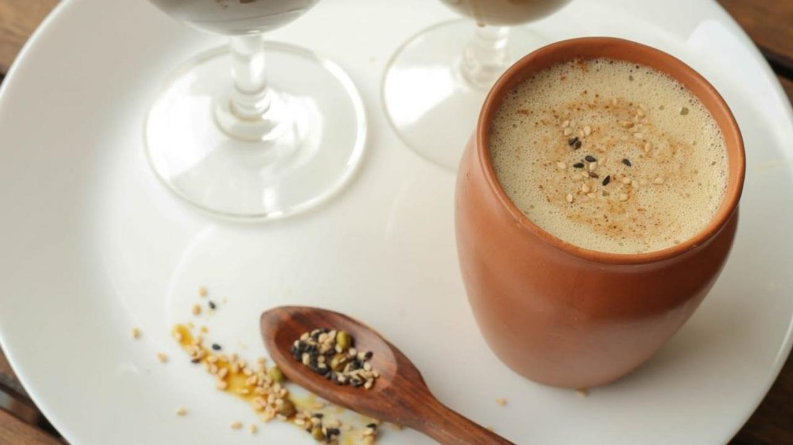

Slurrrp! Have you ever tasted Tila Udhak? My friend, if you haven’t, walk to your kitchen as you read this recipe. 😀

Back in school, we would spend our summer holidays in Bhatkal, where I was born. Huge gangs of cousins and relatives all under one roof – so many stories to listen to, and so many mouths to feed! My aunt, Shashikala Kharvi, would invariably prepare Tila Udhak or sesame mylk every day for all of us. I still remember her sitting at the grinding stone every afternoon. Don’t worry though, you can still make a decent sesame mylk with a blender or mixie!

If you walk on the streets of towns in coastal Karnataka, you will find Tila Udhak or Ellu Neeru being sold in roadside shops. Bhatkal, Kundapur or Udupi, you can be sure to get a good cold glass any time of the day. Make sure to check if they use cow’s milk though!

You will find that this recipe gives you a brownish milk, while the milk available in shops is white. This is because they use white, refined til. The calcium and healing properties that til is known for is present in the black, unrefined til, hence that is what we have used. We have also used date syrup instead of sugar or jaggery. See Nutrition Science Highlights below for details.

Tila Udhak is Konkani name, Til / Ellu is sesame seeds and Udhak means water, mylk is the term for plant based milks.

### Whole Food Plant Based Tila Udhak Recipe

Course: Beverage; Snack; Dessert; Dairy Alternative  
Cuisine: Udupi Recipe from Coastal Karnataka in South India  
Prep Time: 2 minutes   
Passive Time: 30 minutes  
Servings: 1 glass

#### INGREDIENTS

2 tsp Black Sesame Seeds / Til / Ellu soaked  
2 tbsp Coconut Grated  
1/4 cup [Date Syrup](https://www.nutritionscience.in/blog/date-syrup-recipe-whole-food-plant-based)  
1/4 tsp Elaichi / Cardamom Powder  
3/4 glass Water

#### INSTRUCTIONS

1. Soak sesame seeds in water for 30mins. This can be skipped if no time.
2. Blend soaked sesame seeds, grated coconut, date syrup, and elaichi / cardamom powder together to a paste. Add water and blend to get Tila Udhak with milk-like consistency. Adjust sweetness if required, as black sesame is mildly bitter and may be overpowering without enough sweetness.
3. Garnish with a dash of cardamom powder and sesame seeds, and serve chilled. Remember to mix once, just before serving, as the solids will separate out within a few minutes if left standing.

### Plant Based Chef Pro Tips for Best Tila Udhak Recipe

1. Similar mylk can be prepared with roasted ragi (finger millet).
2. For more flavour, clove powder, vanilla, or cocoa powder can be added..

# 144.Cashew Parmesan Cheese Recipe | Vegan Dairy Alternatives | Whole Food Plant Based Recipes

### Whole Food Plant Based Cashew Parmesan Cheese Recipe

Course: Cheeze Recipe; Dairy Alternative; Fundamental Recipe  
Cuisine: American Recipe  
Prep Time: 1 minute  
Servings: 1 cup

#### INGREDIENTS

1 cup Cashews  
2 tbsp Nutritional Yeast

#### INSTRUCTIONS

1. Grind cashews and nutritional yeast together to a powder. Serve fresh, sprinkled on some delicious [Pasta Integrale](https://www.nutritionscience.in/blog/pasta-integrale-recipe-handmade-whole-wheat-tagliatelle-pasta-recipe-whole-food-plant-based-recipes)!

### Plant Based Chef Pro Tips for Cashew Parmesan Cheese

1. Prepare Cashew Parmesan Cheese ahead of time, and store in the refrigerator. Sprinkle little bit evey day!
2. Nutritional yeast is optional, but it is what gives this cashew parmesan cheese recipe the authentic taste!
3. Mix in basil powder, garlic powder, or onion powder for more delicious cashew parmesan cheese recipe flavours!

# 145.Sweet Potato Chocolate Ice Cream Recipe | How to Make Ice Cream | Whole Food Plant Based Recipe



### Whole Food Plant Based Sweet Potato Ice Cream Recipe

Sweet potato and chocolate together? That too ice cream?

Don't be surprised, it's actually delicious! It's rich, creamy and really filling making it a super fulfilling dessert.

What's more? It's easy to make and a great way of eating sweet potatoes as well.

Course: Dessert in Course 3 (Grain Dishes) at Lunch & Dinner Meals; NiceCream Recipe; Dairy Alternative  
Cuisine: American Recipe  
Prep Time: 30 minutes  
Cook Time: 15 minutes  
Servings: 1 cup

#### INGREDIENTS

1/2 kg Sweet Potatoes  
1/4 cup Cashews  
1/2 cup [Date Syrup](https://www.nutritionscience.in/blog/date-syrup-recipe-whole-food-plant-based)4 tbsp Cocoa Powder  
1/2 tsp Cinnamon Powder

#### INSTRUCTIONS

1. Wash sweet potatoes well. Chop into 1 inch thick slices and boil in minimal water or steam until well cooked.
2. Grind cashews to a powder using a high powdered blender or mixie, then continue grinding until it sticks to the sides of the blender. Scrap down the sides of the blender and continue blending. Repeat this until liquid cashew butter is formed.
3. Blend sweet potatoes with cashew butter and date syrup until smooth. Do NOT peel sweet potatoes before grinding, as the peel is the healthiest part!
4. Once blended smoothly, add cocoa powder and cinnamon powder, and blend again.
5. Freeze and serve Sweet Potato Chocolate NiceCream fresh, garnished with a few cashews!

### Plant Based Chef Pro Tips for Best Sweet Potato Ice Cream Recipe

1. Adjust the quantities of:
   1. Date syrup for sweetness
   2. Cashew butter for oiliness
   3. Cocoa Powder for chocolatiness! It is also bitter, so keep that in mind!

# 146.Red Rice Puttu Recipe | How to Make Puttu | Puttu Kadala Curry | Whole Food Plant Based Recipe

### Whole Food Plant Based Red Rice Puttu Recipe

Course: Course 3 (Grain Dish) for Lunch & Dinner Meals  
Cuisine: Kerala Recipe from South India  
Prep Time: 10 minutes   
Cook Time: 30 minutes  
Servings: 4 people

#### INGREDIENTS

1/2 cup Red Rice  
1/2 cup Coconut grated

#### INSTRUCTIONS

1. Coarsely grind red rice to a coarsely ground flour.
2. Steam in a puttu maker. Alternatively, stuff into tumblers / glasses and steam.
3. Once cooked, allow to cool completely.
4. Garnish with grated coconut, and serve fresh with [Kerala kadala curry](https://www.nutritionscience.in/blog/kadala-curry-recipe-kerala-kadala-curry-for-puttu-recipe-whole-food-plant-based-recipes).

### Plant Based Chef Pro Tips for Best Red Rice Puttu Recipe

1. Red rice puttu is a dry dish, and is best served with a gravy like [Kerala kadala curry](https://www.nutritionscience.in/blog/kadala-curry-recipe-kerala-kadala-curry-for-puttu-recipe-whole-food-plant-based-recipes), or, even better, with ripe bananas!

# 147.Bisi Bele Bath Recipe | With Bisi Bele Bath Powder Recipe | Whole Food Plant Based Recipes

### Whole Food Plant Based Bisi Bele Bath Recipe

Course: Course 3: Grain Dish for Lunch & Dinner Meals  
Cuisine: Karnataka Recipe from South India  
Prep Time: 20 minutes   
Cook Time: 30 minutes  
Servings: 4 people

#### INGREDIENTS

##### Bisi Bele Bath Ingredients

1/2 cup Red Rice / Unpolished Rice soaked  
1/4 cup Toor Dal / Togri Bele  
2 tbsp Peanuts  
1 Potato  
1 Carrot  
10 Beans  
1 Onions  
2 tbsp Green Peas shelled  
2 Tomatoes  
5 dried fruits Kokum  
1 Green Chili slit

##### Bisi Bele Bath Powder Ingredients

1 tsp Turmeric Powder  
2 tsp Dhaniya / Coriander Seed Powder  
1 tsp Black Sesame / Til  
1 Red Chili  
1 tsp Cumin Seeds / Jeera  
1 tsp Black Pepper Powder  
1 Green Cardamom  
1 inch Cinnamon  
2 Cloves  
¼ tsp Methi / Fenugreek Seeds  
10 Curry Leaves  
1/2 tsp Asafoetida / Hing

##### Bisi Bele Bath Garnishing

4 tsp Miso Paste (Healthy Salt Alternative. See Nutrition Science Highlights below)  
1 tbsp Cashews soaked  
1/4 cup Coconut Paste  
1 tsp Mustard Seeds  
5 Curry Leaves

#### INSTRUCTIONS

##### How to Make Bisi Bele Bath Powder

1. Dry roast methi / fenugreek seeds on low flame until just cooked. Do not allow to brown too much or burn.
2. Grind all bisi bele bath powder ingredients together to a powder.

##### How to Make Bisi Bele Bath

1. Soak 1 cup unpolished red rice and toor dal with turmeric powder for 30 minutes. Cook with 3 cups water until it is soft and mushy.
2. Grind tomatoes and kokum together into a paste. Peel and chop onions into long, thin slices. Chop potato, carrot, and beans into 1 inch long pieces. Slit green chilli along its length. Cook chopped potato, carrot, onion, beans, and peas in tomato kokum paste until cooked. Add more water if required.
3. Mash cooked rice and dal, and mix into boiling vegetables with 1-2 tbsp bisi bele bath powder masala. Cook until raw smell goes away.
4. Dry roast mustard seeds. As soon as they start sputtering, mix into bisi bele bath. mix in miso paste.
5. Garnish with cashew nuts, coconut paste, and curry leaves. Once it cools down completely, serve fresh!

### Plant Based Chef Pro Tips for Best Bisi Bele Bath Recipe

1. Add more tomato paste for sourness, if needed.
2. Vegetables take longer than usual to cook in tomato paste, so do plan accordingly!

# 148.Watermelon Relish | Watermelon Fruit with Watermelon Seeds | Whole Food Plant Based Recipes

### Whole Food Plant Based Watermelon Relish Recipe

Course: Breakfast; Course 1 (Raw Dish) for Lunch & Dinner Meals; Snack; Salad  
Cuisine: Indian Recipe  
Prep Time: 10 minutes  
Servings: 2 people

### INGREDIENTS

4 cups Watermelon diced  
2 tbsp Cashews  
1 Onion  
5 cloves Garlic  
1/2 tsp Black Pepper Powder  
2 tsp Miso Paste  
Juice of 1/2 Lemon

### INSTRUCTIONS

1. Chop watermelon into 1 inch squares. Do not remove watermelon seeds. See Nutrition Science Highlights below for details.
2. Peel onion. Chop into long slices. Peel and slice garlic.
3. Soak cashews overnight in water or at least for half an hour in hot water. Grind to a paste, with black pepper powder, miso paste, and lemon juice.
4. Mix all ingredients. Serve fresh!

### Plant Based Chef Pro Tips for Best Watermelon Relish Recipe

1. Garnish with raisins for bursts of flavour.
2. Garnish with coriander leaves for a fresh aroma.

# 149.Dill Cabbage Vada Recipe | Dal Vada Recipe | Whole Food Plant Based Recipe

Introducing Baked Dill Cabbage Vada, made without a single drop of oil or any white rice flour. Hot Dill Cabbage Vada with a side of spicy mint dip and date-based sweet dip make for amazing snacks. Just the very thought of Vada makes the mouth water!

Make healthy, scrumptious, Baked Dill Cabbage Vadas today and send us pictures!

## Whole Food Plant Based Baked Dill Cabbage Vada Recipe

Course: Snacks, Side Dish for Lunch & Dinner Meals  
Cuisine: South Indian Recipe  
Prep Time: 15 minutes  
Cook Time: 40 minutes  
Servings: 4 People

### INGREDIENTS

1. 1/2 cup Dill Leaves
2. 1/2 cup Cabbage shredded
3. 1 cup Besan / Gram Flour
4. 1/4 cup Peanut
5. 1/4 cup Flaxseed
6. 1 inch piece Ginger
7. 1 tsp Jeera / Cumin Seeds
8. 1 Green Chili
9. 1 tsp Turmeric Powder
10. 1/2 tsp Black Pepper Powder
11. 1/2 tsp Jeera Powder / Cumin Seed Powder
12. 4 tsp Miso Paste (Healthy Salt Alternative. See Nutrition Science Highlights below)
13. Water as required

### INSTRUCTIONS

1. Shred cabbage. Remove dill leaves. Use the rest of the dill plant for compost.
2. Coarsely grind peanuts into peanut powder. Grind flaxseeds into a fine powder.
3. Mix all ingredients together with just enough water to form a chunky dough. Shape the dough into round discs of 1 inch diameter and 1 cm height.
4. Line a baking tray with unbleached parchment paper or silicone baking sheet.
5. Place the shaped vada at even intervals on the baking tray.
6. Bake at 120 deg C for 30 minutes, then turn the vadas over and bake for ten more minutes. Watch that they don't become too brown! The lighter, the healthier. See Nutrition Science Highlights for WFPB Dill Cabbage Vadas Recipe below for details.
7. Oil-free Baked Dill Cabbage Vada is ready! Serve fresh with Pudina Chutney!

### Plant Based Chef Pro Tips for Best Baked Dill Cabbage Vada Recipe

1. While shaping dill cabbage vadas, wet your hands from time to time to make it easier.

# 150.Sukrunde Recipe | Udupi Recipes | Green Gram Stuffed Dumpling Recipe | Whole Food Plant Based Recipes

Sukrunde! Baby showers? Planning to gift a box of sweets to someone you know who is pregnant? This green gram stuffed dumpling is the perfect sweet to prepare. Sukrunde or Sukkina Unde is a traditional dumpling recipe from Karnataka that is specially prepared when relatives invite pregnant women home for meal.

Every region of Karnataka has its own unique recipe for Sukrunde, but the components remain the same – a cereal, a pulse and a nut with a sweetener. The stuffing can be bengal gram, toor dal, green gram, rice, or sesame seeds. In most homes, this unde is either deep fried in coconut oil or steamed.

In our Whole Food Plant Based Sukrunde recipe, we have used unpolished rice along with green gram and date syrup. There are two variations – an easy, one-step recipe and another layered recipe, both served with fresh coconut!

### Whole Food Plant Based Sukrunde Recipe / Green Gram Stuffed Dumpling

Course: Dessert in Course 3 (Grain Dishes) at Lunch & Dinner Meals, Festival Dishes, Snack, Sweets  
Cuisine: Recipe for Pregnant Women from Udupi, Mangalore, and Puttur in Coastal Karnataka in South India  
Prep Time: 30 minutes   
Cook Time: 30 minutes  
Servings: 5 people

#### INGREDIENTS

1 cup Green Gram / Whole Moong  
2 cups Unpolished Red Rice  
2 cups Date Syrup  
1/2 tsp Cardamom powder  
Water as required  
1/2 cup Coconut grated

#### Instructions

##### Easy Sukrunde Recipe

1. Dry roast 1 cup green gram and 1 cup unpolished rice separately. Stop roasting rice before it starts popping! Ensure that both do not get too brown. See Nutrition Science Highlights below to learn why.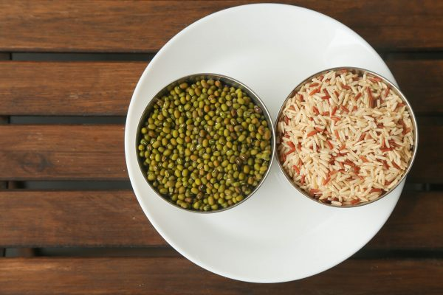
2. Spread on a plate and let them cool. Once cool, powder both roasted green gram and rice. They should not be too fine or too coarse.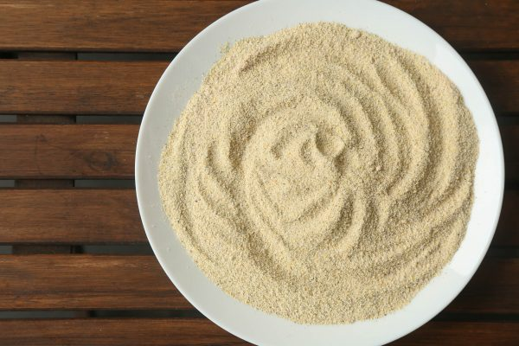
3. Mix date syrup with powdered green gram and rice mixture and make ladoos.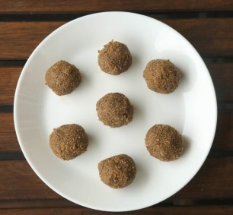
4. You can choose to stop here, mix with grated coconut and serve. If you wish to add extra charm to the Sukrunde, See 'Expert Sukrunde Recipe' below.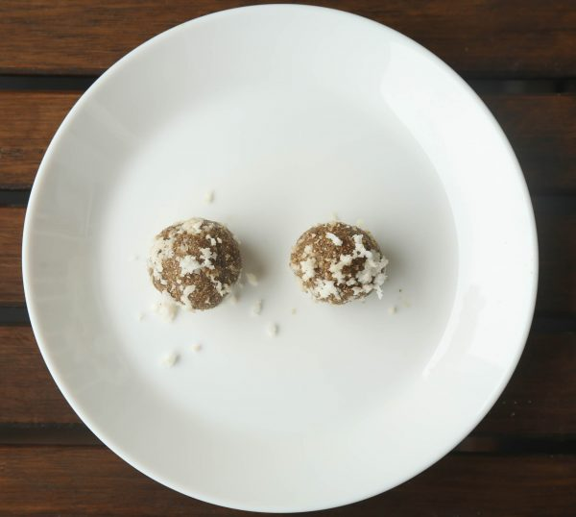

##### Expert Sukrunde Recipe

1. Make sukrunde laddoos as explained above.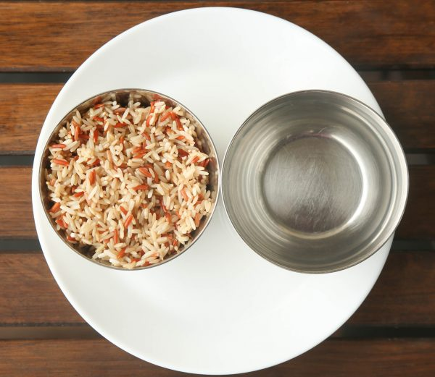
2. Soak 1 cup unpolished, red rice overnight and blend into a thick batter with 1/2 cup water.
3. Dip ladoos into rice batter and steam for 10 to 15 minutes.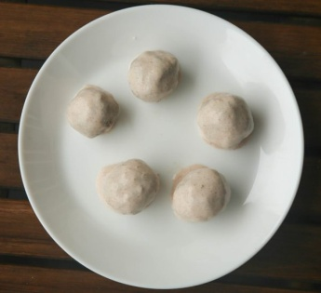
4. Once cooked, let them cool fully.
5. Once cool, top with grated coconut and serve fresh! Enjoy!

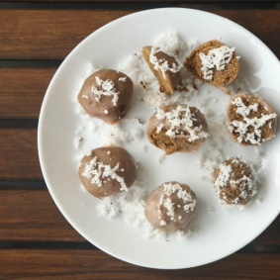

### Plant Based Chef Pro Tips for Best Sukrunde Recipe

1. Red rice & moong dal powder from step 2 can be stored and used to make instant sukrunde anytime.
2. You can make a stuffing of cooked green gram / bengal gram / toor dal and date syrup as well.
3. Add sesame for a nutty flavour.
4. Instead of steaming, the ladoos can be cooked in boiling water as well, like [pasta integrale recipe](https://www.nutritionscience.in/blog/pasta-integrale-recipe-handmade-whole-wheat-tagliatelle-pasta-recipe-whole-food-plant-based-recipes).

# 151.Jowar Rava Upma Recipe | Millet Upma Recipe | Whole Food Plant Based Recipes

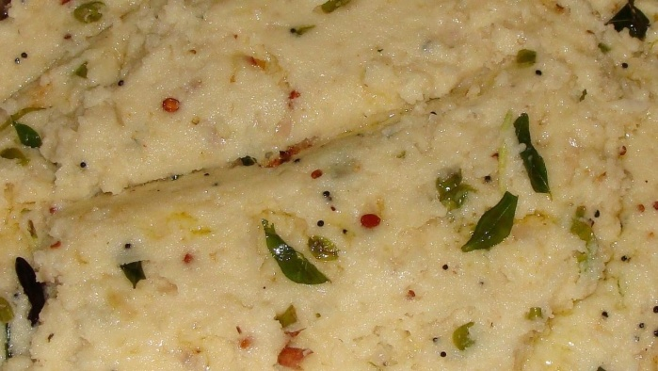

Best served with Karuvepilai Thuvaiyal (Curry Leaves Chutney)! Upgrade to food that loves you back.

## Whole Food Plant Based Jowar Rava Upma Recipe

Course: Course 3: Grain Dish for Lunch & Dinner Meals, Millet Dishes  
Cuisine: Tamil Recipe from South India  
Prep Time: 10 minutes   
Cook Time: 25 minutes  
Servings: 4 People

### INGREDIENTS

1 cup Jowar Rava / Sorghum Semolina  
2 Onions  
1 tbsp Urad Dal  
1 tbsp Bengal Gram Dal  
1 inch piece Ginger peeled & chopped  
1 small Green Chili chopped  
1/2 tsp Black Pepper Powder  
1 tsp Mustard Seeds  
1 pinch Asafoetida  
10 Curry Leaves  
2 tbsp Coriander leaves chopped  
4 tsp Miso Paste (Healthy Salt Alternative. See Nutrition Science Highlights below)  
1/4 cup Coconut freshly grated

### INSTRUCTIONS

1. Roast the mustard, urad dal and bengal gram dal separately. Ensure you keep stirring while roasting as you will not have any oil to keep them from charring. Roasting them separately, is also towards this. Ensure to roast them minimally, only until they start sputtering or turn light brown. Once done, keep aside. See Nutrition Science Highlights below for details.
2. Chop green chili, peel and chop ginger and onion.
3. Heat 2 cups of water in a kadai or thick bottomed vessel with chopped green chili and chopped ginger.
4. When the water comes to a boil, add jowar rava / sorghum semolina slowly. Mix and keep covered on sim until cooked. Stir once in a while to ensure it does not get burnt.
5. Once done, remove on to a plate, mix in miso paste, asafoetida / perunkaayam, black pepper powder, and roasted mustard and dals, and wait until they are completely cool.
6. Once cooled, garnish with freshly grated coconut, coriander leaves, and curry leaves. Serve Fresh!

### Plant Based Chef Pro Tips

1. Serve with sambar and chutney, moist or watery dishes, to compensate for the dry nature of the jowar rava upma.

# 152.Karuvepilai Thuvaiyal Recipe | Curry Leaves Chutney Recipe | Whole Food Plant Based Recipes

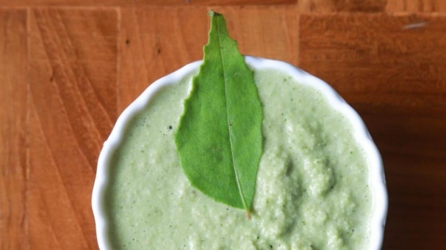

### Whole Food Plant Based Karuvepilai Thuvaiyal (Curry Leaves Chutney)

Course: Chutneys, Side dish for Course 3 (Grain Dishes) at Lunch & Dinner Meals  
Cuisine: Tamil Recipe from South India  
Prep Time: 10 minutes   
Servings 4 people

#### INGREDIENTS

3/4 cup Curry Leaves (Karuvepilai / Karibevinasoppu / Kari patta)  
2 tsp Urad Dal (Uluthamparuppu / uddina bele)  
2 tsp Bengal Gram Dal (Kadalai Paruppu / Kadlebele)  
1 dried fruit Garcinia (Punarpuli / Kokum)  
1 tsp Cumin Seeds Jeera  
1/4 tsp Pepper  
1 small Green Chili  
1/2 cup Fresh Coconut  
1 pinch Asafoetida (Perungaayam / Hing)  
4 tsp Miso Paste (Healthy Salt Alternative. See Nutrition Science Highlights below for details)

#### INSTRUCTIONS

1. Dry roast the dals (each separately)
2. Dry roast jeera and pepper until jeera starts popping.
3. Grate or chop coconut into small pieces.
4. Grind all the ingredients together in a mixie, with water as required. The thick chutney is our personal favourite, with just a little water.
5. Serve fresh with jowar rava upma.

### Plant Based Chef Pro Tips for Best Karuvepilai Thivaiyal Recipe (Curry Leaves Chutney)

1. If you want a tadka, dry roast mustard seeds and mix into chutney as soon as it starts sputtering.

# 153.Fresh Amla Pickle Recipe | Homemade Pickle Recipes | Whole Food Plant Based Recipes

**Whole Food Plant Based Fresh Amla Pickle Recipe**

Course: Side Dish for Course 3 (Grain Dishes) at Lunch & Dinner Meals, Pickle  
Cuisine: Tamil Recipe from South India  
Prep Time: 5 minutes  
Servings: 4 People

**INGREDIENTS**

4 Amla / Gooseberry / Nellikkai  
½ Green Chili  
Juice of 1 Lemon  
1 tsp Mustard Seeds  
1 tbsp Sunflower Seeds

**INSTRUCTIONS**

1. Grate amla / gooseberry / nellikkai and use seed pods for your compost.
2. Grate green chili. Mix into grated amla.
3. Chop sunflower seeds into slivers. Mix into fresh amla pickle.
4. Dry roast mustard seeds. When they start sputtering, immediately mix into fresh amla pickle.
5. Squeeze lemon into pickle. Mix well. Serve fresh!

**Plant Based Chef Pro Tips for Best Fresh Amla Pickle Recipe**

1. This is a super spicy pickle! Substitute green chili with green pepper or black pepper powder for a milder version.

# 154.Foxtail Millet Rice | Millet Recipes | How to Cook Millet | Whole Food Plant Based Recipes

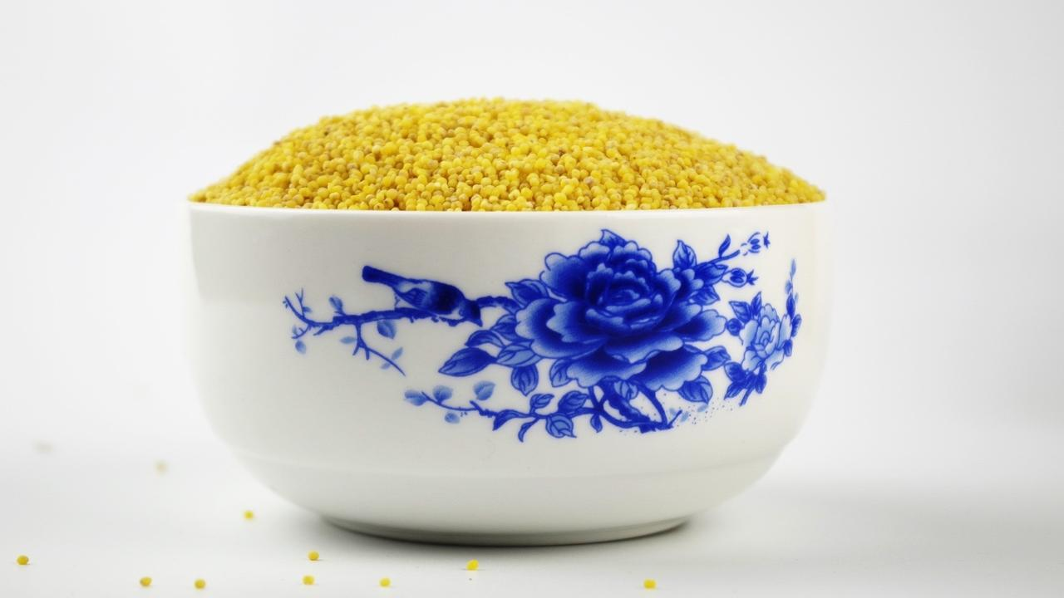

Upgrade to food that truly loves you back.

## Whole Food Plant Based Foxtail Millet Rice Recipe

Course: Course 3: Grain Dishes for Lunch & Dinner Meals  
Cuisine: Fundamental Recipe, South Indian Recipe  
Prep Time: 2 minutes  
Cook Time: 20 minutes  
Servings: 4 people

### INGREDIENTS

1 cup Foxtail Millet

### INSTRUCTIONS

1. Cook foxtail millet with 2 1/2 cups of water. Stir from time to time, ensuring it does not get burnt. Cook until cooked enough.
2. Once cooked, spread on a plate or large vessel to cool down completely. Serve fresh with [Vendakkai Sambar](https://www.nutritionscience.in/blog/vendakkai-sambar-recipe-without-tamarind-okra-or-bhindi-sambar-whole-food-plant-based-recipe)!

### Plant Based Chef Pro Tips for Best Foxtail Millet Rice

1. If you like your rice grains separate, use slightly less water and stir as little as possible, while ensuring to prevent burning
2. If you like your rice mashable, use slightly more water and stir well while cooking.

# 155.Lemon Ginger Kashayam Recipe | Herbal Tea Recipe | Whole Food Plant Based Recipes.

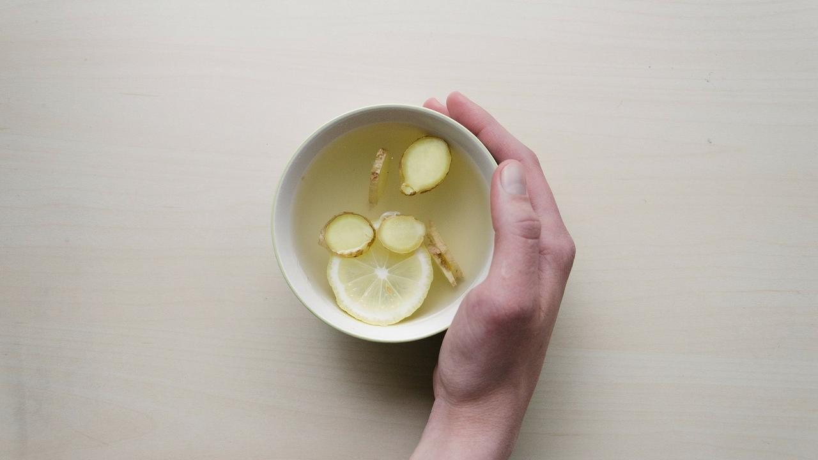

### **Whole Food Plant Based Lemon Ginger Kashayam Recipe**

Course: Beverage, Snack  
Cuisine: Indian Recipe  
Prep Time: 5 minutes  
Servings: 2 Glasses

#### **INGREDIENTS**

½ cm piece Ginger  
1 Lemon  
1 tsp Raisins  
2 glasses Water  
6 walnuts

#### **INSTRUCTIONS**

1. Peel and chop ginger. Chop raisins.
2. Boil 2 glasses of water. Once hot, remove from stove and mix in all ingredients.
3. Close and allow to steep for 3 minutes.
4. Squeeze juice of lemon into the lemon ginger kashayam. Serve fresh with a side dish of walnuts!

### **Plant Based Chef Pro Tips for Best Lemon Ginger Kashayam Recipe**

1. Use other herbs and spices, like sage leaves, moringa leaves, or cinnamon to create different flavours!

# 156.Radish Lettuce Salad with Garlic Vinaigrette Recipe | Salad Recipes | Whole Food Plant Based Recipes

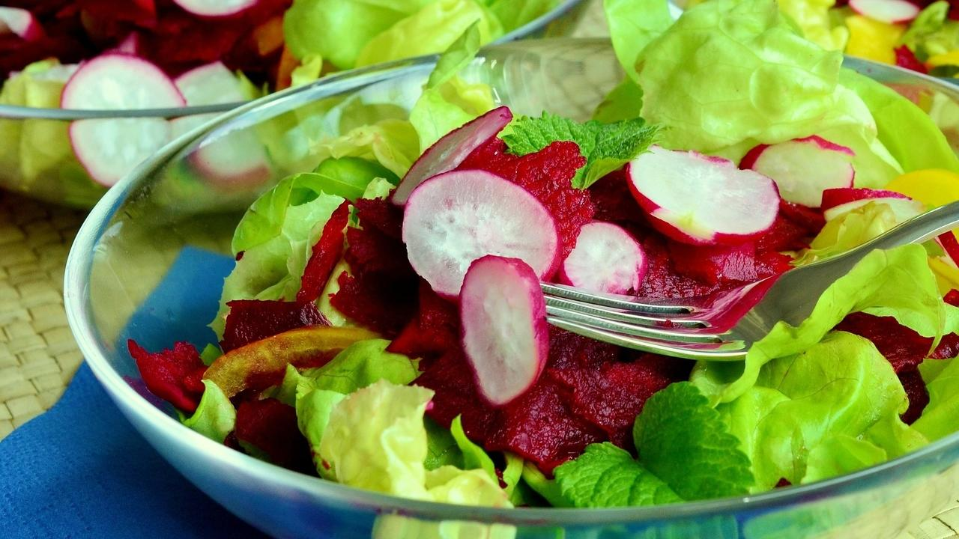

### **Whole Food Plant Based Radish Lettuce Salad with Garlic Vinaigrette Recipe**

Course: Salad, Snacks, Course 1 (Raw Dish) for Lunch & Dinner Meals  
Cuisine: Italian Recipe  
Prep Time: 20 minutes  
Passive Time: 30 minutes  
Servings: 4 People

#### **INGREDIENTS**

2 Radishes  
2 slices Beetroot  
2 cups Lettuce mixed (except iceberg lettuce)  
1 tsp Almonds  
1 sprig Mint Leaves

#### For Garlic Vinaigrette

¼ cup Apple Cider Vinegar  
1 tsp Raisins  
4 cloves Garlic  
1 tsp Green Pepper OR ½ tsp Black Pepper Powder  
2 tsp Miso Paste (Healthy Salt Alternative. See Nutrition Science Highlights below)

#### **INSTRUCTIONS**

1. Wash radish and peel off only black spots. Do not remove the entire peel. Slice thinly using a mandolin or sharp knife.
2. Roughly chop or tear lettuce leaves into large pieces. Chop beetroot slices into large pieces.

#### How to Make Garlic Vinaigrette

1. Peel and chop garlic into small pieces.
2. Chop raisins and green pepper into pieces.
3. Mix all ingredients for garlic vinaigrette together. Marinate for 30 minutes.

#### How to make Radish Lettuce Salad with Garlic Vinaigrette

1. Just before serving. pour garlic vinaigrette over chopped radish and lettuce.
2. Mix well. Garnish with mint leaves and almonds. Serve fresh!

### **Plant Based Chef Pro Tips for Best Radish and Lettuce Salad with Garlic Vinaigrette Recipe**

1. Marinate vinaigrette for longer to get a well-blended taste.
2. Mix in vinaigrette just before serving, otherwise the salad tends to become soggy.

# 157.Cabbage Curry Recipe | Cabbage Recipes | Whole Food Plant Based Recipes

Cabbage! When amma cooks it, we can smell it all over the house! Yum! Take care not to let it rot, though – you can smell it in the next house, too! Yikes!

An abundant source of Vitamin C, cabbage is a versatile vegetable, going into side dishes, soups and salads!

Do you think cooking cabbage without oil is difficult? No it isn’t! We use the best quality oil in whole nuts instead of lower quality extracted oil.

Try out this simple oil free stir fry cabbage curry recipe – a quick recipe with simple ingredients. Serve it with warm rotis, or as we like it best, with rice and sambar! 🙂

### Whole Food Plant Based Cabbage Curry Recipe

Course: Course 2 (Vegetable Dish) for Lunch & Dinner Meals  
Cuisine: Karnataka Recipe from South India  
Prep Time: 5 minutes   
Cook Time: 15 minutes  
Servings: 2 people

#### INGREDIENTS

1 small Cabbage chopped  
1/2 tsp Mustard Seeds  
1/2 tsp Bengal Gram Dal  
1/2 tsp Jeera cumin seeds  
1/8 tsp Asafoetida / Hing  
1 Green Chili slit  
1 inch Fresh Ginger chopped  
1 strand Curry Leaves  
1/8 tsp Turmeric Powder  
2 tsp Miso Paste (Healthy Salt Alternative. See Nutrition Science Highlights below)  
1/4 cup Fresh Coconut grated  
1/4 cup Coriander leaves chopped  
1/8 cup Water as required

#### INSTRUCTIONS

1. Finely chop cabbage using a mandolin or a sharp knife. Peel and chop ginger into small pieces. Slit green chilli along its length.
2. Cook chopped cabbage, ginger, and green chilli with turmeric powder and 1/8 cup water, with closed lid. Once done, switch off the stove.
3. Heat an iron tawa or thick bottomed steel vessel. Add bengal gram and roast it till becomes slightly golden in color. Add mustard seeds & jeera. Dry roast until it splutters. Immediately mix into cabbage curry.
4. Garnish with grated coconut, curry leaves, and coriander leaves. Serve it with your favorite roti or sambar rice!

# 158.Scrambled Eggs with Tofu Recipe | Tofu Recipes | Whole Food Plant Based Recipes

### **Whole Food Plant Based Scrambled Eggs with Tofu Recipe**

Course: Snacks, Side Dish for Lunch & Dinner Meals  
Cuisine: American Recipe, Egg Alternative Recipe  
Prep Time: 15 minutes  
Cook Time: 20 minutes  
Servings: 2 People

**INGREDIENTS**

1. 1 Packet Tofu / 200g Tofu
2. 2 tbsp Flaxseed Powder
3. 1 Onion
4. 2 Tomatoes
5. 1 Green Chili
6. 1/2 tsp Turmeric Powder
7. 1/2 tsp Black Pepper Powder
8. 1 tbsp Apple Cider Vinegar
9. 2 tsp Miso Paste
10. 1 tsp Almond Butter
11. 1 tbsp Coriander Steams & Leaves chopped

**INSTRUCTIONS**

1. Peel and chop onions into small pieces. Chop tomatoes into small peices. Slit green chili along its length.
2. Cook chopped onion, tomato, and chili together, with apple cider vinegar.
3. Scramble tofu. Mix with flaxseed powder and turmeric powder. When onions and tomatoes are half cooked, add tofu flaxseeds mix and continue cooking.
4. Once done, remove from stove. Mix in black pepper powder, miso paste, almond butter, and coriander leaves. Serve scrambled eggs with tofu fresh!

### **Plant Based Chef Pro Tips for Best Scrambled Eggs with Tofu Recipe**

1. Once you add tofu, stir continuously to prevent it from burning!

# 159.Spicy Cabbage Peanut Salad Recipe | Thai Salad Recipe | Whole Food Plant Based Recipes

### **Whole Food Plant Based Spicy Cabbage Peanut Salad Recipe**

Course: Salad, Breakfast, Course 1 (Raw Dish) for Lunch & Dinner Meals, Snacks  
Cuisine: Thai Recipe  
Prep Time: 15 minutes  
Servings: 2 People

**INGREDIENTS**

1. ½ head of Cabbage
2. ¼ cup Peanuts
3. 1 Dried Red Chili
4. 1 tsp [Date Syrup](https://www.nutritionscience.in/blog/date-syrup-recipe-whole-food-plant-based)
5. ½ tsp Black Pepper Powder
6. 2 tsp Miso Paste (Healthy Salt Alternative. See Nutrition Science Highlights below)
7. 10 Basil Leaves
8. Juice of 1 Lemon

**INSTRUCTIONS**

1. Finely shred cabbage using a mandolin or peeler.
2. Soak peanuts overnight or at least for 3 hours.
3. Once soaked, grind peanuts to a smooth paste with red chili, date syrup, and minimal water.
4. Cook peanut paste, adding more water if required, for five minutes until raw smell goes away. Mix in miso paste and black pepper powder, and garnish chopped cabbage with this sauce.
5. Finely chop basil leaves. Garnish spicy cabbage peanut salad with basil leaves and lemon juice. Serve fresh!

### **Plant Based Chef Pro Tips for Best Spicy Cabbage Peanut Salad Recipe**

1. Cook peanut sauce with lemon grass for an ever more authentic thai flavour!

# 160.Thai Chickpea Soup Recipe | How to Cook Chickpeas | Whole Food Plant Based Recipes

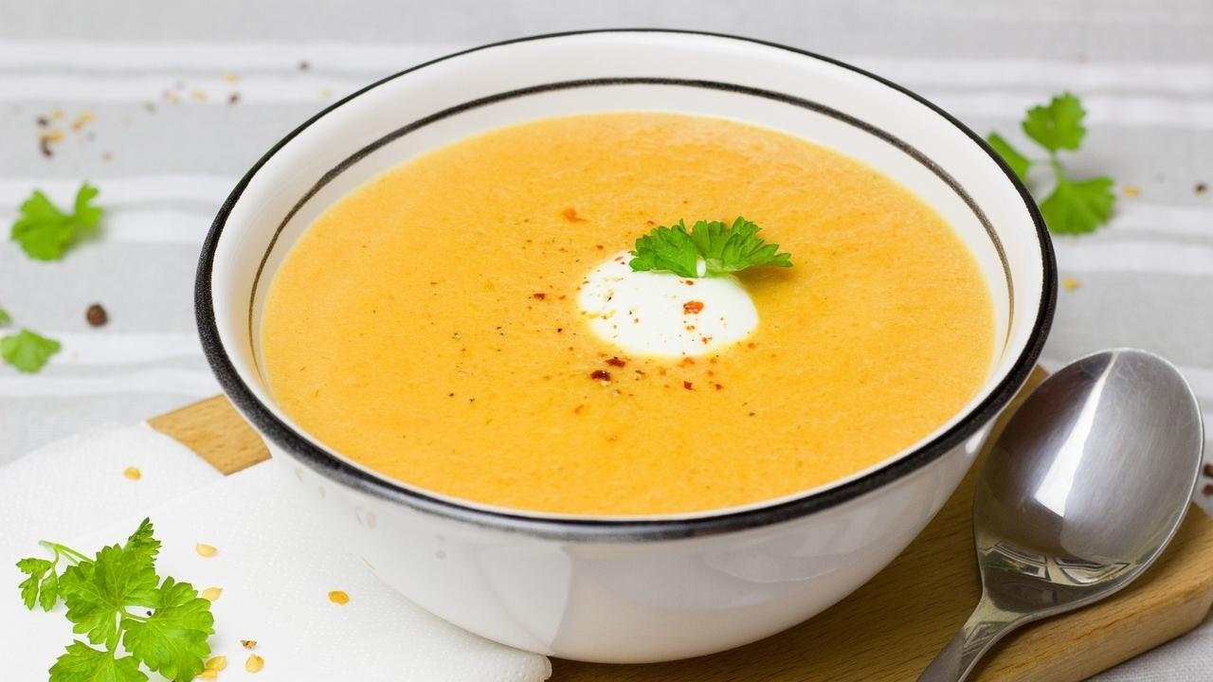

**Whole Food Plant Based Chickpea Soup Recipe**

Course: Soup, Snacks, Breakfast  
Cuisine: Thai Recipe  
Prep Time: 30 minutes  
Passive Time: 6 hours  
Servings: 4 People

**INGREDIENTS**

1 cup Chickpeas / Garbanzo Beans / Kabuli Chana  
½ tsp Turmeric Powder  
1 tsp Black Pepper Powder  
1 tbsp Date Syrup  
4 tsp Miso Paste (Healthy Salt Alternative. See Nutrition Science Highlights below)  
1 tsp Almond Butter  
2 tbsp Coriander Leaves  
Juice of 1 Lemon

**INSTRUCTIONS**

1. Soak chickpeas / kabuli chana / garbanzo beans overnight or at least for 6 hours.
2. Cook with minimal water or steam until cooked.
3. Cool completely, then blend with turmeric powder, black pepper powder, date syrup, miso paste, and lemon juice.
4. Dilute almond butter with a little water to make almond cream. Garnish chickpea soup with almond cream and coriander leaves. Warm up if needed. Serve fresh!

**Plant Based Chef Pro Tips for Best Chickpea Soup Recipe**

1. Use other herbs to garnish, such as basil leaves, curry leaves, and sage leaves for a wider range of flavours.
2. Add lemon grass while cooking chickpeas for a stronger thai flavor.

# 161.Vendakkai Sambar Recipe without Tamarind | Okra or Bhindi Sambar | Whole Food Plant Based Recipe

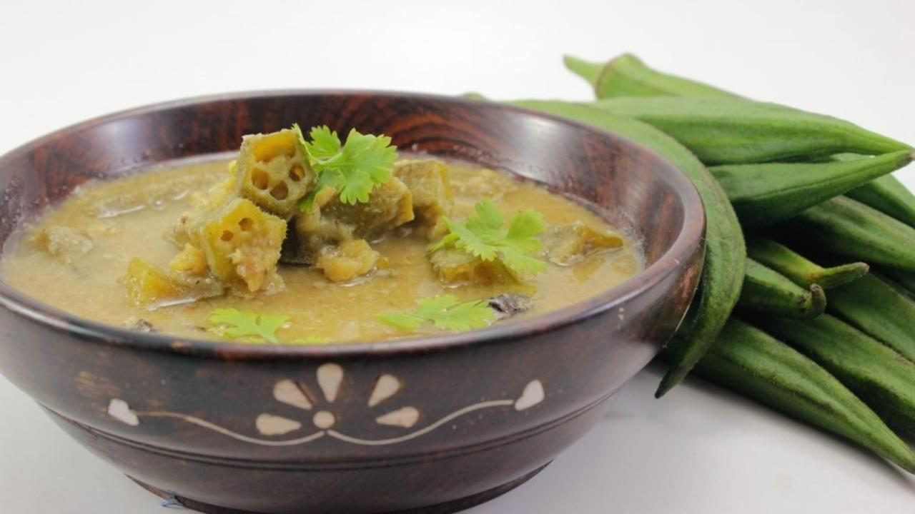

Sambar traditionally calls for tamarind to be used as the souring agent in the lentil-based dish. Tamarind was in widespread use in Tamil Nadu, Andhra Pradesh and surrounding areas for many reasons – one important reason being, the ground water contained a lot of fluoride, and tamarind impeded fluoride absorption. It also helps prevent kidney stone formation when your food is dry on a daily basis.

In a healthy diet, tamarind is not necessary and does not give any additional benefits. On the other hand, it only causes more harm than good, leading to that well-known feeling of acidity after eating that puliyogre and sambar rice. The good news is, you can make amazing sambar by using any other sour food – tomato, amla (nellikkai / gooseberry), kokum (punarpuli / garcinia), raw mango, dry mango powder, or even lemon juice! In this recipe, we have used tomato. To really get the flavour out, we have ground up the tomatoes into a paste.

Oil-based tadka / oggarane was used in places and times when fresh nuts weren’t easily available. Fresh oil inside fresh nuts is best quality oil. Extracted oil is lower quality. We have used fresh coconut instead of the usual tadka. You could use any fresh nuts. If they are dried, soak them before grinding.

We hope you enjoy it! 🙂

### Whole Food Plant Based Vendakkai Sambar Recipe Without Tamarind

Course: Side Dish for Course 3 (Grain Dishes) for Lunch & Dinner Meals  
Cuisine: Tamil Recipe from South India  
Prep Time: 15 minutes   
Passive Time: 10 minutes  
Cook Time: 10 minutes  
Servings: 4 people

#### INGREDIENTS

##### Dal / Paruppu

1/2 cup Toor dal Pigeon Peas

##### Vegetable base

10 pieces Ladies finger Vendakka / Bhindi  
6 Tomato  
1 tsp Turmeric Powder  
To taste Asafoetida  
4 tsp Miso Paste (Healthy Salt Alternative. See Nutrition Science Highlights)  
2 Green Chili

##### Sambar Powder

2 tsp Bengal Gram Dal  
2 tsp Toor dal  
1/2 tsp Urad Dal  
1/2 tsp Fenugreek seeds Methi seeds  
1 tsp Black Pepper  
1 tsp Jeera Cumin seeds  
2 tsp coriander seeds Dhaniya seeds  
10 leaves Curry Leaves  
1 tsp Mustard Seeds

##### Garnishing

1/2 cup Fresh Coconut  
1 small bunch Coriander plants

#### INSTRUCTIONS

##### Dal / Paruppu

1. Soak dal in water overnight, or for 2 - 3 hours. This makes iT more nutritious and easier to cook. If you are unable to soak it, no issues, use dry dal.
2. Boil dal with 1 cup water in a closed vessel. Stir every few minutes and add more water as the dal cooks if required, to prevent burning.
3. Once fully cooked, remove from stove and mash well.

##### Sambar Powder Recipe

1. Dry roast all the ingredients - dals, methi seeds, pepper, jeera, dhaniya and curry leaves - on low flame. If you wish to make it spicy, use 2 tsp of pepper powder. Use a small, thick-bottomed pan to prevent burning. To ensure that each one is roasted the right amount, roast each separately. Otherwise, put the dals and methi on the stove first, roast until half done, then add the other spices to roast fully. Remember, do not let any of the ingredients get burnt or browned too much.
2. Grind to a fine powder.
3. Dry roast mustard seeds. As soon it starts sputtering, mix into the powder. Keep aside to cook with vegetable base.

##### Vegetable Base for Vendakkai Sambar

1. Wash vegetables, cut ladies fingers into 1 inch pieces after removing stalks. Grind tomatoes to a paste. Put them in an open vessel and cook.
2. Add the sambar powder you have prepared, turmeric powder, and asafoetida. Cook with a closed lid until the ladies finger is cooked well and the raw smell goes away. Add dal towards the end and mix well.

##### Vendakkai Sambar Recipe

1. After the vendakkai sambar is cooked, remove from stove. Grind 1/2 cup fresh coconut to a smooth paste with miso paste and mix.
2. Add chopped coriander plants (leaves and stems) on top before serving. Serve with a cereal dish - rice, porridge, modakas, etc.

### Plant Based Chef Pro Tips for Best Vendakkai Sambar Recipe

1. To try different varieties of Sambar, use amla / kokum / raw mango / lemon juice instead of tomato! Sourness gives Sambar its trademark taste, and prevents ladies finger from becoming gooey! 😀
2. If you wish to make the curry leaf flavour stand out, pinch some fresh curry leaves and drop them in.
3. If you wish to make it spicy, you can add one or two green chilis. Slit along one side and drop them in. This makes it easier to remove them while eating.
4. You could also try using some cinnamon in the sambar powder, or fresh herbs like pudina in the ground coconut garnish to give your own spin to the Sambar! Have fun! 🙂

# 162.Mooli Paratha Recipe | Radish & Whole Wheat Flatbread | Whole Food Plant Based

## Whole Food Plant Based Mooli Paratha Recipe

Course: Course 3: Grain Dishes for Lunch & Dinner Meals, Breads  
Cuisine: North Indian Recipe  
Prep Time: 10 minutes  
Cook Time: 5 minutes  
Servings: 2 People

### INGREDIENTS

1. 1 cup Whole Wheat Flour Coarsely Ground
2. 3 tbsp Flaxseed Powder
3. 1/2 Radish
4. 1/2 tsp Turmeric Powder
5. 1/2 tsp Black Pepper Powder
6. 1/2 tsp Cumin / Jeera Powder
7. 1/2 tsp Coriander Seed / Dhaniya Powder
8. 2 tbsp Coriander Leaves Chopped
9. 1/2 tsp Garam Masala
10. 2 tsp Miso Paste

### INSTRUCTIONS

1. Grate Radish.
2. Mix all ingredients except with 1/4 of the whole wheat flour in a large bowl and knead into a dough, adding water little by little while kneading. Since the radish has water in itself, you will not require as much water as you do for plain whole wheat rotis. Once the dough has come together, stop adding water and knead to a stiff dough. The dough should be soft to the touch, but not sticky. If sticky, add more flour. If too hard, add more water.
3. Take a ping-pong ball sized piece of dough and roll it into a ball between your hands. Flatten into a thick disc.
4. Dust with the remaining whole wheat flour and roll it out into a mooli paratha with a rolling pin.
5. Heat a thick bottomed pan or tawa. It is hot enough when a bit of water dropped on the pan dances instead of evaporating immediately.
6. Dust off any extra flour from the mooli paratha, place it on the tawa and reduce flame to sim or medium. Close with a lid. After 30 to 60 seconds, once cooked, flip over. It is cooked on the first side if light brown spots have begun appearing. If the spots are large or dark brown, the mooli paratha has been overcooked. Tear off the dark parts and consume only the unbrowned parts.
7. After 20 to 30 seconds, take the mooli paratha off the tawa. By now, small, light brown spots should have appeared on both sides and the mooli paratha should have been fully cooked.
8. Wait for a few minutes until it cools down, then serve fresh with a side dish containing mustard seeds or some raw radish! (See Nutrition Science Highlights to find out why!)

# 163.Dry Fruit Laddoo Recipe | Laddoo Recipes | Whole Food Plant Based Recipes



A tasty yet healthy laddoo that vanishes the moment it gets made!

### Whole Food Plant Based Dry Fruit Laddoo Recipe

Course: Snack, Course 1 (Raw Dish) or Dessert in Course 3 (Grain Dishes) at Lunch & Dinner Meals  
Cuisine: Indian Recipe  
Servings: 15 Small Laddoos

#### INGREDIENTS

1 cup Dates  
1 cup Nuts mixed  
1/4 cup Raisins  
1/2 cup Fresh Coconut grated  
1 pod Cardamom

#### https://s3.amazonaws.com/kajabi-storefronts-production/blogs/10455/images/BxSLtO2RynBFLgMROZAL_Dry_Fruit_Laddoo_1.jpg

#### INSTRUCTIONS

1. Soak dates overnight or at least for 30 minutes in hot water.
2. Dry grind the nuts coarsely
3. Grind dates coarsely with raisins.
4. Powder cardamom kernels.
5. Add the nuts and dates together, along with the grated coconut and powdered cardamom kernels. Make small laddoos with your palms. The sweet is now ready to be eaten. 🙂

### Plant Based Chef Pro Tips for Best Dry Fruit Laddoo Recipe

1. To make it more tastier, garnish with nuts and coconut.
2. If this recipe is too sticky to work with, use a greater proportion of nuts.
3. To make a dry fruit laddoo that stays good for a week, substitute soft dates for soaked dates and copra or dry coconut for fresh coconut.

# 164.Barnyard Millet Ribbon Pakoda Recipe | Oil Free Millet Recipes | Whole Food Plant Based Recipes

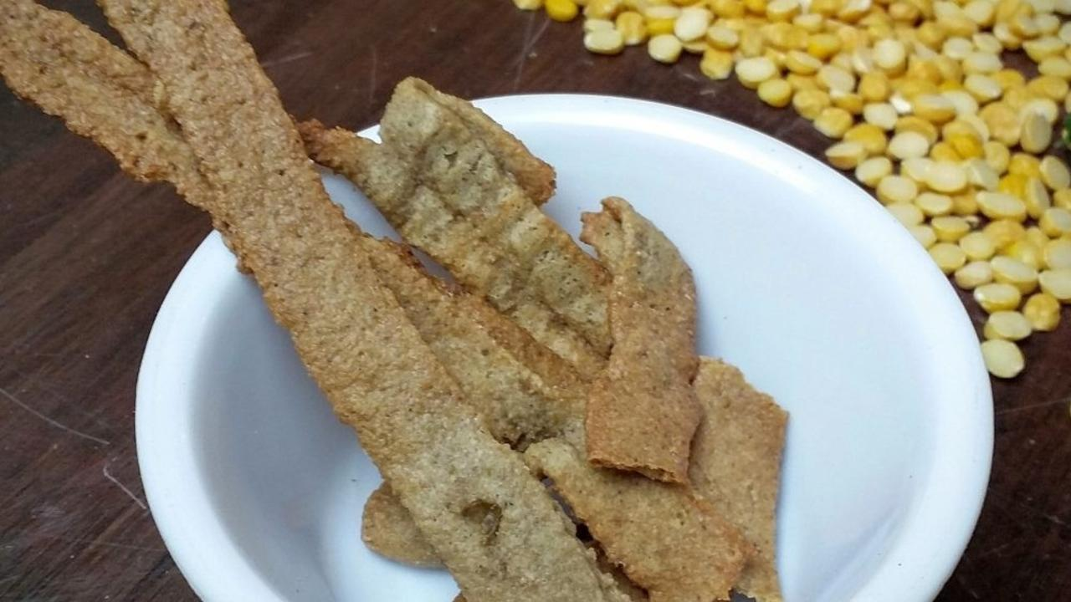

Who doesn’t love a good ribbon pakoda? Or a dozen? How about when it’s baked? And oil-free? And made from Barnyard Millet? 😀

The problem with fried food is, well, it are fried. First, we extract oil from a nut or seed, stripping most of the nut’s nutrition. Then, we heat the oil to a high temperature, destroying what little nutrition remains in the oil. Then, we fry something in it, forming disease-causing chemicals. Have you ever tried burning a couple of banana chips? If you haven’t, do try it today. Be sure to hold the chips with a pair of tongs – and place a sheet of paper underneath to catch all the oil that drips from it!

How to make this recipe healthier? Use an oven instead of a frying pan. And, replace oils with whole nuts. That will amp up the nutrient quotient significantly.

However, foods like ribbon pakoda or murukku, even when baked, are cooked at a high temperature and are very dry. Try eating them mindfully, you will find that you do not enjoy them as much as fresh food like fruits or vegetables – or even fresh nuts! Here’s a recipe that takes you closer to health. If you want to go all the way, enjoy a cup of fresh fruits and nuts instead! 🙂

### Whole Food Plant Based Barnyard Ribbon Pakoda Recipe

Course: Side Dish for Course 3 (Grain Dishes) at Lunch & Dinner Meals; Snacks  
Cuisine: Tamil Recipe from South India  
Prep Time: 10 min   
Cook Time: 20 min  
Servings: 8 servings

#### INGREDIENTS

1 cup Barnyard Millet Flour  
1/2 cup Fresh Toor Dal / Pigeon Peas (alternatively, use peas or potato)  
1/2 cup Groundnuts  
1/2 cup Flaxseeds  
8 tsp Miso Paste (Healthy Salt Alternative. See Nutrition Science Highlights below)  
1 tsp Black Pepper Powder  
1/3 cup Water

#### INSTRUCTIONS

##### Barnyard Millet Dough Preparation

1. Grind groundnuts in a mixie without water until you get raw peanut butter. You may need to scrape the sides of the mixie a few times. Use a small jar!
2. Grind flaxseeds to get flaxseed powder.
3. Grind fresh whole pigeon peas or peas or potato to a fine paste.
4. Mix all ingredients together with water and knead well to make a soft dough.

##### Baking

1. Pre-heat oven to 160 deg C
2. Line a baking tray with unbleached parchment paper or a silicone sheet. Do not apply any oil on the paper or the tray.
3. Use a murukku machine or press machine with long, flat holes to squeeze out long ribbon pakodas on the parchment paper. Be careful not to make too many layers, as they will remain soft. Squeeze single layer for best results.
4. Bake at 160 deg C. Flip once after 10 to 12 minutes.
5. Remove Barnyard Millet Ribbon Pakoda once cooked, but before it turns brown (See Nutrition Science Highlights below for details). It will be ready in about 20 - 30 minutes, depending on the thickness. Once done, Cool down completely and enjoy with a vegetable or nut dip!

### Plant Based Chef Pro Tips for Best Barnyard Ribbon Pakoda Recipe

1. This may taste a little drier than fried ribbon pakoda. This is normal.
2. Serve with a watery dip or dish to enjoy barnyard millet ribbon pakoda better!
3. This dough can be used to make murukku or chakli as well. Squeeze it out in a single layer so it gets baked through.

# 165.Methi Paratha Recipe | How to Make Paratha | Whole Food Plant Based Recipes

## Whole Food Plant Based Methi Paratha Recipe

Course: Course 3: Grain Dishes for Lunch & Dinner Meals, Breads  
Cuisine: North Indian Recipe  
Prep Time: 10 minutes  
Cook Time: 5 minutes  
Servings: 2 People

### INGREDIENTS

1. 1 cup Whole Wheat Flour Coarsely Ground
2. 3 tbsp Flaxseed Powder
3. 1/4 cup Methi Leaves / Fenugreek Leaves
4. 1/2 tsp Turmeric Powder
5. 1/2 tsp Black Pepper Powder
6. 1/2 tsp Cumin / Jeera Powder
7. 1/2 tsp Coriander Seed / Dhaniya Powder
8. 2 tbsp Coriander Leaves Chopped
9. 1/2 tsp Garam Masala
10. 2 tsp Miso Paste

### INSTRUCTIONS

1. Mix all ingredients except 1/4 of the whole wheat flour in a large bowl and knead into a dough, adding water little by little while kneading. Once the dough has come together, stop adding water and knead to a stiff dough. The dough should be soft to the touch, but not sticky. If sticky, add more flour. If too hard, add more water.
2. Take a ping-pong ball sized piece of dough and roll it into a ball between your hands. Flatten into a thick disc.
3. Dust with the remaining whole wheat flour and roll it out into a methi paratha with a rolling pin.
4. Heat a thick bottomed pan or tawa. It is hot enough when a bit of water dropped on the pan dances instead of evaporating immediately.
5. Dust off any extra flour from the methi paratha, place it on the tawa and reduce flame to sim or medium. Close with a lid. After 30 to 60 seconds, once cooked, flip over. It is cooked on the first side if light brown spots have begun appearing. If the spots are large or dark brown, the methi paratha has been overcooked. Tear off the dark parts and consume only the unbrowned parts.
6. After 20 to 30 seconds, take the methi paratha off the tawa. By now, small, light brown spots should have appeared on both sides and the methi paratha should have been fully cooked.
7. Wait for a few minutes until it cools down, then serve fresh! (See Nutrition Science Highlights to find out why!)

# 166.Vegan Dal Makhani Recipe | Dal Recipe with Masoor Dal | Whole Food Plant Based Recipes

The aromatic flavours of Dal Makhani waft from the kitchen through the entire house. It's one of those flavours that you would wake up to with a growling stomach. The warm and homely Dal Makhani brings memories of eating well-spiced buttery dal wrapped in freshly made rotis.

Here is our whole food plant based Dal Makhani recipe which retains all the goodness of the dish. Enjoy!

## Whole Food Plant Based Dal Makhani Recipe

Course: Side dish for Course 3: Grain Dishes at Lunch & Dinner Meals  
Cuisine: North Indian Recipe  
Prep Time: 10 minutes  
Cook Time: 30 minutes  
Passive Time: 5 hours  
Servings: 2 people

### INGREDIENTS

1. 1/4 cup Whole Black Gram / Sabut Urad Dal
2. 1/8 cup Red Rajma / Red Kidney Beans
3. 1 Bay Leaves
4. 1 stick Cinnamon
5. 1 Onions Red
6. 1 Tomatoes
7. 1 inch piece Ginger
8. 4 cloves Garlic
9. 1 tsp Cumin / Jeera Powder
10. 1/2 tsp Pepper Powder
11. 1/2 tsp Turmeric Powder
12. 1/4 cup Cashews
13. Juice of 1 Lemon
14. 2 tsp Miso Paste (Healthy Salt Replacement. See Nutrition Science Highlights below)

### INSTRUCTIONS

1. Soak whole black gram and red rajma / red kidney beans overnight. Pressure cook soaked dals with bay leaf and cinnamon until well cooked.
2. Peel and mash / grind garlic. Keep aside for ten minutes to rest.
3. Peel onions. Grind onions, tomato, and ginger. Heat on a kadai and cook.
4. After ten minutes of waiting, add garlic paste and cook for two minutes, then remove from stove and mix with cooked dal.
5. Mix in cumin / jeera powder, turmeric powder, and pepper powder. Grind lemon juice and miso paste with some of the cooked dal, then mix back into the dal makhani.
6. Grind soaked cashews to a smooth paste and garnish dal makhani with cashew paste. Serve fresh!

# 167.Brinjal Curry | Badanekai Saaru | Whole Food Plant Based

Ah! Brinjal Coconut Curry and I go a long way back. I remember stuffing my face with this curry, wrapped in warm fluffy chappatis.

Generally, the Brinjal Coconut Curry, much like other side-dishes would be super oily. The Brinjal would typically be fried in oil and dunked in an equally oily gravy.

Learning about the powerful correlation between refined food and lifestyle diseases led us to upgrade our lives to a Whole Food Plant Based lifestyle. We missed our favourite curries and gravys, but only until we figured out how to make them with healing ingredients! We also learned additional methods of cooking that best preserve and enhance nutrition.

Follow this recipe and make some super yummy Brinjal Curry full of healing ingredients AND one that is super yummy! It goes well with unpolished rice, millet, or millet rotis, so pick your favourite cereal and tell us how you like it.

Upgrade to food that truly loves you back!

## Brinjal Curry / Badnekai Saaru

Course; Course 2: Vegetable Dishes, Side dishes for Lunch & Dinner Meals  
Cuisine: Karnataka Recipe from South India  
Prep Time: 10 minutes  
Cook Time: 20 minutes  
Servings: 2 people

### INGREDIENTS

#### Veggies

1. 4 Brinjal small, purple variety
2. 1/2 Tomato chopped
3. 1/4 Green Chilli slit
4. 3/4 cup Water

#### Masala

1. 1/2 Tomato
2. 1 tsp Cumin Powder / Jeera
3. 1/4 tsp Turmeric Powder / Haldi / Manjal / Arshina
4. 1/4 tsp Black Pepper Powder
5. 2 tsp Coriander Powder / Dhaniya Powder
6. 1/2 tsp Fennel Seeds / Saunf
7. 1/2 tsp Urad Dal / Split black gram dal
8. 1/2 tsp Poppy Seeds / Khus khus
9. 1/2 inch Fresh Ginger
10. 1 handful Fresh Coriander Leaves
11. 1/4 tsp Black Sesame Seeds / Til / Ellu
12. 1 tsp Peanut
13. 1/2 inch Cinnamon
14. 1/4 tsp Cloves
15. 2 tsp Miso Paste (Healthy Salt Replacement. See Nutrition Science Highlights below)

#### Garnish

1. 1 handful Fresh Coriander Leaves
2. 1/2 Lemon
3. 1 cup Fresh Coconut

### INSTRUCTIONS

1. From the bottom, cut twice through the middle of each brinjal, creating quarters, making sure to keep all quarters attached to the intact stalk. Soak these in water for a few minutes.
2. Chop 1/2 a tomato into small pieces. Slit a green chilli. Boil the brinjal, tomato and chilli in sufficient water to cover half the vegetables. Keep the flame low and the dish covered.
3. Dry roast poppy seeds and urad dal separately.
4. Blend all raw spices and roasted poppy seeds & urad dal with groundnut to a smooth powder. Add tomato, miso paste, and coriander leaves, and blend to a smooth paste.
5. Add this mixture to the boiling vegetables. Let it cook well so that the brinjal absorbs all the flavours.
6. Grate coconut, blend it with water to get a smooth paste. Keep aside.
7. Once the brinjal is well cooked, switch off the stove and add the ground coconut.
8. Garnish with coriander leaves and squeeze some lemon juice for extra tanginess. Serve hot!

# 168.Beetroot Soup Recipe | Whole Food Plant Based

When it comes to making soups, we are only limited by our imagination. There are so many different kinds of soups we can make, both in terms of the vegetables/base we use as well as seasoning. In this recipe, we show you how to make thick beetroot soup with Indian spices.

It's not only easy to make but also filling and yummy, not to mention, a storehouse of nutrients.

Enjoy this whole food plant based beetroot soup and let us know how you like it.

## Beetroot Soup

Course: Soup, Snack  
Prep Time: 5 minutes  
Cook Time: 15 minutes  
Servings: 2 people

### INGREDIENTS

1. 1 Beetroot Large
2. 5 plants Spring Onions
3. 1/2 tsp Cumin / Jeera Powder
4. 1/2 tsp Black Pepper Powder
5. 1/2 tsp Turmeric Powder
6. Juice of 1/2 Lemon
7. 4 tsp Miso Paste (Healthy Salt Alternative. See Nutrition Science Highlights below)
8. 2 tbsp Coriander Leaves

### INSTRUCTIONS

1. Peel and chop beetroot. Boil with enough water to cover the beetroot pieces.
2. While beetroot is boiling, chop spring onions into small pieces.
3. Grind spices, lemon juice, and miso paste with a few spoons of water to a smooth masala paste.
4. Once beetroot is fully cooked, drain stock and set aside to add back after grinding. Mix chopped spring onion into hot stock and keep covered.
5. Spread beetroot pieces on a plate to cool off. Once cool, grind with masala paste. Mix masala beetroot paste with spring onion in stock.
6. Garnish with freshly chopped coriander leaves. Serve fresh!\

# 169.Southekaayi Amla Kosambari Recipe | Cucumber Lentil Gooseberry Salad | Whole Food Plant Based

Kosambari is a delicious traditional South Indian salad with vegetables and lentil. This particular recipe is Southekaayi Amla Kosambari (cucumber lentil gooseberry salad) a delicious, tangy starter of sorts.

Enjoy this mouth-watering, crunchy, nutritious whole food plant based Southekaayi Amla Kosambari!

## Southekaayi Amla Kosambari Recipe

Course: Breakfast, Course 1: Raw & Side Dish for Lunch & Dinner Meals, Salad & Raw Snack  
Cuisine: Kannada / Karnataka / Tamil Recipe from South India  
Prep Time: 10 minutes  
Passive Time: 5 hours  
Servings: 2 people

### INGREDIENTS

1. 1/4 cup Moong Dal
2. 1/2 Cucumber
3. 1 Amla / Gooseberry / Nellikkai
4. 1/8 inch Fresh Turmeric Root
5. 2 plants or 4 tbsp Fresh Coriander Leaves
6. 1/8 tsp Black Pepper Powder
7. 1 tbsp Almonds Crushed
8. Juice of 1/2 Lemon
9. 1 tsp Miso Paste (Healthy Salt Alternative. See Nutrition Science Highlights below)

### INSTRUCTIONS

1. Soak moong dal overnight in water or at least for 4-5 hours. Drain water.
2. Peel fresh turmeric root. Grate turmeric root and amla. Chop cucumber into tiny pieces. Mix all ingredients with crushed almonds, miso paste, and pepper.
3. Garnish with coriander leaves and lemon juice. Serve fresh!

# 170.Sakkarai Pongal Recipe | Sugar Free Pongal Recipe Sweet | Whole Food Plant Based Recipes

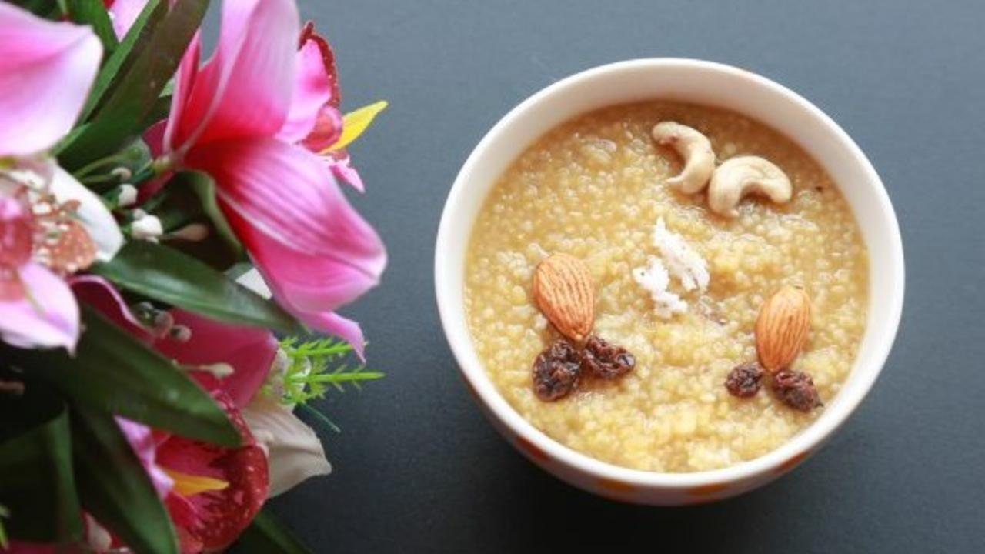

Pongal means festivity or celebration. Maybe this is why a bite of sakkarai pongal is like a celebration in your mouth!

Sakkarai Pongal is a traditional dessert. It is especially prepared during the Makar Sankranti or Pongal festival in Southern India. Traditionally, it is a preparation with rice, moong dal and jaggery. Today, many of us use sugar or refined jaggery, ghee and polished rice to make the sweet. However, there is a better way to enjoy the goodness and enhance health.

We have for you a dish that will melt in your mouth and leave you wanting more. A ghee-less, millet sweet pongal which makes for a healthy, guilt-free indulgence.

We use foxtail millet instead of white rice and date syrup. Ghee is an animal food and causes disease, so we have replaced it with finely ground coconut for a super rich and mouth-watering dish.

Enjoy this delicious sweet!

### Whole Food Plant Based Sakkari Pongal Recipe

Course: Pongal Festival Dish, Dessert in Course 3 (Grain Dishes) at Lunch & Dinner Meals  
Cuisine: Tamil Recipe from South India  
Prep Time: 10 minutes   
Cook Time: 30 minutes  
Servings: 4 people

#### INGREDIENTS

2/3 cup Foxtail Millet  
1/3 cup Paitham Paruppu / Pasi Paruppu / Yellow Moong Dal / Split Yellow Lentil   
1 cup Date Syrup  
1/2 tsp Cardamom Powder / Elaichi  
1/2 cup Coconut grated  
1/4 cup Mixed nuts soaked  
3 cups Water as required

#### INSTRUCTIONS

1. Soak Foxtail Millet and Paitham Paruppu / Moong Dal at least for 30 minutes. Drain the water (and use it for your garden!). Cook them together with 2 cups of water with a partially closed lid. Check on it once in a while an adjust water if required. Do not allow to boil over or get burnt.
2. Meanwhile, grind coconut into a smooth paste, along with date syrup and cardamom powder.
3. Once foxtail millet and moong dal is cooked, remove from stove and mix in coconut date syrup mixture.
4. Wait until it cools down completely. Garnish with soaked nuts. Serve Fresh!

### Plant Based Chef Pro Tips for Best Sakkarai Pongal Recipe

1. Add cinnamon and cloves for a greater range of flavor.
2. Cooking foxtail millet and moong dal separately is easier if you don't have time to check on them often.
3. Cooking foxtail millet & moong dal in a mud pot is easier than a steel vessel, as it gets cooked evenly.
4. While partially covering the boiling moong dal and foxtail millet with a plate for sweet pongal recipe, it is wise to pour some water on the plate. If the plate remains cool, the boiling mixture will not boil over!

# 171.Pongal Recipe | Foxtail Millet Ven Pongal Recipe | Whole Food Plant Based Recipes

.

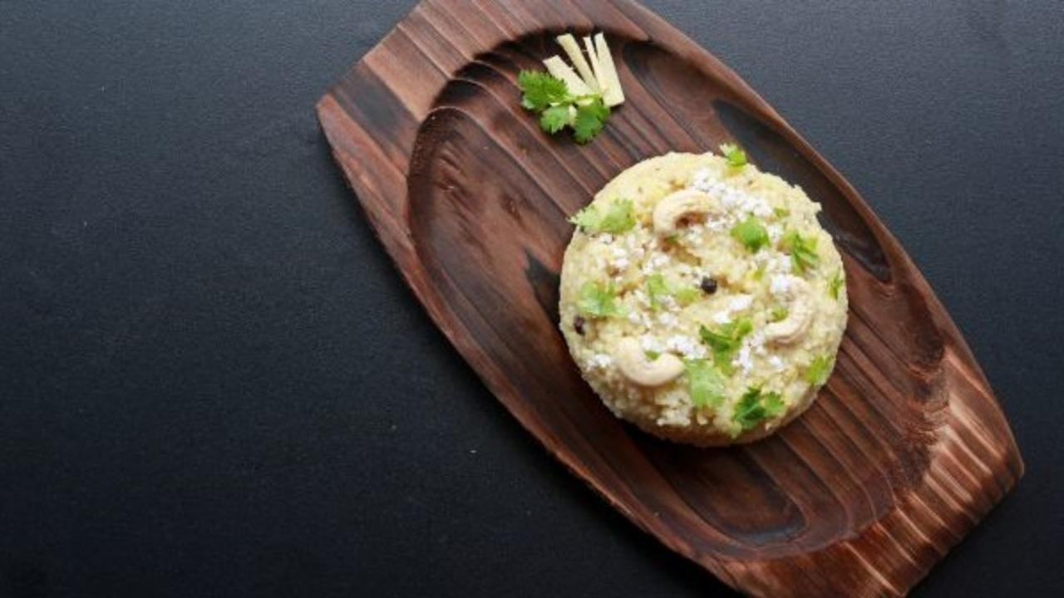

Pongal is a much loved dish. Perhaps because of the flavours from warm aromatic spices and feeling of comfort with every mouthful.

It is popular in many parts of India and known by different names. Khichdi in North India, Ven Pongal in Tamil Nadu, Khara Pongal in Karnataka and Katte Pongali in Andhra Pradesh. For all its different avatars, the same set of basic ingredients are used—rice and split yellow lentil or moong dal.

We show you how to make this popular dish healthier and tastier! We use foxtail millet with lentil since millets are healthier than white rice.

Needless to say, khara or ven pongal is a staple during Makar Sankranti or ‘Pongal’, as the festival as called in Tamil Nadu.

Try out this one-pot super healthy dish with some tangy coconut chutney!

### Whole Food Plant Based Ven Pongal Recipe

Course: Course 3 (Grain Dishes) at Lunch & Dinner Meals; Pongal Recipe; Millet Recipe  
Cuisine: Tamil Recipe from South India  
Prep Time: 10 minutes   
Passive Time:  30 minutes  
Cook Time 30 minutes  
Servings: 4 people

#### INGREDIENTS

1 cup Foxtail Millet  
1/2 cup Moong dal split yellow lentil  
1 inch piece Ginger  
1 tsp Turmeric Powder  
4 cups Water

##### Garnishing

1/4 tsp Cashew  
2 tsp Coriander Stems & Leaves chopped  
1/4 cup Coconut paste  
1/2 tsp Black Pepper  
1 pinch Asafoetida / Hing / Perunkaayam  
4 tsp Miso Paste (Healthy Salt Alternative. See Nutrition Science Highlights below)  
1/2 tsp Cumin Seeds / Jeera  
1 strand Curry Leaves

#### INSTRUCTIONS

1. Wash and Soak millet and lentil for at least 30 minutes. Use the water for your garden.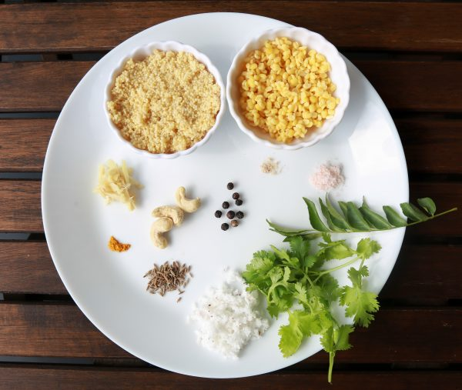
2. Peel and chop ginger into small pieces. Mix foxtail millet, moong dal, ginger and turmeric powder with water and cook with a partially closed lid. Check the water once in a while and add more if required. Ensure to not let is boil over or get burnt. This is easiest when using a mud pot.
3. Dry roast jeera mildly. Crush jeera and black pepper coarsely.
4. Once foxtail millet ven pongal is cooked, add crushed black pepper, crushed jeera, miso paste, perunkaayam / asafoetida, chopped coriander leaves, curry leaves, coconut paste and cashews.
5. Allow to cool completely and serve fresh with [avial](https://www.nutritionscience.in/blog/avial-recipe-pongal-recipe-whole-food-plant-based-recipes).

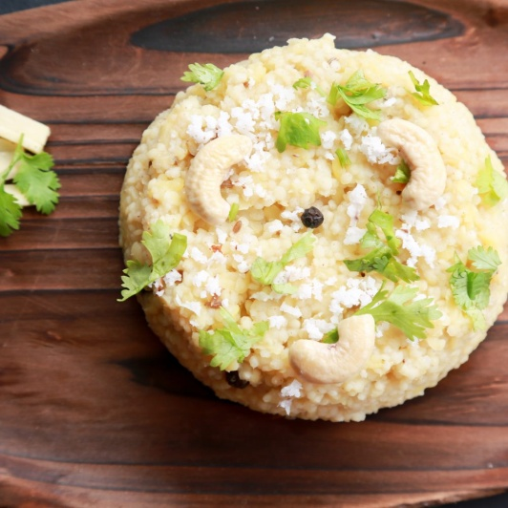

### Plant Based Chef Pro Tips for Best Ven Pongal Recipe

1. "Pongal is only pongal when you add copious amounts of ghee", you may hear your relatives saying. Don't worry, though, because copious amounts of freshly ground coconut paste will make your pongal recipe taste divine!

# 172.Avial Recipe | Pongal Recipe | Whole Food Plant Based Recipes

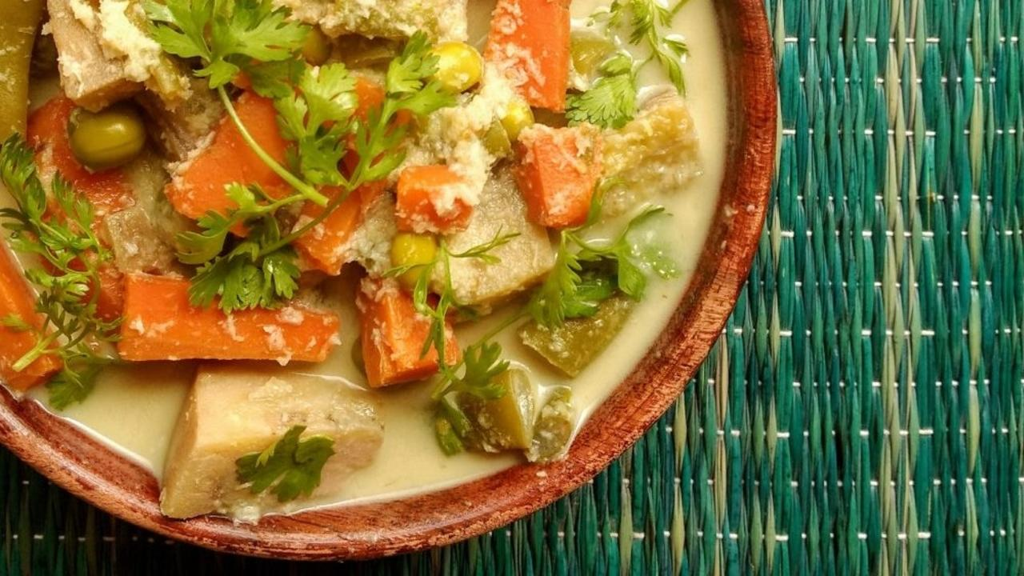

Avial! Mixed vegetable stew in rich coconut paste, a rare non-spicy dish that totally satisfies the South Indian palate.

While we prepare the dish throughout the year, in some cultures it is a part of the menu for Makar Sankranti. With freshly harvested vegetables and rich coconut paste, it is a festive dish!

Most avial recipes call for curds. If you're wondering how to make avial without curds, peanut curds works even better! In this recipe, we have used finely ground coconut. When this is mixed in the stew, it makes for a divine tasting dish!

Enjoy this festive Pongal dish!

### Whole Food Plant Based Avial Recipe

Course: Course 2 (Vegetable Dish) and Side Dish for Course 3 (Grain Dishes) at Lunch & Dinner Meals; Pongal Recipe  
Cuisine: Tamil Recipe from South India  
Prep Time: 20 minutes   
Servings: 4 people  
Cook Time: 20 minutes

#### INGREDIENTS

1 Raw Banana  
100 g Avare Kaalu  
3 Carrots medium sized  
200 g Beans  
100 g Peas  
1/2 Coconut cut into pieces or grated  
1 tsp Jeera Powder  
1/2 tsp Black Pepper Powder  
Juice of 1/2 Lemon  
4 tsp Miso Paste  
1 pinch Asafoetida / Hing  
2 tbsp Coriander Steams & Leaves chopped

#### INSTRUCTIONS

1. Peel, string and cut vegetables into long, 1 inch pieces. Put all of them together with peas in a vessel with just enough water to cover the vegetables and cook with closed lid.
2. Once cooked, Grind coconut to fine paste with just enough water, jeera powder, black pepper powder, lemon juice, miso paste and hing, and mix into avial.
3. The dish should be like a stew, but not too thin. Garnish with coriander leaves and serve fresh with [Ven Pongal](https://www.nutritionscience.in/blog/pongal-recipe-foxtail-millet-ven-pongal-recipe-whole-food-plant-based-recipes)!

### Plant Based Chef Pro Tips for the Best Avial Recipe

1. Add cooked peanut mylk or even peanut curds to make avial thicker.
2. Add a slit green chili if you like it spicy.

# 173.Creamy Mango Bowl Recipe | Sugar Free & Dairy Free Recipe | Whole Food Plant Based Recipes

Creamy Mango Bowl! Sounds delicious, doesn't it?  The king of fruits made even richer with fresh nut butter and seasoned with saffron, the king of spices.

Enjoy this delicious bowl first thing in the morning, as an evening snack or even a part of your meal because any excuse is a good one to eat this whole food plant based creamy mango bowl.

### Whole Food Plant Based Creamy Mango Bowl Recipe

Course: Course 1 (Raw Dish) for Breakfast, Lunch & Dinner Meals; Snack; Salad  
Cuisine: Satwik Recipe  
Prep Time: 10 minutes   
Servings: 2 people

#### INGREDIENTS

2 Ripe Mangoes  
1/4 cup Raisins  
2 tbsp [Almond Butter](https://www.nutritionscience.in/blog/almond-butter-recipe-whole-food-plant-based)  
4 strands Saffron

#### INSTRUCTIONS

1. Chop mangoes into bite-sized pieces.
2. Dilute [almond butter](https://www.nutritionscience.in/blog/almond-butter-recipe-whole-food-plant-based) with an equal amount of water to make instant almond cream.
3. Mix all ingredients together. Garnish with saffron strands. Serve fresh!

### Plant Based Chef Pro Tips for the Best Creamy Mango Bowl Recipe

1. For almond butter recipe, click [here](https://www.nutritionscience.in/blog/almond-butter-recipe-whole-food-plant-based).
2. Like creamy mango bowl, you can make creamy chikoo bowl, creamy banana bowl, or creamy papaya bowl with the same recipe!

# 174.Baked Mirchi Bajji Recipe | Oil Free Stuffed Chili Pakoda Recipe | Whole Food Plant Based Recipes

Hot Mirchi Bajji on a rainy evening is a picture perfect setting to gorge on these spicy mouth-watering snack.   
The downside of most finger foods such as bajjis, pakodas, wedges and fries is that they are all deep fried making them extremely unhealthy. When we upgraded to a whole food plant based diet, we experimented constantly and found ways of having the best of both worlds. Tasty food that brings us goodness and life.

Here is our whole food plant based Baked Mirchi Bajji recipe. Enjoy!

## Whole Food Plant Based Baked Mirchi Bajji Recipe

Course: Course 2: Vegetable Dish for Lunch & Dinner Meals, Snack  
Cuisine: Rajasthani Recipe from North India  
Prep Time: 20 minutes   
Cook Time: 30 minutes  
Servings: 10 Mirchi Bajjis

### INGREDIENTS

10 Bajji Mirchis / Banana Peppers  
1/2 cup groundnuts  
1/4 cup Besan / Gram Flour  
1 tbsp Dhaniya / Coriander Seed Powder  
1 tbsp Jeera / Cumin Powder  
1 tbsp Turmeric Powder  
1 tsp Black Pepper Powder  
5 tsp Miso Paste (Healthy Salt Alternative. See Nutrition Science Highlights below)

### INSTRUCTIONS

1. Wash and slit bajji mirchis along their length. Remove seeds. Seeds can be used instead of chilis for any other dish.
2. Grind groundnuts into a coarse powder. Mix with besan / gram flour, dhaniya powder, jeera powder, turmeric powder, black pepper powder, and miso paste. Add a little water and knead into a slightly moist stuffing that holds together, but breaks easily.
3. Stuff each deseeded bajji mirchi with the stuffing to make mirchi bajjis.
4. Line a baking tray with unbleached parchment paper or silicone sheet. Arrange stuffed mirchi bajjis on the tray without letting them touch each other.
5. Bake at 160 deg C for 15 minutes or so until fully cooked.
6. Remove from oven and serve fresh with [coconut chutney](https://www.nutritionscience.in/blog/coconut-chutney-recipe-how-to-make-coconut-chutney-whole-food-plant-based-recipes)!

### Plant Based Chef Pro Tips for Best Baked Mirchi Bajji Recipe

1. Add whole dhaniya / coriander seeds, jeera / cumin seeds, or ajwain / omum / caraway for an extra burst of flavour!
2. These baked mirchi bajjis can be super spicy, especially for those who don't generally eat spicy food. Watch out!
3. Baked Mirchi Bajjis can also be served with a sweet date chutney or a [Raw Vegan Raitha](https://www.nutritionscience.in/blog/raw-vegan-raitha-recipe-whole-food-plant-based), to blunt their spiciness.

# 175.Capsicum Raisin Raitha Recipe - Whole Food Plant Based

Raithas make for great sides to a range of flavoured and spiced rice such as pulao, biriyani, and bisi bele bath. Creamy, soothing and flavoured, raithas are perfect to have just plain by the spoonful.

Here we have a recipe for a dairy-free Capsicum Raisin Raitha. The sweet-sour-spice balance of this raitha makes it unique and yummy, and the whole plant ingredients make it a healing dish.

Try this whole food plant based capsicum raisin raitha recipe and let us know if anyone found out that you haven't used dairy.

## Capsicum Raisin Raitha Recipe

Course: Course 1: Raw / Side Dish for Lunch & Dinner Meals  
Cuisine: Tamil Recipe from South India  
Prep Time: 10 minutes  
Servings: 2 people

### INGREDIENTS

1. 1 Capsicum
2. 1/4 cup Raisins
3. 1/2 cup Cashews
4. 1/2 Green Chili
5. 1 tsp Miso Paste
6. Juice of 1/2 Lemon
7. 1/4 cup Coriander Leaves Chopped, loosely packed

### INSTRUCTIONS

1. Remove stalk and chop capsicum into tiny pieces with seeds. Slit green chili along its length.
2. Grind cashews with lemon to a powder in a high powered blender. Add water and grind to a smooth paste. Add miso paste and blend well.
3. Mix cashew cream, slit green chili and chopped cucumber. Garnish with plenty of coriander leaves. Serve fresh!

# 176.Peas Pulao Recipe | Whole Food Plant Based

## Peas Pulao Recipe

Course: Course 3: Grain Dishes for Lunch & Dinner Meals  
Prep Time: 15 minutes  
Cook Time: 25 minutes  
Servings: 4 people

### INGREDIENTS

1. 1/2 cup Brown Basmati Rice
2. 1/2 cup Fresh Peas or half the quantity of dry peas
3. 1 Carrot Medium
4. 5 Beans
5. 1 leaves Bay Leaves
6. 1 stick Cinnamon
7. 3 pods Star Anise
8. 1 pods Cardamom Elaichi
9. 1 tsp Turmeric Powder
10. 2 tsp Pepper Powder
11. 1 tsp Cumin / Jeera Powder
12. 1 cm Ginger
13. 1/2 cup Pudina / Mint Leaves
14. 1/2 cup Grated coconut Loosely packed
15. 1/4 cup Cashews
16. 2 tbsp Miso Paste
17. Juice of 2 Lemons

### INSTRUCTIONS

1. String beans and chop into 1 inch long pieces. Chop carrots into thin, 1 inch long pieces.
2. Take rice along with double the quantity water, bay leaves, cinnamon, star anise, and cardamom, and bring to a boil in a closed vessel.
3. After five minutes of cooking, add green peas.
4. After five more minutes, add carrot and beans.
5. Once the pulav has finished cooking, switch off stove, remove lid and allow to cool off.
6. In the meantime, grind coconut with ginger, pudina leaves, turmeric powder, pepper powder, jeera powder, lemon juice and miso paste.
7. Spread the cooked rice and allow to cool. Once cool, gently fold the ground masala mix into the pulav, taking care not to smash the cooked rice grains.
8. Garnish with cashews mint leaves. Serve fresh!

# 177.Gobi Manchurian Recipe | Zero Oil Baked | Whole Food Plant Based Recipes

Gobi Manchurian, hot and spicy, served with some tomato sauce is a popular street / fast food through the country. Gobi florets tossed in the spicy tangy sauce, cooked to perfection makes it a super yummy dish.

This recipe takes you through how to make this delicious, otherwise deep fried dish with no extracted oil. Yes, healthy scrumptious Gobi Manchurian for the food lovers' soul!

Try it our and send us pictures of your dish.

## Whole Food Plant Based Baked Gobi Manchurian Recipe

Course: Snack; Course 2 (Vegetable Dish) or Side Dish for Course 3 (Grain Dishes) at Lunch & Dinner Meals  
Cuisine: Indian Fast Food Recipe  
Prep Time: 20 minutes   
Cook Time: 40 minutes  
Servings: 4 people

### INGREDIENTS

1 Cauliflower / Gobi  
6 Tomatoes  
3 Onions  
8 cloves Garlic  
2 inch Ginger  
1/2 Green Chili  
2 tbsp Apple Cider Vinegar  
1/2 tsp Turmeric Powder  
1/2 tsp Black Pepper Powder  
1/2 bunch Spring Onions  
4 tsp Miso Paste (Healthy Salt Alternative. See Nutrition Science Highlights below)

### INSTRUCTIONS

1. Chop gobi / cauliflower into bite sized pieces. Steam or boil for 4 minutes until half cooked, then transfer to a large vessel for mixing later. Add cooked chana to this.
2. While the cauliflower / gobi is being cooked, peel onion and ginger. Grind onion, tomato, vinegar and ginger to a smooth paste. Boil in a heavy saucepan or thick bottomed kadai.
3. Peel and crush or grind garlic into a paste. Keep aside for ten minutes, then add into the boiling sauce, along with turmeric powder and black pepper powder.
4. Chop spring onion into small pieces. Once sauce is cooked, remove from stove and mix in spring onion pieces along with miso paste to make gobi manchurian sauce.
5. Pour the sauce into the large vessel with half cooked gobi / cauliflower  and mix well.
6. Line a baking tray with unbleached parchment paper or silicone sheet. Arrange the gobi manchurian sauce coated gobi / cauliflower florets on the tray without them touching one another. If you have excess sauce, leave it behind in the vessel to mix in later. Bake at 180 deg C for 15 minutes, until fully cooked and beginning to slightly brown. Remove and transfer to a vessel. Keep aside.

### Plant Based Chef Pro Tips for the Best Baked Gobi Manchurian Recipe

1. Keep freshly chopped cauliflower florets immersed in water until baking, to remove any worms that may be in the cauliflower, especially if it is an organic cauliflower!

# 178.Coconut Thambuli Recipe | Dairy Free Buttermilk Thambli | Dairy Alternative | Whole Food Plant Based Recipes

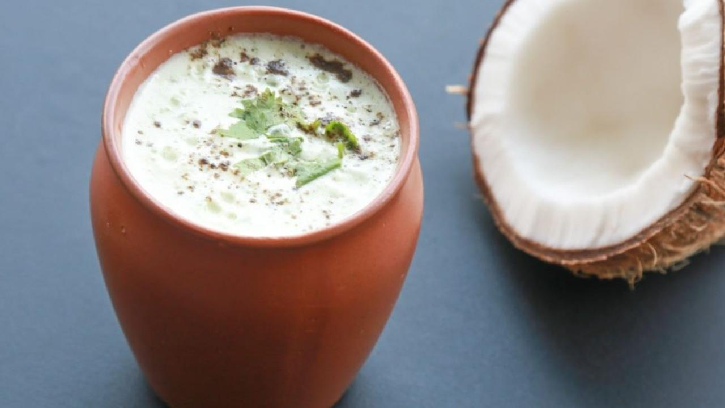

If you are Indian, depending on which part of the country you are from, you will most likely have either curd or buttermilk with every meal! It is an inevitable part of a meal that goes towards making it wholesome. Only the few who do not like milk or curds would not want to have a cup of buttermilk during meals. This Coconut Tambuli is a beautiful alternative to this well-liked dairy product. Try it on your guests and surprise them with the fact that it has no milk product in it. Serve it with this delicious Millet Pongal

### Whole Food Plant Based Coconut Thambuli Recipe

Course: Dairy Alternative, Snack, or Side Dish for Course 3 (Grain Dishes) at Lunch or Dinner Meals  
Cuisine: Indian Recipe  
Prep Time: 20 minutes  
Servings: 2 Glasses

#### INGREDIENTS

1/4 cup Fresh Coconut grated or chopped  
1/4 Green Chili  
1/2 Gooseberry / Nellikkai / Amla  
Juice of 1 Lemon  
2 tsp Miso Paste  
1 pinch Asafoetida / Perunkaayam / Hing  
1 tbsp Coriander leaves chopped  
Water as required

#### INSTRUCTIONS

1. Chop amla into pieces and remove amla seed pod.
2. Cut or grate fresh coconut and grind along with amla pieces, lemon juice, miso paste, and hing into a smooth paste. Add 1 3/4 cups of water and dilute.
3. Chop green chili and coriander leaves and mix in. Stir well and serve fresh!

### Plant Based Chef Pro Tips for the Best Coconut Thambulli Recipe

1. Coconut Thambuli is a Dairy Alternative for buttermilk. Serve towards the end of meals, with rice or without, or just as a snack on a hot afternoon!

# 179.Raw Vegan Mango Parfait Recipe | Whole Food Plant Based Recipes

We wait for summer because come summer it’s time to indulge in Mango Parfait! Gorge on this delicious, frozen raw vegan dessert to beat the heat! Are you that person who can’t help but take a second helping of dessert? Well, this dish is your dream come true and more!

Parfait is a frozen dessert made from a base of sugar syrup, egg, and cream. Can there be healthy and guilt free version of this? You bet! It’s easy too and you can have some every day this summer right out of your refrigerator. This recipe shows you how to make raw vegan Mango Parfait, which is sugar-free as well. This mouth-watering dessert is a layered crunchy-creamy mango goodness in every spoonful. Mangoes and nuts combine to make a heavenly, power-packed dessert that feeds more than just your taste buds.

Try this simple Raw Vegan Mango Parfait while the Mango season lasts 😀

### Whole Food Plant Based Raw Vegan Mango Parfait Recipe

Course: Raw Snack; Breakfast; Course 1 (Raw Dish) at Lunch or Dinner Meals  
Cuisine: American, French  
Prep Time: 10 minutes  
Servings: 2 people

#### INGREDIENTS

##### Base layer

1/2 cup Mixed Nuts: almonds, cashews, walnuts, pista (raw)  
1/4 cup Dates or soaked raisins  
2 tsp Buckwheat groats (optional)  
2 tsp Mango ripe, few chopped pieces for flavour  
1 pinch Cardamom Powder / elaichi

##### Middle Layer

1 cup Cashews soaked  
1/4 cup Dates or soaked raisins  
1/8 cup Mango ripe, few chopped pieces for flavour  
1 tsp Lemon Juice  
2 tsp Water as required

##### Top Layer

1 cup Mango ripe, chopped

##### Garnishing

2 tsp Mango riped, chopped  
1 tsp Mixed nuts chopped

#### INSTRUCTIONS

1. Blend raw nuts into a coarse powder.
2. Blend dates (if dates are hard or dry, soak in water for 1 or 2 hours to make them soft), raw buckwheat groats, mango, cardamom powder with powdered nuts so that it sticks together to form a base layer. Adjust sweetness with extra dates if required.
3. Transfer this to a shot glass or any vessel of choice and press this mixture as the base or crust. Freeze for 1 hour, until next layer is prepared.
4. Soak cashews overnight or at least for 2 hours. Blend soaked dates, soaked cashews, mango, and lemon juice into a smooth paste. Adjust sweetness if required. Add this mixture on the crust. Freeze again for 2 hours.
5. Puree ripe mango. Pour it on the above layer and garnish it with chopped mangoes and nuts.
6. Add as many layers as you wish! After adding each layer, freeze for 1-2 hours. Serve fresh!

### Plant Based Chef Pro Tips for the Best Raw Vegan Mango Parfait Recipe

1. You can use pumpkin or sunflower seeds as well for the base layer.
2. Use tender coconut pulp in place of cashews in second layer if allergic to cashews.
3. Fresh grated coconuts can also be used in base layer along with other nuts.
4. Freeze it for couple of more hours and serve it as a yummy cheesecake
5. Replace cardamom with cinnamon or vanilla for completely different hints of flavour!

# 180.How to Make Ragi Mudde | Ragi Mudde Recipe | Whole Food Plant Based Recipes

Ragi mudde could well be one of the oldest staple dishes in south Karnataka, in cities like Bengaluru, Mandya and Mysore. Ragi or finger millet is one of the most nutritious, protein and calcium rich millets, very popular among farmers’ communities.

Getting ragi mudde perfect needs some practice. There are various methods one can follow to prepare ragi balls.

People say the best way to eat ragi mudde is to swallow every mouthful without chewing much. This will make you really full and keep hunger away for a long time, but it also means your body will have to work extra hard to digest it! So, ensure that you chew each mouthful and mix with enough saliva so you digest it well.

Ragi mudde is bland so it is always served with some yummy coconut curries. If you want to get really authentic with this recipe, serve it with bass saaru (basidha saaru), or massoppu saaru.

### Whole Food Plant Based Ragi Mudde Recipe

Course: Course 3 (Grain Dish) for Lunch & Dinner Meals  
Cuisine: Karnataka Recipe from South India  
Prep Time: 5 minutes  
Servings 1 person  
Cook Time: 10 minutes

#### INGREDIENTS

1/2 cup Ragi flour Finger millet flour  
2 tbsp Flaxseeds  
1 cup Water

#### INSTRUCTIONS

1. Grind flaxseeds to get flaxseed powder.
2. Mix 1/2 cup ragi flour with 1 cup water and keep it on the stove, on low flame.
3. Keep stirring with a wooden ladle or spatula to avoid lumps. Continue stirring till it cooks well. Close lid for few minutes and keep the flame on low. Make sure it doesn't get burnt.
4. Once it is properly cooked, switch off the stove and keep it closed for few minutes.
5. Take water in a small bowl. Pour the cooked mixture on a wooden board or a steel plate. Add flaxseed powder. Dip your hands in cold water and then knead the mixture for sometime. Apply cold water on both hands and then mould it into a sphere.
6. Serve ragi mudde with warm [massoppu saaru](https://www.nutritionscience.in/blog/massoppu-saaru-recipe-ragi-mudde-side-dish-whole-food-plant-based-recipes) and [hesaru kaalu](https://www.nutritionscience.in/blog/hesaru-kaalu-recipe-how-to-make-hesaru-kaalu-whole-food-plant-based-recipes)!

### Plant Based Chef Pro Tips for the Best Ragi Mudde Recipe

1. Another method is to keep water for boiling, add ragi flour to it and close the lid. Once it is cooked well, then stir it well. But there are chances that this won't work, especially if the ragi and the water don't mix well.
2. Traditionally, ragi mudde is prepared in a mud pot fixed with a y-shaped wooden tool, and another long, thick piece of wood is used to stir and mash it inside the pot.

# 181.Massoppu Saaru Recipe | Ragi Mudde Side Dish | Whole Food Plant Based Recipes

Massoppu saaru is a south Karnataka delicacy, from Bengaluru, Mandya and Mysore. It is a hot favourite with Ragi balls / Mudde. This dish is filled with goodness that comes from greens and lentils. Massoppu (Masidha soppu) translates to ‘mashed greens’. Cooked greens are mashed to make this dish.

Enjoy making Massoppu Saaru the whole food plant based way with this recipe.

### Whole Food Plant Based Massoppu Saaru Recipe

Course: Course 2 (Vegetable Dish) or Side Dish for Course 3 (Grain Dishes) at Lunch & Dinner Meals  
Cuisine: South Karnataka Recipe from South India  
Prep Time: 10 minutes  
Passive Time: 2 hours  
Cook Time: 20 minutes  
Servings: 2 people

#### INGREDIENTS

2 cup Mixed Greens: Spinach, Amaranth, Dill  
1/4 cup Togri Bele / Toor Dal / Pigeon Pea  
1 Tomato  
1 Onion  
8 cloves Garlic  
1 tsp Jeera  
1 tsp Pepper  
1 tsp Fennel Seeds / Saunf  
1 tsp Poppy Seed / Gasagase / Khus Khus  
1 tsp Coriander Seed / Dhaniya Powder  
3 tsp Miso Paste  
Water As required  
1/2 cup Coconut grated or ground to a paste  
2 tsp Coriander leaves

#### INSTRUCTIONS

1. Soak toor dal for 2 hours.
2. Wash greens and chop it into small pieces. Peel and chop onion into small pieces. Chop tomato into small pieces.
3. Cook toor dal with a half closed lid, taking care not to let us boil over or get burnt. Once half cooked, add greens, tomato, and onion. Continue cooking.
4. Peel and grind or crush garlic into a paste. Keep aside for ten minutes.
5. In the meantime, dry grind jeera, pepper, fennel, poppy seeds, dhaniya powder, and miso paste.
6. Once garlic has sat for ten minutes, mix into the boiling massoppu saaru, along with the freshly ground masala.
7. Once dal and greens are well cooked, let it cool for few minutes, then mash well with a wooden or metal masher. Alternatively, you could add 3/4 of the dish into a blender and blend to a paste, and then mix it back. However, mashing enhances the texture of the dish compared to blending.
8. Dry roast mustard seeds until they just start sputtering, then mix into massoppu saaru.
9. Garnish with grated coconut or coconut paste, and coriander leaves. Serve fresh with [ragi mudde](https://www.nutritionscience.in/blog/how-to-make-ragi-mudde-ragi-mudde-recipe-whole-food-plant-based-recipes), red rice or steamed savory kadubus.

### Plant Based Chef Pro Tips for the Best Massoppu Saaru Recipe

1. Any choice of green leafy vegetables can be used.
2. Dry roasted curry leaves and urad dal can be added along with dry roasted mustard seeds too.
3. A tsp of date syrup can be used for some sweetness and extra tomato or kokum for extra sourness.

# 182.Hesaru Kaalu Recipe | How to Make Hesaru Kaalu | Whole Food Plant Based Recipes

Hesaru Kaalu or Green gram dal is a storehouse of nutrition, high in dietary fibre, protein, and folates among many other important micro and macro nutrients.

This side dish is delicious and goes well with anything from rice to rotis to ragi mudde.

Try our whole food plant based version of the Hesaru Kaalu Recipe and send us pictures!

### Whole Food Plant Based Hesaru Kaalu Recipe

Course: Side Dish for Course 3 (Grain Dishes) at Lunch & Dinner Meals  
Cuisine: North Karnataka Recipe from South India  
Prep Time: 10 min  
Passive Time: 6 hours  
Cook Time: 20 mins  
Servings: 2 Cups People

#### INGREDIENTS

1/2 cup Hesaru Kaalu / Sabut Moong Dal / Whole Green Gram  
1 Onion  
2 Tomatoes  
4 cloves Garlic  
1 cm piece Ginger  
1 Green Chili  
1 tsp Turmeric Powder  
2 tsp Dhaniya / Coriander Seeds Powder  
1 tsp Jeera / Cumin Powder  
1 tsp Black Pepper Powder  
1/4 cup loosely packed Coconut grated  
1 tsp Mustard Seeds  
10 Curry Leaves  
2 tbsp Coriander Stems & Leaves chopped  
4 tsp Miso Paste (Healthy Salt Alternative. See Nutrition Science Highlights below)

#### INSTRUCTIONS

1. Soak hesaru kaalu / sabut moong dal / whole green gram overnight or at least for 6 hours. Cook until half cooked.
2. While this is being cooked, peel and chop onion into long, thin pieces. Chop tomatoes into small pieces. Peel and chop ginger into tiny pieces. Slit green chili along its length. Add to hesaru kaalu and continue cooking.
3. While this is cooking, peel and crush or grind garlic into a paste. Keep aside for ten minutes.
4. Once garlic has rested for minutes, mix into the hesaru kaalu on the stove along with turmeric powder, dhaniya powder, jeera powder, and black pepper powder.
5. After a minute or two, once the raw smell goes away, turn off stove and add in grated coconut, curry leaves, chopped coriander leaves, and miso paste. Mix well.
6. Dry roast mustard until it just starts sputtering. Once it does, mix into hesaru kaalu. Serve fresh with [bajra roti](https://www.nutritionscience.in/blog/bajra-roti-recipe-pearl-millet-flatbread-whole-food-plant-based) or [ragi mudde](https://www.nutritionscience.in/blog/how-to-make-ragi-mudde-ragi-mudde-recipe-whole-food-plant-based-recipes)!

### Plant Based Chef Pro Tips

1. For added nutrition, soak hesaru kaalu / green gram two days in advance and sprout!

# 183.Fruit Salad Recipe | Banana & Pear Salad | Whole Food Plant Based Recipes

Fresh Fruit Salad with juicy crunchy pear and soft sweet bananas topped off with some nuts and raisins. Yummy! This is a great way of eating loads of fruit, especially for those who don't like fruits too much.   
With the right amount of crunchiness, juiciness, and sweetness, this banana pear salad is simple to put together and great to start the day with.

Enjoy!

### Whole Food Plant Based Banana Pear Salad Recipe

Course: Course 1 (Raw Dish) for Breakfast, Lunch & Dinner Meals; Snack; Salad  
Cuisine: Satwik Recipe  
Prep Time: 10 minutes   
Servings: 2 people

#### INGREDIENTS

4 Yelakki Bananas or 1 Large Banana  
2 Pears  
1/4 cup Raisins  
1 tbsp Almonds  
1/4 Vanilla Pod

#### INSTRUCTIONS

1. Peel and chop banana and into slices.
2. Remove stems and chop pears into small pieces.
3. Coarsely chop almonds.
4. Scrape vanilla seeds off vanilla pods.
5. Mix all ingredients together. Serve fresh!

### Plant Based Chef Pro Tips for Best Banana Pear Salad Recipe

1. Ensure to serve fresh, otherwise both banana and pear will get oxidised and brown.

# 184.Baked Onion Pakoda Recipe | Oil Free Recipe | Whole Food Plant Based

Introducing Baked Onion Pakoda, made without a single drop of oil or any maida. Hot Onion Pakodas with a side of spicy mint dip and date based sweet dip make for amazing snacks. Just the very thought of Onion Pakodas make the mouth water.

Make healthy, scrumptious, Baked Onion Pakoda today and send us pictures!

## Baked Onion Pakoda Recipe

Course: Snacks, Side Dish for Lunch & Dinner Meals  
Cuisine:   
Prep Time: 15 minutes  
Cook Time: 40 minutes  
Servings: 4 People

### INGREDIENTS

1. 1 cup Besan / Gram Flour
2. 1/4 cup Peanut
3. 1/4 cup Flaxseed
4. 2 Onion
5. 1 cm piece Ginger
6. 1 tsp Dhaniya / Coriander Seeds
7. 1/2 tsp Ajwain / Omum / Caraway Seeds
8. 1 Green Chili
9. 1 tsp Turmeric Powder
10. 1/2 tsp Black Pepper Powder
11. 1/2 tsp Jeera Powder / Cumin Seed Powder
12. 1 tsp Amchoor Powder / Raw Mango Powder
13. 4 tsp Miso Paste
14. Water as required

### INSTRUCTIONS

1. Peel and chop onions into long, thin slices.
2. Coarsely grind peanuts into peanut powder. Grind flaxseeds into a fine powder.
3. Mix all ingredients together with just enough water to make the flour stick to the onion pieces and form roughly shaped balls that break easily. If there is too much, it becomes onion bajji and not onion pakoda!
4. Line a baking tray with unbleached parchment paper or silicone baking sheet.
5. Form roughly shaped balls of the onion pakoda dough and place at even intervals on the baking tray.
6. Bake at 160 deg C for 30 minutes, then turn the pakodas over and bake for ten more minutes. Watch that they don't become too brown! The lighter, the healthier.
7. Oil-free Baked Onion Pakodas are ready! Serve fresh with Pudina Chutney!

# 185.Bajra Roti Recipe | Roti Bakar | Pearl Millet Flatbread | Whole Food Plant Based

Bajra Roti is a gluten free Indian flatbread. This millet roti is extremely nutritious, affordable and easy to make. It is a staple cereal in many parts of the country, predominantly Rajasthan and parts of North Karnataka. Bajra like many millets are hardy crops and grow well in dry conditions making it a boon in hot dry areas.

Having a variety of whole grains like Pearl Millet in our diet ensures that we have better nutrition and the new flavours and textures are a bonus.

Enjoy our whole food plant based Bajra Roti recipe and send us pictures of your experiments with them.

## Whole Food Plant Based Bajra Roti Recipe

Course: Course 3: Grain Dishes for Lunch & Dinner Meals  
Cuisine: Rajasthani, Udupi & North Karnataka Recipe from India  
Prep Time: 30 minutes  
Cook Time: 20 minutes  
Servings: 10 Bajra Rotis

### INGREDIENTS

1. 2 1/2 cups coarsely ground Bajra Flour (Pearl Millet Flour) for dough
2. 1/2 cup Flaxseed Powder (Ground up Flaxseeds)
3. 1 cup coarsely ground Bajra Flour (Pearl Millet Flour) for rolling out bajra rotis
4. Water as required

### INSTRUCTIONS

1. Boil 2 cups water.
2. Mix bajra flour with flaxseed powder and keep ready. Once water boils, slowly add water little by little into the flour mixture and mix well. Stop adding water once the flour comes together into a kneadable dough. The consistency must be soft but not sticky.
3. Knead for five to ten minutes. At the end, you should be able to make a ball without any breaks. If it breaks, add a little water and knead again. If it is too sticky, add some flour. The consistency should be perfect for the perfect roti.
4. Take a ping-pong ball sized piece of pearl millet & flaxseed powder dough and roll it into a ball between your hands. Flatten into a thick disc.
5. Dust with bajra flour and roll it out into a bajra roti with a rolling pin.
6. Heat a thick bottomed pan or tawa. It is hot enough when a bit of water dropped on the pan dances instead of evaporating immediately.
7. Dust off any extra flour from the pearl millet flatbread, place it on the tawa and reduce flame to sim or medium. Close with a lid. After 30 to 60 seconds, once cooked, flip over. It is cooked on the first side if light brown spots have begun appearing. If the spots are large or dark brown, it has been overcooked. Tear off the dark parts and consume only the unbrowned parts.
8. After 20 to 30 seconds, take the roti / chapathi off the tawa. By now, small, light brown spots should have appeared on both sides and the roti / chapathi should have been fully cooked.
9. Wait for a few minutes until it cools down, then serve.

# 186.Amte Kai Chutney Recipe | Ambade Ambarella or Hog Plum Dip | Whole Food Plant Based Recipes

Amte kai chutney! Have you tasted ambarella? It looks like a small raw mango, and tastes amazing! The perfect sourness for a lip-smacking chutney.

Known by many names like Amte kai in Kannada, Ambade in Tulu, Ambado in Konkani, Ambarella or Hog Plum in English, this fruit is very popular in Asian, American and African countries. In India, it is used in chutney, pickles, soups, and curry. It is a rich source of dietary fibre and Vitamin B complex!

Chutneys today are popularly garnished with an oil tadka. This is unnecessary and does not add any health benefit to the chutney. Whole nuts are the best sources of oil.

Amte kai chutney is a traditional dip prepared with ambarella with selected spices.

### Whole Food Plant Based Amte Kai Chutney Recipe

Course: Chutneys; Side Dish for Course 3 (Grain Dishes) at Lunch & Dinner Meals  
Cuisine: Satwik Karnataka Recipe from South India  
Prep Time: 10 minutes   
Cook Time: 5 minutes  
Servings: 2 people

#### INGREDIENTS

5 Amte Kai / Ambarella / Hog Plum, peeled & chopped  
1/4 tsp Fenugreek Seeds / Methi Seeds  
1/2 tsp Cumin Seeds / Jeera  
1/4 tsp Turmeric Powder  
1 tsp Urad Dal / Whole Black Gram  
1 tsp Bengal Gram Dal  
1/4 tsp Black Pepper  
2 Dates  
2 tsp Miso Paste (Healthy Salt Alternative. See Nutrition Science Highlights below)  
1/4 cup Water as required

#### INSTRUCTIONS

1. Wash, peel and chop ambarella into small pieces. Remove seed if fruit is not tender.
2. Dry roast fenugreek seeds, black urad dal, and bengal gram dal separately and grind to a powder with jeera / cumin seeds and black pepper.
3. Add chopped ambarella, miso paste, and a little water. Grind to a smooth paste to make Amte Kai Chutney. Serve fresh with dosa or roti.
4. Dry tadka or seasoning can be prepared with mustard seeds and curry leaves.  
   Amte kai can be replaced with raw mango or gooseberry (nellikai / amla) in case you don't find ambarella.

# 187.Baingan Aloo Recipe | One Pot Brinjal Potato Curry | Whole Food Plant Based Recipes

Baingan Aloo gravy with soft fluffy rotis is truly a lip-smacking meal. Aloo (potato) is almost a universally loved vegetable and it makes any dish it is in a popular one. In this recipe, we show how you can make the healthiest Baingan Aloo dish while retaining the deliciousness of it.  
Making everyday dishes healthy is the key to long-term health. These changes are also super easy to make and require little to no additional effort.

Enjoy our whole food plant based Baingan Aloo recipe and send us pictures!

## Whole Food Plant Based Baingan Aloo Recipe

Course: Course 2 (Vegetable Dish) for Lunch & Dinner Meals  
Cuisine: North Indian Recipe  
Prep Time: 15 minutes   
Cook Time: 20 minutes  
Servings: 4 people

### INGREDIENTS

1/2 kg Brinjal / Baingan  
1/4 kg Potato / Aloo  
4 Tomatoes  
2 Onions  
4 cloves Garlic  
1 inch piece Ginger  
1 tsp Turmeric Powder  
2 tsp Dhaniya / Coriander Seeds Powder  
1 tsp Jeera / Cumin Powder  
1 tsp Black Pepper Powder  
4 tsp Miso Paste (Healthy Salt Alternative. See Nutrition Science Highlights below)  
2 tsp Coriander Leaves

### INSTRUCTIONS

1. Wash and chop brinjal into quarters and potato into cubes.
2. Cook in a vessel with minimal water until half cooked.
3. Peel onion and ginger. Grind them both with tomato into a paste. Add to the boiling baingan and aloo and continue cooking.
4. Peel and crush or grind garlic. Keep aside for ten minutes, then add to the boiling baingan aloo sabji with turmeric powder, dhaniya powder, and jeera powder.
5. Once cooked, remove from stove. Grind cashews to a paste with minimal water and mix cashew cream into aloo baingan sabzi along with black pepper powder and miso paste.
6. Wait until it cools down fully. Garnish with fresh coriander leaves and serve fresh!

### Plant Based Chef Pro Tips for Best Baingan Aloo Recipe

1. Keep freshly chopped potato and brinjal immersed in water until baking, to prevent browning.

# 188.Panakam Recipe | Muskmelon Panakam | Whole Food Plant Based Recipe

On the occasion of Ram Navami festival which is celebrated as the birth of Lord Rama in India, a special traditional drink called Panaka is prepared. Temples and community groups get ready with huge vessels to prepare Panaka, Neer majjige (Buttermilk) or Kosambari (Cucumber lentil salad) on the festival day to offer as Naivedya or Prasad(offering) to Lord Rama.

This festival falls in summer and these drinks and salad help beat the summer heat! Panaka is prepared with different fruits, but the main festival one is prepared with Muskmelon.

Although it is popularly made for the festival, this drink makes for a good snack on a regular basis.

Celebrate today with this delicious drink.

### Whole Food Plant Based Panakam Recipe

Course: Course 1: Raw, Juice & Smoothie, Ram Navami Festival Dish, Snack  
Cuisine: Indian Traditional Festival Recipe  
Prep Time: 10 minutes  
Servings: 4 glasses

#### INGREDIENTS

1 Muskmelon  
1 cup [Date Syrup](https://www.nutritionscience.in/blog/date-syrup-recipe-whole-food-plant-based)  
1 tsp Cardamom Powder / Elaichi Powder

#### INGREDIENTS

1. Peel musk melon and remove seeds.
2. Grind muskmelon to get musk melon smoothie. Mix with date syrup to get muskmelon panakam.
3. Crush cardamom into a fine powder and mix into muskmelon panakam.
4. Add drinking water if needed to dilute. Keep in mind that sweetness will reduce too!
5. Serve chilled!

# 189.Green Smoothie Recipe | Tropical Smoothie | Whole Food Plant Based Recipes

Green Smoothie, the perfect way to kick-start the day! With the goodness of greens and bananas, sweetened with dates and flavoured with spices, these smoothies certainly pack a punch.   
Anti-oxidant rich and super filling, they are a great post-workout refresher as well. Although everyone knows that smoothies are healthy, not may know that they can be yummy too!

Try this Green Smoothie after a good workout session or just before a long day.

### Whole Food Plant Based Green Smoothie Recipe

Course: Course 1: Raw, Juice & Smoothie, Snack  
Cuisine: Raw Vegan Recipe  
Prep Time: 10 minutes  
Servings: 2 glasses

#### INGREDIENTS

4 Yelakki Bananas / 2 Large Bananas  
1/4 cup [Date Syrup](https://www.nutritionscience.in/blog/date-syrup-recipe-whole-food-plant-based)1/4 cup Raisins  
1 cup Spinach chopped  
1/2 tsp Cinnamon Powder  
1/4 tsp Pepper Powder  
1 tbsp Flaxseed Powder  
3 Walnuts

#### INGREDIENTS

1. Peel Bananas.
2. Grind all ingredients together, except walnuts, to get green smoothie.
3. Garnish with walnuts. Serve fresh!

### Plant Based Chef Pro Tips for Best Green Smoothie

1. The more greens, berries, and spices you use, the healthier and yummier your smoothie becomes!

# 190.Cruciferous Soup Recipe | Whole Food Plant Based

Cruciferous soup? Yes, it's literally a soup with cruciferous vegetables; cauliflower, broccoli, turnip or radish.   
Our version of the Cruciferous Soup is enriched with the flavours of ginger, garlic, and lemongrass to make for the most soothing mid-day refresher. This spice packed soup is also amazingly healthy while being a treat to the taste buds.

Try this whole food plant based cruciferous soup and let us know how you like it.

## Cruciferous Soup

Course: Breakfast, Soups  
Prep Time: 10 minutes  
Cook Time: 15 minutes  
Servings: 2 people

### INGREDIENTS

1. 1/2 cup Cauliflower chopped
2. 1/2 cup Broccoli chopped
3. 1 Turnip or Radish
4. 1 Onion chopped
5. 5 pods garlic
6. 1 inch Ginger
7. 2 long leaves Lemon Grass
8. 1/2 tsp Turmeric Powder
9. 1/2 tsp Black Pepper Powder
10. Juice of 1 Lemon
11. 2 tbsp Almonds Soaked overnight or at least for 5 hours
12. 4 tsp Miso Paste
13. 1/2 tsp Mustard Seeds
14. 10 Thai Basil Leaves

### INSTRUCTIONS

1. Chop cauliflower and broccoli. Peel and chop turnip or radish, onion, and ginger. Take all chopped vegetables in a vessel with lemongrass, turmeric powder, and little (minimal) water and cook with a closed lid.
2. While the vegetables are being cooked, peel and crush garlic. Keep aside for ten minutes. After ten minutes, add crushed garlic to the boiling vegetables.
3. Once cooked, drain stock and keep aside to mix back later. Spread vegetables on a plate to cool off. Remove lemon grass.
4. Once vegetables are cool, blend them in a high powered blender along with pepper powder, soaked almonds, and miso paste.
5. Dry roast mustard seeds until they begin sputtering. As soon as they begin sputtering, switch off stove and mix the mustard seeds into the soup.
6. Garnish with lemon juice and thai basil leaves. Serve fresh!

# 191.Makki ki Roti Recipe | Punjabi Maize Flatbread | Whole Food Plant Based Recipes

Picture this. Makki ki Roti, fresh and hot served with warm sarson ka saag (mashed mustard greens) and lemony dal on a cold winter night! Doesn’t it sound divine?

This famous Punjabi flatbread made with maize flour is traditionally flattened on the palm. One acquires this skill over time with practice while having a lot of fun trying.

Maize flour is slightly yellowish in colour. It is made by coarsely grinding corn kernels.

Make this a-MAIZE-ing flatbread and send us pictures because we would love to see them and drool.

### Whole Food Plant Based Makki Ki Roti Recipe

Course: Course 3: Grain Dishes for Lunch & Dinner Means  
Cuisine: Punjabi Recipe from North India  
Prep Time: 15 minutes  
Cook Time:10 minutes  
Servings:

#### INGREDIENTS

1 1/4 cup Makki ki Atta / Maize Flour coarsely ground  
1/4 cup Flaxseed Powder  
1/2 tsp Caraway Seeds / Ajwain, crushed  
2 tsp Kasuri Methi / Dried Fenugreek Leaves  
1/2 cup Water

#### INSTRUCTIONS

1. Heat water until it boils.
2. Add all the dry ingredients in a big bowl and mix. Add boiling water little by little and knead into a soft dough. You may require only 1/4 cup, depending on the flour. Use as much as required. Knead well.
3. Use dry flour and roll the dough into flatbreads. A parchment paper or reusable silicone or plastic sheet can be used to roll the dough to avoid sticking or breaking.
4. Heat an iron tawa and cook the rotis on both sides till it is well cooked and with a few light brown spots on both sides. It can be cooked on tawa and then directly on fire similar to wheat phulka as well.
5. Serve with [Sarson ka saag](https://www.nutritionscience.in/blog/sarson-ka-saag-recipe-punjabi-makki-ki-roti-side-dish-whole-food-plant-based-recipes)!

#### Plant Based Chef Pro Tips for Best Makki Ki Roti Recipe

1. Grated radish or other vegetables can be added to dough.
2. Make sure the rotis are cooked well, but not browned or burnt.
3. Turmeric powder can be added as well.

# 192.Sarson ka Saag Recipe | Punjabi Makki ki Roti Side Dish | Whole Food Plant Based Recipes

Sarson Ka Saag and Makki Ki Roti are quite popular especially in cold wintery Punjab. This wonderfully falvourful dish can be had with any roti, but the popular choice is makki ki roti.

In our recipe we've eliminated oil and dairy, both of which take away from the goodness of the otherwise nutritious dish. Try our rich and flavourful whole food plant based Sarson Ka Saag. Winter is coming!

## Sarson Ka Saag Recipe

Course: Course 2: Vegetable Dish / Side Dish for Course 3: Grain Dishes for Lunch Meal  
Cuisine: Indian, North Indian  
Prep Time: 15 minutes  
Cook Time: 15 minutes  
Servings: 4 people

### INGREDIENTS

1. 1 bunch Mustard Greens
2. 1/2 bunch Bathua / lamb's quarters plants / Pappukura / Paruppukkeerai / Kaduoma / Vastuccira (optional)
3. 1/2 bunch of Spinach leaves/Palak
4. 3 Tomatoes
5. 1 inch Ginger
6. 1 tsp Dhaniya Powder / Coriander Seed Powder
7. 3/4 tsp Jeera Powder
8. 1/2 tsp Pepper Powder
9. 1/2 tsp Turmeric Powder
10. 1/2 tsp Mustard Seeds
11. 4 tsp Miso Paste
12. Juice of 1 Lemon
13. 2 tbsp Cashews

### INSTRUCTIONS

1. Wash the mustard greens, bathua plants and palak. Remove leaves and use the rest of the plants for compost.
2. Grind all ingredients except miso paste and cashews to a chunky paste in a mixie / blender.
3. Cook the ground mixture in a vessel until fully cooked. Once done, switch off stove and mix in miso paste.
4. Mildly roast mustard seeds until they begin sputtering. As soon as they start sputtering, switch off the stove and mix seeds into the dish immediately.
5. Preferably, soak cashews overnight or at least for 5-6 hours. Blend in high powered blender with very little water and a pinch of turmeric powder until smooth. Top your sarson ka saag with fresh golden cashew cream.
6. Serve fresh with [Makki ki Roti](https://www.nutritionscience.in/blog/makki-ki-roti-recipe)!

# 193.Date Syrup Recipe | Whole Food Plant Based

Have you had Date Syrup? No, not the filtered one that are available in stores, but freshly made at home. Rich and delicious, this fruit-based sweetener is perfect for all kinds of desserts.

In addition to making the dish sweet, it also makes it super rich and mouth-watering. In fact, make date syrup and pop it in the fridge, after a few hours, take it out and eat it plain. Yummmmmmyy!

100% Date Syrup nice cream! :)

## Date Syrup Recipe

Course: Fundamental Recipes  
Cuisine: American, Indian  
Prep Time: 5 minutes  
Passive Time: 5 hours  
Servings: 1 cup

### INGREDIENTS

1. 3/4 cup Seedless / Pitted Dates
2. Juice of 1/2 Lemon

### INSTRUCTIONS

1. Soak seedless / pitted dates overnight or at least for 5 hours.
2. Grind soaked dates to a smooth paste and squeeze lemon into it.
3. Use fresh, homemade date syrup for all your beverages, sweets and desserts, instead of sugar, honey or jaggery. Can be stored in the refrigerator for up to 2 weeks.

# 194.Coconut Chutney Recipe | How to Make Coconut Chutney | Whole Food Plant Based Recipes

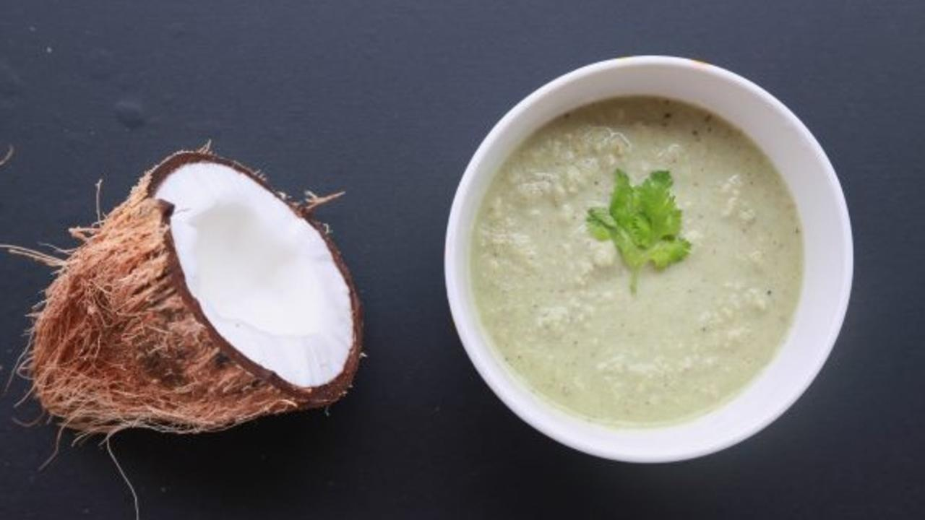

Coconut chutney – can you imagine eating pongal without it? It is a must have for us! Yum!

Coconut is a super versatile nut, and goes well with any sort of recipe, savory and sweet, adding its unique flavor to the dish. In South India, coconut is used in pretty much every dish, from chutney to sambar to poriyal to avial!

Chutneys today are popularly garnished with an oil tadka. This is unnecessary and does not add any health benefit to the chutney when nuts are already used. In fact, nut-based chutneys have plenty of natural oil by themselves, from the whole nut. This oil is of much better quality than any extracted oil, whether it is unrefined or refined.

Here’s a super easy and delicious coconut chutney recipe. It can be used as dip with vegetables or salads, or with pongal, idli, dosa or roti. We have replaced green chili with pepper, to bring out spice that does not irritate the intestines. Bring out the creative side in you using herbs and spices to flavor this versatile chutney. Hope you enjoy it! 🙂

### Whole Food Plant Based Coconut Chutney Recipe

Course: Chutneys, Side Dish for Course 3: Grain Dishes at Lunch & Dinner Meals  
Cuisine: Satwik South Indian Recipe  
Prep Time: 10 minutes   
Servings: 2 people

#### INGREDIENTS

1/2 cup Fresh Coconut grated or cut  
1/4 tsp Black Pepper  
1 cm piece Ginger  
2 tsp Roasted Gram Hurigadale, putani, pottukadalai  
2 tsp Miso Paste (Healthy Salt Alternative. See Nutrition Science Highlights below)  
1 tsp Mustard Seeds  
2 tsp Coriander leaves chopped  
Water as required  
1 pinch Asafoetida / Hing

#### INSTRUCTIONS

1. Grind coconut with black pepper, and make it into a fine paste. Add just enough water to get the right consistency.
2. Pour the chutney into a bowl and garnish with chopped coriander leaves.
3. Dry roast mustard seeds until they just start popping. When they do, immediately pour them on to the coconut chutney, and serve with pongal, dosa or roti!

### Plant Based Chef Pro Tips

1. Squeeze some lemon juice or add amla to make it tangy.
2. Any herb can be used instead of coriander leaves.
3. Do not add too much water as coconut chutney will become too watery.
4. If coconut chutney does become too watery, squeeze lemon juice and dilute it

# 195.Pidi Kozhukattai Recipe | Steamed Broken Grain Dumplings | Whole Food Plant Based Recipes

Pidi Kozhukattai. Amma makes it best! Fragrant, steamed, and light, these dumplings are super easy to prepare. Here’s how!

The traditional recipe uses coconut mixed with the kozhukattai batter and steamed. Here we just ensure we don’t heat the coconut in the dish. Equally yummy and tasty as well! Best served with Karuvepilai Thuvaiyal (Curry Leaves Chutney)!

## Whole Food Plant Based Pidi Kozhukattai Recipe

Course: Breakfast, Course 3: Grain Dish for Lunch & Dinner Meals, Millet Dishes  
Cuisine: Tamil Recipe from South India  
Prep Time: 10 minutes   
Cook Time: 25 minutes  
Servings: 10 Kozhukattais

### INGREDIENTS

1/2 cup Millet Rava (proso, kodo, foxtail, little millet or any other millet, even rice)  
1 tsp Urad Dal  
1 tsp Bengal Gram Dal  
1 inch piece Ginger peeled & chopped  
1 small Green Chili chopped  
1/2 tsp Mustard Seeds  
1 pinch Asafoetida  
5 Curry Leaves  
2 tbsp Coriander leaves chopped  
3 tsp Miso Paste (Healthy Salt Alternative. See Nutrition Science Highlights below)  
1/4 cup Coconut freshly grated

### INSTRUCTIONS

1. Roast the mustard, Urad Dhal and Bengal Gram Dhal separately. Ensure you keep stirring while roasting as you will not have any oil to keep them from charring. Roasting them separately, is also towards this. Ensure to roast them minimally, only until they start sputtering or turn light brown.
2. Pour 1.5 cups of water in a kadai and put in all the roasted lentils and mustard.
3. Add the chopped chilly, ginger, crushed curry leaves, salt and asafoetida.
4. When the water comes to a boil, add the millet rava slowly. Keep stirring the mixture until the mixture becomes thick, like idli batter.
5. Take the mixture off the stove. Let it cool. Make small balls out of it. Steam the balls in an idli steamer.
6. Once done, remove on to a plate and wait until they are completely cool. Garnish with freshly grated coconut. Serve Fresh!

### Plant Based Chef Pro Tips

1. Serve with sambar and chutney, moist or watery dishes, to compensate for the dry nature of the kozhukattais.

# 196.Karnataka Knol Kohl Kootu | Kohlrabi Lentil Curry from Karnataka | Whole Food Plant Based Recipe

Knol Kohl or Kohlrabi is another common vegetable cooked in many a home. This kootu recipe, like all of our others is aimed at making our everyday dishes healing. We've taken what you make at home regularly and shown you how to make it into a whole food plant based dish with little or no significant additional effort.

Try this traditional Knol Kolh Kootu with rasam and brown rice and send us pictures of your whole food plant based meal.

## Karnataka Knol Kohl Kootu / Kohlrabi Lentil Curry Recipe from Karnataka

Course: Course 2: Vegetable Dish / Side dish for Lunch & Dinner Meals  
Cuisine: Kannada / Karnataka, South Indian  
Prep Time: 10 minutes  
Cook Time: 30 minutes  
Servings: 2 people

### INGREDIENTS

1. 1/4 cup Moong Dal Green Gram Dal / Paasi Paruppu / Paithamparuppu
2. 1 tbsp Peanuts
3. 2 tbsp Fresh Peas
4. 1 cup Knol Kohl / Kohlrabi

#### Kootu Masala

1. 1/4 cup Coconut Grated
2. 1 tsp Urad Dal Black Gram Dal / Ulutham Paruppu / Uddina Bele
3. 1 tsp Pepper Powder
4. 1/2 tsp Tumeric Powder
5. 2 tsp Miso Paste (Healthy Salt Replacement. See Nutrition Science Highlights below for details)
6. Juice of 1 Lemon
7. 10 Curry Leaves
8. 5 Dates Soaked overnight (or for 20-30 min in hot water) to soften
9. 1 tsp Mustard Seeds

### INSTRUCTIONS

#### Kootu Masala

1. Dry roast urad dal until light brown. Do not allow to darken or burn. Remove from stove and keep aside.
2. Dry roast mustard until it begins sputtering. As soon as it starts sputtering, switch off stove and transfer to a cup.
3. Grind all masala ingredients (except mustard seeds) into a paste, then mix mustard seeds into it.

#### Knol Kohl Kootu

1. Preferably, soak moong dal overnight or at least for 4-5 hours. Take soaked moong dal in vessel, add enough water to cover the dal and start cooking with a partially closed lid.
2. Peel and chop knol kohl / kohlrabi into small pieces. Add to the moong dal after about ten minutes of cooking. Stir from time to time and add water if required. The final consistency should be a thick, pourable liquid. While this is cooking, you can prepare the kootu masala as outlined above.
3. Once knol kohl / kohlrabi is fully cooked, switch off stove and mix in masala. Garnish with curry leaves. Serve fresh!

[Login](https://www.nutritionscience.in/login)

# 197.Chukku Kaapi Recipe | Traditional Tamil Recipe | Whole Food Plant Based



“Chukkillaatha Kashaayamillai”, there is no kashaya without Ginger.

The original ‘Kaapi’ that most of Tamil Nadu and Kerala drank before ‘By-Two Kaapi’ became popular, Chukku Kaapi is an amazing drink to start the day with. It clears your senses when you’re groggy in the morning or tired in the evening and totally refreshes you. It is also a wonderful aid during respiratory infections (especially sore throat) or when gas trouble threatens to ruin your reputation.

## Whole Food Plant Based Chukku Kaapi Recipe

Course: Beverage, Herbal & Spice Tea  
Cuisine: Tamil Recipe from South India  
Servings: 2 Glasses

### INGREDIENTS

1 tsp Dry Ginger Powder  
1/2 tsp Dhaniya Powder / Coriander Seed Powder  
1/2 tsp Jeera Powder / Cumin Seed Powder  
1/2 tsp Pepper Powder   
4 tbsp Date Syrup  
1 1/2 glasses Water

### INSTRUCTIONS

1. Add all the ingredients together in a bowl and place it on the stove at medium flame. Boil for 2-**3 minutes. Serve** warm.

### Plant Based Chef Pro Tips

1. It is a good idea to mix the powders and store it in an airtight container so you can make it everyday without much effort!

# 198.Amaranthus Double Beans Soup Recipe - Whole Food Plant Based

A warm bowl of Amaranthus Double Beans Soup makes for a fully nutritious and delicious dish. Amaranthus, rich in iron, Vitamin C and potassium among others and Double Beans, rich in folate, protein and magnesium, among others come together with antioxidant rich spices in this recipe.

Try our whole food plant based soup and let us know if you found it as delicious as we did.

## Amaranthus Double Beans Soup Recipe

Course: Soup  
Cuisine: Indian  
Prep Time: 10 minutes  
Cook Time: 20 minutes  
Passive Time: 5 hours  
Servings: 2 people

### INGREDIENTS

1. 50 g Dried Double Beans If using fresh, use double the quantity
2. 1/2 bunch Amaranthus
3. 1 Onion
4. 6 pods garlic
5. 1 inch Cinnamon
6. 1 Bay Leaf
7. 1/2 tsp Long Pepper Powder
8. 1/2 tsp Pepper Powder
9. 2 cm Ginger
10. 1 tsp Black Sesame Seeds / Til
11. 1 Lemon Peeled
12. 1 tbsp Miso Paste
13. 1/4 cup Mint Leaves Loosely Packed

### INSTRUCTIONS

1. Soak double beans overnight or at least for five hours.
2. Pressure cook soaked beans for three whistles, or as many whistles as it takes to normally cook dal in your pressure cooker.
3. Chop off Amaranthus roots and wash. Chop into medium sized pieces. Peel and chop onion into quarters. Slice ginger. Boil both together with cinnamon, bay leaves, ginger, and minimal water, in a closed vessel.
4. Peel and crush/grind garlic to a paste. Leave aside for ten minutes, then add to the boiling vegetables.
5. Once the vegetables are well cooked, drain the water (reserve it to add back after grinding). Spread the vegetables on a plate to cool off. Remove cinnamon stick and bay leaves.
6. Once cool, grind with long pepper powder, pepper powder, miso paste, peeled and quartered lemon, sesame seeds, most of the mint leaves, and cooked double beans to a smooth paste.
7. Mix in stock, garnish with remaining mint leaves. Serve fresh!

# 199.Milagu Kuzhambu Recipe | Pepper Broth | Whole Food Plant Based Recipes

Milagu Kuzhambu as the name goes is a peppery broth popular in South India. The strong pepper flavour of this broth makes it super spicy but with the goodness of the medicinal properties of pepper.

Not one for the fainthearted, Milagu Kuzhambu is so full of flavour and spices that it will leaving you smacking your lips as you finish up every last drop of it. Try of whole food plant based Milagu Kuzhambu and enjoy the burst of flavours and spices in your mouth.

## Milagu Kuzhambu / Pepper Broth

Course: Side Dish for Course 3: Grain Dishes for Lunch & Dinner Meals, Soup / Beverage  
Cuisine: Tamil Recipe from South India  
Prep Time: 5 minutes  
Cook Time: 10 minutes  
Servings: 2 people

### INGREDIENTS

#### Main Ingredients

1. 2 Tomatoes Medium Sized
2. 1/2 tsp Turmeric Powder
3. 1/2 Dried Red Chili
4. 2 tsp Miso Paste (Healthy Salt Alternative. See Nutrition Science Highlights below)
5. A pinch Hing / Asafoetida / Perunkaayam
6. 1/2 tsp Mustard Seeds
7. 2 tsp cashews

#### Pepper Masala Powder

1. 4 tsp Black Pepper Whole
2. 2 tsp Coriander Seeds
3. 1 tsp Toor Dal
4. 1/4 cup Curry Leaves
5. 1/4 tsp Fenugreek Seeds / Methi / Menthya / Venthayam

### INSTRUCTIONS

#### Pepper Masala

1. Dry roast toor dal in an iron ladle or a small, heavy bottomed vessel / kadai.
2. Grind toor dal with black pepper, coriander seeds, curry leaves, and methi seeds (fenugreek seeds) to a paste.

#### Milagu Kuzhambu / Pepper Broth

1. Grind tomatoes and boil tomato paste in a vessel. Once it starts boiling, add the pepper masala paste, turmeric powder, dried red chili, hing, and miso paste. Boil for five more minutes, until it loses the raw smell.
2. Dry roast mustard seeds for a few seconds until they start sputtering. Once they start sputtering, immediately drop them into the milagu kuzhambu. Garnish with cashews. Serve fresh.

# 200.Brown Rice Recipe | Whole Food Plant Based

Brown Rice is a variety of unpolished rice that retains the bran of the rice. The bran of the rice is rich in dietary fibre, phytonutrients, and other antioxidants. Whole grains such as brown rice has a unique flavour and texture in addition to being healthy.

Here's how you can switch your polished grains with unpolished ones such as brown rice.

## Brown Rice Recipe

Course: Fundamental Recipe, Course 3: Grain Dish for Lunch & Dinner  
Cuisine: Indian  
Prep Time: 2 minutes  
Cook Time: 20 minutes  
Passive Time: 5 hours  
Servings: 2 servings

### INGREDIENTS

1. 1/2 cup Brown Rice Raw
2. Water

### INSTRUCTIONS

1. Soak raw brown rice in water overnight, or at least for 6 hours. If you don't have time to soak this, don't worry, just skip to the next step and increase cooking time by five minutes.
2. Boil brown rice with double the quantity of water. Keep the lid half closed. Check from time to time. If water spills over, open lid some more for a few minutes, until some water evaporates. If rice is gettig burnt from lack of water, add more water. Once rice is nearly fully cooked, remove from stove and keep closed. Once it has cooled down completely, serve fresh.

# 201.Tendli Sukka Recipe | Ivy Gourd Curry | Whole Food Plant Based

Tendli Sukka is a lip-smacking Konkani ivy gourd delicacy. Topped with fresh coconut & cashews, this masala filled dish is an unforgettable experience!

This authentic recipe uses either chickpeas or black channa and soaked cashews as well, along with ivy gourd. Tendli Sukka is a must have in any coastal Karnataka feast!

Gourds are rich sources of nutrients with many health benefits. Chickpeas are a rich source of protein and calcium. This recipe is highly nutritious and is recommended for pregnant women.

Serve fresh with foxtail millet pulav and coconut mylk thambulli! 🙂

## Tendli Sukka Recipe / Thodekai Palya / Ivy Gourd Curry

Course: Course 2: Cooked Veg / Side dish at Lunch & Dinner  
Cuisine: Konkani recipe from Udupi, Puttur, and Mangalore from Coastal Karnataka, India  
Prep Time: 10 minutes  
Cook Time: 15 minutes  
Servings: 4 people

### INGREDIENTS

#### Vegetables

1. 2 cups Ivy gourd / Tendli / Thondekai / Kovakkai chopped into 4 long pieces each
2. 1/4 cup Kabuli Chana / White Chickpeas
3. 1/2 tsp Ginger chopped
4. 2 tsp Cashews soaked

#### Masala

1. 1 cup Coconut grated
2. 1 tsp coriander powder
3. 1/2 tsp Jeera Powder
4. 1/4 tsp Pepper Powder
5. 1 pinch Coriander Seeds
6. 1/4 tsp Mustard Seeds roasted
7. 1/4 tsp Methi seeds roasted
8. 1 tsp Date Syrup for sweetness
9. 4 tsp Miso Paste (Healthy Salt Alternative, see Recipe Notes below)
10. 1 cup Water as required

### INSTRUCTIONS

1. Soak chickpeas overnight.
2. Cook ivy gourd, ginger and chickpeas together with a little water and salt.
3. Meanwhile, dry roast mustard and methi seeds. Powder it. Blend all masala ingredients with coconut into a coarse mixture without adding any water.
4. Once vegetables are cooked, switch off the stove. Use very little water so that it does't become a gravy. Mix in the ground masala.
5. Garnish with soaked cashews and coriander leaves. Serve fresh!

# 202.Vellarikkai Pacchadi / Cucumber Raitha Recipe - Whole Food Plant Based

Vellarikkai Pacchadi or Cucumber Raitha is a hugely popular accompaniment to a range of flavoured and spiced rice dishes including pulao, biriyani, and bisi bele bath. This recipe, like all our recipes shows how one can make this delicious raitha without using any dairy.

Try our Cucumber Raitha and let us know if anyone could tell the difference.

## Vellarikkai Pacchadi / Cucumber Raitha Recipe

Course: Course 1: Raw or Side Dishes at Lunch & Dinner  
Cuisine: Indian, North Indian, South Indian, Tamil  
Prep Time: 10 minutes  
Servings: 2 people

### INGREDIENTS

1. 1/2 Cucumber
2. 1/2 cup Cashews
3. 1/2 Green Chili
4. 1 tsp Miso Paste
5. 1/2 Lemon Peeled
6. 1/4 cup Coriander Leaves Chopped, loosely packed

### INSTRUCTIONS

1. Chop cucumber into tiny pieces. Slit green chili along its length.
2. Grind cashews with lemon to a powder in a high powered blender. Add water and grind to a smooth paste. Add miso paste and blend well.
3. Mix cashew cream, slit green chili and chopped cucumber. Garnish with plenty of coriander leaves. Serve fresh!

# 203.Almond Butter Recipe - Whole Food Plant Based Recipe

Almond Butter anyone? This versatile butter is not only easy to make at home, but can be made instantly. You can use it as a spread on toast, for baking, to make gravies richer, in smoothies, and well, the list is endless. Almond butter has a unique texture and flavour which adds to the dish in addition to making it richer and creamier.

Nut butters are great dairy replacements as they give pretty much similar results while making the dish so much healthier.

Try using almond butter is a variety of dishes and tell us which one you like best!

## Almond Butter Recipe - Whole Food Plant Based

Course: Fundamental Recipe, Dairy Alternative  
Cuisine: American  
Prep Time: 5 minutes  
Servings: 1 cup

### INGREDIENTS

2 cups Kashmiri Almonds

### INSTRUCTIONS

1. Blend almonds in a high speed blender. If required, split into two or three batches, depending on the size of your blender.
2. After a minute or so, almonds will get blended into almond powder, and then get stuck to the sides of the blender, causing the blade to spin freely. At this point, stop the blender and scrape down the sides of the jar, and blend again. Repeat this until smooth, pourable almond butter is formed.
3. If you are using a regular mixie, ensure to not let your mixie get overheated. Take breaks for a minute or two when needed.

# 204.Whole Wheat Roti | Oil Free Roti Recipe | Whole Food Plant Based Recipe

Whole Wheat Rotis are one of the most common cereal dishes in the country. Especially after the Green Revolution, where wheat was promoted and grown en mass, whole wheat rotis have become a staple. Although they are more popular in North India as compared to the South, they are fairly common across the country.

In this recipe, we have added an uncommon yet important ingredient in making the rotis. Follow this recipe to make your rotis that much healthier!

## Whole Wheat Roti

Course: Course 3 (Grain Dishes) for Lunch & Dinner  
Cuisine: Indian, North Indian  
Prep Time: 10 minutes  
Cook Time: 5 minutes  
Servings: 2 People

### INGREDIENTS

1. 1 cup Whole Wheat Flour Roughly Ground
2. 2 tbsp Flaxseed Powder
3. Water

### INSTRUCTIONS

1. Mix flaxseed powder with 3/4 of the whole wheat flour in a large bowl. Make a well in the center, slowly add water little by little, while kneading. Once the dough has come together, stop adding water and knead to a stiff dough. The dough should be soft to the touch, but not sticky. If sticky, add more flour. If too hard, add more water.
2. Take a ping-pong ball sized piece of dough and roll it into a ball between your hands. Flatten into a thick disc.
3. Dust with the remaining whole wheat flour and roll it out into a roti or chapathi with a rolling pin.
4. Heat a thick bottomed pan or tawa. It is hot enough when a bit of water dropped on the pan dances instead of evaporating immediately.
5. Dust off any extra flour from the chapathi, place it on the tawa and reduce flame to sim or medium. Close with a lid. After 30 to 60 seconds, once cooked, flip over. It is cooked on the first side if light brown spots have begun appearing. If the spots are large or dark brown, it has been overcooked. Tear off the dark parts and consume only the unbrowned parts.
6. After 20 to 30 seconds, take the roti / chapathi off the tawa. By now, small, light brown spots should have appeared on both sides and the roti / chapathi should have been fully cooked.
7. Wait for a few minutes until it cools down, then serve.

# 205.Baked Sweet Potato Wedges Recipe | Whole Food Plant Based Recipes

Looking for a yummy yet healthy snack? Or maybe a side dish that's different from what you usually make? Look no further, Baked Sweet Potato Wedges are here and here to stay. These wedges are packed with flavour and perhaps the best way of eating this extremely nutritious tuber.

Enjoy this whole food plant based baked sweet potato wedges and let us know if you want more recipes like these!

## Whole Food Plant Based Baked Sweet Potato Wedges Recipe

Course: Course 2: Vegetable Dish for Lunch & Dinner Meals, Snack  
Cuisine: Indian Fast Food Recipe  
Prep Time: 10 minutes   
Cook Time: 30 minutes  
Servings: 4 people

### INGREDIENTS

1/2 kg Sweet Potato  
1 tsp Turmeric Powder  
1 tsp Black Pepper Powder  
1 tsp Red Chili Powder  
4 tsp Miso Paste (Healthy Salt Alternative. See Nutrition Science Highlights below)  
2 tsp Coriander Leaves

### INSTRUCTIONS

1. Wash and chop sweet potato into 1 inch thick slices, then chop each slice into 4 wedges. Steam for five minutes to half cook sweet potato wedges.
2. Mix turmeric powder, black pepper powder, red chili powder, and miso paste into a paste. Spread over each half cooked sweet potato wedge.
3. Line a baking tray with unbleached parchment paper or silicone sheet. Arrange spiced sweet potato wedges on the tray without letting them touch each other.
4. Bake at 160 deg C for 15 minutes or so until fully cooked.
5. Remove from oven and wait until they cool down fully. Garnish with fresh coriander leaves and serve!

### Plant Based Chef Pro Tips for Best Baked Sweet Potato Wedges Recipe

1. Keep freshly chopped sweet potato wedges immersed in water until baking, to prevent browning.

# 206.Moong Dal Kheer with Raisins & Elaichi | Whole Food Plant Based Recipe

Uncategorized Nov 16, 2018

Moong Dal Kheer for the dessert lovers' soul. This dal-based kheer flavoured with elaichi and topped off with raisins is a thick, rich Indian dessert. Making deserts healthy sounds like a bummer, but it's really not. Imagine! You can have all the dessert you want, while not risking your long term health or expanding your waistline.

What's more? Since this Moong Dal Kheer is made without using any dairy, extracted oil, or refined sugar, it doubles up as a delicious protein packed snack.

So the next time someone asks you where you get your protein from, you can send them this link.

# 207.Moong Dal Kheer with Raisins & Elaichi Recipe

Course: Snacks, Desserts  
Cuisine: Indian Recipe  
Servings: 4  
Prep time: 10 minutes  
Passive time: 6 hours  
Cook time: 25 minutes

## Ingredients

1/4 cup Moong Dal  
100 g Dates  
1/4 cup Almonds Grated  
1 pod Cardamom  
Water

## Instructions

1. Soak moong dal and dates separately.
2. Boil moong dal in minimal water until well cooked, then mash to a coarse paste.
3. Grind almond and dates with water to smooth paste separately, to make almond paste and date syrup. Peel cardamom and grind to a powder using a mortar and pestle.
4. Mix in date syrup, almond paste and cardamom powder to the cooked moong dal. Serve fresh!

# 208.Nimbu Paani Recipe | Lemon Date Cooler | Whole Food Plant Based

Nimbu Paani is a refreshing, cool, thirst quenching lemon cooler which flows freely especially during the festival of Ramanavami.

This cool, thirst quenching drink is made with mainly fresh juicy lemons and jaggery or sugar. Since both sugar and jaggery are processed sweeteners, we show you how you can make this with dates.

Nimbu Paani is a welcome relief during the sweltering summer in India. Lemons are a rich source of Vitamin C and antioxidant phytonutrients. They are believed to ‘cool down’ the body.

So when life give you lemons, make extra yummy Lemon Date Cooler!

## Nimbu Paani / Panaka / Lemon juice

Course: Beverage, Juice, Snack, Breakfast  
Cuisine: Indian Recipe  
Servings: 2 glasses  
Prep Time: 5 minutes

### INGREDIENTS

1 Lemon  
4 tbsp [Date Syrup](https://www.nutritionscience.in/blog/date-syrup-recipe-whole-food-plant-based)  
1/8 tsp Cardamon powder / Elaichi  
1/8 tsp Pepper Powder  
1 1/2 glasses Water

### INSTRUCTIONS

1. Squeeze lemon juice in water, add other ingredients. Mix well. Serve cool.

### Plant Based Chef Pro Tips for Delicious Nimbu Paani / Panaka

1. Fresh grated ginger is usually added to this panaka.
2. Mint juice can also be added for extra flavours.

# 209.Thandu Keerai Kootu Recipe | Amaranthus Lentil Stew | Whole Food Plant Based

'Thandu Keerai Kootu' is a soupy protein packed amaranthus dish. This well-spiced thandu keerai kootu is a staple in some parts of South India. This nutritional dish is a great accompaniment for tangy rasam rice. Our recipe makes some simple changes to make this a delicious healing Whole Plant dish.

Try this wholesome dish and let us know how you like it.

## Whole Food Plant Based Thandu Keerai Kootu Recipe from Tamil Nadu

Course: Course 2: Vegetable Dish / Side dish for Lunch & Dinner Meals  
Cuisine: Tamil Recipe from South India  
Prep Time: 10 minutes  
Cook Time: 30 minutes  
Servings: 2 people

### INGREDIENTS

1. 1/4 cup Moong Dal / Green Gram Dal / Paasi Paruppu / Paithamparuppu / Herasu Bele
2. 2 cups or 1 bunch Amaranthus leaves & stems

#### Kootu Masala

1. 1/4 cup Coconut Grated
2. 1 tsp Urad Dal / Black Gram Dal / Ulutham Paruppu / Uddina Bele
3. 1 tsp Pepper Powder
4. 1/2 tsp Turmeric Powder
5. 2 tsp Miso Paste (Healthy Salt Replacement. See Nutrition Science Highlights below)
6. 1 Lemon
7. 10 Curry Leaves (plus few for garnishing)
8. 1 tsp Mustard Seeds

### INSTRUCTIONS

#### Kootu Masala

1. Dry roast urad dal until light brown. Do not allow to darken or burn. Remove from stove and keep aside.
2. Dry roast mustard until it begins sputtering. As soon as it starts sputtering, switch off stove and transfer to a cup.
3. Grind all masala ingredients (except mustard seeds and lemon) into a paste, then squeeze in lemon and mix mustard seeds into it.

#### How to make Thandu Keerai Kootu

1. Preferably, soak moong dal overnight or at least for 4-5 hours. Take soaked moong dal in vessel, add enough water to cover the dal and start cooking with a partially closed lid.
2. Cut off roots and chop thandu keerai / amaranthus into small pieces. Add to the moong dal after about ten minutes of cooking. Stir from time to time and add water if required. The final consistency should be a thick, pourable liquid. While this is cooking, you can prepare the kootu masala as outlined above.
3. Once dal and greens are fully cooked, switch off stove and mix in masala. Garnish with few curry leaves. Serve fresh!

# 210.Falafel Recipe | Baked Oil Free Veg Falafel | Whole Food Plant Based Recipes

Falafels, do you really love them but hold off because they are fatty and unhealthy? Well, fret no more! Here is a falafel recipe that is a dream come true for falafel lovers.

How to make falafel healthy?

Simple! by making it without using any processed ingredients; in this case, oil. Our no fry veg falafel nuggets can be eaten as is or you can make a falafel wrap or falafel sandwich to switch things up. The best dip for these delicious and easy falafel is, of course, hummus.

Try our healthy falafels and send us pictures of this delicious, wholesome and nutritious dish.

### Whole Food Plant Based Falafel Recipe

Course: Side dish for Course 3: Grain Dishes at Lunch & Dinner Meals, Snack  
Cuisine: Mediterranean Recipe from the Middle East  
Prep Time: 20 mins  
Cook Time: 20 mins  
Servings: 25 Patties

#### INGREDIENTS

2 cups Chickpeas dried  
2 Onions  
5 cloves Garlic  
1 tbsp Sesame / Til / Ellu  
2 tbsp Coriander Seed / Dhaniya Powder  
1 tbsp Cumin / Jeera Powder  
1 tbsp Black Pepper Powder  
1 tsp Red Chili Powder  
1 pinch Cardamom / Elaichi Powder  
1/2 cup Dill Leaves chopped  
1 cup Coriander Stems & Leaves chopped  
2 tbsp Miso Paste (Healthy Salt Alternative. See Nutrition Science Highlights below)

#### INSTRUCTIONS

1. Soak chickpeas overnight or at least for 8 hours.
2. Peel and grind garlic to a paste. Keep aside for ten minutes. In the meantime, peel onions and chop into quarters.
3. Once soaked, drain water and grind in a food processor with all other ingredients until coarsely ground.
4. Make balls from the falafel mixture and pat into cutlet-shaped patties. If you find the mixture sticking to your fingers while doing this, keep a cup of water next to you and keep wetting your fingers as you make the falafels.
5. Line a baking tray with parchment paper or a silicone sheet, or use a wire tray. Arrange  the falafels on the tray without touching each other. Bake at 160 deg C for 30 minutes, flipping about halfway through. Serve fresh with

# 211.Bale Hannina Rasayana Recipe | Banana Pudding Recipe | Whole Food Plant Based Recipes

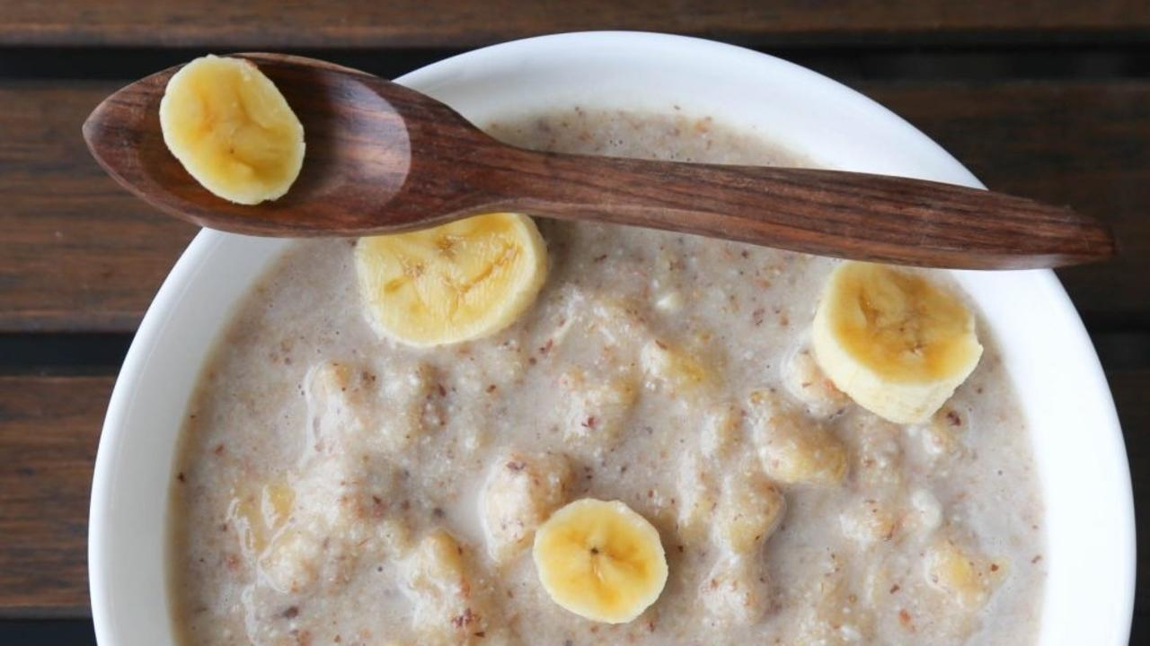

Bale hannina rasayana recipe or banana pudding recipe is a dish for every sweet tooth out there. It is very famous around coastal Karnataka. It is popularly served as a drink or pudding to guests and visitors. Commonly, banana, cow’s milk, sugar and crushed cashews go into making it as these ingredients have dominated our kitchens for a few years now. We have given it a healthy twist by using almond mylk as the base and dates syrup for sweetness. Almond mylk can be prepared same way as peanut mylk without heating.

### Whole Food Plant Based Bale Hannina Rasayana Recipe

Course: Course 1: Raw, Salad, Snacks, Desserts  
Cuisine: Coastal Karnataka Recipe from South India  
Prep Time: 10 minutes   
Servings: 3 people

#### INGREDIENTS

1 cup Banana mashed  
1 cup Almond Mylk  
1/4 cup Cashew broken  
1 tsp Fresh Coconut grated  
1 tbsp [Date Syrup](https://www.nutritionscience.in/blog/date-syrup-recipe-whole-food-plant-based)  
1 pinch Elaichi cardamom powder

#### INSTRUCTIONS

1. Mix all ingredients together. Top with bananas and serve immediately. 🙂

### Plant Based Chef Pro Tips for Best Bale Hannina Rasayana Recipe

1. Fully ripe bananas are best for this recipe.
2. It should be eaten as soon as it prepared, otherwise it gets discolored and loses nutrition.
3. Make **Instant Almond Mylk** by dissolving one tbsp [almond butter](https://www.nutritionscience.in/blog/almond-butter-recipe-whole-food-plant-based) in one glass of water!
4. Instead of almond mylk, you can use any nut mylk to prepare this dish from the heart of coastal Karnataka.

# 212.Cabbage Pickle Recipe | Oil Free Pickle Recipe | Whole Food Plant Based Recipes

Have you tasted cabbage pickle? It's super simple to make this fresh, tangy, and super spicy pickle. The crunchiness of the fresh cabbage adds to the yumminess of the pickle.

These types of fresh vegetable pickles are great because unlike store bought or stored pickles they do not contain oil or excessive salt.

Enjoy your fresh homemade whole plant-based cabbage pickle!

### Whole Food Plant Based Cabbage Pickle Recipe

Course: Side Dish for Course 3: Grain Dishes at Lunch & Dinner Meals, Pickle  
Cuisine: Indian Recipe  
Prep Time: 5 minutes  
Passive Time: 30 minutes  
Servings: 4 people

#### INGREDIENTS

1/4 cup Cabbage  
1 small or 1/2 long Green Chili  
1 tsp Mustard Seeds  
Juice of 1/2 Lemon

#### INSTRUCTIONS

1. Finely chop or shred cabbage into long, thin pieces.
2. Grind green chili and mix with shredded cabbage.
3. Dry roast mustard seeds until they start popping. As soon as they start popping, immediately transfer to shredded cabbage. Squeeze lemon and mix everything together. Serve fresh!

### Plant Based Chef Pro Tips for Best Cabbage Pickle Recipe

1. This is an extremely spicy pickle, especially because it has no salt. Reduce green chili quantity for a less spicy version.

# 213.Lemon Rice Recipe | Chitranna Recipe | Whole Food Plant Based

It is no surprise that Chitranna (Lemon Rice) is among the most popular South Indian rice dishes. What may come as a surprise that we've made this without any oil. This mouthwatering lemony and tangy dish has been a part of many of my school lunches and a must have during festivals.

Commonly, lemon rice is topped off with mustard seeds, lentils, groundnuts, and curry leaves fried in oil. The onions if used, are sauteed in oil as well. Heated extracted oil is unhealthy, unlike the abundance of health that oil within the whole nuts provide.

Here’s how you can enjoy Chitranna, be it with mango, lemon, amla or kokum, without a single drop of extracted oil.

## Whole Food Plant Based Lemon Rice Recipe

Course: Course 3: Grain Dish for Lunch & Dinner Meals  
Cuisine: Karnataka Recipe from South India  
Prep Time:10 minutes   
Cook Time: 30 minutes  
Servings: 2 people

### INGREDIENTS

1 cup Unpolished Rice soaked  
1 tsp Mustard Seeds  
1 tsp Urad Dal \ Split Black Gram  
3 tsp Peanuts roasted  
1 tbsp Curry Leaves  
2 tsp Coriander leaves chopped  
2 tsp Coconut grated  
2 Green Chili slit  
2 tsp Miso Paste (Healthy Salt Alternative. See Nutrition Science Highlights below)  
1/4 cup Lemon Juice  
1/2 tsp Turmeric Powder  
2 cup Water as required  
Servings: 2 people

### INSTRUCTIONS

1. Soak 1 cup unpolished, red or brown rice for 30 minutes. Cook it with 2 cups water until it is soft but not over cooked. Spread it out on a large plate so it doesn't become sticky.
2. Dry roast groundnuts over low flame until just done.  Ensure that it does not darken. Remove on to a plate and roast urad dal the same way. Once it is light brown, add mustard seeds, curry leaves, slit green chili and switch off the stove as soon as it starts sputtering. Make sure you do not over-roast any of these.
3. Once done, add the above seasoning to cooked rice, with miso paste and turmeric powder. Mix well.
4. Switch off the stove and add lemon juice. Garnish with coriander leaves and grated coconut.

### Plant Based Chef Pro Tips

1. Replace lemon juice with grated raw mango for Mango Chitranna Recipe!

# 214.Chana Masala Recipe | Chickpea Curry Recipe | Whole Food Plant Based Recipes

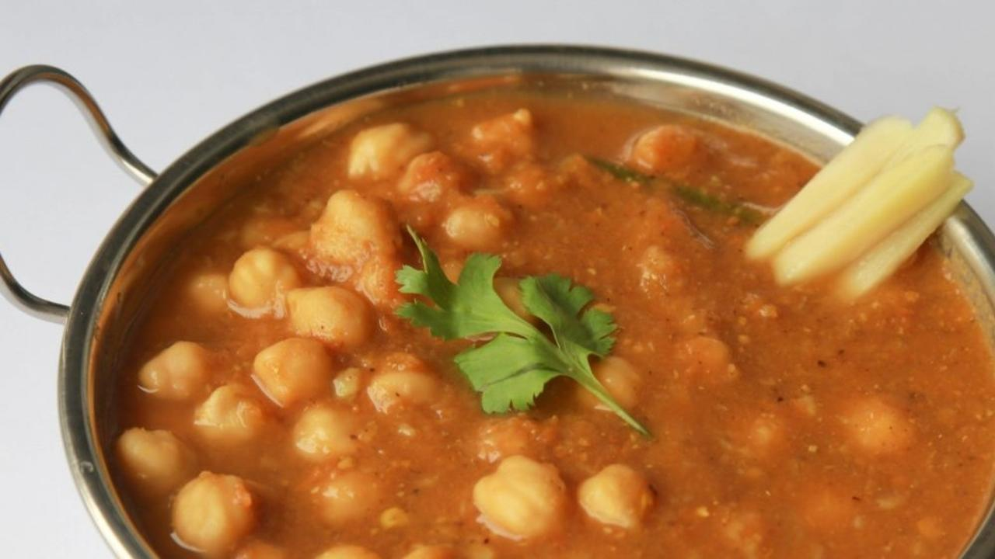

Chana Masala, is a tangy, juicy, and yummy dish! With a perfect blend of spices, hot and sweet, chana masala is a crowd favourite side dish that goes with all kinds of rotis.

This chickpea curry recipe is a super yum one that shows you how to make the same yummy dish without oil, ghee, butter or red chili. Oil is a processed food and ghee and butter are animal foods, the consumption of which has been linked to chronic lifestyle diseases such as diabetes, hypertension and heart disease. Red chili powder irritates the digestive tract, so  we recommend that you reduce consuming the same. Some alternatives to red chili powder are pepper, slit fresh chili, broken red chili.

### Whole Food Plant Based Chana Masala Recipe

Course: Course 2: Vegetables Dishes & Side Dish for Course 3: Grain Dishes for Lunch & Dinner Meals  
Cuisine: Punjabi Recipe from North India  
Prep Time: 10 mins  
Servings: 4 people   
Cook Time: 30 mins

#### INGREDIENTS

##### For Boiling

1 cup Chana dried and soaked, or black chickpeas can be used  
1 Bay Leaf  
1 stick Cinnamon  
4 Cloves  
2 pods Cardamom / Elaichi  
2 Green Chili slit  
1 cup Water as required

##### Chana Masala gravy

2 Tomato chopped  
1/2 inch Fresh Ginger chopped  
1/4 tsp Turmeric Powder  
1/4 tsp Garam Masala  
3/4 tsp Dry Mango Powder / Amchur Powder  
4 Black Peppercorns  
1/4 tsp Carom Seeds / Ajwain  
1 tsp Cumin / Jeera  
3/4 tsp Coriander Seeds / Dhaniya  
1 tsp Fennel seeds sompu, saunf  
1 tsp Amla Powder  
4 tsp Miso Paste (Healthy Salt Alternative. See Nutrition Science Highlights below)

##### Garnishing

4 tsp Coriander leaves chopped  
Juice of 1/2 Lemon  
2 tsp Groundnuts mildly roasted and powdered

#### INSTRUCTIONS

1. Boil chickpeas with other ingredients in the 'For Boiling' section above with closed lid.
2. While it cooks, prepare the gravy masala by dry roasting cumin, coriander, carom, fennel seeds and peppercorns. Blend all this into powder and then add other Chana Masala Gravy ingredients and blend again to get a smooth paste.
3. Add this mixture to the boiling mixture and cook it well.
4. If you want a thicker gravy, blend some of the cooked chickpeas and add it back.
5. Once everything is cooked well, garnish with ginger, coriander leaves, and powdered, roasted groundnuts. Squeeze some lemon juice for tanginess.
6. Serve fresh with rotis, rice or millets.

### Plant Based Chef Pro Tips

1. To make it richer, blended coconut can be added as well, after the chickpea curry is cooked.
2. Onion and garlic can be blended with the masala and boiled, but this takes away the sattvic nature of the dish.
3. If you don't want too much tanginess or sourness, reduce the amount of tomato or dry mango powder.

# 215.Pan Tossed Carrot & Gobi - Whole Food Plant Based Recipe

This pan-tossed carrot and gobi is a simple everyday dish that we have made healthy. Both carrot and gobi are crunchy vegetables and retain some of their texture when one doesn't overcook them. Also, both these vegetables have lovely flavours that compliment one another, often we can't taste individual vegetables because of our otherwise high sugar and high salt diet.

Get ready to feast of some delicious, semi-crunchy carrot and gobi cooked in aromatic spices. It's simple to make and pretty much all of us will have the required ingredients at home.

Simple, Step-by-step, and practical upgrades towards achieving perfect health.

# 216.Pan-Tossed Carrot and Gobi Recipe

Course: Course 2: Vegetable Dishes, Meals: Lunch & Dinner, Side dishes  
Cuisine: Indian, North Indian  
Prep Time: 10 minutes  
Cook Time: 15 minutes  
Servings: 2 people

## INGREDIENTS

### Main Dish

1. 2 Carrots Medium-sized
2. 1/4 Head Cauliflower
3. 1 Onion
4. 4 pods garlic
5. 2 tbsp Coriander Leaves Chopped

### Masala

1. 2 tbsp Bengal Gram Dal
2. 1 tsp Mustard Seeds
3. 1/2 tsp Pepper Powder
4. 1/2 tsp Turmeric Powder
5. 1 tsp Garam Masala
6. 1 tbsp Almonds
7. 1/2 Lemon Peeled
8. Miso Paste to taste

## INSTRUCTIONS

### Masala

1. Dry roast bengal gram dal until slightly browned, on low flame. Do not allow to turn dark brown or brown too much. Remove bengal gram from the vessel.
2. In the same vessel, add mustard seeds and dry roast until they start popping. As soon as they start popping, remove from the vessel into a cup. It is important to roast them only as little as required. If possible, avoid roasting them altogether.
3. Finely grind peeled lemon and miso paste to a smooth paste. Add roasted bengal gram, almonds, pepper powder, turmeric powder, and garam masala, and grind to a coarse powder. Remove from mixie and mix in roasted mustard seeds. Masala is ready.

### Main Dish

1. Peel and chop onions into long, thin pieces. Chop carrots into thick, medium sized pieces. Chop cauliflower into small florets. Peel and crush/grind garlic to a paste. Keep aside for ten minutes before cooking.
2. Take 1-2 tbsp water in a thick bottomed pan / wok / kadai and add onions. Switch on the stove and stir continuously until cooked.
3. Add chopped carrots and cauliflower, mix, turn the stove to sim and close with a lid/plate.
4. Once garlic paste has rested for ten minutes, add to the vegetables and continue cooking with a closed lid.
5. While the vegetables are being cooked, prepare masala as explained above.
6. When vegetables are cooked just enough, remove from stove and mix masala.
7. Garnish with chopped coriander leaves. Serve fresh!